
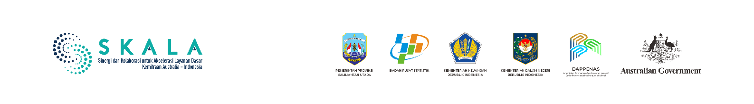
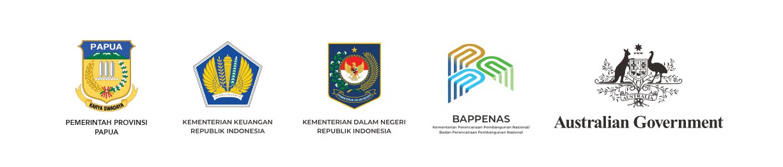


PEMERINTAH PROVINSI MALUKU

NAVIGATING THE WAVES,

REACHING THE COMMUNITY
COLLABORATION STRENGTHENS BASIC SERVICES IN MALUKU

OCTOBER, 2026


Ensuring basic services for all citizens requires an integrated system. Indonesia’s minimum Service Standards (Standar Pelayanan Minimal/SPM) are a shared reference to ensure that planning, budgeting and implementation proceed harmoniously within a single governance framework.
Maluku Province’s archipelagic geography presents challenges for equitable basic service provision. Inter-island isolation, the concentration of service facilities in district capitals, and the high costs associated with reaching remote areas necessitate a more collaborative and data-driven governance approach.

“Maluku possesses specific challenges as an archipelagic region. Development is frequently inequitable, concentrated in districts and cities. Meanwhile, ensuring equitable distribution across the islands requires exorbitant financing. This has direct implications for the provision of services to vulnerable groups, including people with disability.”

Anton Lailossa,
Head of Maluku’s Regional Development Planning Agency


Synergy across regional agencies is paramount to ensuring that basic services are accessible to the community, including people who live in remote areas. Maluku has lately entered a critical new phase in strengthening SPM implementation – the process now has more clearly defined mechanisms and steps embedded in regional development priorities.
As a strategic measure Maluku Province initiated an SPM action plan – a collective guideline for fulfilling basic services. The action plan was integrated into planning documents such as the Regional medium-term development plan (RPJMD), Strategic plan (Renstra) and Regional government work plan (RKPD) and reinforced by coordination across regional apparatus organisations. This approach has led to better consistency in program implementation, a clearer legal foundation and sufficient budget support. The goal is to make genuine contact with the community where provision of education, health and social protection services are concerned.
The transformation has been underpinned by three pillars: cross-functional institutional synergy, technical assistance, and the capacity to adapt to regional fiscal dynamics. Together, these pillars strengthen SPM implementation in Maluku.
This approach aligns with Government Regulation No. 2 of 2018 on SPM, which mandates that delivering basic services in a planned, measurable and sustainable manner is the responsibility of local governments. Minister of Home Affairs Regulation No. 59 of 2021 also directs provincial governments to undertake Korbinwas (coordination, guidance and supervision) to implement SPM in districts and cities.

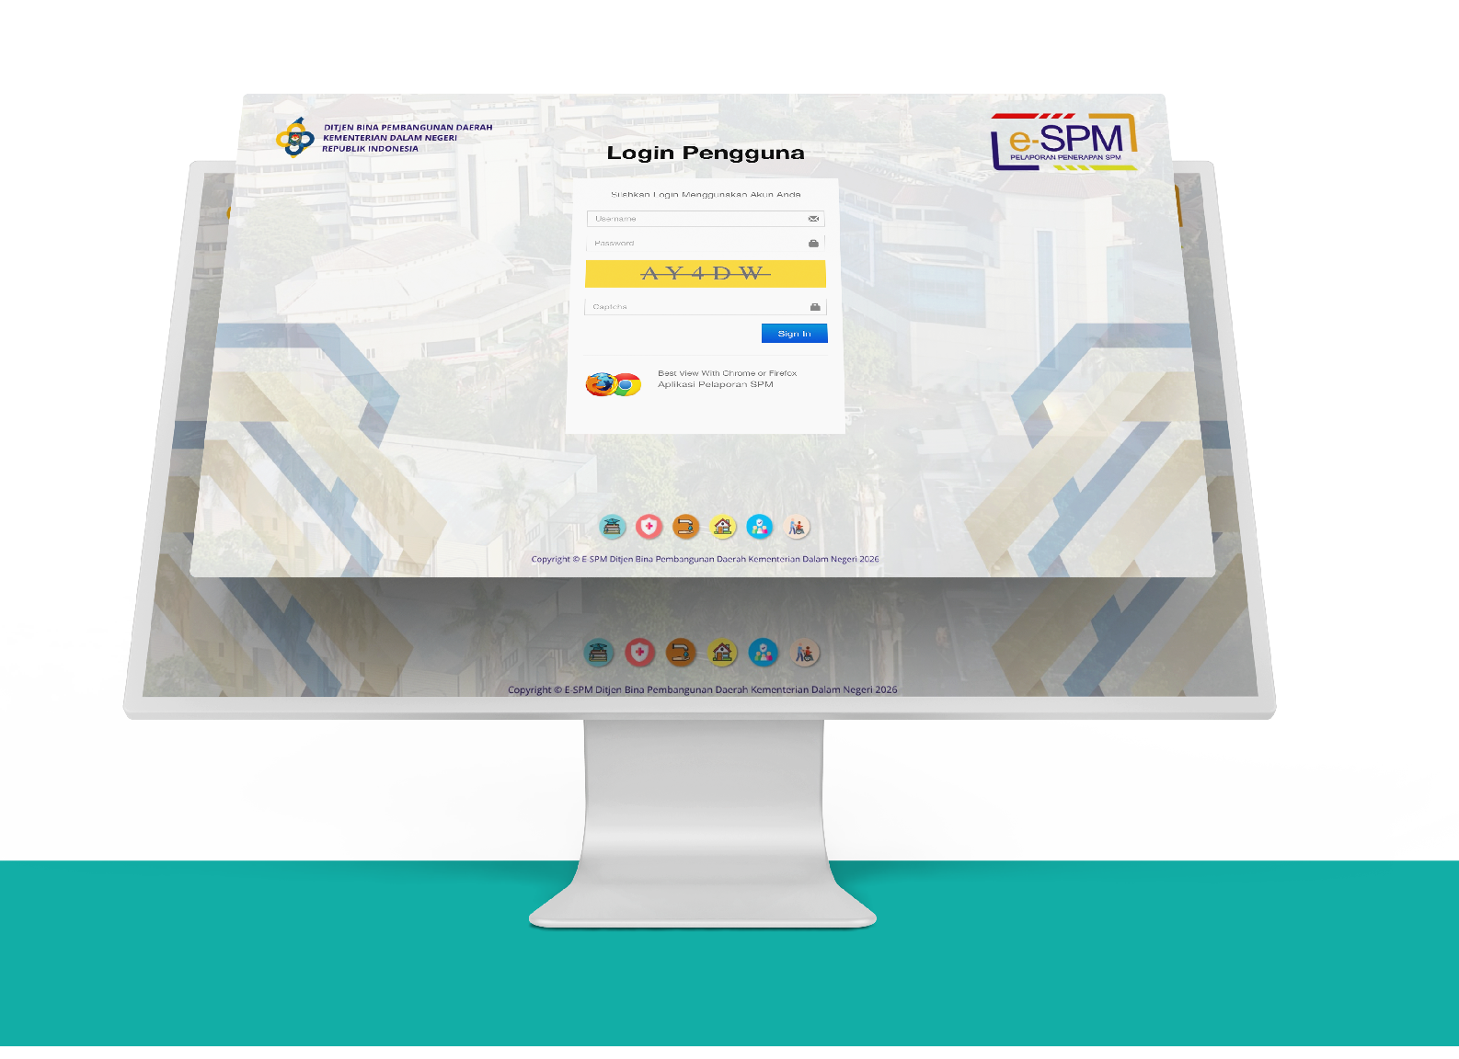
Cross-Functional Institutional Synergy

SPM implementation in Maluku is organised as an interconnected system. Each regional government agency has a defined role within a governance cycle covering planning and budgeting, implementation, coordination, guidance and supervision.
Cross-functional institutional synergy between the Maluku Provincial Government and Secretariat of the Directorate General of Regional Development at the Ministry of Home Affairs (MoHA) is an important part of this process. Technical facilitation and monitoring help keep indicators, reporting mechanisms and SPM implementation standards aligned between the national and local governments.
Understanding the need for a coordination mechanism, the Maluku Provincial Government established an SPM Implementation Team through Maluku Governor’s Decree No. 82 of 2022. The team brings regional government agencies together and helps to integrate SPM implementation.

The Regional Development Planning Agency (Bappeda) integrates SPM indicators into regional planning documents and aligns them with the performance indicators of agency heads. This makes the fulfilment of basic services a leadership responsibility within each regional government agency.

The Regional Financial and Asset Management Agency (BPKAD) supports the fiscal side through orderly and timely budgeting and fund disbursement. Sound budget management helps sustain promotive and preventive services, including capital expenditure for health facilities and infrastructure.

The Bureau of Government Affairs coordinates SPM implementation at both provincial and district/city levels. Through regular coordination forums and assistance with reporting through the e-SPM application, implementing agencies are encouraged to carry out each stage according to the required schedule and standards.

This division of roles makes SPM implementation a shared responsibility across regional government agencies. Korbinwas helps to maintain connectedness and consistency, including in island communities where institutional capacity varies.


“The key is the coordinator. If the coordinator does not coordinate well and cannot mobilise the different parties, mandatory basic service responsibilities will not move forward. We have to be the driving force that ensures all agencies responsible for SPM are working towards one vision.”

Dominggus Nicodemus Kaya,
Head of Maluku’s Bureau of Government Affairs and Regional Autonomy

Technical Assistance


Institutional arrangements need to translate into day-to-day technical work. Regional government agencies must assess service needs, prepare plans, allocate budgets and meet reporting requirements. This is where technical assistance helps keep SPM implementation on track.
Ahead of each quarterly reporting deadline, the Bureau of Government Affairs actively reminds implementing agencies to complete their reports. What was once handled individually has developed into a more systematic process through quarterly pre-reporting Korbinwas coordination meetings. With support from SKALA, the Australia–Indonesia partnership program, cross-sector technical meetings are now held more regularly to integrate the SPM action plan into regional government agencies’ planning documents.
Technical assistance covers the use of data, service needs planning, budgeting and reporting. Together with the SPM Implementation Team and Secretariat of the Directorate General of Regional Development at MoHA, SKALA works to strengthen technical capacity and promote collaboration across regional government agencies and development partners.
Strengthening human resource capacity is equally important so that knowledge and practical experience of SPM implementation can be carried forward within local government. The technical assistance also helps improve data quality and makes planning and budgeting for service needs more accurate and focused on beneficiaries.

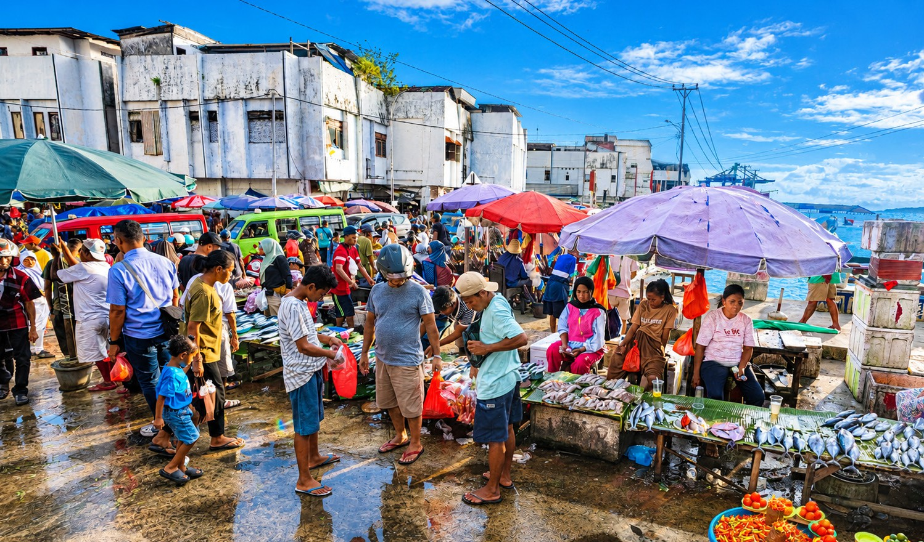
Adapting to Regional Fiscal Dynamics

As an archipelagic province, it is challenging for Maluku to maintain reliable data while experiencing fiscal constraints. To improve the accuracy of planning, the Maluku Provincial Government uses socioeconomic data integrated into the National Single Socioeconomic Data (DTSEN) through SEPAKAT (Integrated Planning and Poverty Analysis System). This platform is a cross-sector reference for SPM planning and strengthens the evidence base for basic service interventions to reach those most in need.
The Housing and Residential Areas Agency, as an example, uses this approach to target assistance for disaster-affected households. Beneficiaries are identified by combining post-disaster survey results (BNBA) with verified socioeconomic data in DTSEN, particularly for poor and vulnerable households (deciles 1 and 2). Annual data updates have made the list of intended beneficiaries more precise.

“We do not serve ourselves, but the nation and our homeland.
With DTSEN, we are no longer making decisions based on vague information. Our interventions are now reaching the people who most need the support of SPM.”
Alan Pribadi Far Far,
Policy Technical Reviewer, Bappeda Maluku


Alongside improving data quality, the Maluku Provincial Government has begun to develop alternative financing through a standard operating procedure (SOP) for proposing Corporate Social and Environmental Responsibility (CSER/ TJSL) support.
The scheme creates opportunities for government to work with state-owned enterprises (BUMN), regionally owned enterprises (BUMD) and the private sector to support basic services. These include public order and safety, basic service infrastructure such as drinking water supply systems (SPAM) and domestic wastewater management systems (SPALD), as well as social services through the provision of essential supplies and emotional and spiritual support for residents of care facilities.
Cross-functional institutional synergy across regional government agencies was the starting point for developing this alternative financing mechanism. Six agencies responsible for SPM – Education; Health; Public Works and Spatial Planning; Housing and Residential Areas; Social Affairs; and the Civil Service Police Unit – worked together to map basic service needs as yet unable to be financed through the regional budget (APBD). The resulting assessment became the basis for proposals submitted to the Maluku Provincial TJSL Forum.
SKALA has supported use of the TJSL scheme through dialogue with the TJSL Forum and assistance to prepare alternative financing proposals. Through this mechanism, the provincial government is expanding partnerships with the private sector to support the financing of basic services.
This collaboration shows efforts to meet SPM in Maluku are being underpinned by stronger fiscal governance and strategic partnerships that are structured and accountable, alongside support from the regional budget.

“SKALA has helped and facilitated us in finding other sources of funding to meet SPM needs. It has been a collaborative effort – we are doing it together, rather than working separately.”

Rufaidah,
Head of Research and Development, Bappeda Maluku

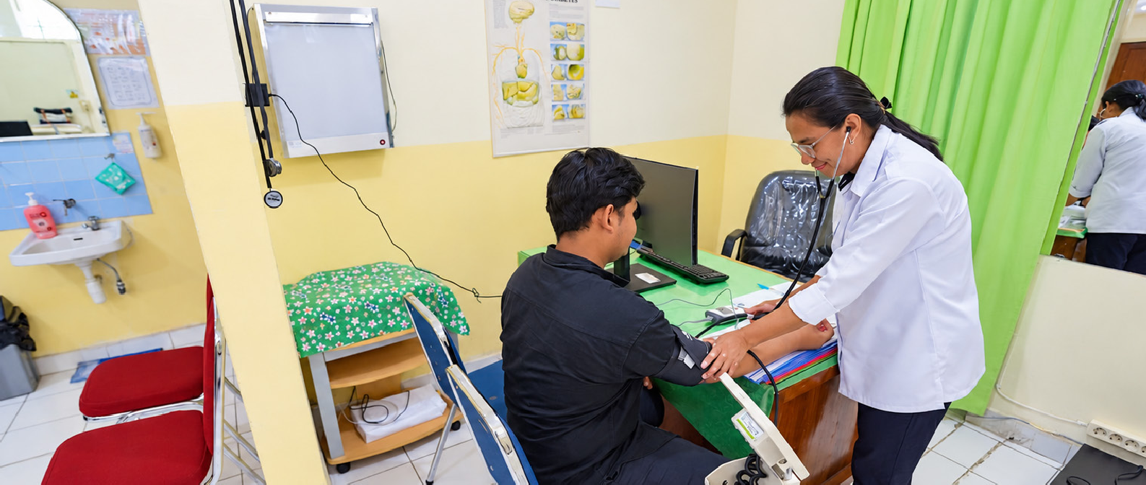
Towards Better Basic Service Delivery

The changes in government processes are starting to show in the services people receive. In health, education and social services, planning is increasingly being translated into programs that respond more closely to needs on the ground.
During the past three years, Maluku Province’s SPM Achievement Index (IP SPM) has consistently been rated Tuntas Utama (primarily fulfilled at a rate of 90 to 99 per cent ). This performance earned Maluku the 2025 SPM Award for Best Performing Province in the Maluku–Papua Region.
In health, planning for service needs is more closely aligned with real-life conditions. BPKAD support by way of SPM budgeting helps provide funding, including capital expenditure for health facilities and infrastructure.

“In the past, we did not think through to the output

for beneficiaries. What mattered was completing budget realisation administratively. Now, direct results for the community are truly
the priority and the main objective of the entire SPM process.”

Maria Ulfa Marasabessy,
Secretary of Maluku’s Health Agency



In education, the ‘education report’ is used to inform planning so that programs are better targeted. One example is the acceleration of Special Schools (SLB) in Seram Timur and Maluku Barat Daya districts as part of efforts to expand access to inclusive education. Of the 11 districts and cities in Maluku Province, these two areas have been prioritised to expand education services for children with special needs.

“In the past, many of our graduates could not find jobs. Now, with government policy and attention, some of them are working in various institutions. This is a real change.”

Padil Sarip Mako,
Acting Head of the Ambon State Special School

“We now design our education SPM programs based on recommendations from the education report, and then incorporate them into the strategic plan and SIPD.”

Tyastika Dwi Gusma
Planning staff member, Maluku Education Agency

The use of education data is also expanding. Data managed by the Ministry of Religious Affairs through the Education Management Information System (EMIS), which had not previously been used to its full potential, is being used to strengthen the evidence base for decision-making.
Acting Head of the Ambon State Special School, Padil Sarip Mako, said some of their graduates were now out doing paid work.

In the social sector, integrating the SPM action plan into the Strategic plan 2025–2029 has created a more comprehensive approach to services. The approach covers health services, mental health support and spiritual needs for residents of care facilities.

“The SPM action plan has been incorporated into our Strategic plan 2025–2029. This means SPM is no longer something added on; it has become part of the planning system.”

Yahya S. Baljanan,
Acting Head of Maluku’s Social Affairs Agency

The commitment of provincial leaders, Bappeda’s active role in integrating SPM into planning, and the work of the SPM Implementation Team provide an important foundation for sustaining these changes. Strengthening the commitment of all agencies responsible for SPM remains a shared task.
Support from MoHA and SKALA will remain crucial to sustaining SPM implementation in Maluku. The SPM Award recognises the progress made while encouraging the provincial government to continue improving the quality of basic services.
Looking ahead, further strengthening non-APBD financing through CSER, aligning the cost standards for social services, and maintaining a consistent focus on low-income communities and people with disability will be essential to fulfilling SPM in Maluku.
With stronger governance in place, Maluku Province is better positioned to provide basic services that respond to the needs of communities across its many islands.



SPM as a Unified System
The successful implementation of SPM in Maluku Province hinges on integrated governance. Planning, budgeting and execution are managed in a unified manner through cross-agency coordination, ensuring that basic services are delivered more effectively and that their benefits are felt by the community.



