

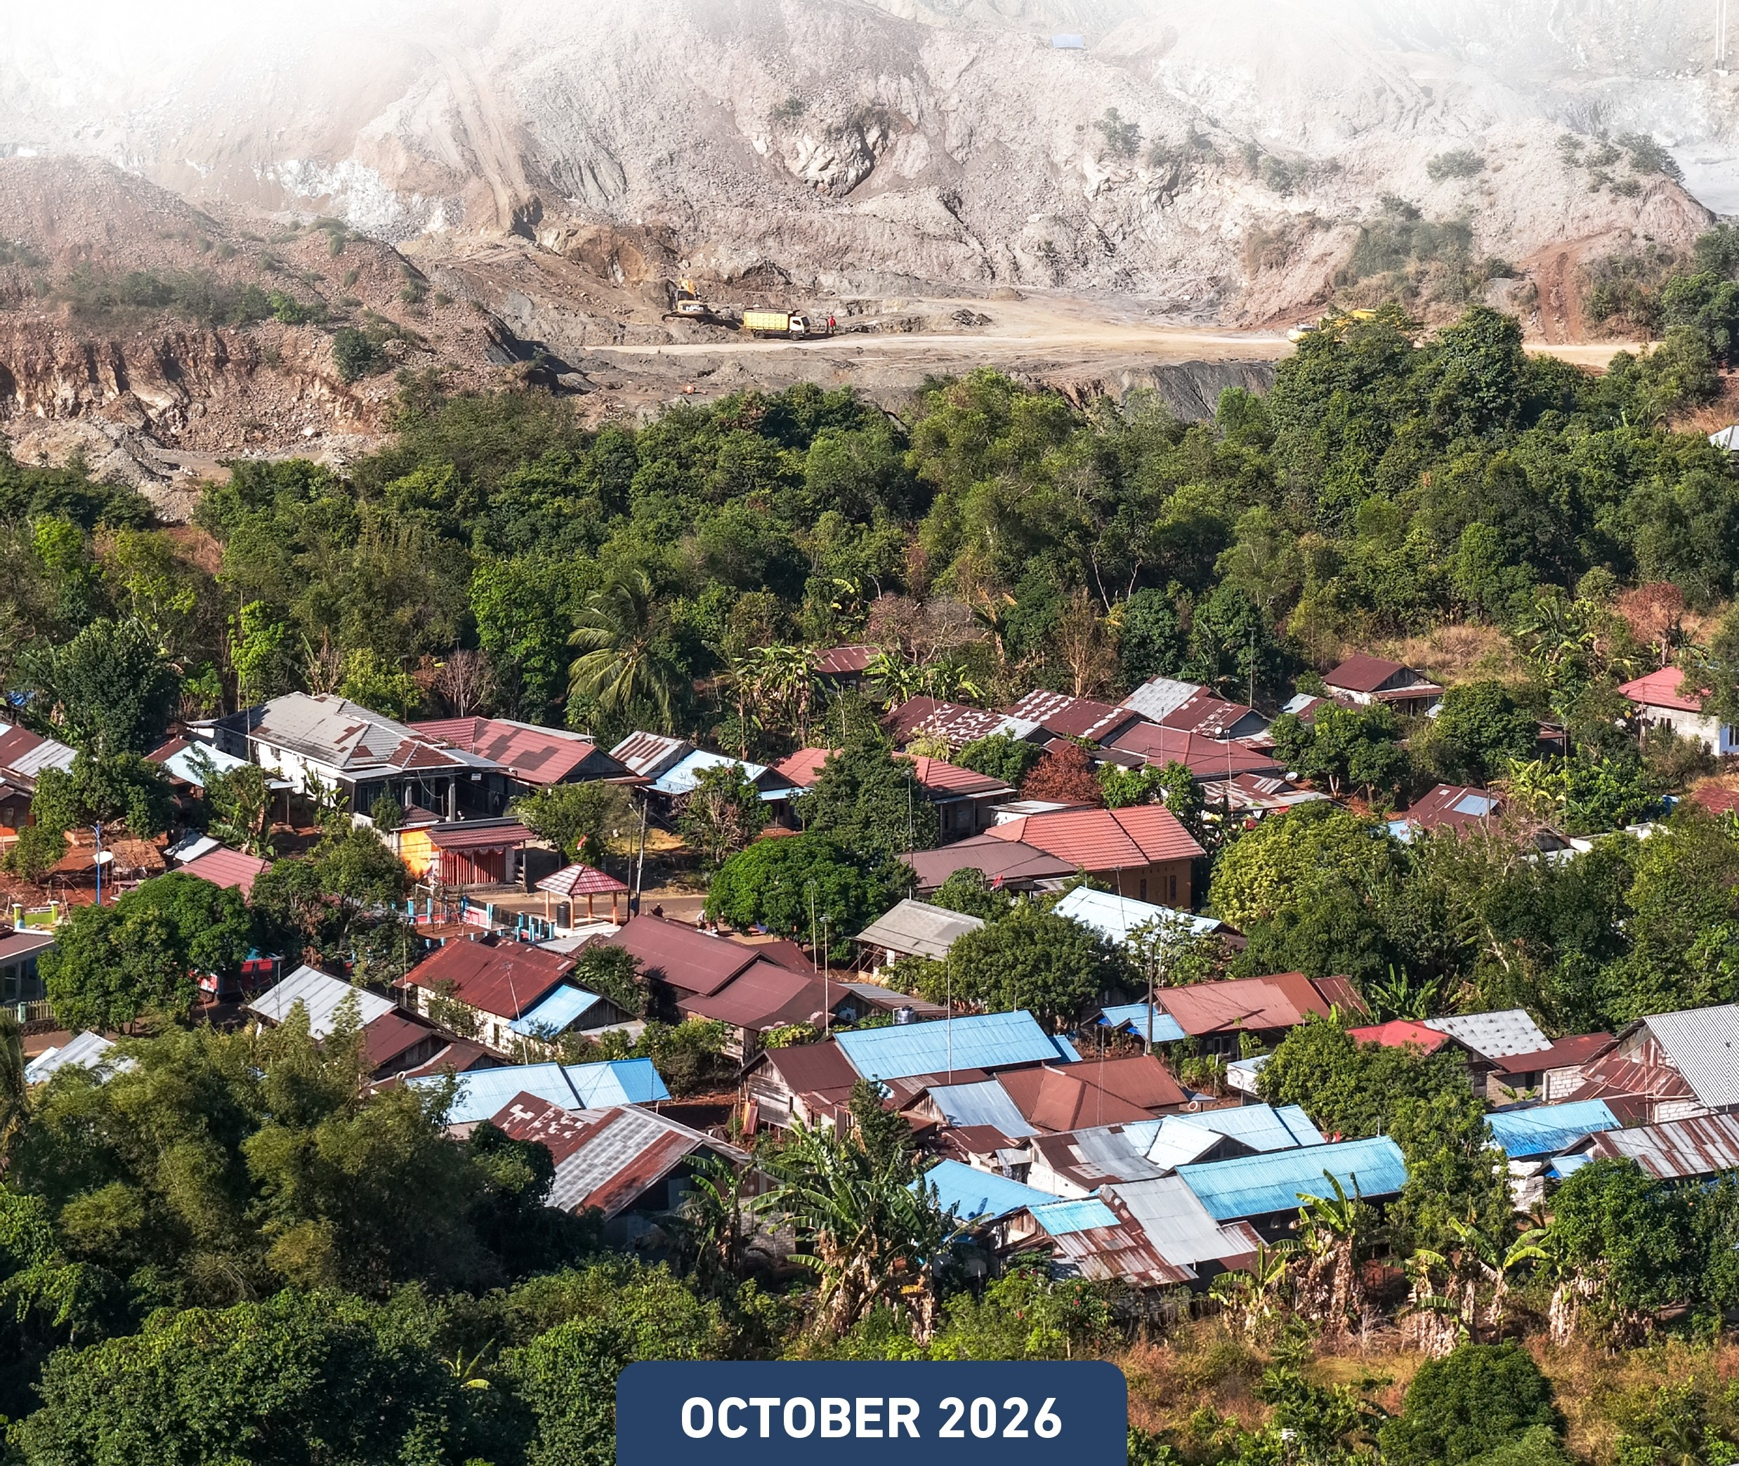
•• J�
-��.!:���-"-
KEMENTERIAN KEUANCAN KEMENTERIAN DALAM NECERI Australian Government
REPUBLIK INOONESIA REPUBLIK INOONESIA e..i.n...,Ptm-nN..-.

STORY BOOKLET

MAKING CENTRAL GOVERNMENT FUNDING

MORE RESPONSIVE TO SUBNATIONAL 3 GEOGRAPHIC CHALLENGES

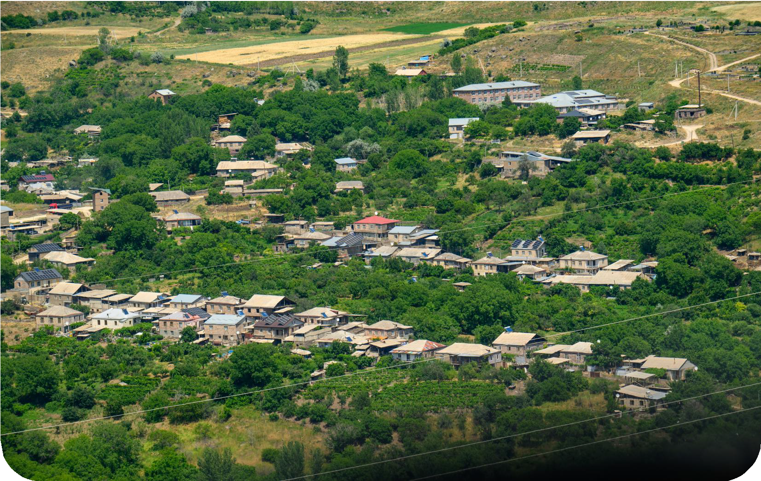

n paper, the amount a subnational government receives from the General Allocation Fund (DAU) may look like just another number in a funding document.
O
In practice, it helps determine how much a government can spend on schools and health services, how much infrastructure it can provide and how effectively it can carry out essential government functions.
For the 2027 DAU allocation, the government is addressing the question of fairness - whether the allocated amount fairly reflects what each subnational government needs to provide basic services to its citizens - in a new way. For the first time, it will reflect the particular circumstances of 3T areas – Indonesia’s term for disadvantaged, border and outlying areas such as remote islands – through a 3T Regional Index.
The Ministry of National Development Planning (Bappenas) developed the 3T Regional Index through its Directorate of Spatial Planning, Urban Affairs, Land and Disaster Management. The results of the index’s calculations have been submitted to the Ministry of Finance’s Directorate of General Fund Transfers (DTU) to consider its use in calculating the 2027 DAU allocations.
Incorporating the 3T Regional Index into the DAU formula is a crucial step toward making government funding policy more responsive to each subnational government’s different circumstances. Getting there has involved a lengthy process of bringing data together, developing a methodology, testing the formula and ensuring that the resulting measure reflects the development challenges facing 3T areas.



Fairer funding – or fiscal equity – does not mean the central government should give every subnational government the same treatment or level of support. It means assessing their different needs and adjusting the allocations accordingly.
- Challenges related to geography, transport infrastructure and distances in Indonesia can mean that one subnational government needs to spend considerably more than another to deliver basic services. Some examples include:
- constructing a school on a small island only accessible by sea is more costly than doing so in an easy-to-reach location
- deploying health workers to border areas presents challenges related to relocation that do not arise in cities
- building basic infrastructure is more difficult in areas where villages are far apart and hard-to-reach.
These differences in the cost and difficulty of providing public services needed to be better reflected in DAU allocations. Thus, the DAU serves not only as an instrument for equalising fiscal capacity but also recognises the need for targeted support for regions facing significant geographical challenges, including island regions and disadvantaged, frontier and outermost (3T) regions.
This complex challenge was one of the starting points for developing the 3T Regional Index. The next step was to gather data and devise a methodology to capture these geographic differences more fully.




The 3T Regional Index combines three geographic dimensions: ‘tertinggal’, ‘terdepan’ and ‘terluar’.
The tertinggal (disadvantaged) dimension is defined in Indonesia’s 2025–2029 National medium-term development plan (RPJMN). The classification considers several broad development indicators, including the Human Development Index, the percentage of people living in poverty and the Village Index for measuring rural welfare and development.

The terdepan (border) dimension covers areas along Indonesia’s international borders. Data on priority subdistricts in these areas help identify locations that face development challenges and are strategically important.
The terluar (outlying) dimension covers Indonesia’s outermost small islands.
Notably, an area might be classified as disadvantaged without being located on an international border. Another might be both a border area and home to an outermost small island, and still another might combine characteristics of all three dimensions.
Hence the index needed to capture each of the dimensions, as well as have the flexibility to capture different combinations of them.

Data was one of the biggest challenges in developing the 3T Regional Index. Responsibility for data that relates to disadvantaged areas, border areas and outermost small islands is spread across ministries and agencies with different mandates.
This being the case, those involved needed a shared understanding of why 3T areas required differentiated support, what distinguished these areas and how each funding instrument could respond to their needs.
Head of the Regular DAU Planning Team in the DTU, Imam Sumardjoko, described the process as an ‘orchestration’. For him, the main challenge was not simply bringing the data together, but aligning institutions with different mandates and priorities.

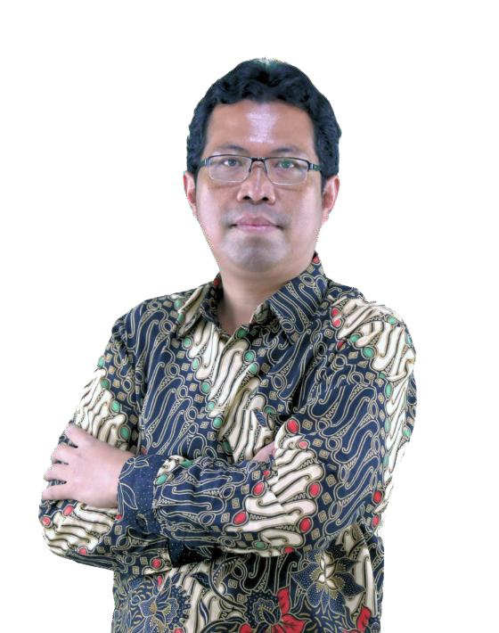
The most important thing has been to coordinate our efforts around a common purpose.
Supporting 3T areas is not the responsibility of the Ministry of Finance alone. It involves many ministries and agencies, and we all need to work towards the same goal: improving public services, strengthening governance and developing infrastructure in these areas
Imam Sumardjoko
Head of the Regular DAU Planning Team in the Dana Transfer Umum (DTU), Ministry of Finance

Developing the index therefore required coordination across sectors. SKALA, the Australia–Indonesia partnership program, worked with the DTU to establish a forum to bring together the ministries and agencies responsible for 3T data. The intention was to provide a space to build a shared understanding of definitions, data sources, indicators and how the data could be used.

The forum brought together Bappenas, the National Border Management Agency, Ministry of Marine Affairs and Fisheries, and Ministry of Villages, Development of Disadvantaged Regions and Transmigration.
The forum’s cross-government participation helped bring different data sources into a common framework to calculate DAU allocations for subnational governments across Indonesia.
By combining the three dimensions in its design, the 3T regional Index creates an overall picture of which areas have 3T characteristics and the scale of the challenges they face.

A methodology that looks good on paper may not work as intended in practice. Modelling was therefore an important part of developing the 3T Regional Index.
Different combinations of indicators and weightings were tested to see how the index performed when incorporated into the DAU formula. Could the index distinguish areas with different characteristics? Were the results consistent with development conditions? And how did the index affect the distribution of DAU allocations?
These questions were tested through simulations before the index was incorporated into the 2027 DAU formula. This was important to ensure that differentiated support for 3T areas had a practical effect. The aim was for DAU allocations to reflect additional costs and service needs created by the particular circumstances of each area. Simulations are also required to examine the magnitude of change in allocations compared to the baseline prior to the 3T intervention, enabling a clearer measurement of policy impacts.


Conditions on the ground can reveal more than the numbers alone, so field visits were important for testing whether the indicators reflected the challenges subnational governments actually face.
One of the areas selected for field validation was Nunukan in North Kalimantan, a disadvantaged regency on Indonesia’s border. Nunukan’s island geography, limited transport links and long distances between communities and service centres make public services more difficult to provide.
From the subnational government’s perspective, these characteristics directly affect development needs. According to Head of North Kalimantan’s Regional Development

Planning, Research and Innovation Agency (Bapperida), Bertius, conditions in the province substantially increase the resources needed to provide basic services in some areas.

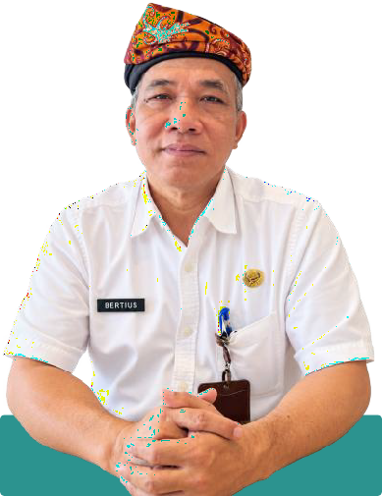
For North Kalimantan, population alone does not tell us what 3T areas need. Communities are often far apart, along the border, on islands or deep inland, with limited transport links. This means longer journeys and higher costs for providing basic services. We therefore need indicators that accurately reflect these geographic challenges, so that the level of support matches the difficulty and cost of providing services
Bertius
Head of North Kalimantan’s Regional Development Planning, Research and Innovation
Agency (Bapperida)

Mr Bertius’s comments underline how important it was to bring a subnational perspective into the index’s development. Data were needed not just to build the formula, but to ensure the realities of subnational service delivery were reflected in fiscal policy.
The Nunukan field visit helped the DTU to understand how the conditions in 3T areas could be captured in the data and measures for building the index. SKALA supported monitoring, evaluation and field visits to assess how well the index indicators reflected actual development conditions.
By bringing together data, modelling and field evidence, the development process drew on the perspectives of central and subnational governments and the ministries and agencies involved.
“We are not simply seeking a larger allocation. We want fiscal support to reflect the actual cost and difficulty of providing basic services. We need accurate, reliable data so that national development and fiscal policies take proper account of the needs of people living in border areas, remote inland areas, islands and other hard-to-reach places. With support that better reflects these needs, local governments can reach more people, reduce gaps in access and provide more equitable public services,” Mr Bertius added. He illustrated this by comparing island regions with areas that are easier to reach.
“Transport costs are clearly different between island regions and Java, and the cost of goods and services varies too. We cannot treat these areas in the same way. That is why the DAU formula includes an adjustment factor to take account of each area’s particular characteristics and geography,” he said.

Incorporating the 3T Regional Index into the DAU formula is not the end of the process. Its effects will need to be evaluated, including whether greater fiscal capacity leads to better education, health and infrastructure outcomes.
Where services improvements do not follow, the government will need to understand why: whether the constraints lie in capacity, planning or implementation, or whether factors other than funding are at play.
Evaluation will also require cooperation across government. The Ministry of Finance will need to assess fiscal outcomes, while other ministries and agencies will need to assess changes in the services within their respective mandates.
Ultimately these efforts will ensure responsive, equitable funding that reflects differences in both the fiscal capacity of subnational governments and their distinct needs in providing public services.

