






Executive summary
Korbinwas: a strategic lever to strengthen Minimum Service Standards
Lessons from North Kalimantan, East Nusa Tenggara and
Papua Barat Daya
August 2026
KNOWLEDGE BRIEF

This brief captures insights on coordination, guidance and supervision (koordinasi, pembinaan dan pengawasan/Korbinwas) to strengthen the implementation of Minimum Service Standards (Standar Pelayanan Minimal/SPM). Drawing on lessons from the SKALA program in East Nusa Tenggara, North Kalimantan and Papua Barat Daya, it points out effective Korbinwas practices. Key recommendations include strengthening institutional capacity, enabling adaptive design and utilising data to refine the SPM action plan and its integration with programs and budgets.

Context and rationale

Law No. 23 of 2014 on Regional Government mandates local governments to fulfil basic service delivery through SPM in six sectors.1 The implementation process is the subject of technical regulations which direct data collection, needs assessment, formulation of an SPM action plan2, service delivery and reporting through the e-SPM system.3
Despite this regulatory framework, implementing SPM remains challenging for many local governments. Progress is hampered by limited technical capacity to monitor performance, weak coordination across

1 The six basic service sectors are education, health, public works, housing, public safety/order and social services. SPM implementation is further regulated by Government Regulation No. 2 of 2018 and Minister of Home Affairs Regulation No. 59 of 2021.
2 The SPM action plan is a document prepared by the relevant sectoral agencies to plan the phasing-in of SPM. It sets out targets, programs, activities and financing requirements, and serves as a reference for the preparation of strategic plans (Renstra) and regional government work plans (RKPD).
3 e-SPM is aweb-based system developed by the Ministry of Home Affairs to monitor local government compliance with SPM. It is a central reporting platform covering implementation stages, indicator achievements and service performance in the six basic service areas.

government agencies, and low compliance with reporting requirements. These challenges cannot be addressed through regulation alone and require a more effective approach.
Korbinwas is a coordination, guidance and supervision mechanism through which designated authorities support local governments to:
- provide coordination, technical guidance and capacity strengthening
- conduct oversight and monitoring of implementing agencies.
The mechanism ensures that government policies, programs and services are implemented effectively, consistently and in compliance with applicable laws, regulations and established standards. While Korbinwas is a cross-government function, its implementation varies across sectors, levels of government and jurisdictions, reflecting differences in institutional arrangements, capacity, resources and policy contexts.
Provincial governors are appointed as the central government’s representative to oversee and guide SPM implementation at the district/city level4. It is crucial to reinforce and strengthen their role for the successful implementation of SPM. However, Korbinwas is often enacted inconsistently, typically to address administrative issues, rather than being used strategically to improve service delivery.
With SKALA’s support, the Directorate General of Regional Financial Development within the Ministry of Home Affairs is collaborating with provincial governments to pilot a cross-functional, systematic and adaptive Korbinwas approach. Implementation has demonstrated that the effectiveness of Korbinwas does not derive solely from the mechanism. Three vital areas require deliberate reinforcement: establishing legitimacy and institutional arrangements, designing effective implementation, and ensuring concrete follow-up. The next section details these elements in action.

Lessons: How Korbinwas strengthens SPM implementation

A formalised, cross-functional implementation team is a key enabler of coordination and accountability
The Provincial Government SPM implementation team (Tim Penerapan SPM) is fundamental to effective Korbinwas, as it carries out coordination and accountability functions. The team brings together cross-functional government agencies and should be formalised through a Governor’s Decree. The team’s structure is based on roles and positions rather than individual names, so that work continues despite staff turnover. Coordination takes place at both horizontal and vertical levels.
At the horizontal level, the Regional Development Planning Agency (Bappeda) and sectoral agencies collaborate in a shared forum to align planning, SPM performance and areas for improvement. At the vertical level, the team provides districts/cities with technical assistance and conducts field visits. These arrangements require clear definition from the outset within a structured work cycle, with each institution responsible for specific stages.

4 Under Law No. 23 of 2014 on Regional Government, the President delegates specific supervisory and administrative authorities to provincial governors.

Accountability is strengthened by submitting regular reports on SPM implementation to the governor/ district head/mayor, either through formal briefings or high-level coordination meetings. Defined reporting timelines and processes ensure service delivery traceability and facilitate timely planning and budgeting adjustments.

An adaptive, targeted, phased and multi-method design facilitates broad outreach and high-quality engagement
Korbinwas for SPM operates across regions with diverse capacities and geographical conditions. Consistent in-person support across all districts/cities is constrained by limited human resources and funding. Meanwhile, providing online support is hindered by uneven internet access, which often reduces engagement to one-way communication and limits discussion depth. Therefore, Korbinwas needs an adaptive, targeted, phased design that integrates approaches tailored to the intervention’s objectives and regional characteristics.
The phased approach begins with providing targeted support to areas that need it most. It involves direct engagement for developing SPM action plans, followed by regular monitoring. A clustering model could be employed to group together districts/cities with similar characteristics – this would be particularly useful in provinces with large, dispersed administrative areas. Experience from East Nusa Tenggara shows that clustering of four to six districts/cities enables deeper engagement to establish synergies, supported by regular meetings (offline or online).
Online mechanisms and informal communication channels facilitate continuous engagement and enable prompt responses to technical issues. Meanwhile, centralised in-person meetings – in provinces with fewer districts/cities – are effective for aligning policy, evaluating SPM performance and building a shared understanding across sectoral agencies.

Data used to inform SPM action plans and their integration into planning and budgeting
Data enables the provincial SPM implementation team to assess and address support needs for districts/ cities. It facilitates the identification of service-delivery gaps and suitable interventions. Data sources such as Regsosek and SEPAKAT provide data on service performance and target population characteristics. In some provinces, by-name by-address (BNBA) data is used to validate beneficiaries and clarify intervention needs at the individual or household level.
Data use varies across provinces. Some provinces face ongoing data quality challenges, incomplete datasets and limited technical capacity, all of which impede effective use of the e-SPM system. However, there are examples of positive practices where data informs gap analysis and cross-sectoral prioritisation. In these instances, data-driven processes support districts/cities to update their SPM action plans and targets, and integrate them within official planning documents. To advance this approach, both improved data availability and strengthened local capacity are required to ensure consistent and effective implementation.
These three elements are implemented to varying degrees in East Nusa Tenggara, North Kalimantan and Papua Barat Daya (see Annex 1).

02
Develop operational guidance for data use
  - Data-driven guidance and
system interoperability
    - Identify data sources, design formats, evaluate performance and gaps
      - Use e-SPM with GIS for performance dashboard
01
03
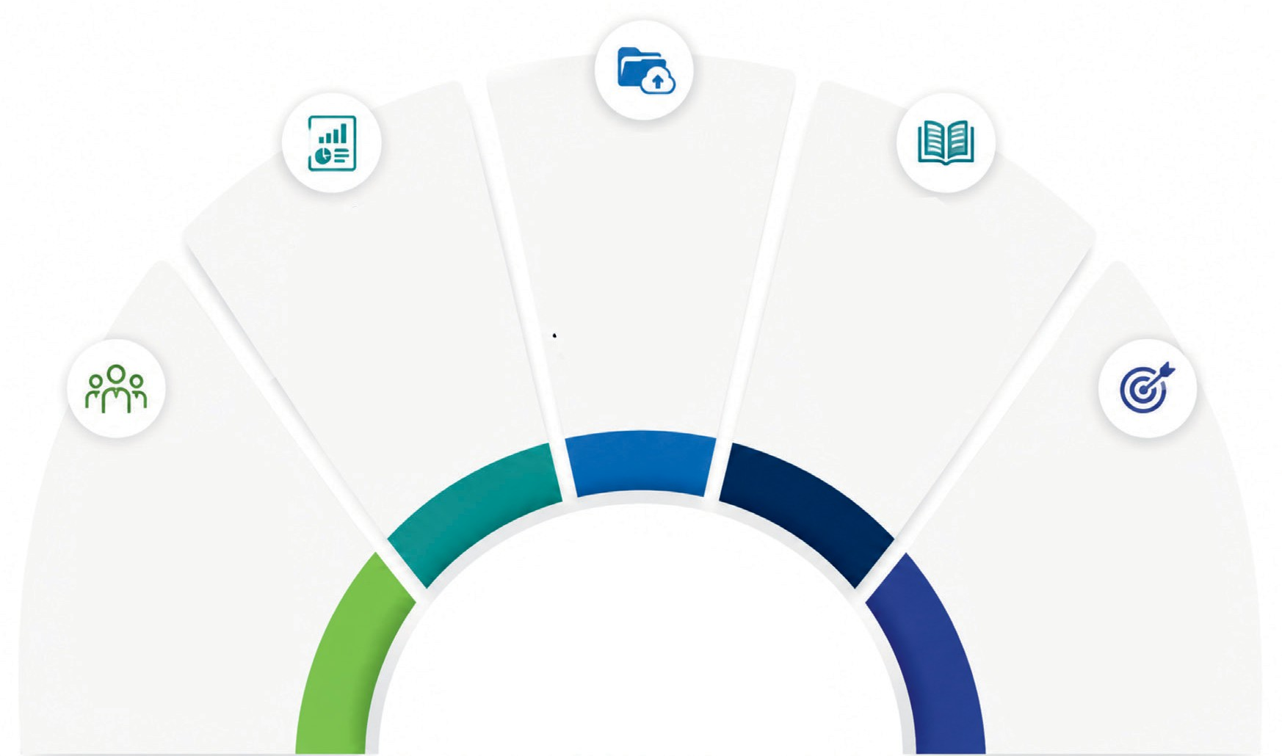
Establish documentation and knowledge transfer mechanisms
- Handover mechanisms: reporting procedures,
e-SPM access, and progress updates
- Use digital knowledge management system

04
Develop standardised modules and materials
  - Develop learning materials and modules
  - Support e-SPM reporting, indicator analysis, and integration into planning
05

Formalise a provincial SPM
implementation team
    - Formalised through Governor’s Decree and Circular Letters
    - Cross-sectoral structure across agencies
    - Clear roles and responsibilities for coordination and reporting
5

KEY PRACTICES
TO STRENGTHEN KORBINWAS
FOR SPM
Determine follow-up actions
- Data updates by sectoral agencies
- Revise and integrate SPM action plans into planning and budgeting; align with national plans
- Targeted capacity development and institutional strengthening
- Clear responsibilities and timelines

Key practices to strengthen Korbinwas for SPM
- Formalise a provincial SPM implementation team. Provincial governments need to formalise this team through a Governor’s Decree and Circular Letter, structure it around cross-sectoral positions across agencies, and define clear roles and responsibilities to ensure consistent coordination and reporting.
- Develop operational guidance for data use. Bappeda is responsible for coordinating the development of operational guidancewithin a data-driven planning framework. It isalsooverseeing the interoperability of systems to ensure similar references for planning, implementation and evaluation. This guidance is expected to help sectoral agencies to identify data sources, design presentation formats, and evaluate service performance and gaps. Bappeda will also encourage use of the e-SPM system to create a performance dashboard. By integrating GIS functionality, this system will be able to identify and display the exact locations of red and green zones – indicating the quality of basic service coverage across districts and cities.
- Establish documentation and knowledge transfer mechanisms. Sectoral agencies at district/ city level should implement handover mechanisms that include SPM reporting procedures, e-SPM account access, and updates on the status of work progress. A digital knowledge management system would also be helpful to strengthen documentation and knowledge transfer mechanisms.
- Develop standardised modules and materials. Provincial governments, in collaboration with the Ministry of Home Affairs and relevant line ministries, need to develop learning materials and modules to help agencies with e-SPM reporting, indicator analysis and integration into planning.
- Determine follow-up actions. Korbinwas participants need to take follow-up actions, such as: enabling data updates by sectoral agencies; implementing targeted capacity development and institutional strengthening; and revising SPM action plans – integrating them with subnational planning and budgeting and aligning them with national plans. Each action should have clear responsibilities and set timelines.

Annex 1:
Korbinwas for SPM implementation across three provinces
The table below compares the implementation of Korbinwas for SPM across several key areas: institutional arrangements, implementation design, the capacity of SPM implementers and follow-up actions. The SKALA program provides technical assistance and facilitates cross-agency collaboration to support this process and strengthen data use.
Aspect
East Nusa Tenggara
North Kalimantan
Southwest Papua

 |  | Formal institutional arrangements are in place, including a Governor’s Circular Letter and a Governor’s Decree on  the SPM implementation team. This team involves agencies from different sectors. | There is no specific Governor’s Decree or Circular Letter on Korbinwas for SPM;  coordination is ad hoc and led by the Bureau of Governance Affairs.
Institutional arrangements and supportive regulations for the provincial SPM implementation team | The SPM implementation team has not been formalised through a Governor’s Decree.  Coordination is handled by the SPM Joint Secretariat, managed by the Bureau of Governance Affairs.
Capacity of SPM implementers in districts/cities | Capacity varies, with districts/cities that regularly join in-  person cluster forums demonstrating a stronger technical understanding. | Technical capacity of the agencies is relatively consistent and stable, although some do not consistently provide complete data. | There is limited capacity, high staff turnover, and no established knowledge transfer mechanism.
Design and format | A cluster-based approach (four to six districts/ cities) with one district/ city becoming a host, and a mix of in-person and online approaches. | Annual high-level meetings and quarterly forums are held to monitor SPM performance. | Ǫuarterly technical evaluation meetings to review e-SPM reporting status and address technical issues.
Discussion focus | SPM implementation stages, including preparing the SPM action plan, conducting a data gap analysis, and improving  e-SPM reporting. | Review of SPM achievements, cross-agency follow-up actions and sectors requiring intervention. | Focus on technical issues relating to submission  of the e-SPM data and reporting form.
Outreach and frequency | Twenty-two districts/cities reached through a cluster approach, with several  in-person meetings held each year. | Five districts/cities reached through quarterly monitoring and targeted technical briefings. | Seven districts/cities reached through quarterly review meetings, and coordination is often carried out via WhatsApp.
Integration into subnational planning and budgeting documents | Several districts have started developing and integrating SPM action plans into their sectoral strategic plans. | Integration of SPM targets into the regional government work plan (RKPD) and the regional  budget (APBD) is included as a follow-up action. | There is no clear integration into planning and budgeting documents. The focus remains on e-SPM reporting.
This publication has been funded by the Australian Government through the Department of Foreign Affairs and Trade. This publication is intended to provide general information only. The views expressed in this publication are the authors’ alone and are not necessarily the views of the Australian Government or the Government of Indonesia.


Sinergi dan Kolaborasi untuk Akselerasi Layanan Dasar (SKALA) is an Australia-Indonesia Partnership Program aimed at supporting the Government of Indonesia’s efforts to reduce poverty and inequality by improving basic-service provisions to poor and vulnerable communities in less-developed regions.

CONTACT US

IFC Tower 2, Level 17
Jl. Jendral Sudirman Kav. 22-23 Jakarta 12G20
 info@skala.or.id

https://s.id/Channel-SKALA




SKALA.or.id

