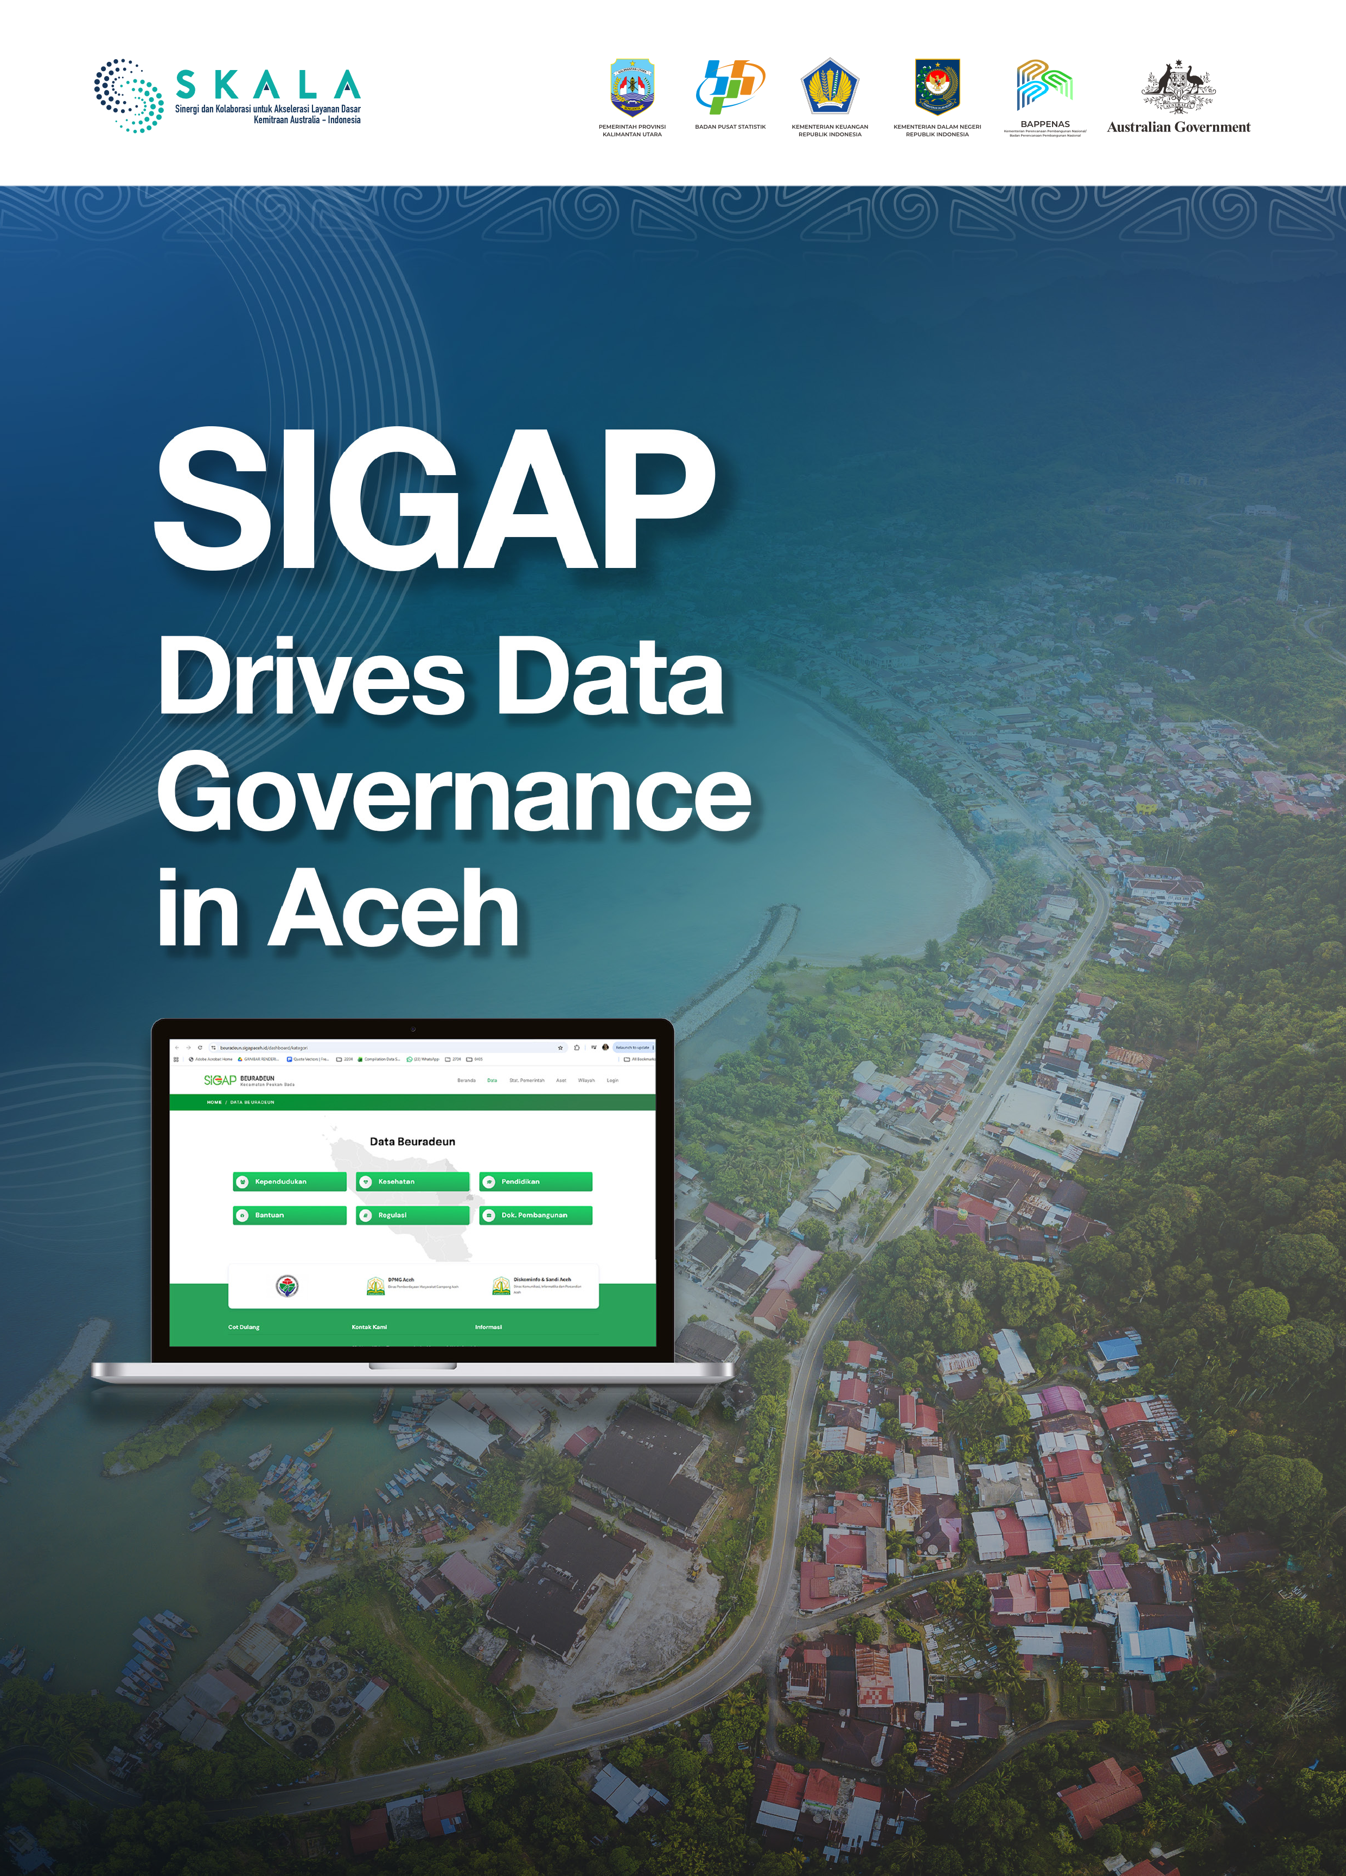
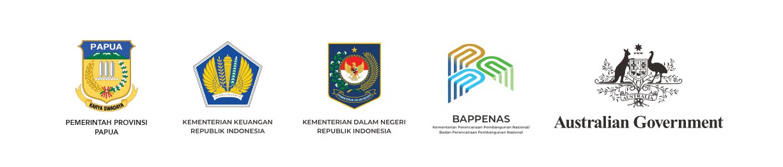

PEMERINTAH PROVINSI ACEH

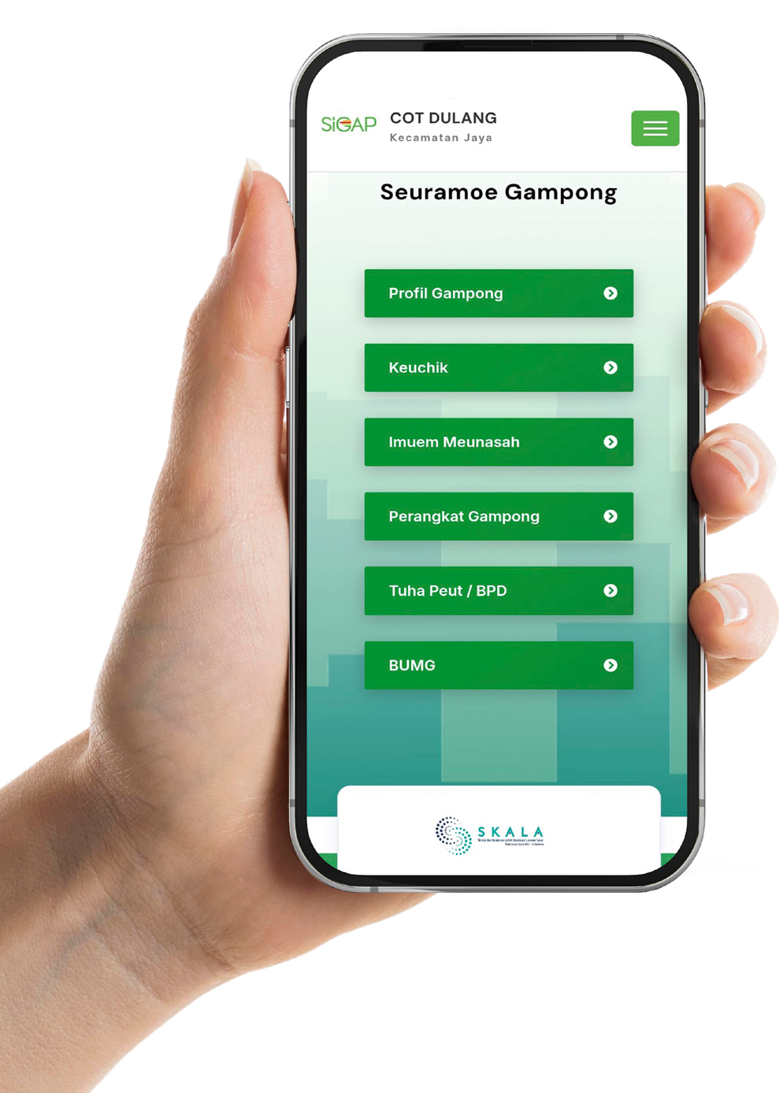

In Aceh, musyawarah gampong (village forums) have long provided a space for communities to take part in determining the direction of development. Through these forums, villagers gather to discuss and share their aspirations as part of the decision-making process. This practice forms an important foundation for strengthening participatory, data-informed village governance.
Over time, gampong governments have continued to strengthen this process so that they can respond to the needs of Acehnese communities in a more targeted and equitable way. One of the main priorities has been to ensure that every decision is supported by accurate and accountable data.
With this in mind, the Aceh Government developed the Village Information System, known as SIGAP, to advance towards more integrated, transparent and evidence-based village governance.
SIGAP’s development responds to the national mandate to build an integrated village information system, as set out in Law No. 3 of 2024 on the second amendment to Law No. 6 of 2014 on Villages, particularly Article 86, which requires the central and regional governments to develop village information systems. This foundation is reinforced through regional policy, including Aceh Qanun No. 7 of 2020 on the Integrated Aceh Information System.
In Aceh, SIGAP is the foundation of Aceh’s One Data (Satu Data) ecosystem, connecting data from the gampong level through to provincial level. SIGAP’s data governance is arranged to enable information on population, socioeconomic conditions and community needs to be collected systematically for use in decision-making processes.
SIGAP was further strengthened in 2025 when the Aceh Government issued Governor of Aceh Instruction No. 05/INSTR/2025 on the Implementation of the Village Information System. Through this policy, SIGAP was designated as the Aceh Government’s single official application
to support village and population data management. In this way, SIGAP is moving from ‘digital platform’ status to becoming a shared data resource for use across all levels of government.
Before SIGAP was strengthened, gampong data was spread across different sources, lacked standardisation and was underutilised as a basis for planning. Now, through SIGAP, that data is brought together in one system under the principle of ‘minimal entry, rich function’. This means that data only needs to be entered once in a standardised format, but can then be used for multiple purposes, from public services and social assistance verification to planning, budgeting, monitoring and decision-making across levels of government. With this approach, data has become a shared reference point that supports transparency and accountability in government.

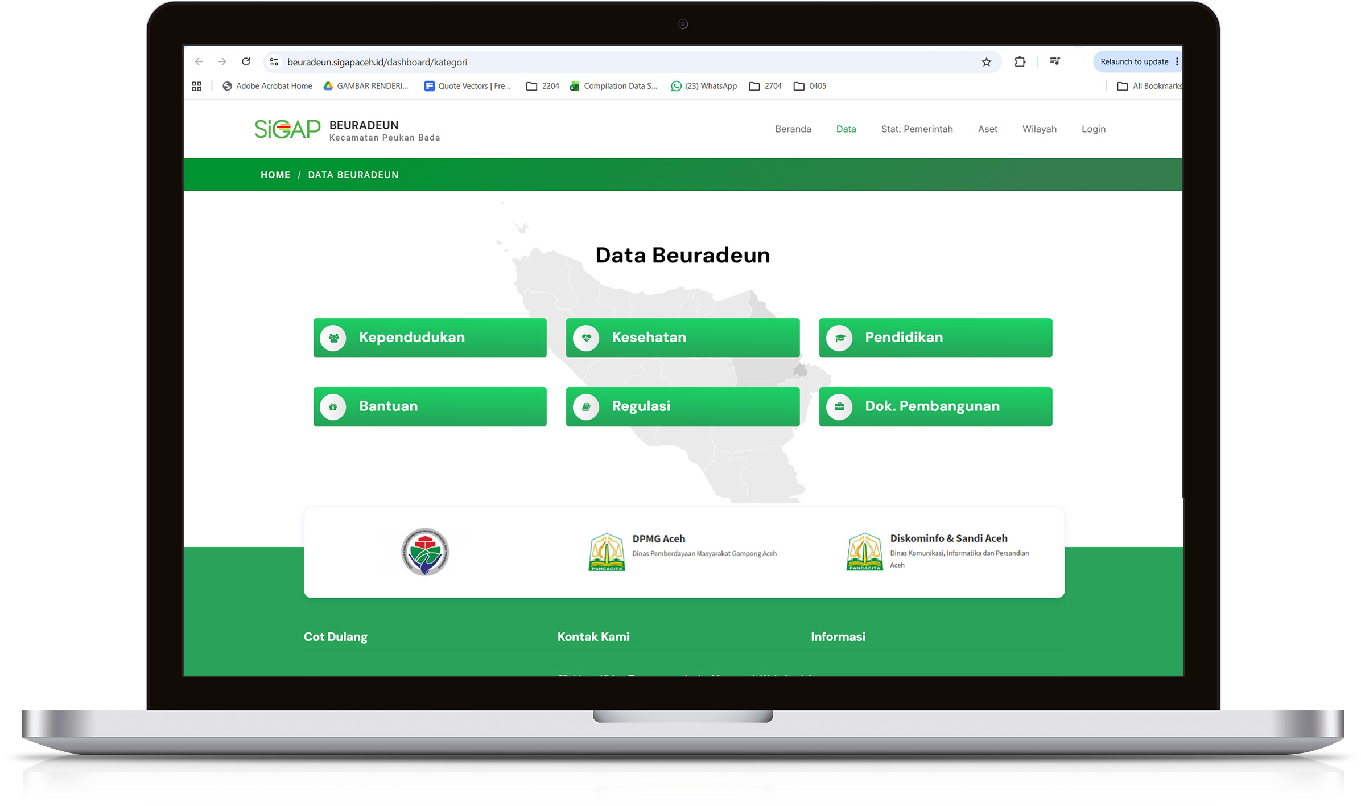
SIGAP as a foundation for services at the gampong level

In Gampong Beuradeun, Aceh Besar District, data has become part of everyday public service delivery. Firda Roza, a SIGAP operator, is a key person in this process. She ensures that population data is kept up-to-date and that both the gampong government and the community can use it.



“My task is to input population data and share it through the SIGAP application with the community members who need it. With that data, we can check who is eligible, ensuring support truly reaches
the right people”
Firda Roza,
SIGAP operator, Gampong Beuradeun

In the context of social assistance, well-managed data gives the gampong government a more complete picture of community conditions. It helps identify who is eligible to ensure that social assistance can be delivered in a more targeted way. Data collection has developed into a service function that supports more accurate interventions at the village level.

Firda Roza,
SIGAP operator, Gampong Beuradeun

“‘When the community’s needs are met, that is what makes us feel we have helped”

For the keuchik (Village Head), Zamzami, SIGAP has brought an important change to gampong governance. With two terms of leadership experience, he has seen firsthand how data has become a key reference in decision-making.

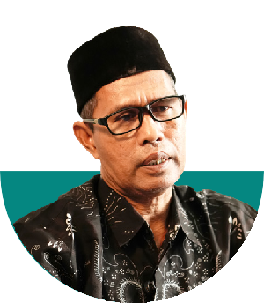

“If someone says they cannot afford something, we open SIGAP. Everything has been recorded and can be verified”
Keuchik Zamzami,
Village Head, Gampong Beuradeun

This helps ensure that social assistance programs can be delivered more objectively and targeted accurately. The use of by-name-by-address (BNBA) data helps the gampong government ensure that assistance genuinely reaches residents who need it, while minimising the potential for duplication among recipients.
The use of SIGAP can also be monitored more openly. Data updates from gampong across Aceh can be tracked through the SIGAP dashboard, while the SIGAP portal aggregates data from around 6,500 gampong in 23 districts and cities. This means that governments have access to the data, and can also monitor the extent to which data updating is taking place in the field.
At the district level, for example, Aceh Selatan has recorded the fourth-highest SIGAP data completion rate among Aceh’s 23 districts and cities. This progress can be monitored in real time through the SIGAP dashboard.
On top of these developments, SIGAP also strengthens accountability in gampong government administration. When data becomes a shared reference point, decision-making becomes more transparent and community trust grows stronger.

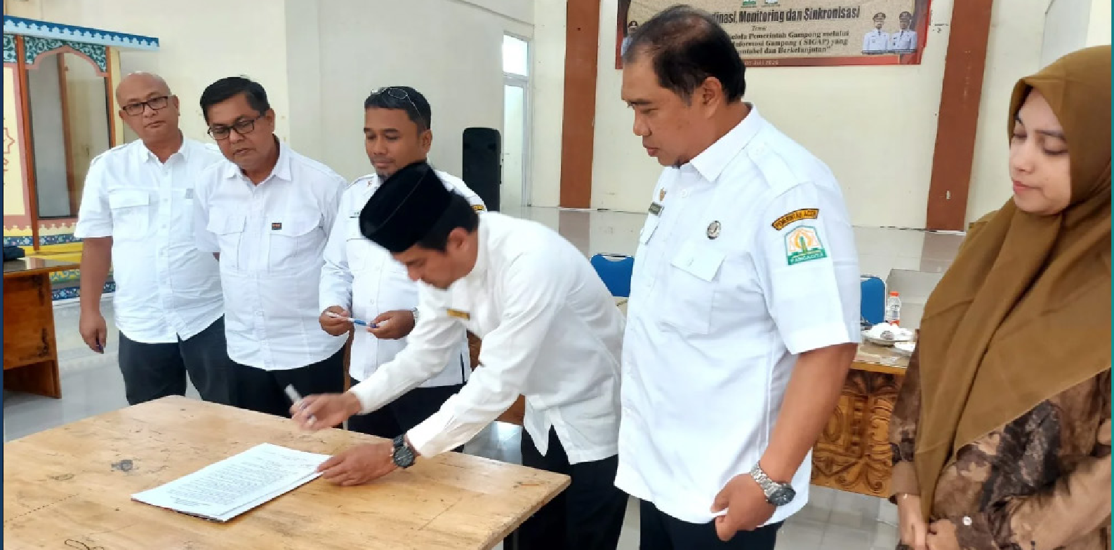

Connecting local knowledge with digital systems
Photo: atjehwatch.com

SIGAP makes local knowledge and experience part of a system that can support planning and policy. One of SIGAP’s strengths is its ability to connect local knowledge with digital systems. Village heads and officials already know their communities well.

Through SIGAP, that knowledge is documented, structured and given a formal place in the planning process. Data collected from gampong becomes an important part of development planning at higher levels. Through its integration within the Satu Data Aceh framework, SIGAP enables gampong data to be used in planning processes at the subdistrict, district/city and provincial levels.



“‘Data at the village level becomes the basis for discussion at the subdistrict, district and
provincial levels”
Hendri Dermawan,
Aceh Communication and Informatics Office

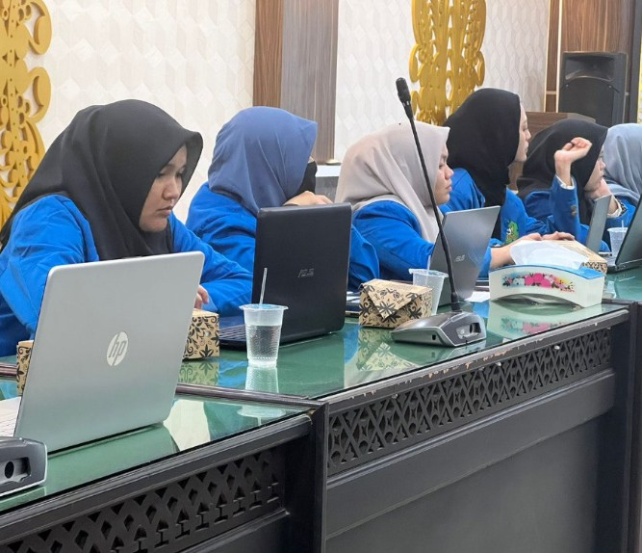
Collaboration to expand impact
Source: DPMG Aceh

With thousands of gampong across Aceh, strengthening SIGAP is being undertaken through cross-sector collaboration. The Aceh Government has engaged universities through community service and independent learning programs to support implementation in the field. This effort has helped accelerate use of the system and strengthen data literacy at the gampong level.

In an earlier phase, SKALA facilitated the involvement of 80 students from Teuku Umar University in Aceh Barat District and 50 students from Malikussaleh University in Lhokseumawe to support SIGAP implementation in the field. This approach helped bring SIGAP closer to gampong needs, while expanding data literacy at the local level.
The Ministry of Home Affairs’ Data and Information Centre also provides supervision to strengthen the system, build capacity and develop SIGAP for its next stage, with support from SKALA. This collaboration helps ensure that SIGAP develops as a jointly owned and maintained system.

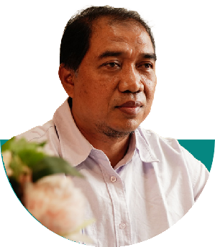

For Wardana, Head of Regional Development, Natural Resources and Appropriate Technology (PKSDA TTG) at the Aceh Village Community Empowerment Agency, this sense of shared ownership is central to SIGAP’s success.

“SIGAP does not belong to the Aceh Government,
but to all the people of Aceh. When we feel ownership, we will be responsible for the data that exists”
Wardana,
Head of PKSDA TTG, Aceh Village Community Empowerment Agency

The successful implementation of SIGAP in Aceh has begun to attract national attention. In the province’s capital, Banda Aceh, SIGAP has become an example of good practice in village digitalisation that can be replicated in other regions. Cross-provincial learning visits, involving Gorontalo, Maluku and East Nusa Tenggara, show that this approach has the potential to strengthen village governance across Indonesia.
SIGAP is proof that the transformation of data governance can begin at the village level and produce impacts that reach the national level.

Towards a sustainable data ecosystem

As SIGAP transforms into SIGAP 2.0, the system is being strengthened to respond to increasingly complex needs. These efforts are focusing on integration across systems, improving data quality and developing digital public services.

More than a data collection system, SIGAP is becoming part of a governance ecosystem that supports more responsive public services.

Hendri Dermawan,
Aceh Communication and Informatics Office

“We are making SIGAP a super-app at the village level, as a tool in planning”

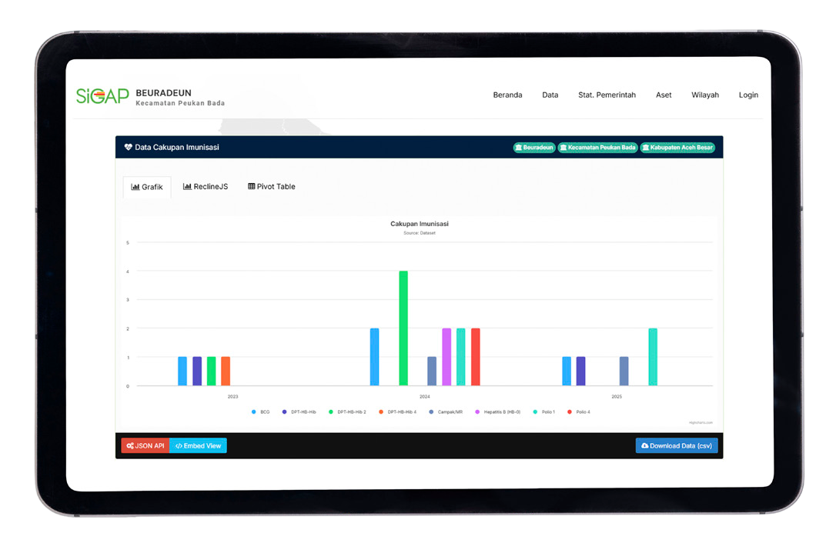
In 2026, implementation monitoring is being carried out in districts and cities, including Aceh Timur and Aceh Selatan, to assess how Governor of Aceh Instruction No. 05/INSTR/2025 is being applied at the gampong level. Notably, this process is revealing the need to strengthen budgeting and system development.
A new feature is being advanced to allow residents and gampong governments to check Aceh Health Insurance (JKA) membership status through SIGAP. This points to SIGAP’s next direction:
going beyond helping government manage data, to using that data to make it easier for communities to access services.
Aceh’s experience shows that strengthening data governance at the village level can bring positive change to development outcomes. When data is well managed, planning becomes more precise, intervention becomes more targeted and services are delivered to those who need them.
Ultimately, this change brings one fundamental result – fairness - that becomes achievable when decisions are based on data that is accurate, transparent and used collectively.



