KEMENTERIAN KEUANGAN REPUBLIK INDONESIA
KEMENTERIAN DALAM NEGERI REPUBLIK INDONESIA



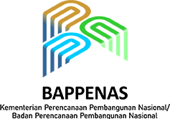






CAMPUS DATA INSIGHT

Supporting university students to become data trailblazers

SEPTEMBER 2026

he North Kalimantan (Kaltara) Provincial Government has positioned data as a strategic asset amid the acceleration of government digitalisation and public
T
service delivery. Accurate and up-to-date data is critical to ensuring government policies are precisely targeted to meet the needs of the community.
Efforts to reform data governance in Kaltara have proceeded by way of strong collaboration between the Regional Development Planning, Research and Development Agency (Bappeda Litbang), the Department of Communication, Informatics, Statistics and Cryptography (DKISP) Statistics Indonesia (BPS) and Regional Apparatus Organisations (OPDs).
Throughout 2025, One Data capacity building was conducted for OPDs, including verification of 172 statistical activities alongside BPS to ensure compliance with data standards. The Kaltara Provincial Government strengthened data governance by instigating a structured working mechanism under the One Data Forum, supported by facilitation teams that provide targeted and intensive guidance to three to five OPDs each.
In 2026, the overall focus for strengthening One Data has been to enhance its quality and utilisation. The data collection process is now conducted concurrently with metadata formulation to ensure data quality is established from the outset. To date, OPDs have successfully generated about 50 per cent of the metadata.
These new processes have helped establish 1,670 sectoral datasets and 85 geospatial datasets in the 2026 Data Inventory, supported by new Regional One Data implementation guidelines as a shared reference for data management.
While these are positive steps, BPS has been cognisant of the need to diffuse a ‘data culture’ beyond the walls of government. Universities are viewed as key partners in breaking down the chain of assumptions in the public sphere and replacing these with valid, data-driven discourse.
Responding to this need, the Kaltara Provincial Government and BPS has introduced Campus Data Insight (CDI) in collaboration with the University of North Kalimantan (Unikaltar). This program is designed to prepare a generation of data-literate academics able to contribute to the National Statistical System (SSN) as custodians of public policy in the future.


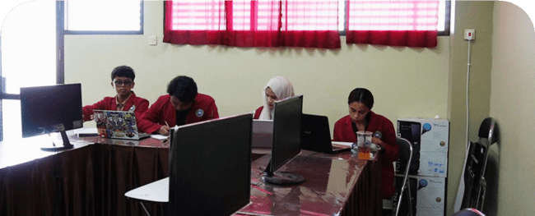

Following a lengthy process of compiling sectoral statistical data from 2020 to 2024, the regional government launched the E-Dataku application in 2025. This platform enables the public to access development data more openly and dynamically – a result of Kaltara Province’s commitment to information transparency.
As of the start of August 2026, E-Dataku hosted 4,606 datasets, comprising 1,882 provincial datasets from 40 OPDs and 2,724 datasets from three districts/cities.
The portal provides affirmative education data sourced from the Dapodik database, alongside thematic data on stunting, gender mainstreaming and social inclusion, and Minimum Service Standards (SPM). Furthermore, it links to the Ministry of Home Affairs’ SDPDN Pelita portal, Bappenas’ SDI portal, and the regional One Data portals of the Malinau, Nunukan and Tana Tidung districts.
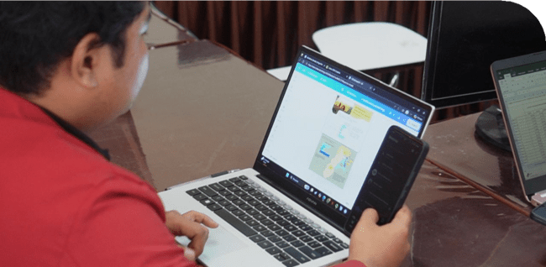

In accordance with the mandate of Presidential Regulation No. 39 of 2019 on One Data Indonesia, published data must be accurate, up-to-date, integrated and accountable. In its role as data custodian, the Kaltara Province DKISP – supported by Bappeda Litbang as the One Data Secretariat and BPS as the data supervisor – ensures data quality through a rigorous verification process across hundreds of sectoral statistical activities before publication via the portal.
It is at this juncture that the next challenge arises: available data can become ‘digital archives’ if the user cannot read, process and extract meaning to underpin policy. Therefore, CDI is positioned as a data literacy accelerator whereby students and lecturers are encouraged to become active users of E-Dataku, as well as agents for driving evidence-based policy.
“Campus Data Insight aims to bridge this gap,” according to Head of BPS Kaltara Province, Mas’ud Rifai


“We want students not merely to view data, but to understand it as a tool for dissecting everyday issues and formulating
development solutions.”
Mas’ud Rifai
Head of BPS Kaltara Province

CDI is anchored to the global statistical philosophy of ‘better data, better life’ – the premise that people’s quality of life will improve if development is underpinned by robust data.
This vision, according to Mr Rifai, cannot be realised by BPS or the regional government alone; it must be shared with strategic partners, particularly universities and academics.


He highlighted that public discourse is frequently dominated by assumptions; for instance, debates on unemployment or poverty that rely on cursory observations rather than measurable indicators. Through CDI, BPS fosters a healthier public sphere: evidence-based discussion, more productive debates and more solution-oriented recommendations. The goal is not simply to teach students to become proficient at reading tables, but rather to inculcate a critical mindset so that evidence-based policy becomes an institutionalised practice.
This perspective aligns with the role of regional planning. The Head of Bappeda Kaltara Province, Bertius, emphasised that for planning agencies, data was the primary foundation for every policy process.

“For us at Bappeda, data is
the heart of planning. Without data, planning is merely assumption. Through Campus Data Insight, students learn
that numbers possess
meaning, tell a story, and can serve as the basis for
development policy directions.”
Bertius
Head of Bappeda Kaltara Province

He added that CDI would help to bridge the regional government’s needs with academic capacity: “As data users, we are immensely helped when universities begin to understand how to read metadata, comprehend data sources, and process them into analytical materials. That renders the dialogue between government and academia more equitable and evidence-based.”



Concrete results are starting to emerge through CDI in the form of analytical products that communicate clear messages. Students have begun to process sectoral statistical data into infographics that help the public to understand the ‘story behind the numbers’. These infographics serve as a bridge between technical data and policy communication needs, making data appear more concise, insightful and readily applicable for cross-stakeholder discussions – both on campus and within the regional government.
Evidence-based development discourse is coming through in articles authored by students. These pieces are typically addressing North Kalimantan's development issues using measurable data, helping to ensure that public debate no longer relies on assumptions or fleeting observations. Hence students are becoming data ‘translators’ by linking statistical indicators with social realities, whilst simultaneously presenting arguments that are more structured, solution-focused and accountable.
According to Sriwati, Acting Head of the Regional Planning Assessment and Development Control Division at Bappeda Kaltara, data literacy among students has a direct impact on the quality of development discourse.

“Historically, data often stopped at the OPDs. Through CDI, students are beginning to utilise official data as a basis for writing, infographics and analysis. This assists in cultivating a culture where opinions must be based on numbers, not just perception,” she said.

Another initiative of the CDI program has been the designation of student ‘data ambassadors’. These students not only become data literacy advocates on-campus, but some are also invited to participate in an internship program.
The internship program is designed to bridge academic analytical capacity with Kaltara Province’s governance requirements for One Data. Students gain practical experience in managing, verifying and utilising data throughout development planning and evaluation cycles, while also helping to accelerate the metadata verification process.
Five data ambassadors are currently undertaking internships across various OPDs in North Kalimantan Province, such as DKISP and the Regional Development Planning, Research, and Innovation Agency (Bapperida).
The Rector of Unikaltar, Didi Adriansyah, welcomed this initiative.
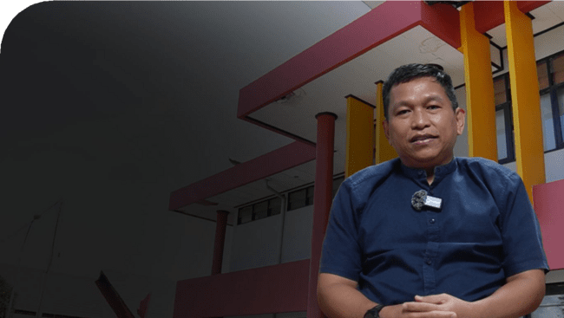

“This program provides new insights. Students now
understand how to translate data into development signals. This aligns with the spirit of the Tri Dharma of Higher Education, wherein university research
must contribute to resolving regional issues.”
Didi Andriansyah
Rector of Unikaltar

As a follow-up to this ongoing capacity building for the academic community, a learning module will be developed under a ‘Data School’ initiative. This will feature extracurricular activities for students regarding data literacy, led by mentors from BPS, the regional government and data practitioners.

Campus Data Insight 6

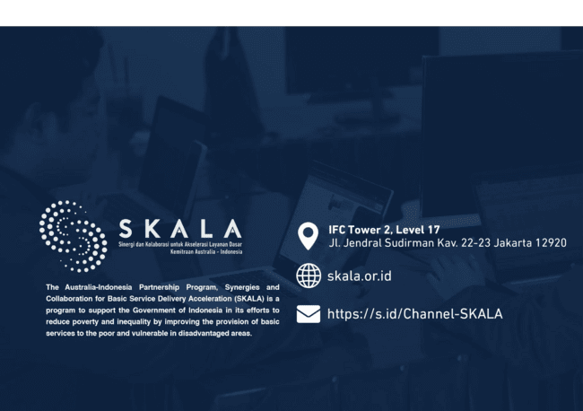

The Head of the Statistics and Information Division at DKISP Kaltara, Elstiven, said CDI would help the regional government gather feedback on data quality: “Students are strategic partners. Through the utilisation of E-Dataku, we hope to see fresh and critical policy briefs or recommendations generated from the campus.”
To maintain its momentum, CDI needs to be underpinned by a clear system, ranging from mechanisms for lecturer and data supervisor facilitation and continuity of cross-semester agendas, to the readiness of OPDs to accept interns with measurable roles and outputs.
The implementation of this program has been made possible through the support of the Data and Information Centre of the Ministry of Home Affairs, with support from SKALA, an Australia–Indonesia partnership program. SKALA is supporting Kaltara Province to enhance data literacy and introduce a social inclusion perspective, ultimately to create a policy ecosystem driven not by assumptions, but by robust data, for the sake of inclusive development and community well-being in the region

Campus Data Insight
7

