KEMENTERIAN KEUANGAN
REPUBLIK INDONESIA
KEMENTERIAN DALAM NEGERI
REPUBLIK INDONESIA
Story Booklet
INCLUSIVE
NUSA TENGGARA BARAT
FROM THE DRIVER’S SEAT
August, 2026
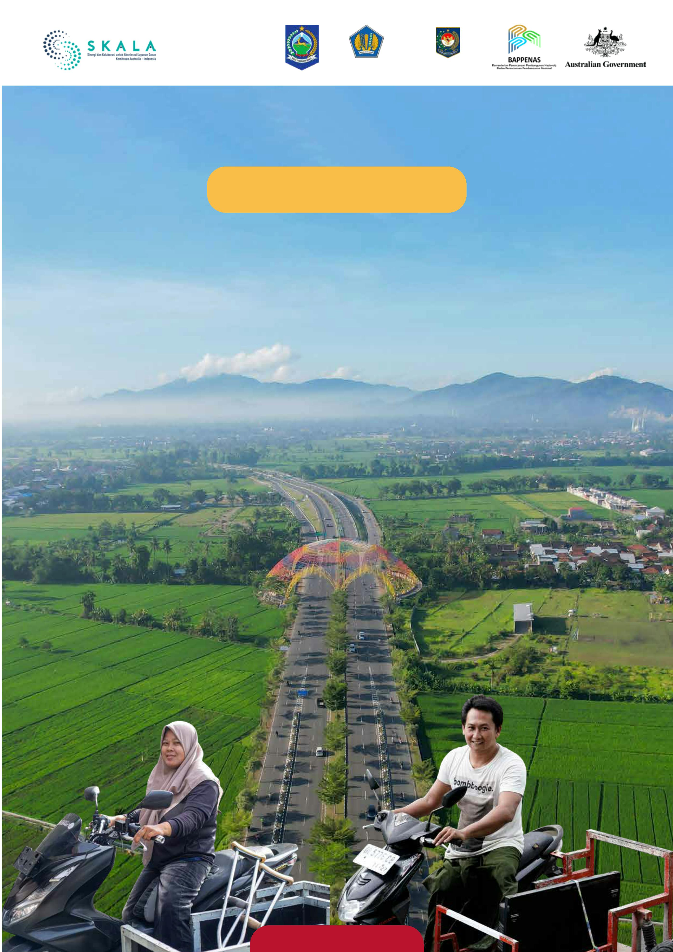

Thirty-nine-year-old Airul, affectionately known as ‘Irul,’ has a physical disability making her heavily
reliant on a specially modified vehicle. Her three-wheel motorcycle is her livelihood. “That motorbike
is my second pair of legs.”
From the modest kitchen of her home in Kuta Village, Narmada District, West Lombok, she sup-
ports her family by selling her own homemade cakes and meals. Her family's economic sur-
vival rests on the wheels of her motorcycle due to the irregular income of her husband.
Irul delivers orders to her customers, but every day this journey to earn a living has been
overshadowed by anxiety: the registration on her modified motorbike has been expired
for years. No matter how sincerely Irul wanted to comply with the law, her low income forced her
to choose, and her family’s immediate need for food had to come first.
“
I was always anxious. Whenever I saw a
police checkpoint, I'd often turn back
because I was afraid of being stopped.
I ended up losing both my investment
and the customer's order because
”
I couldn't complete the delivery.
Airul (39), Person with a physical disability
‘I was always worried. If I encountered a police checkpoint, I would often suddenly decide to go home,
terrified of being stopped. My income was lost because the orders were cancelled,’ Irul recalled.
The loss of a single order meant her family would not eat that day.
n the past, I’ve been frequently fearful of
police checkpoints. Sometimes I would
”
take backstreets to avoid inspection.
Bang Ipi (35), Person with a physical disability
M. Zulaifi, or Bang Ipi (age 35) has a physical disability and faced a similar problem. Ipi is from Central
Lombok and operates a mobile electronics buying, selling and repair business using a modified
motorbike equipped with a cart. His vehicle registration had been expired for more than five years.
‘In the past, I’ve been frequently fearful of police checkpoints. Sometimes I would take backstreets to
avoid inspection,’ said the father of two.
Today, Irul’s fears and Bang Ipi’s backstreet routes are a thing of the past. Irul promotes her merchandise
on social media without fear of failed deliveries. Bang Ipi can travel confidently on the main roads.
‘Now, if I encounter the police, I simply say “Excuse me, Officer.” It is a great relief,’ Ipi shared with a
broad smile. He recently took his motorbike on the ferry to Bali to participate in a wheelchair
marathon. ‘I used to have to rely on friends for a lift. Now I am free to go anywhere.’
1
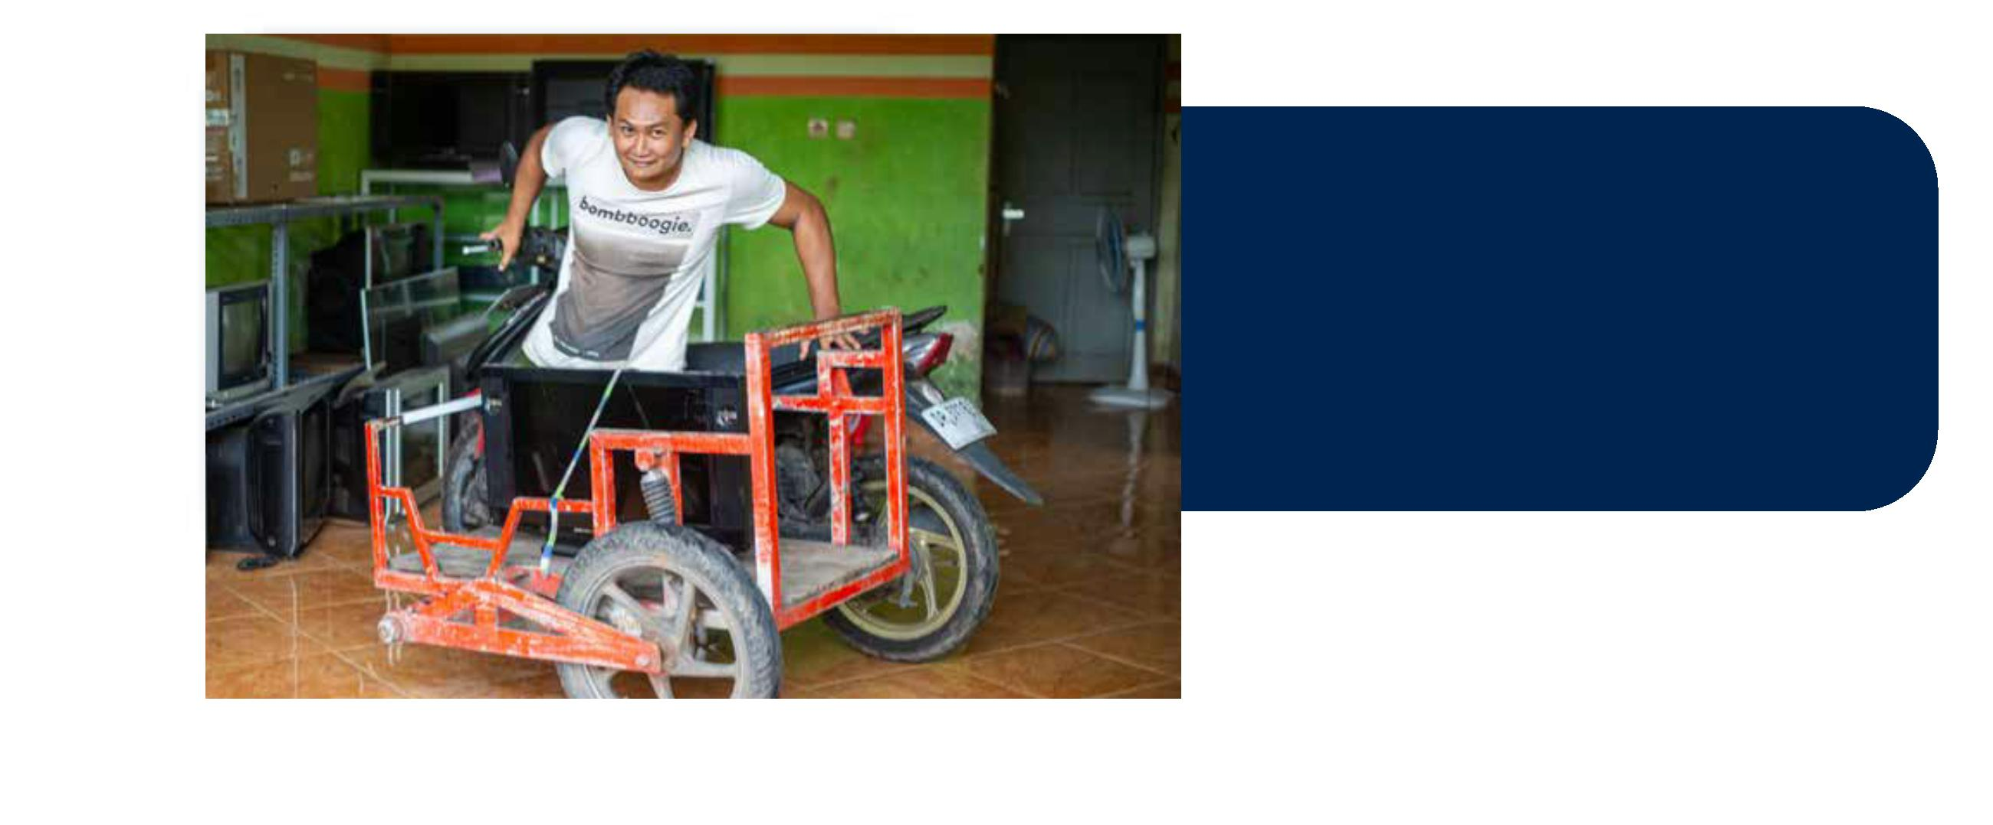

FROM REGIONAL REVENUE
TO SOCIAL INVESTMENT
Irul’s smile of relief and Bang Ipi’s newfound
freedom are the direct results of a policy
implemented by the Provincial Government of
West Nusa Tenggara (NTB), stipulated in
Governer Regulation Number 23 of 2024.
“
We view the motor vehi
tax exemption policy as
means of fulfilling the
fundamental right o
p ersons with disabiliti
Amidst strong focus for every region to boost its
locally-generated Revenue (PAD), the NTB
Provincial Government took the bold step of
granting an exemption on the Motor Vehicle
Tax (PKB) to individuals with disabilities who
utilise modified vehicles.
”
move independently.
Alm. dr. H. Lalu Herman Mahaputra
Kepala Badan Pendapatan Daerah
Provinsi NTB periode Januari–Maret 2026
This initiative marks a paradigm shift in regional government policy, transitioning from a revenue-centric
to a more empowerment-centric approach.
The Head of the NTB Provincial Regional Revenue Agency (Bapenda) for the period of January–March
2026, Lalu Herman Mahaputra, emphasised the tangible impact of this policy on citizens’ daily lives.
‘We view this motor vehicle tax exemption policy as a means of fulfilling the fundamental right of individuals
with disabilities to move independently,” stated Herman. “With the tax exemption, they are able to undertake
activities and run businesses without depending on others. This constitutes a social investment.’
This new policy did not emerge spontaneously. The Sub-Division Head of Motor Vehicle Tax at Bapenda
NTB, Rabiatun Adawiyah, explained that the regulation was developed out of a sensitivity to the realities
on the ground. ‘We feel immensely proud when we meet with beneficiaries of this new policy; we can see
the positive effect it has had in their lives’ she remarked.
2
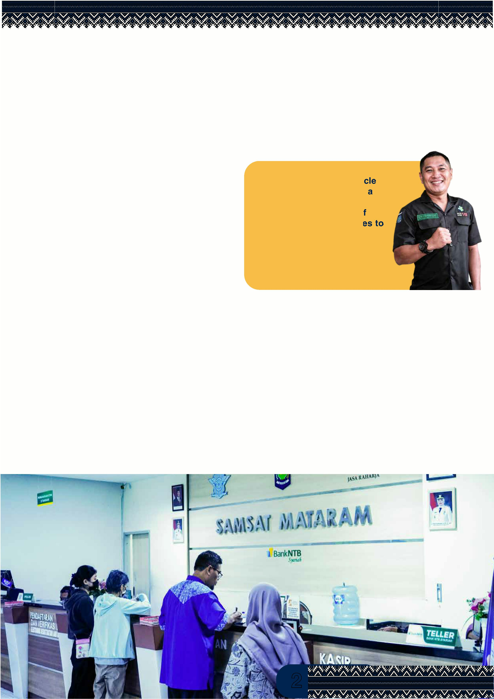

COLLABORATION AND
SERVICE TRANSFORMATION
The process of formulating this regulation required a robust foundation, to ensure alignment
with national legislation. The NTB Provincial Government coordinated intensively with the Directorate of
Regional Taxes and Levies (PDRD) of the Ministry of Finance.
This process was facilitated by the SKALA Program (Synergy and Collaboration for the Acceleration
of Basic Services) Australia-Indonesia Partnership Program through technical assistance and a
data-driven approach. Consequently, this PKB exemption scheme remains administratively compliant
while being responsive to the needs of vulnerable groups within the community.
At the forefront of public service delivery, the face of the bureaucracy is undergoing a transformation. The
Head of the Data Collection and Assessment Section at the Mataram City Samsat (One-Stop
Administration Services Office), Sofyan, ensures that beneficiaries are no longer burdened by rigid
bureaucratic procedures. While ordinary citizens typically manage their administration independently, for
individuals with disabilities, proactive staff ‘bring the service to the customer.’
‘For those with disabilities, we actively step in to assist. They only need to wait; from the physical
inspection to the application and the issuance of the decree, we manage everything,’ said Sofyan.
“
For people with disab
direct, on-site assista
need to stay seated wh
everything—from the p
and application process
the official approval lette
H. SOFYAN
Kasi Pendataan dan Penetapan SAMSAT M
3
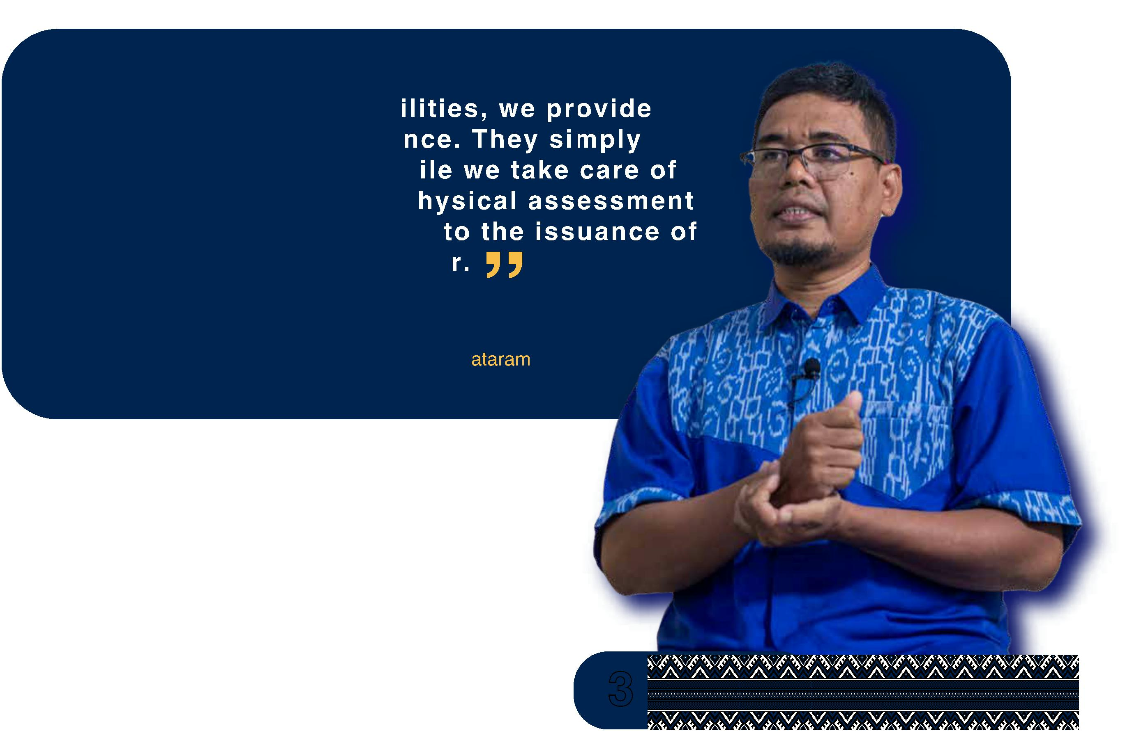

EXECUTION CHALLENGES
AND FUTURE TASKS
Although it possesses the potential to become a
national role model for inclusive policy, the
implementation of Governer Regulation 23/2024
still faces several challenges. To date, only a
few dozen modified vehicles in NTB have
successfully obtained the PKB exemption.
This limited coverage can be attributed to
a lack of socialisation at the regency/city
level. A d m i n istrative hurdles remain a
s p e cific challenge; applicants must be able to
prove their disability status and ensure that any
vehicle modifications comply with legally
required technical specifications. Additionally,
taxpayers with disabilities are currently still
liable for the Mandatory Contribution to the
Road Traffic Accident Fund (SWDKLLJ)
amounting to IDR25,000.
Acknowledging these remaining tasks, Bapenda NTB plans to continually evaluate and
expand the policy’s coverage. This includes a proposal to include holders of a Driver's
License 'D' (for individuals with disabilities) in the beneficiary category. The Mataram City
Samsat is currently designing dedicated counters for individuals with disabilities, ensuring
this service standard becomes permanent rather than relying solely on the individual
initiative of staff.
NTB's actions are a proof of concept, demonstrating that Law Number 8 of 2016 concerning
Persons with Disabilities can be translated into practical fiscal policy. From behind the
wheel of Irul and Bang Ipi's tricycles, NTB is broadcasting a message to the entire nation:
the state is not a tax collector—it is a facilitator, opening the path to independence for its
most vulnerable citizens.
4
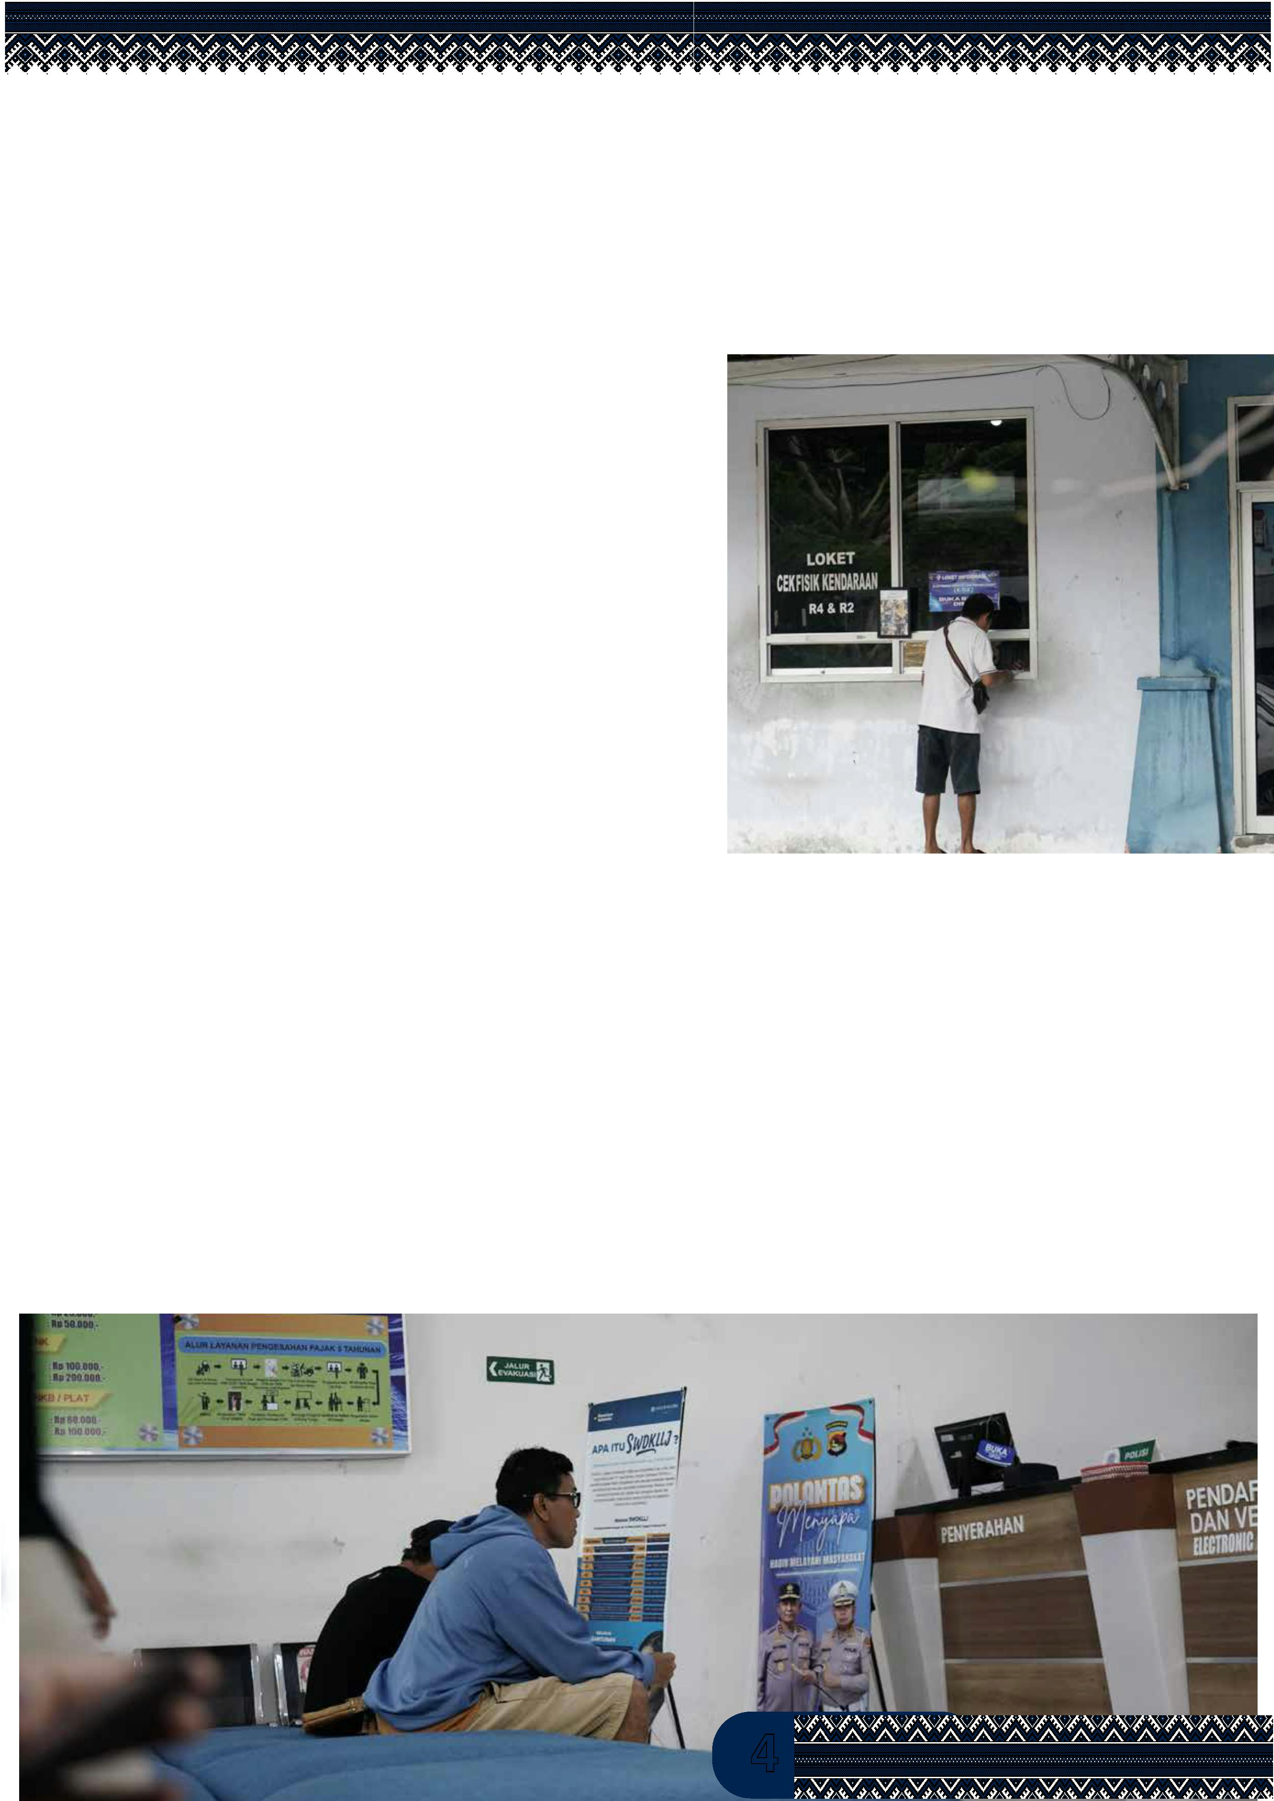

IFC Tower 2, Level 17
Jl. Jendral Sudirman Kav. 22-23 Jakarta 12920
skala.or.id
Sinergi dan Kolaborasi untuk Akselerasi Layanan Dasar (SKALA)
adalah Program Kemitraan Australia-Indonesia untuk mendukung
Pemerintah Indonesia dalam upaya mengurangi kemiskinan dan
ketimpangan dengan meningkatkan penyediaan layanan dasar bagi
masyarakat miskin dan rentan di daerah tertinggal.
https://s.id/Channel-SKALA
