KEMENTERIAN KEUANGAN REPUBLIK INDONESIA
KEMENTERIAN DALAM NEGERI REPUBLIK INDONESIA


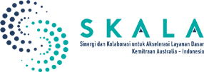
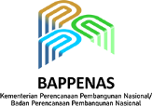




STRENGTHENING
THE IMPLEMENTATION OF MINIMUM SERVICE STANDARDS IN NORTH KALIMANTAN:
Consistent Governance for Equitable Basic Services Delivery

JUNE 2026



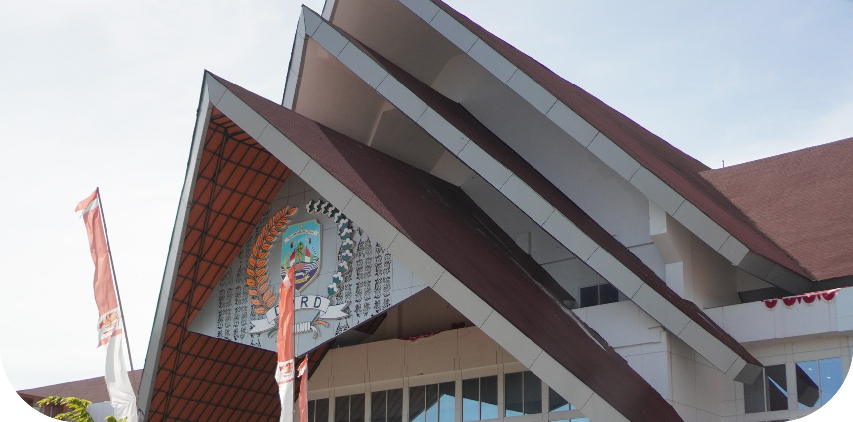
North Kalimantan is committed to providing equitable basic services to all its citizens. Despite geographical challenges—vast distances between regions, uneven population distribution—expanding access to education, healthcare and social protection remains a top priority. North Kalimantan is still in its youth, and its ongoing development is driven by an ambition to reach and raise up its most remote and underserved communities.

Minimum Service Standards (SPM) are the state’s mandate to guarantee citizens’ rights to basic services, a key instrument for achieving social justice. In line with the mandate of Law No. 23 of 2014 on Regional Government, North Kalimantan demonstrates that distance must not be allowed to hinder the state’s responsibility to guarantee its people’s rights,

Through the national regulatory framework of Government Regulation No. 2 of 2018, the SPM sets out the state’s efforts to regulate six areas of basic services: education, health, public works, public housing, public safety and order and community and social protection—all of which must be fulfilled by local governments. In North Kalimantan, these challenges have instead served as a starting point for building strong, consistent governance.

According to Q4 2024 data (as of 13 January 2025), from the Directorate General of Regional Development (Bangda), Ministry of Home Affairs, North Kalimantan Province sustained high levels of SPM implementation throughout 2020–2024. SPM budget allocation decreased from around IDR393 billion in 2021 to IDR142 billion in 2024, coinciding with government spending-efficiency policies set by the national government, including adjustments to regional transfers and a shift towards more targeted spending. Ongoing guidance and close collaboration with the national government, particularly the Secretariat of the Directorate General of Regional Development, Ministry of Home Affairs has ensured focus remain on priorities and efficiency in managing basic service expenditure in the region, and has kept SPM performance high .

Strengthening the Implementation of Minimum Service Standards in North Kalimantan: Consistent Governance for Equitable Basic Services Delivery
1

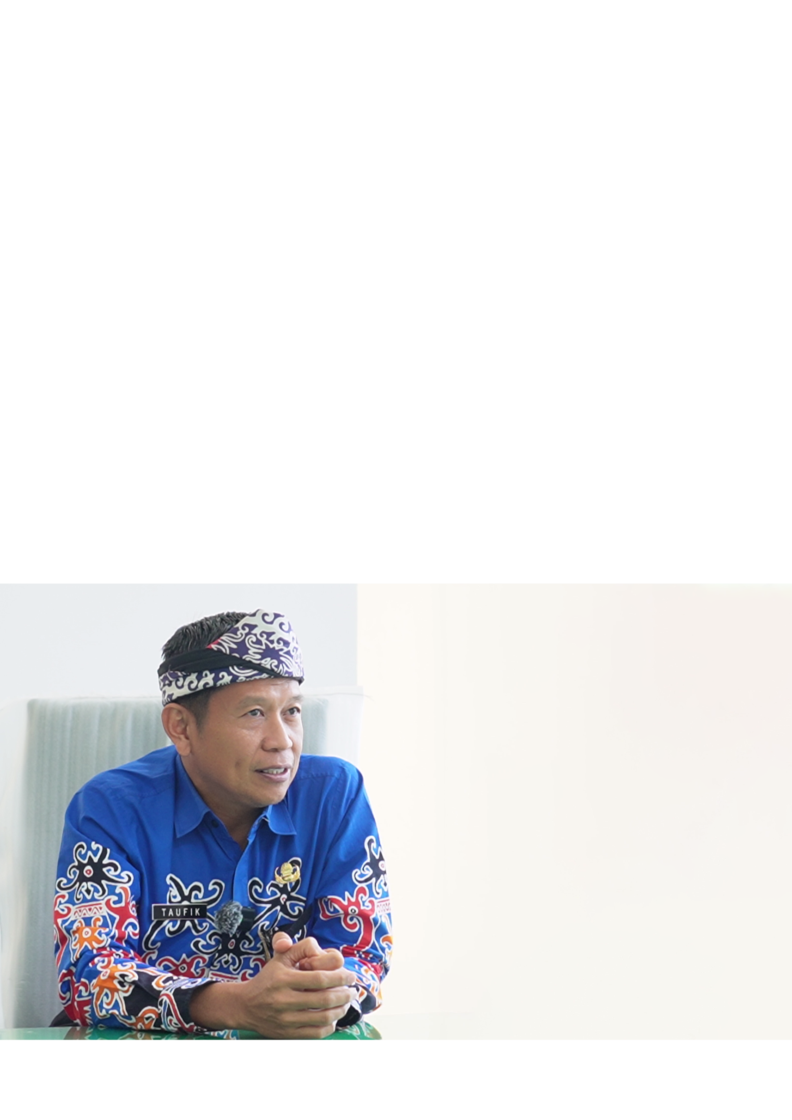
SPM Governance Framework
“
”

Behind the basic services available to the community lies a carefully maintained governance framework. Since 2021–2022, the North Kalimantan Provincial Government has progressively redefined its role in implementing the SPM—not only as a regulator, but an enabler that connects the five responsible regional agencies, sustains coordinated efforts and ensures that each phase of service delivery is carried out consistently from planning through to reporting.

Despite being a relatively new autonomous region, North Kalimantan has kept up SPM governance supported by a culture of cross-agency collaboration, consistency and drive established at its outset.

This approach yielded tangible results. North Kalimantan earned national awards for its SPM implementation performance in two national assessments: in 2023 (based on the 2022 assessment), and in 2025 (based on the 2024 assessment).

These achievements are made possible through strong collaboration between responsible local government agencies: the Education and Culture Agency; the Health Agency; the Public Works, Spatial Planning, Housing and Settlement Areas Agency; the Civil Service Police Unit; the Regional Disaster Management Agency; and the Social Affairs Agency.

SPM is mandatory spending. It must therefore be managed with the utmost professionalism, from the planning stage right through to implementation.

Taufik Hidayat,
Head of the Regional Development and Autonomy Bureau, North Kalimantan

Strengthening the Implementation of Minimum Service Standards in North Kalimantan:
Consistent Governance for Equitable Basic Services Delivery
2
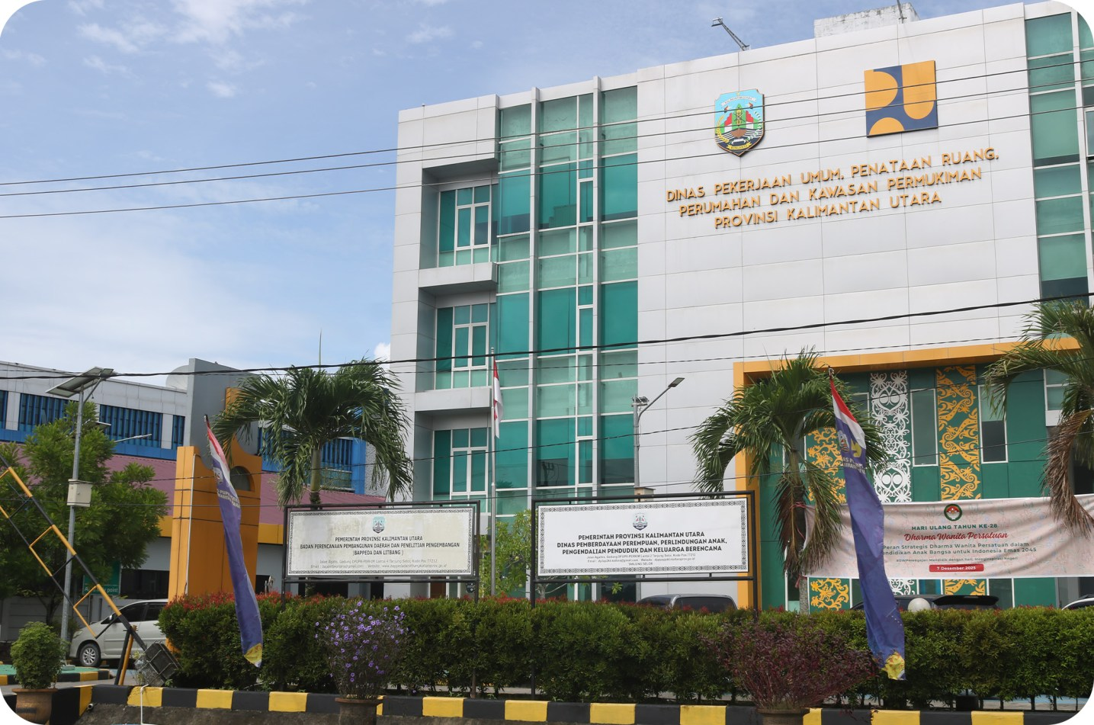
The Bureau of Government Administration strengthens coordination across regional agencies by facilitating engagement, monitoring and collaboration among SPM stakeholders.

Since 2024, work has been closely assessed through quarterly evaluations. Every achievement and challenge is discussed early in the year, well ahead of the SPM reporting process. Coordination is consolidated up to the Head of the Region to ensure that no commitment is abandoned midway.

“Although North Kalimantan is a relatively new province, we must be on par with other provinces, particularly in implementing SPM. This commitment is upheld from the regional leadership—the Governor, Deputy Governor, and Regional Secretary—through to administrators and technical staff on the ground,” explained the head of the Regional Development and Autonomy Bureau, Taufik Hidayat.

High SPM achievement in North Kalimantan, despite year-to-year budget fluctuations, shows that consistent governance is the cornerstone of sustainable basic services. In response to budgetary challenges and the need for more systematic oversight, the North Kalimantan Provincial Government has also established a structured mechanism for monitoring SPM called “the SPM Team” with support from SKALA, an Australia–Indonesia Partnership Program . The formation of the SPM Team reflects North Kalimantan’s mature approach to governance in addressing fiscal challenges by focusing on system strengthening over ad hoc or short-term solutions.

Strengthening the Implementation of Minimum Service Standards in North Kalimantan:
Consistent Governance for Equitable Basic Services Delivery
3

SPM in Education: From Policy to Good Practice in Schools
“
”

In the education sector, SPM offers a set of written standards, that are translated into day-to-day decisions within the learning environment: starting from how teachers are trained, how classrooms are made accessible and how children with special needs receive appropriate support. Over the past two years, changes have begun to take effect, transforming an underserved system through training, regulations and cross-regional collaboration.

SPM implementation is particularly visible in inclusive education services. The Education and Culture Agency of North Kalimantan Province is focusing its efforts on three key aspects:

1. Strengthening human resources,
2. Providing facilities and infrastructure,
3. Improving the capacity of shadow teachers for students with disabilities.

Adhering to the latest regulations on reasonable accommodation, the Education Agency encourages the provision of competent teachers, improvements in access and learning facilities, and assessment training for teachers to support students’ readiness from the commencement of their schooling.

With the issuance of Ministerial Regulation No. 48 of 2023, we are prioritising three factors: educators’ capacity, reasonable accommodation facilities, and improving the capacity of shadow teachers.

Nugraha,
Head of the Special Services Development Division, Education and Culture Agency, North Kalimantan

Efforts are underway to recruit specialist personnel to provide more inclusive education and appropriate teaching. Facilities and infrastructure for children with special needs have been improved, from building accessibility to safe, disability-friendly learning materials.

The shortage of shadow teachers in a relatively new province such as North Kalimantan is addressed through an adaptive approach. Teachers in general education settings who work with students with disabilities receive training and technical guidance in collaboration with academics and disability service units from other regions with more established inclusive education systems.

Strengthening the Implementation of Minimum Service Standards in North Kalimantan:
Consistent Governance for Equitable Basic Services Delivery
4
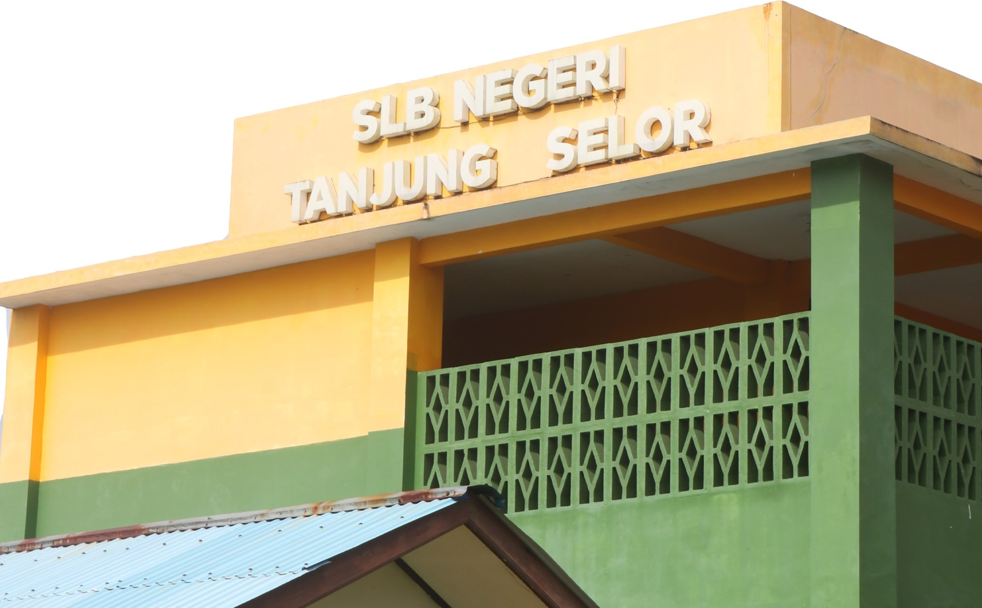

Special Needs Schools (SLB): The Reality of SPM Inclusivity

The implementation of SPM in education is increasingly evident in Special Needs Schools (SLB). At Tanjung Selor SLB, service improvements have been carried out gradually, but consistently. Many students come from families with limited financial means, so school transport services for student pick-up and drop-off are being developed to ensure access to education. Vocational activities and talent development have also been strengthened, supported by Education Operational Assistance (BOS) funding and collaboration with private partners.

Over the past two years, capacity building for SLB teachers has been conducted systematically through continuous professional development. Forums for SLB Principals across North Kalimantan have served as platforms for sharing best practices and enhancing teachers’ competencies, with a focus on the diverse needs of learners. Existing services still require strengthening to address teacher shortages and the provision of basic facilities, such as accessible toilets, which necessitate cross-sectoral support and further policy measures.

Support from the local government has further reinforced service delivery. The recruitment of additional teaching staff, the appointment of teachers through the Government Employee with Work Agreement (PPPK) scheme and plans to improve school health facilities all form part of the sustainability agenda.

Strengthening the Implementation of Minimum Service Standards in North Kalimantan:
Consistent Governance for Equitable Basic Services Delivery
5
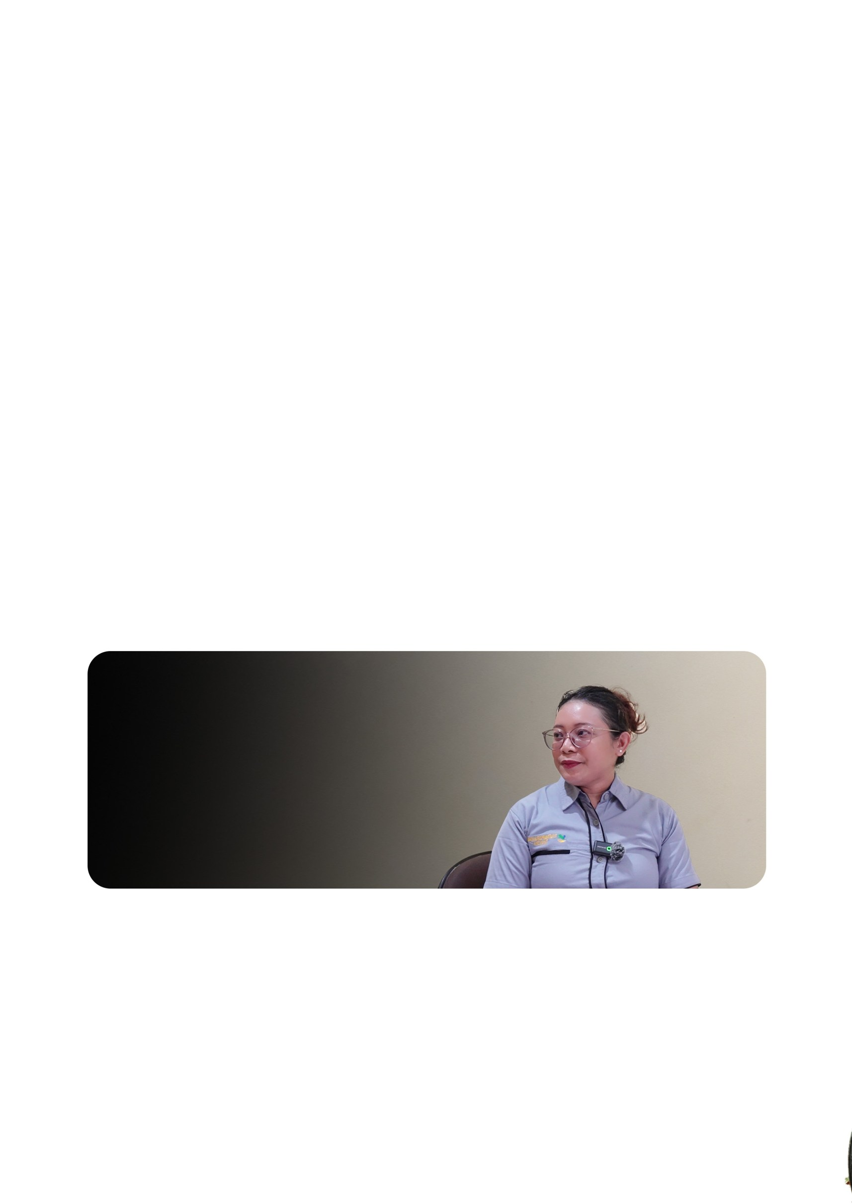
SPM for Social Services: Honouring the Dignity of Older People
“
”

In the social sector, SPM is reflected in the services provided to older people at the Tresna Werdha Marga Rahayu Residential Care Home in North Kalimantan. This facility accommodates residents from various districts and cities, and from across provincial boundaries, as part of inter-regional cooperation. The basic services currently provided focus on meeting essential needs: nutritious food, appropriate clothing and primary healthcare, as well as referrals to community health centres.

The presence of healthcare professionals such as nurses and nutritionists has further improved the quality of services. Supporting facilities, including a hall for residents’ physical activities and transport services for medical referrals, have also been progressively enhanced.

However, addressing infrastructure challenges remains a key priority. Existing facilities will soon require refurbishment to adequately support the diverse and complex care needs of their residents. Support from the North Kalimantan Provincial Social Affairs Agency is essential, both for budget allocation and strategic planning.

We are committed to continuously improving this care home.

Tasya,
Manager of the Tresna Werdha Marga Rahayu Residential Care Home North Kalimantan

Tasya, Manager of the Tresna Werdha Marga Rahayu Residential Care Home in North Kalimantan, expressed her hope that cross-sector collaboration—including with the business community and development partners—can be further strengthened.

For residents, basic services are not merely performance indicators; they are something that makes their daily lives possible. “Early morning prayers, followed by cleaning the front area of the home to maintain well-being. Sometimes we exercise or go for a walk,” said Sri Wahyuni, a resident at the Tresna Werdha Marga Rahayu Residential Care Home.

Strengthening the Implementation of Minimum Service Standards in North Kalimantan:
Consistent Governance for Equitable Basic Services Delivery
6

The SPM Team Building Consistency, Ensuring Sustainability
“
”

Although it has demonstrated strong performance, the North Kalimantan Provincial Government recognises that the challenges ahead will remain significant. Budgetary limitations and human resource constraints continue to be the primary obstacles in implementing Minimum Service Standards (SPM).

In response, collaboration strategies are continually being developed, including the formation of the SPM Team . This team carries a critical mandate: to oversee the implementation of SPM in a more structured and coordinated manner, ensuring that every action taken extends beyond administrative compliance and truly delivers tangible outcomes for communities. The SPM Team is strengthened through a joint effort involving the Secretariat of the Directorate General of Regional Development within the Ministry of Home Affairs, supported by SKALA through technical assistance to enhance adaptive governance practices and prioritise practical implementation.

North Kalimantan aims to reinforce a comparative advantage approach across districts and cities. Each region is encouraged to develop its own flagship SPM indicators based on its unique strengths—for instance, one region focusing on education and another on health—so that good practices can be shared, adapted and replicated. This approach is both realistic and strategic, allowing positive practices to spread across regions without requiring every region to excel in all indicators at once.

Excellence should not come at the expense of others; instead, each area should complement the others. If every district or city develops its own strengths in SPM, good practices will spread and be adopted across regions, enabling them to learn from one another.

Taufik Hidayat,
Head of the Regional Development and Autonomy Bureau, North Kalimantan

Strengthening the Implementation of Minimum Service Standards in North Kalimantan:
Consistent Governance for Equitable Basic Services Delivery
7

North Kalimantan demonstrates that consistent governance, cross-sectoral commitment and sustained coordination can transform SPM from an administrative requirement into a meaningful instrument for development. Inclusive education, services for children with diverse needs and care for older persons are all examples SPM addressing everday needs of citizens at different stages of life.
“
”

Ensuring services remain equitable is a key challenge. Basic services must be delivered equally and reach all communities, particularly those in remote locations and those experiencing vulnerability. North Kalimantan continues to face barriers, including geographic distance and connectivity constraints, disparities in service capacity across regions, and limitations in human resources and infrastructure at service delivery points. At the same time, data consistency and cross-sectoral follow-up must be further strengthened to ensure that coordination moves beyond governance and translates into measurable improvements in service delivery on the ground.

Nevertheless, the foundations established provide a strong basis for continued progress. By maintaining consistency, strengthening capacity and fostering collaboration, SPM in North Kalimantan shows itself to be a genuine commitment from the state—not only documented in reports, but experienced in the everyday lives of the community.

Awards are not the ultimate goal. What matters most is ensuring that basic services are genuinely experienced by the community.

Taufik Hidayat,
Head of the Regional Development and Autonomy Bureau, North Kalimantan

The reliability of basic services is evident in its consistent implementation—commitments are upheld across sectors, coordination extends beyond meetings into action and services continue to improve despite ongoing challenges. As demonstrated by North Kalimantan, SPM becomes more than a standard: it represents a state commitment actively delivered and realised for its citizens.

Strengthening the Implementation of Minimum Service Standards in North Kalimantan:
Consistent Governance for Equitable Basic Services Delivery
8







IFC Tower 2, Level 17
Jl. Jendral Sudirman Kav. 22-23 Jakarta 12920

skala.or.id The Australia-Indonesia Partnership Program, Synergies and

Collaboration for Basic Service Delivery Acceleration (SKALA) is a program to support the Government of Indonesia in its efforts to reduce poverty and inequality by improving the provision of basic
services to the poor and vulnerable in disadvantaged areas.

https://s.id/Channel-SKALA

