KEMENTERIAN KEUANGAN

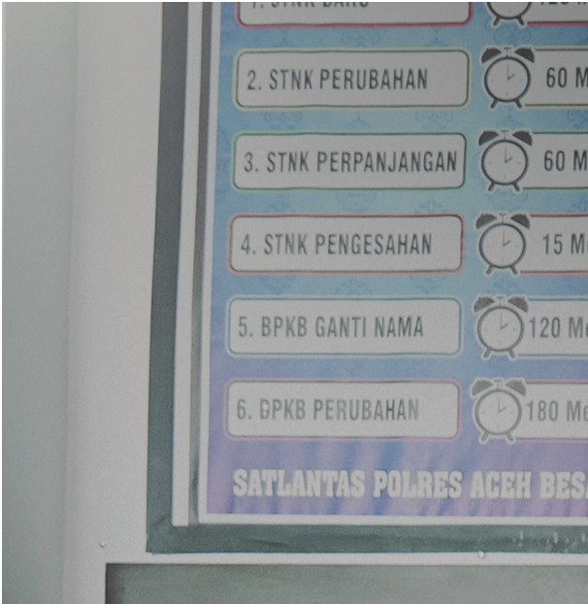
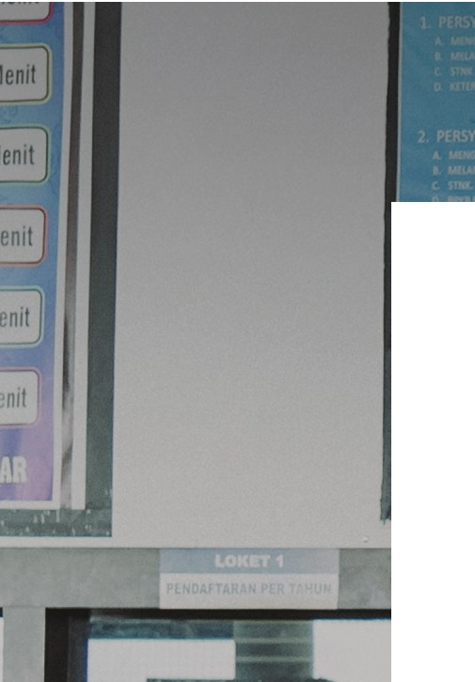

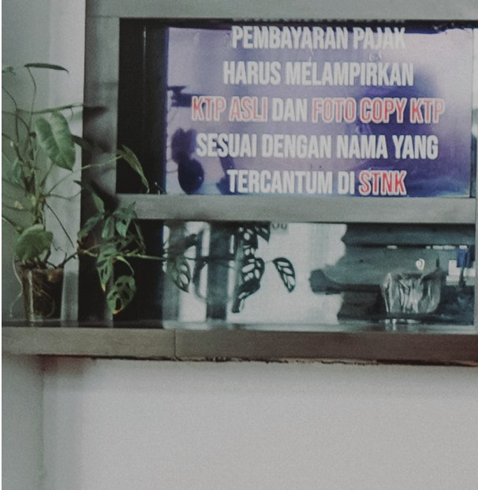




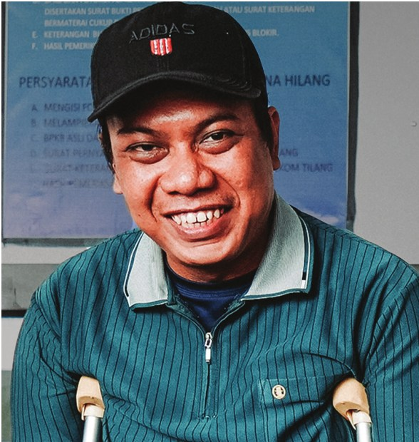




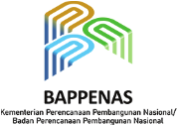




REPUBLIK INDONESIA
ACEH’S
TAX
RELIEF
KEMENTERIAN DALAM NEGERI
REPUBLIK INDONESIA

DISABILITY

Keeps People Moving


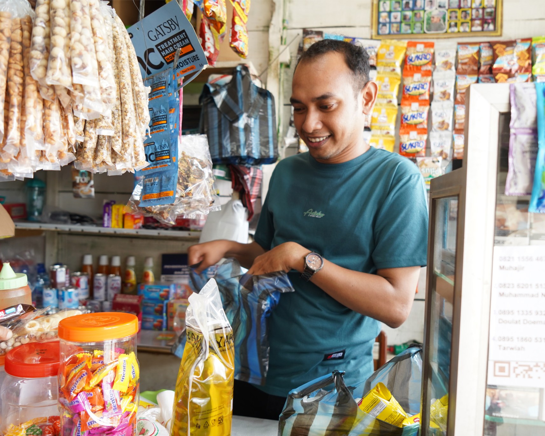
Muhajir (29) has never allowed his disability to hold him back. Raised by his mother and late father in Lhoknga, Aceh Besar, he grew up with mental toughness and a strong sense of self-determination, qualities that shaped his entrepreneurial spirit from an early age when he sold food and drinks at village football tournaments. In secondary school, Muhajir switched to selling prepaid mobile phone vouchers, saving up his earnings little by little.

Born with a physical disability and limited vision, Muhajir knew that finding regular employment would not be easy. Instead, he looked for ways to earn an income independently. “I realised that doing work like my other friends without disabilities would be difficult. So, I looked for opportunities I could do myself. As it happens, I like trading, so I've kept at it ever since,” he said with a smile.

Through careful saving and persistence, he was eventually able to open a grocery store, which he runs with his mother. To keep his shop stocked, mobility is key. He relies on a three-wheeled modified motorbike provided by the Aceh Government to deliver goods and stay active in disability organisations. “Before, I used a bicycle that I’d modified with a basket. But it was exhausting, especially when carrying heavy goods, and I couldn’t go far. With the motorbike, I can now get around places and stay active,” Muhajir recalled.

Aceh’s Disability Tax Relief Keeps People Moving 1

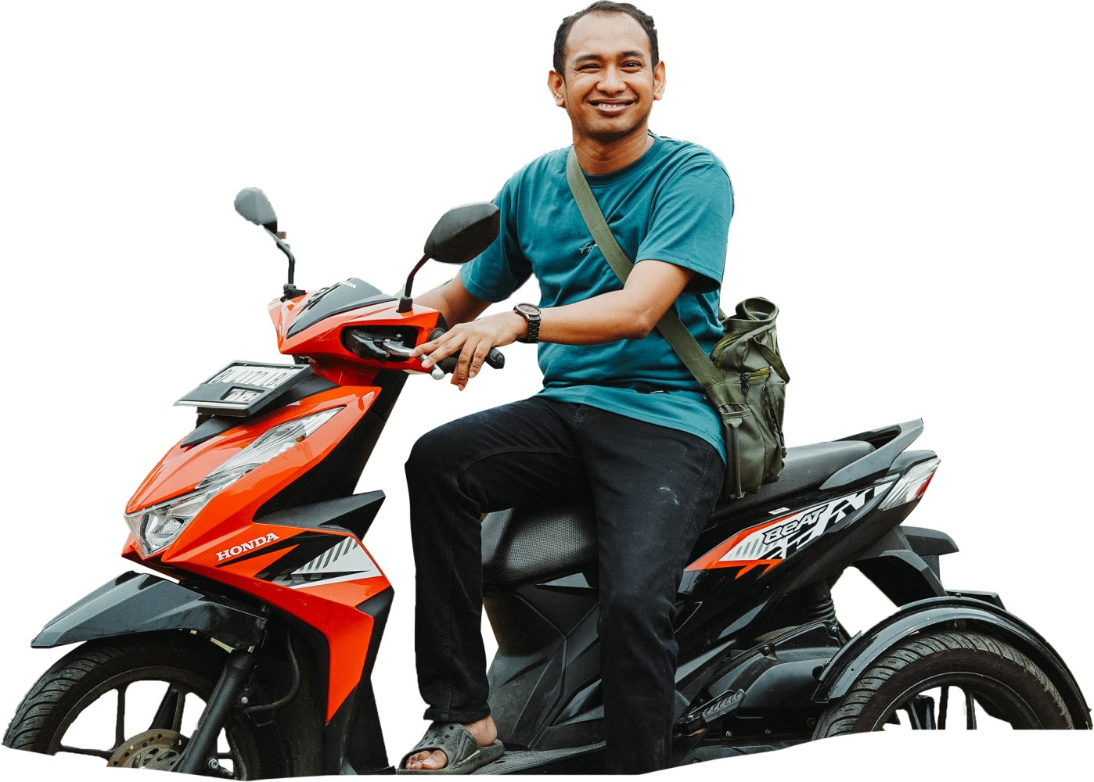


Since the motorbike is the lifeblood of his business, the introduction of a vehicle tax discount program for people with disabilities was a huge relief. He said he was overjoyed when contacted about receiving the discount.
“
”

This policy is helpful. The 50% discount makes a difference. I can now spend my money on rice instead of paying vehicle tax.

Muhajir, Beneficiary of Motor Vehicle Tax Relief in Aceh

While this policy has made life a little easier for him, Muhajir knows that many other people with disabilities still struggle to make a living. That’s why he advocates for their rights through a youth organisation for people with disabilities in Aceh and works closely with the local government to develop inclusive regulations. He hopes his efforts will lead to broader opportunities for people with disabilities. “I hope that in the future there will be even better policies. It’s hard for us to earn an income, so we need more job opportunities. It's like giving us a fishing rod instead of a fish. Fish run out quickly, but with a rod, we can catch them whenever we need to,” said Muhajir.

Aceh’s Disability Tax Relief Keeps People Moving 2




Dedy Kurniadi Beneficiary of
Motor Vehicle Tax Relief in Aceh

As a student, Dedy Kurniadi (34) dreamed of becoming a bicycle racer. But a tragic accident in his first year of high school shattered his hopes. He lost one of his legs, and the daily challenge of getting by, replaced the racing he once dreamed of.

Today, Dedy faces financial hardship. He works as a technical assistant, helping a friend who is an electrician. “My job is to install things closer to the ground. I can't climb up high,” he said.

When he heard about the vehicle tax discount program for people with disabili-ties, Dedy didn’t hesitate. He went straight to the Aceh Besar Samsat, the regional vehicle registration and taxation office, to settle his overdue tax penalty. “Thank God, I got a discount on my motorcycle tax fines. I had been making late payments because of financial difficulties,” he said.

“This program has eased a lot of pressure. Before I paid the tax, I was always nervous when riding my motorbike. Now I feel much more at ease,” said Dedy, adding

His work is irregular. He is only called in when his friend needs help, and when there’s no work, he has no income. Becau-se Dedy’s earnings were so uncertain, he kept putting off paying the tax penalty on
that he enjoys touring Aceh on his three-wheeled motorbike.

his modified motorbike, a gift from the Aceh Social Services Agency.

Aceh’s Disability Tax Relief Keeps People Moving


Saifudin (57) from Aceh Besar district has faced a lifelong struggle for independence. After contracting polio at the age of five, mobility has always been a major challenge. For years, he relied on a bicycle or walking to get around.
“
”

A father of six, he works as a fisherman to support his family. But his physical condition limits how much he can work, so money is always tight. The three-wheeled motorbike received from Aceh’s Social Services Agency is essential for his mobility, but his irregular income has long prevented him from paying the vehicle tax.

Saifudin doesn’t own a mobile phone, so news about the tax discount program from the regional tax office reached him unexpectedly through one of his children's phone. He didn’t want to miss the opportunity. He went to the local Samsat to request the cancellation of his vehicle tax fines.

Before, I always felt anxious when riding my motorbike because I knew I was breaking the rules.

Saifudin, Beneficiary of Motor Vehicle Tax Relief in Aceh

Aceh’s Disability Tax Relief Keeps People Moving
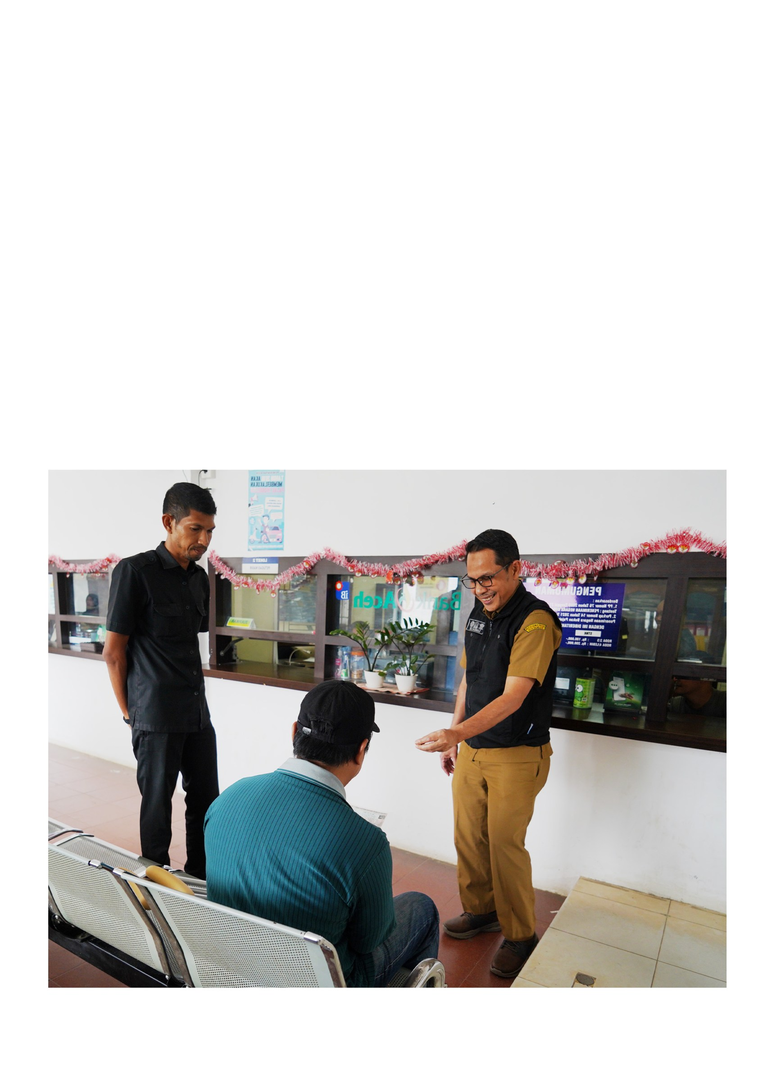
Implementing vehicle tax relief is more than a simple administrative adjustment. For people with disabilities, it can determine whether they can carry out daily activities. According to Saumi Elfiza, Head of Revenue at the Aceh Financial Management Agency (BPKA), the tax relief policy has not significantly reduced government revenue. Instead, it has improved tax compliance.
“
”

When people feel cared for, they are more enthusiastic about paying their taxes. There is an aspect of trust that grows.

Saumi Elfiza, Head of Revenue Division, Aceh Financial Management Agency

Furthermore, this policy strengthens the Aceh Government's commitment to inclusive development and aligns with national and international agendas on the rights of people with disabilities.

Aceh’s Disability Tax Relief Keeps People Moving 5


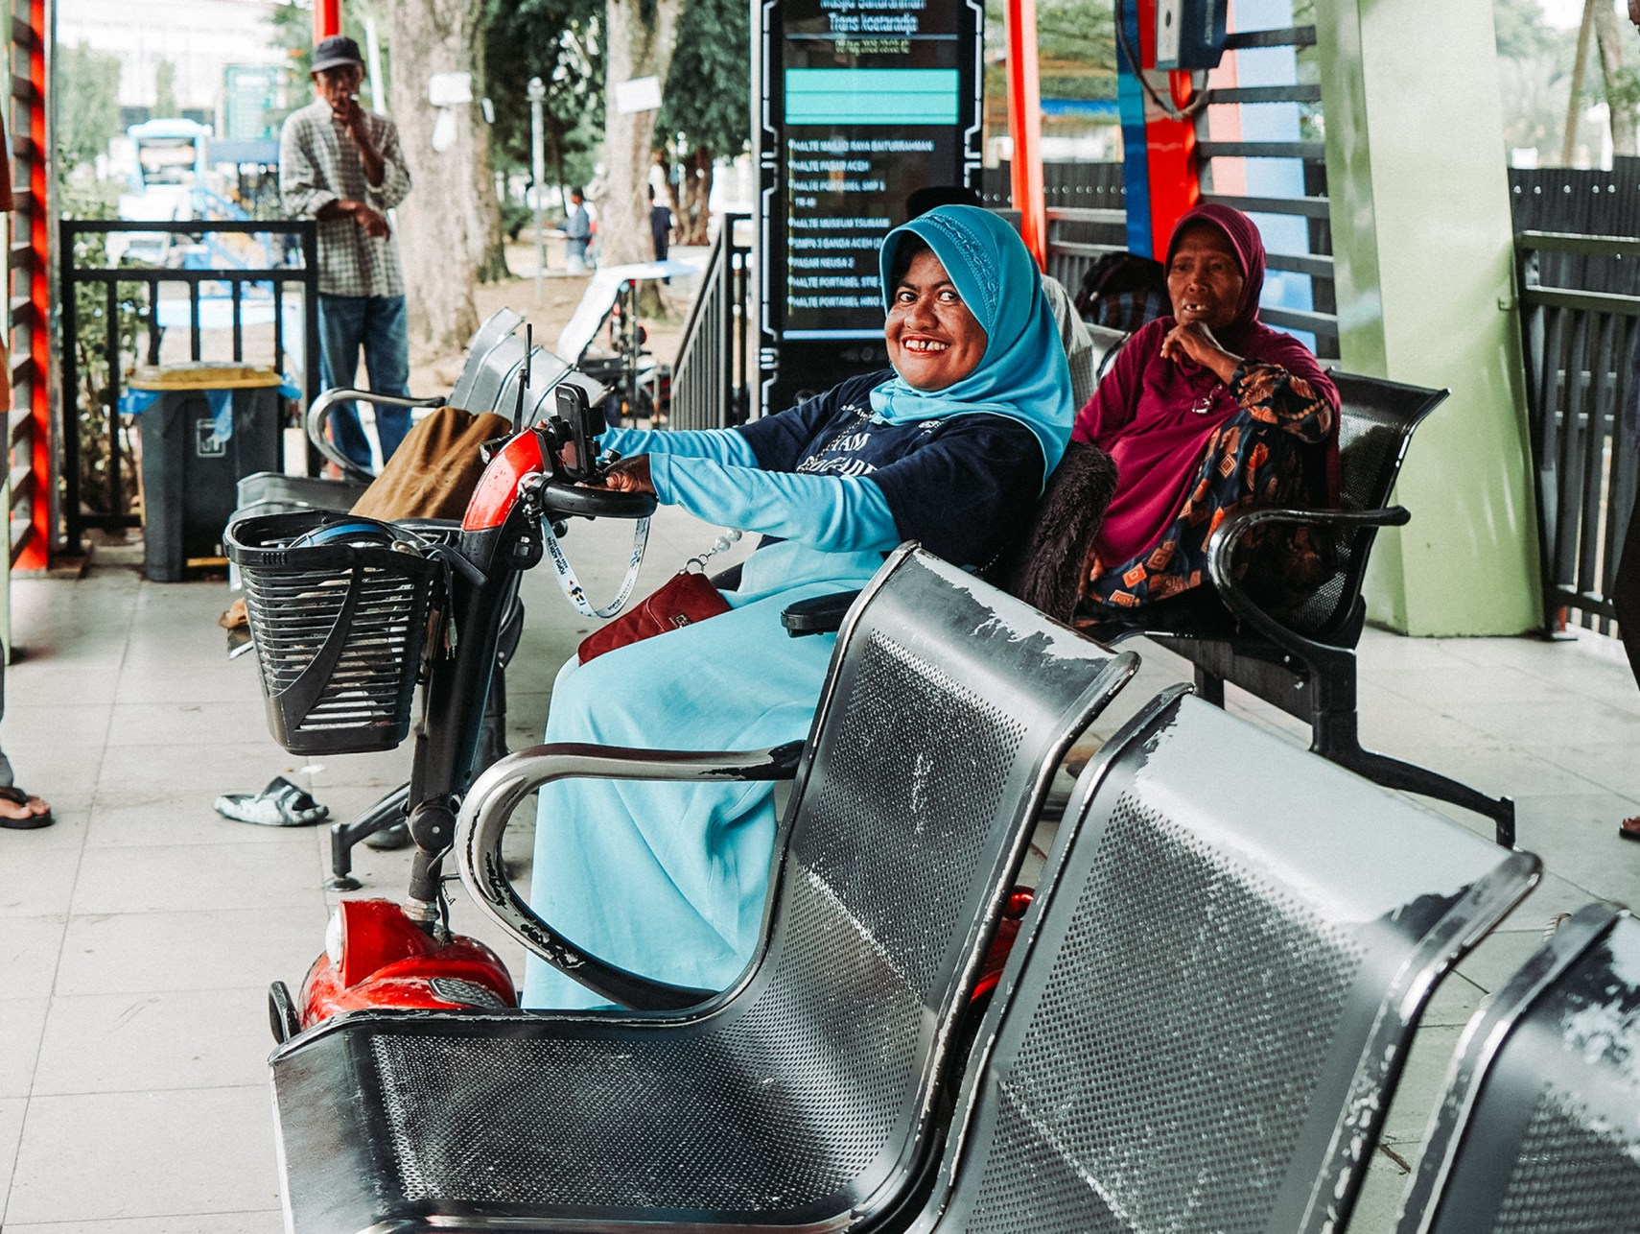
Mobility: The Key to Inclusivity
and Independence

Mobility is the key to achieving independence and active participation in public life for people with disabilities. With greater freedom of movement, they can realise their full potential. Improving mobility is not only about meeting basic needs but also a strategic investment in building an inclusive and productive society.

A clear example comes from the Aceh Government, which has taken the lead by launching a motor vehicle tax relief program for people with disabilities. The policy emerged from close collaboration between the government, civil society organisations and organisations for people with disabilities, which have become strategic partners in overseeing the policy. The initiative has been warmly welcomed by the disability community, which sees it as a meaningful step towards greater independence and social inclusion.

Aceh’s Disability Tax Relief Keeps People Moving 6


Progressive Steps
in Aceh: Vehicle Tax Relief
to Support Disability Mobility Legal Basis

The Aceh Government has demonstrated its commitment to inclusive development by introducing a vehicle tax reduction program for people with disabilities. Under Governor Regulation No. 34 of 2024, eligible residents receive a 50% motor vehicle tax reduction and a full waiver of administrative sanctions.

The regulation also provides further concessions, including a 15% reduction in local levies for economically disadvantaged people and a 10% discount for people with disabilities registered with Baitul Mal, the provincial Islamic financial body that manages charitable funds for eligible beneficiaries.

These policy adjustments stem from Law No. 1 of 2022 on Financial Relations between the Central and Regional Governments (HKPD) and align with the national Ministry of Finance and its efforts to optimise subnational revenue through fairer fiscal policies that support improved local services. Reflecting this synergy, the national reform has been adopted in Aceh through local regulation Qanun No. 4 of 2023 and implemented under Aceh Governor Regulation No. 34 of 2024.

Aceh’s Disability Tax Relief Keeps People Moving 7
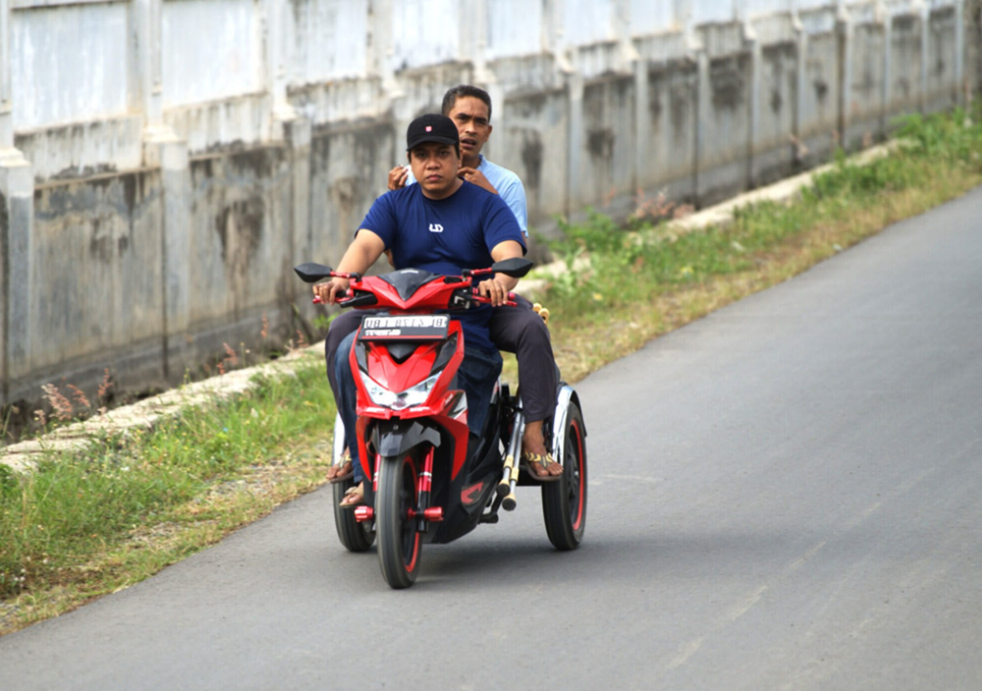
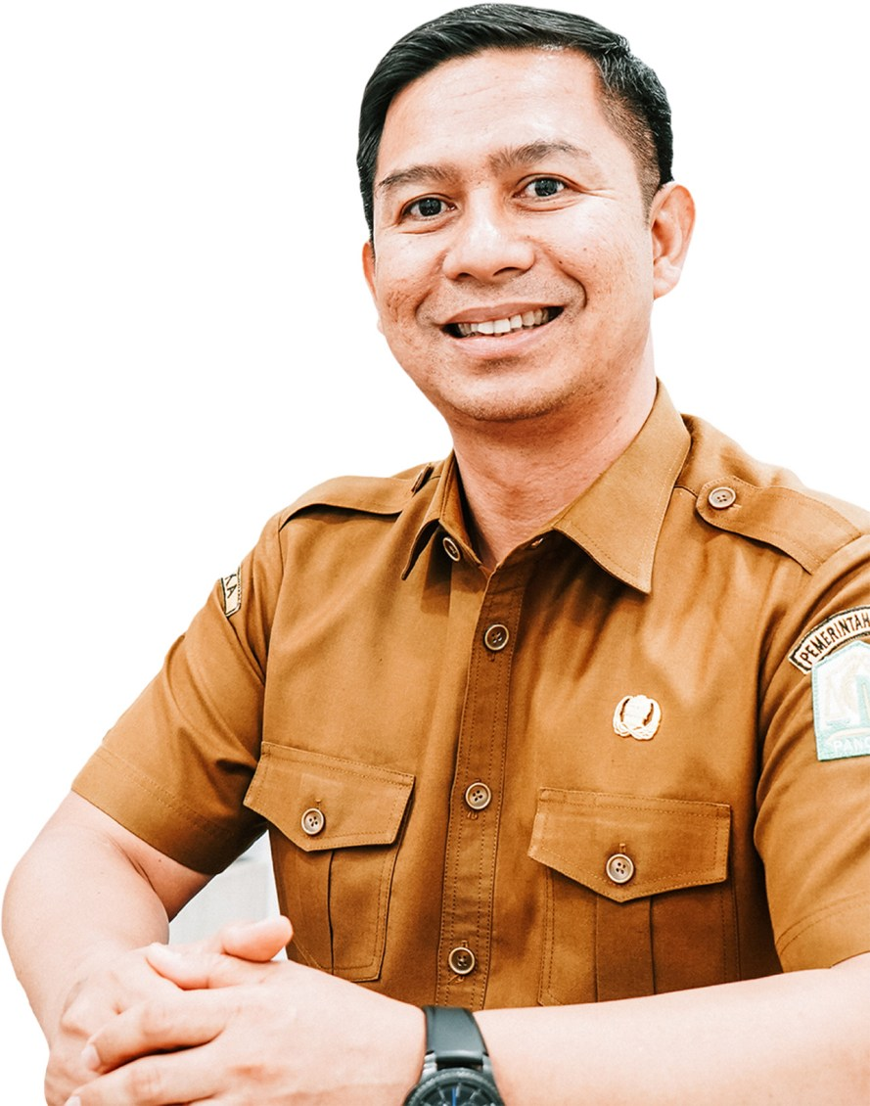

Governor Regulation Formulation

The Governor Regulation was developed through a collaborative process led by BPKA, involving a range of stakeholders. Input was gathered from taxpayer groups, subnational governments and supervisory institutions such as the Inspectorate and the Financial and Development Supervisory Agency. Importantly, the process involved representatives from organisations for people with disabilities. The process was supported by the Australia–Indonesia Partnership Program, SKALA (Synergy and Collaboration for the Acceleration of Basic Services), through technical support to strengthen civil society networks, including training in data collection, policy advocacy and effective information dissemination.

Saumi Elfiza noted that the policy is a form of government support for vulnerable groups. ”We want to ensure that people with disabilities have equal opportunities to access public services, including owning motor vehicles with lower tax burdens,” he said. Saumi added that the process also included academic reviews to ensure the regulation could be implemented effectively.

Three key institutions are collaborating to ensure the smooth implementation of the program: BPKA, the Aceh Regional Police Traffic Directorate, and Jasa Raharja, the state-owned insurance company.

Saumi Elfiza Head of Revenue Division,
Aceh Financial Management Agency

Aceh’s Disability Tax Relief Keeps People Moving 8

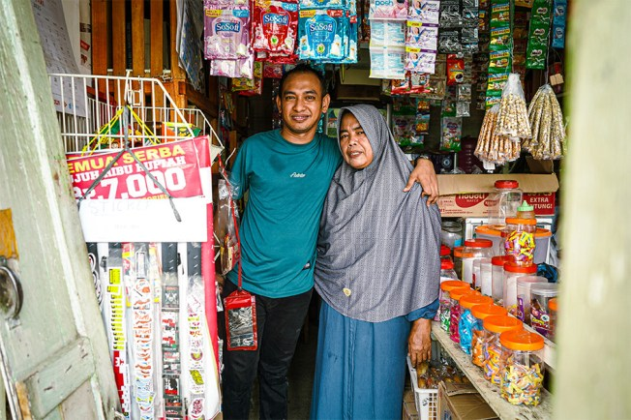
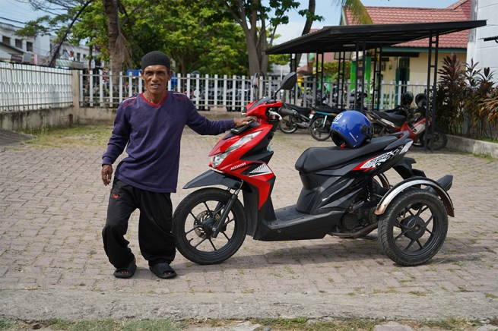
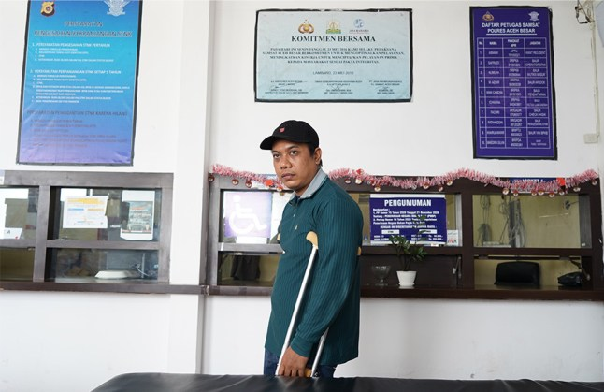
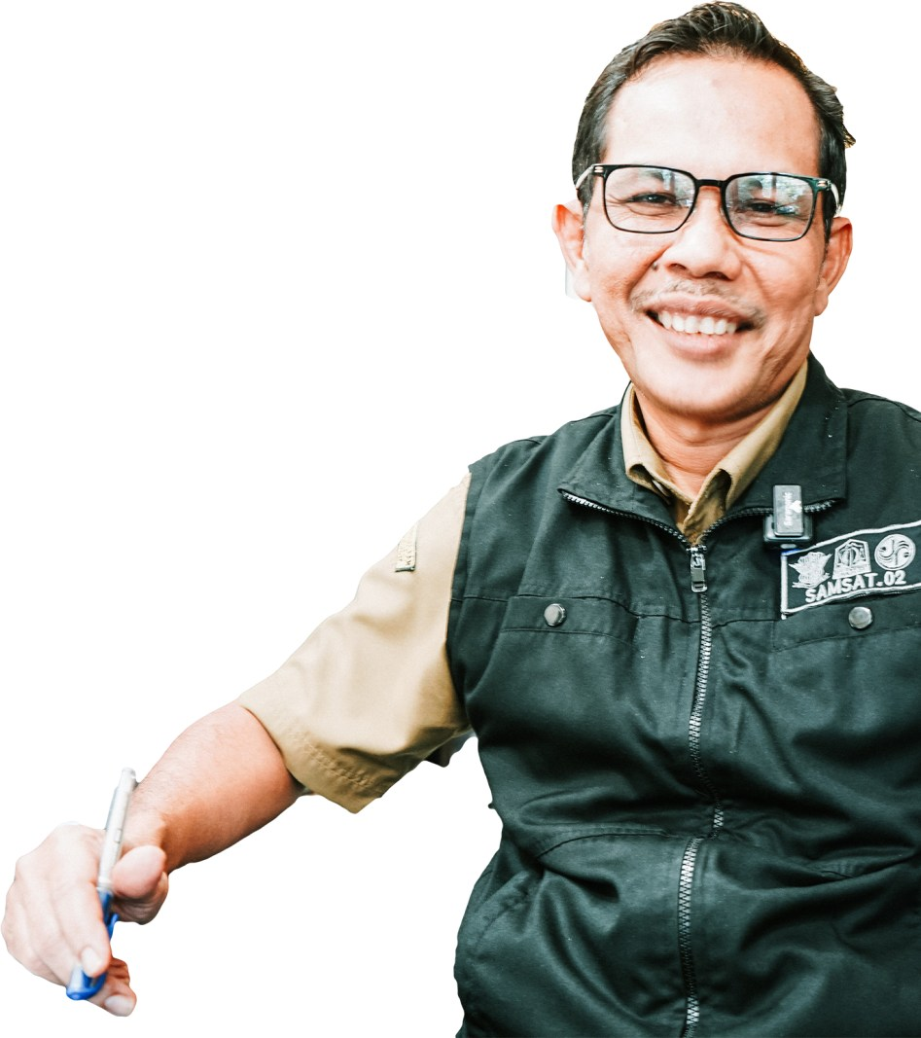
Implementation at
“
the Service Level

At the service level, this policy is implemen-ted by Samsat in each regency and city. Muhammad Rizal, Head of Region II in Aceh Besar, emphasised his office's commitment to providing friendly, inclusive and efficient services. He has directed his staff to provide dedicated assistance for people with disabili-ties who come to pay their vehicle taxes.

The process is simple and only requires verification of personal and vehicle data. We have also set up a dedicated service lane to make them feel

comfortable.

Muhammad Rizal
Head of UPTD Region II, Aceh Besar

”

Rizal added that the main priority is to ensure that information about the policy reaches as many people with disabilities as possible. “To support this, we are sharing information through social media and collaborating with disability organisations,” he said.

This initiative by the Aceh Government offers a useful example for other subnational gover-nments across Indonesia, supporting efforts to build a more inclusive society.

Aceh’s Disability Tax Relief Keeps People Moving 9


