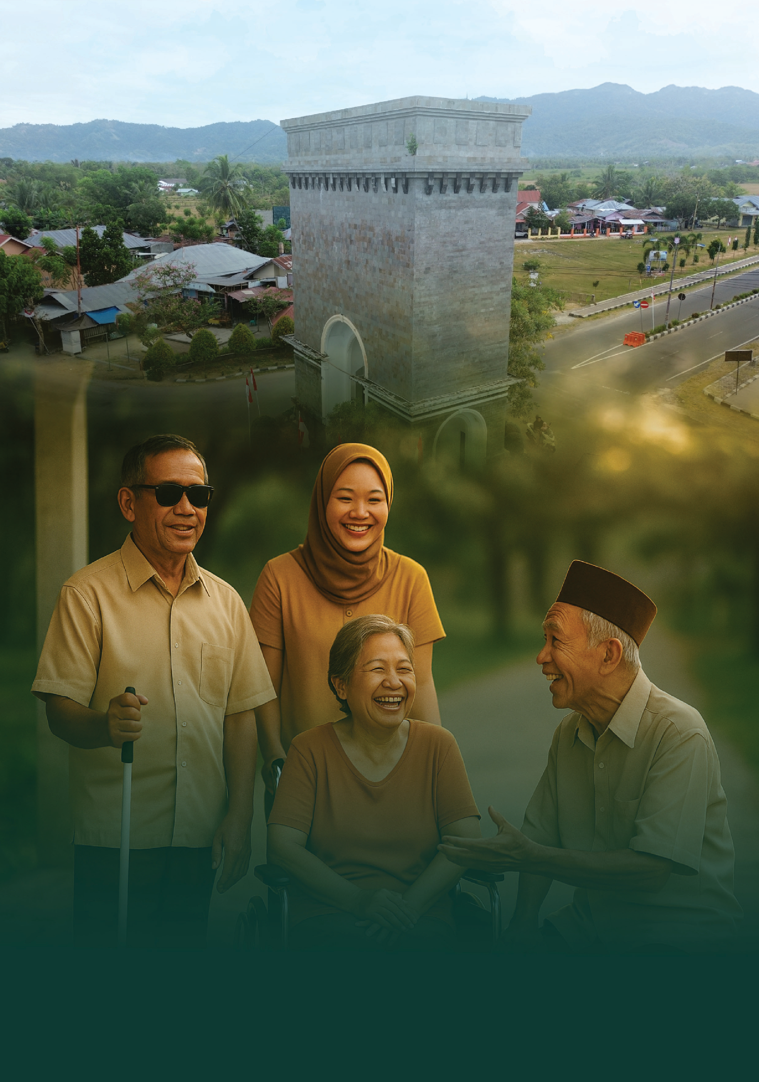

DULOHUPA:
Gorontalo’s Path to Inclusive Development

September 2025


Dulohupa: Gorontalo’s Path to Inclusive Development

2

Development is not only about economic growth or building infrastructure. It is also about ensuring all citizens benefit fairly and equally. Yet, vulnerable groups, including women, children, people with disabilities, older people, and other marginalised communities, often face unequal access to basic services, such as education, health care, and social protection.

In formal planning forums, the participation of marginalised people is too often performative. Their voices and proposals are rarely recorded or integrated into official planning documents. This creates inequities in development, with some communities benefiting while others are left behind. These disparities are widespread and persistent across Indonesia.

The government promotes a rights-based approach, including the right to speak, to be heard, and to participate in decision-making that attects people’s lives. The voices of vulnerable groups must not simply be placed on “mute”; they must be realised through meaningful participation. Being present without influence is like watching football from the sidelines – you see what is happening, but cannot change the score. Meaningful dialogue means not only having a seat at the table but also a hand on the microphone, and the assurance that voices will shape decisions.

Komitmen inklusivitas tercermin dalam sejumlah regulasi. Pemerintah telah mengeluarkan:


Law No. 25 of 2004 on the National Development Planning System and the importance of participatory planning.
Law No. 23 of 2014 on Regional Government, which gives local governments the authority to design development policies based on community needs, including ensuring the participation of vulnerable groups.

Law No. 8 of 2016 on Persons with Disabilities and Government Regulation No. 70 of 2019 on the fulfilment of disability rights, which obliges the government to create inclusive spaces in policy and services.

Globally, Indonesia is also committed to the Sustainable Development Goals (TPB - Tujuan Pembangunan Berkelanjutan) with the principle of No One Left Behind. Development must reach everyone, without exception.


Gorontalo’s Commitment: From Policy to Action

Gorontalo Province h as shown a strong commitment to embedding inclusion in its development planning. Yet with low fiscal capacity, persistent poverty, disparities between districts, and limited access to basic services, the province needs solutions that are grounded in data and strengthened by broad participation to ensure fiscal fairness and social wellbeing.

The provincial government recognised persistent problems in data quality and targeting. Too often, assistance reached those who were not eligible, while people in genuine need were overlooked. This showed that unless marginalised groups are heard, development will fail to serve everyone.


Dulohupa: Gorontalo’s Path to Inclusive Development

3

To address this the provincial government established a dedicated forum to give vulnerable groups a voice ahead of the regular Development Planning Forum (Musrenbang – Musyawarah Perencanaan Pembangunan) with support from SKALA . This initiative became the Gorontalo Inclusive Forum Dulohupa (FGI Dulohupa - Forum Gorontalo Inklusif Dulohupa), named after the local tradition of Dulohupa or ‘deliberating for consensus,’ which reflects Gorontalo’s strong culture of togetherness.

FGI Dulohupa: From Idea to Inclusive Space

FGI Dulohupa serves as a pre-Musrenbang forum where women, people with disabilities, children, older people, civil society organisations, and government agencies meet as equals to identify the needs of vulnerable groups.

Unlike formal meetings that often feel rigid, FGI Dulohupa uses participatory methods. Facilitators encourage everyone to speak using plain language, visual tools, and even role play, ensuring communication barriers are removed.
The aspirations raised are concrete and practical, for example:



Disability-friendly health services at local health centres
Safe public transport for women and children
Mobile health programs for older people



Safe spaces and violence-free schools for children
Dormitory support for students from remote villages

All proposals are documented in official minutes and submitted to the Provincial RKPD Musrenbang. Andre Wartabone, a person with vision impairment, expressed her satisfaction at finally being heard.
“We were often invited to attend, but never knew whether our input was accepted. For the first time, we feel heard, because during the FGI Dulohupa, our proposals were written into the official record and included in planning documents,’ she said.

To sustain the initiative, the provincial government developed an FGI Dulohupa Implementation Guide, outlining its key principles: participation, non-discrimination, transparency, inclusion, evidence, and sustainability. This has ensured the forum is seen not as an add-on but as an integral part of the planning cycle.

The province also plans to revise Governor Regulation No. 8 of 2016 on the Regional Development Planning System to give FGI Dulohupa a strong legal basis and ensure its continuity beyond changes in leadership.

“Development must unite, not divide. The Dulohupa Forum is our commitment that every voice matters”
The Deputy Governor of Gorontalo

Dulohupa: Tradition Inspiring the Future

The forum has already shown a tangible impact. Children’s groups called for child-friendly schools. Women’s groups highlighted the need for dormitories for girls from remote areas. People with disabilities pushed for more accessible public service offices.

“We want safe schools, free from violence. Through this forum, we dare to speak because someone is listening”
Rivaldi Tangahu, peserta Forum Anak

The initiative was further strengthened by Governor Decree No. 225/28/VIII/2025 establishing the FGI Dulohupa Implementation Team for 2025–2029. The guide will also be formalised by a decree of the Provincial Development Planning Agency (Bappeda - Badan Perencanaan Pembangunan Daerah), enabling budget allocation from the 2026 Regional Revenue and Expenditure Budget (APBD - Anggaran Pendapatan dan Belanja Daerah). Several district and municipal governments have already shown interest in replicating the model.

This was reinforced by the statement of the Head of Bappeda for Gorontalo Province, Dr Wahyudin A. Katili, S.Stp, M.T, who said, “We hope that the regional government agencies (OPD) will accommodate the points put forward in this forum so that they can be directly incorporated into the 2026 budget.” This statement demonstrates the Gorontalo Provincial Government’s strong commitment to following up on the proposals raised in this consultation.

FGI Dulohupa demonstrates how local cultural values can inspire modern governance. Dulohupa is no longer only a cultural tradition. It is also a foundation for public policy. With strengthened guidelines and regulations, Gorontalo has proven that inclusive development can be systematically planned, participatory, and sustainable.

The legacy of Dulohupa shows that the best development is development that listens to every voice. In Gorontalo, those voices are now stronger – and being heard.







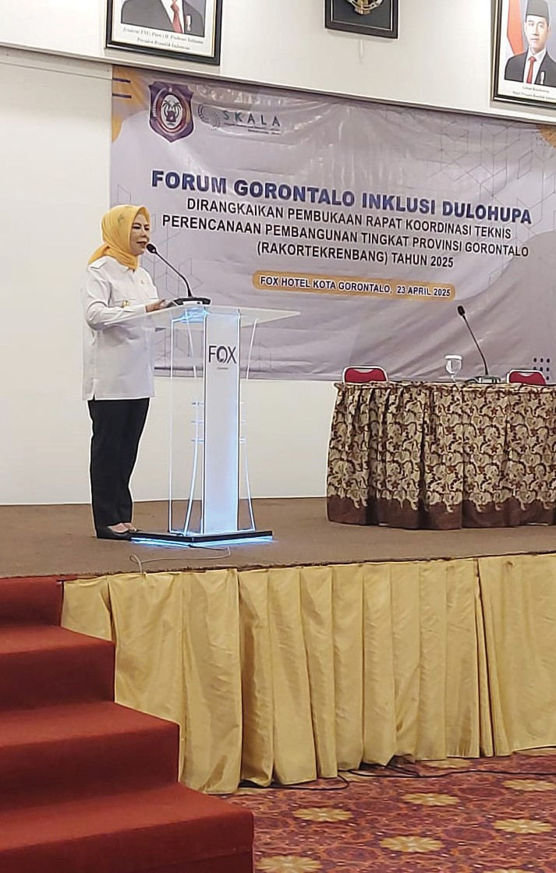

Sinergi dan Kolaborasi untuk Akselerasi Layanan Dasar (SKALA) is an Australia-Indonesia Partnership Program aimed at supporting the Government of Indonesia’s efforts to reduce poverty and inequality by improving basic-service provisions to poor and vulnerable communities in less-developed regions.
CONTACT US
IFC Tower 2, Level 17
Jl. Jendral Sudirman Kav. 22-23 Jakarta 12G20
info@skala.or.id
https://s.id/Channel-SKALA

SKALA.or.id

