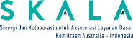


Pemerintah Provinsi Kalimantan Utara
Kementerian Keuangan Republik Indonesia
Kementerian Dalam Negeri Republik Indonesia

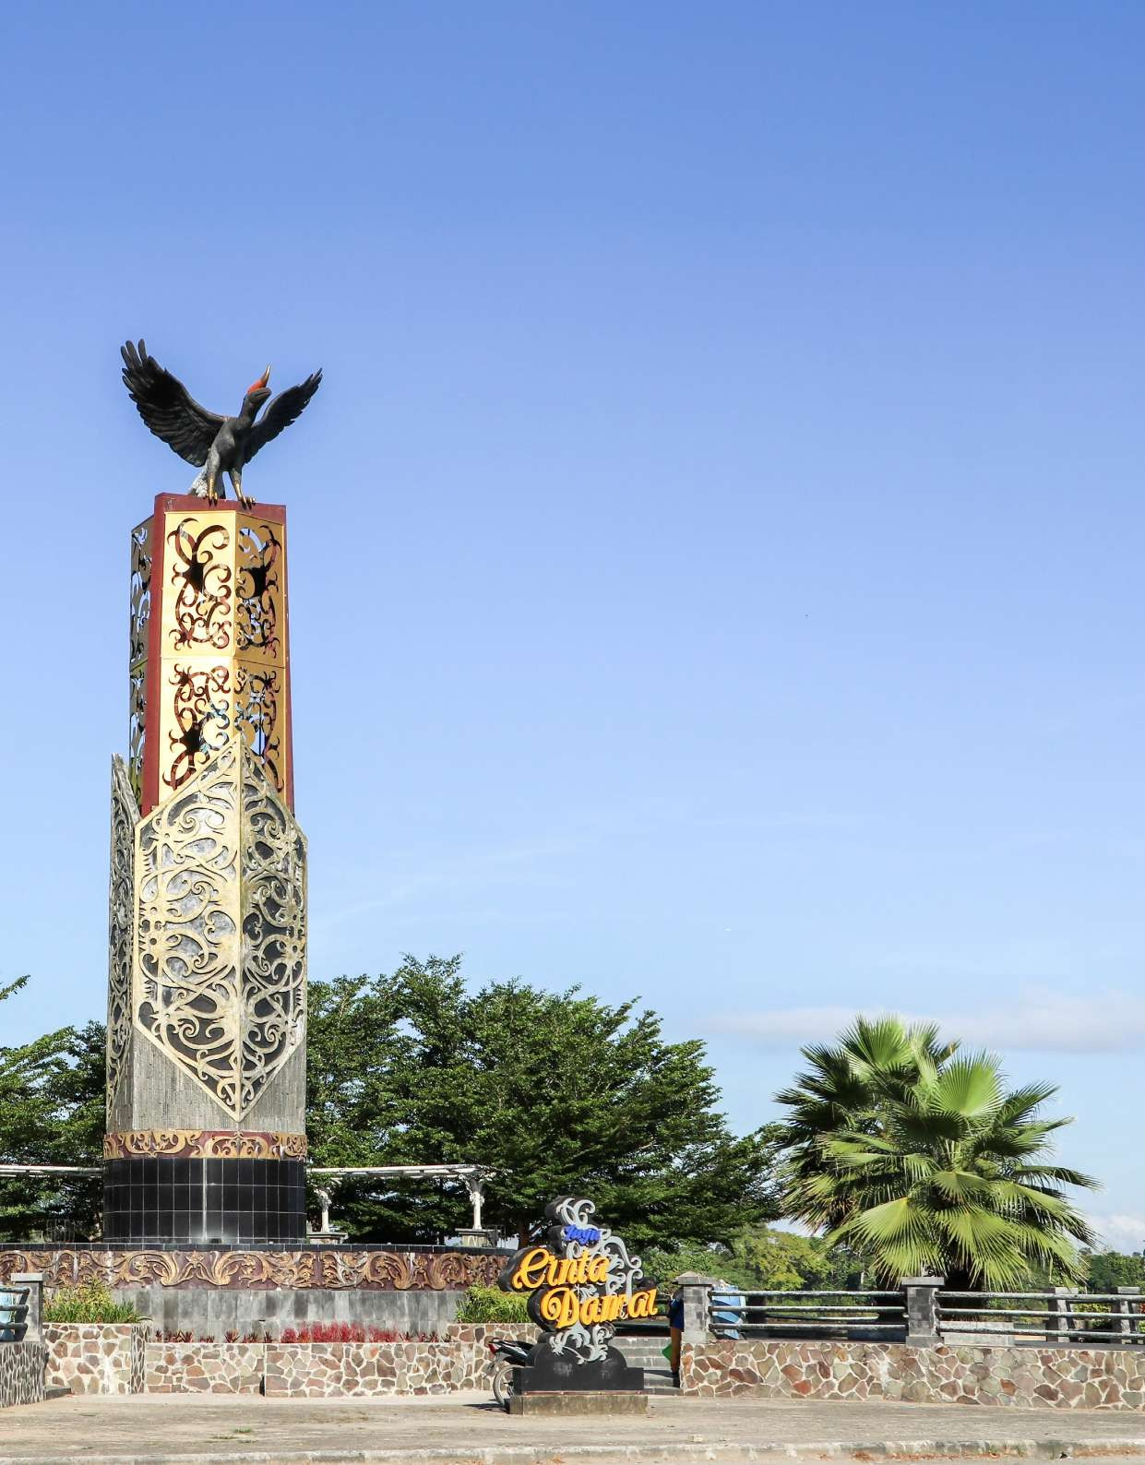

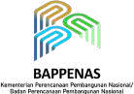
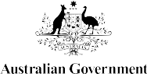
BUILDING EVIDENCE-BASED

DATA
for a Progressive, Prosperous and Sustainable
North Kalimantan

“The Provincial Government of North Kalimantan recognises the necessity of integrating and standardising data to foster better, more transparent, and accountable governance. We intend for the ‘Satu Data’ (One Data) program to provide accurate, accessible, and useful data for all stakeholders, particularly in the formulation of
regional planning and budgeting.”
(Governor of North Kalimantan, Dr. H. Zainal A. Paliwang)


Effective development begins with data. Planning and policies that are supported by accurate and integrated data are better able to meet community needs. Complete and well-managed data help focus development priorities and ensure they are grounded in evidence.

Recognising the importance of reliable data, the national government issued several key regulations, most notably, Presidential Regulation No. 39/2019 on One Data Indonesia, later strengthened by Minister of Home Affairs Regulation No. 5/2024 on One Data for Sub-national Governance (SDPDN – Satu Data Pemerintahan Dalam Negeri). These regulations affirm that all development policies in Indonesia must be based on valid, accountable data and place local governments at the centre of effective data governance.

These policies aim to build a stronger, integrated system of government data management by applying common standards, clear metadata, consistent reference codes, and interoperable systems. This approach enables information from both central and subnational governments to be shared and used collectively in planning, program delivery, and evaluation.

Yet building better data governance is not an easy task. In many regions, data is scattered across different producers, often stored in different formats, lacking standardisation, and managed with limited human resources. Another challenge is that existing data is often not fully utilised in decision-making and development policies. Overcoming such obstacles requires provincial governments to be proactive in ensuring data are effectively applied.

2 Building Evidence-Based Data for a Progressive, Prosperous and Sustainable North Kalimantan

North Kalimantan’s Commitment: From Regulation to Action
North Kalimantan (Kaltara), a province categorised as terdepan, terluar, dan tertinggal – 3T (frontier, outermost, and lagging), has moved quickly to ensure its development remains progressive and does not lose ground. Since its establishment, the provincial government has recognised that quality development is founded on reliable data.

This commitment was formalised through Governor Regulation No. 30/2022 on One Data Indonesia at the provincial level, which provided the legal framework for data governance. The institutional structure for One Region One Data (SDD – Satu Data Daerah) in Kaltara was established through Governor Decree No. 100.3.3.1/173/2025.

The Governor of North Kalimantan, Dr H. Zainal A. Paliwang, underlined Kaltara’s determination to strengthen data governance. He said, “The Provincial Government of North Kalimantan recognises the necessity of integrating and standardising data to foster better, more transparent, and accountable governance. We intend for the ‘Satu Data’ (One Data) program to provide accurate, accessible, and useful data for all stakeholders, particularly in the formulation of regional planning and budgeting.”

The Governor’s statement demonstrates Kaltara’s commitment to evidence-based development, supported by accurate and credible data, reducing reliance on assumptions.
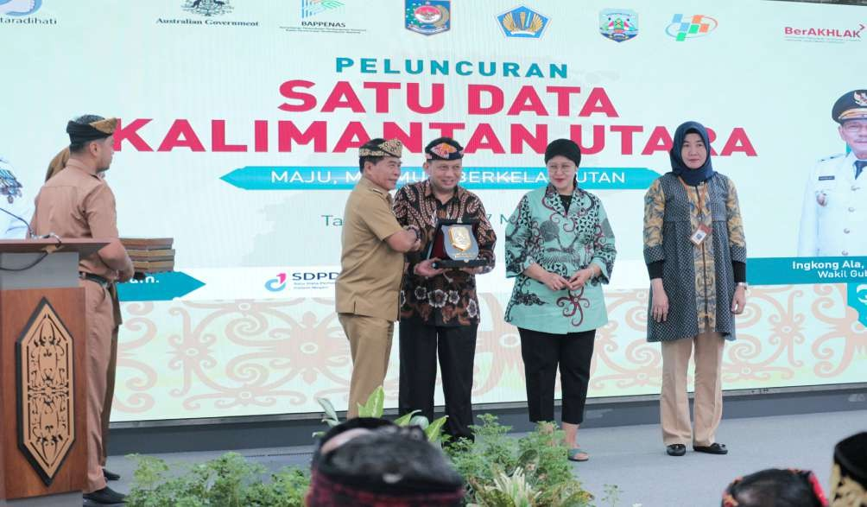

Building Evidence-Based Data for a Progressive, Prosperous and Sustainable North Kalimantan 3

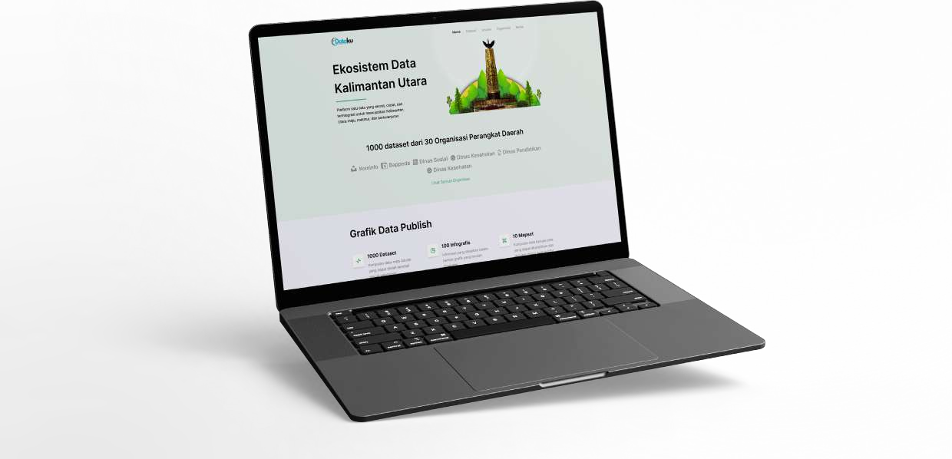
Launching the E-Dataku Portal – Sidara Cantik 2.0

4 Building Evidence-Based Data for a Progressive, Prosperous and Sustainable North Kalimantan
A key milestone in Kaltara’s One Data journey was the launch of the E-Dataku – Sidara Cantik 2.0 portal on 27 May 2025 in Tanjung Selor. The portal serves as the central hub for integrating sectoral data from all provincial government agencies.

The launch reflected Kaltara’s readiness to realise One Data Indonesia in Bumi Benuanta. The portal is designed as an open, transparent, and publicly accessible platform for government, academia, the media, and the wider community.

Through the Regional One Data Forum, the Kaltara provincial government approved 1,961 sets of sectoral statistical data for 2025. This process was supported by the Regional Development Planning and Research Agency (Bappeda Litbang – Badan Perencanaan Pembangunan Daerah, Penelitian dan Pengembangan) as the secretariat, the Department of Communications, Statistics and Encryption (DKISP – Dinas Komunikasi, Statistik dan Persandian) as the data custodian, and Statistics Indonesia BPS– Badan Pusat Statistik) as the data coach, with line agencies as data producers. These data sets were compiled, verified, and disseminated through the E-Dataku Sidara Cantik 2.0 portal, ensuring data quality and accuracy while making information accessible and shareable.

Today, the portal is the face of Kaltara’s data transparency. The public can access a wide range of development information, from socioeconomic and health data to education and environmental indicators. Looking ahead, the portal will be expanded to include micro and spatial data and will be linked with the national data platform.

The implementation of One Data Kaltara has been achieved through collaboration, supported by strong national-level support. The Ministry of National Development Planning (Bappenas – Badan Perencanaan Pembangunan Nasional) has highlighted the importance of integrated regional data for effective planning documents. At the same time, the Ministry of Home Affairs has emphasised the need for alignment of data across regions to improve the accuracy of planning and budgeting.

The SKALA Program, an Australia–Indonesia partnership to accelerate the delivery of basic services, has also played a significant role. SKALA’s support extends beyond technical assistance to include mentoring in the data cycle, capacity building for human resources, and promoting inclusivity in data governance.
“This platform aligns with Indonesia’s national One Data policy. SKALA is proud to support these efforts to ensure development truly reaches all communities.”
(Hannah Derwent, Counsellor fior Human Development at the Australian Embassy)

At the portal’s launch, Hannah Derwent, Counsellor for Human Development at the Australian Embassy, noted the platform’s fit with Indonesia’s efforts to strengthen data systems for inclusive development. ‘This platform aligns with Indonesia’s national One Data policy. SKALA is proud to support these efforts to ensure development truly reaches all communities,’ she said.

This cross-sector collaboration has strengthened Kaltara’s progress, ensuring that One Data is not just an administrative obligation but an essential tool for development.

One Data Kaltara’s achievements include:

- Integrated sectoral data: collected and verified nearly 2,000 data sets.
- Institutionalised the One Data Forum: provided a platform for cross-agency coordination, action planning, and addressing strategic issues.
- Launched a public portal: E-Dataku Sidara Cantik 2.0 opened up public access to development data.
- Enhanced transparency and accountability: provided easier access to information, strengthening public trust in government.

These achievements mark an important step towards the provincial vision: “Building a strong foundation for North Kalimantan’s transformation as the Frontline of the Republic of Indonesia—progressive, prosperous and sustainable.” They also demonstrate Kaltara’s commitment to its mission: “Transforming data governance through collaboration and innovation.”

Building Evidence-Based Data for a Progressive, Prosperous and Sustainable North Kalimantan 5

The Road Ahead
To sustain progress, Kaltara must address several key challenges, including:

- Strengthening human resources: building the capacity of data managers to meet standards in analysis and management.
- Ensuring continuous updating: refreshing data regularly to keep it accurate, timely, and useful for decision-making.
- Embedding the use of data in policy: integrating data into planning, budgeting, and program evaluation.
- Deepening cross-sector collaboration: strengthening district and municipal participation to achieve full integration.
- Promoting public data literacy: encouraging people to access and use data for research, advocacy, and innovation.

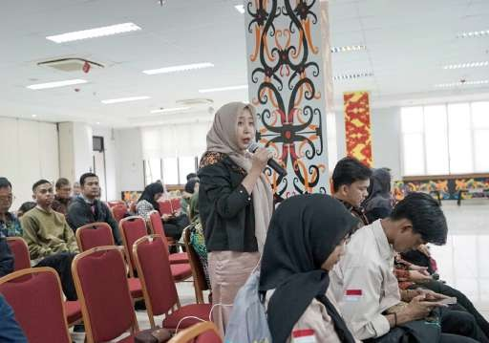
If addressed effectively, these challenges will make One Data Kaltara more robust and impactful.

North Kalimantan’s story shows that, despite its 3T status, the province has moved quickly to build a solid data system. With clear regulations, institutional backing, multi-stakeholder collaboration, and strong leadership commitment, One Data Kaltara has become a reality, not just a slogan.

One Data Kaltara can serve as an inspiration for other regions. The message is clear: evidence-
based development is achievable with commitment, cooperation, and a supportive system. Open and integrated data are not just numbers, but the foundation of more equitable, inclusive and sustainable development.

As the Kaltara Governor emphasised, data is not just for public servants. It is also for the public they serve: “Data is not only for government, but for everyone. With data, we can ensure development reaches all people, without exception.”


www.skala.or.id info@skala.or.id
Whatsapp Channel SKALA
SKALA Office
IFC Tower 2, Level 17
Jl. Jendral Sudirman Kav. 22-23 Jakarta 12920

