


Pemerintah Provinsi Aceh

STORY BOOKLET

Aceh’s One Data:
Paving the Way Towards Evidence-Based Governance

September 2025

In development, data is more than just numbers on a page. It provides the foundation for planning, implementing programs, and evaluating results objectively. Without accurate, up-to- date, and integrated data, planning is akin to guessing the direction of the wind. Policies that begin this way rarely land where they were intended: on the real needs of society, particularly vulnerable groups.

The Government of Indonesia has long recognised this. Presidential Regulation Number 39 of 2019 on One Data Indonesia (SDI – Satu Data Indonesia) was later strengthened by Regulation Number 5, 2024 from the Minister of Home Attairs (Kemendagri – Kementerian Dalam Negeri)on One Data for Domestic Governance (SDPDN – Satu Data Pemerintahan Dalam Negeri). These two regulations emphasise the importance of sound data governance, in which local governments not only use data but also produce and manage it.

Among Indonesia’s provinces, Aceh has emerged as one of the fastest to respond to implement SDI, through its provincial program One Data Aceh (SDA – Satu Data Aceh). Its status as a special region, with a unique and layered governance structure, is often seen as a challenge. Yet for Aceh, this complexity has become an opportunity to build a data system that is inclusive, transparent, and accountable.
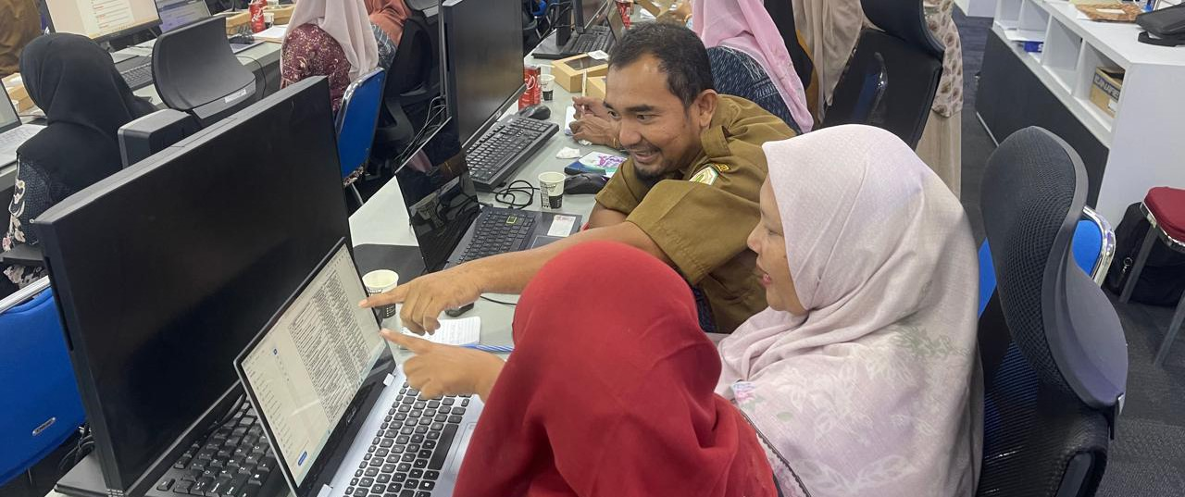
Before the implementation of SDI, Aceh faced the following common challenges:
- Information was scattered in inconsistent formats across ditterent Aceh Regional Government Work Units (SPKA – Satuan Kerja Perangkat Aceh).
- Most data were used internally and rarely published.
- Development planning often relied on partial data, making cross-sector coordination inefficient.
In addition, the capacity of statt managing data varied widely. Some SKPA had skilled IT statt and data analysts. Others lacked adequate infrastructure and understanding of SDI’s standards. As a result, the preparation of regional planning documents often took more time and was vulnerable to duplication.

These challenges spurred the Aceh Government to act more decisively. Aceh realised that to become a leading province, a major step was required: building a strong, comprehensive, and integrated data system.

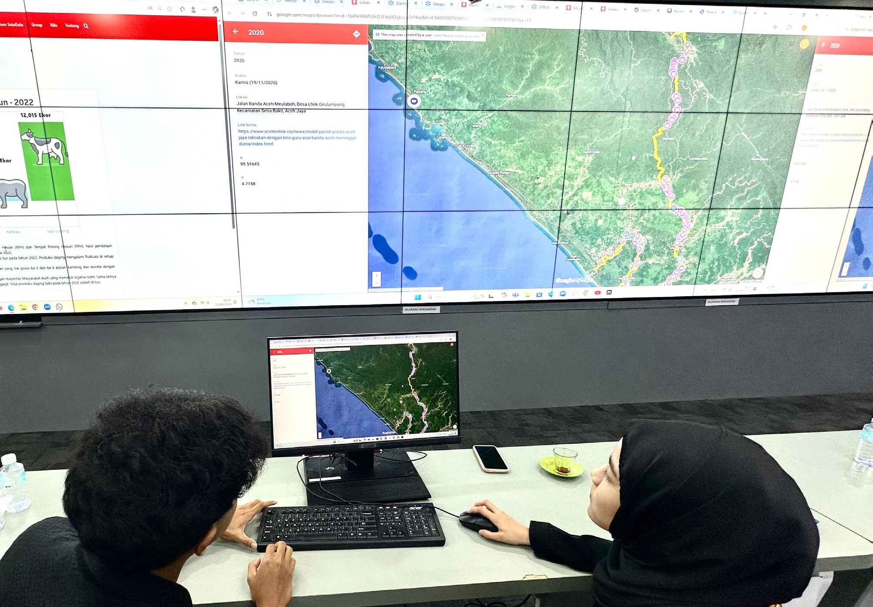
 Implementation and Innovation: The One Data Aceh (SDA) Portal
Through the Quick Wins program (Gercap – Gerak Cepat) of the Governor and Deputy Governor of Aceh for 2025–2029, SDA was designated as a flagship initiative. Far from being symbolic, its implementation has been supported by a clear institutional framework:

The Aceh Provincial Secretary coordinates SDA.

The Aceh Regional Development Planning Agency (Bappeda - Badan Perencanaan Pembangunan Daerah supports the One Data Forum (FDS – Forum Satu Data), facilitates coordinated data governance across SKPAs.

The Office of Communication, Informatics and Statistics of Aceh (Diskominsa
- Dinas Komunikasi, Informatika dan Statistik Aceh) functions as the primary data manager.
n
Statistics Indonesia – Aceh (BPS – Badan Pusat Statistik) Aceh is the sectoral data supervisor.
This structure demonstrates that data governance is not the responsibility of a single agency, but a collective ettort across institutions. Political commitment from regional leaders, supported by regulation, has given SDA a strong foundation.
A major milestone was the launch of the SDA Portal, available at https://satudata.acehprov. go.id This portal is not just a storage facility but an integrated digital platform that consolidates data from all SKPAs and regency and city governments.

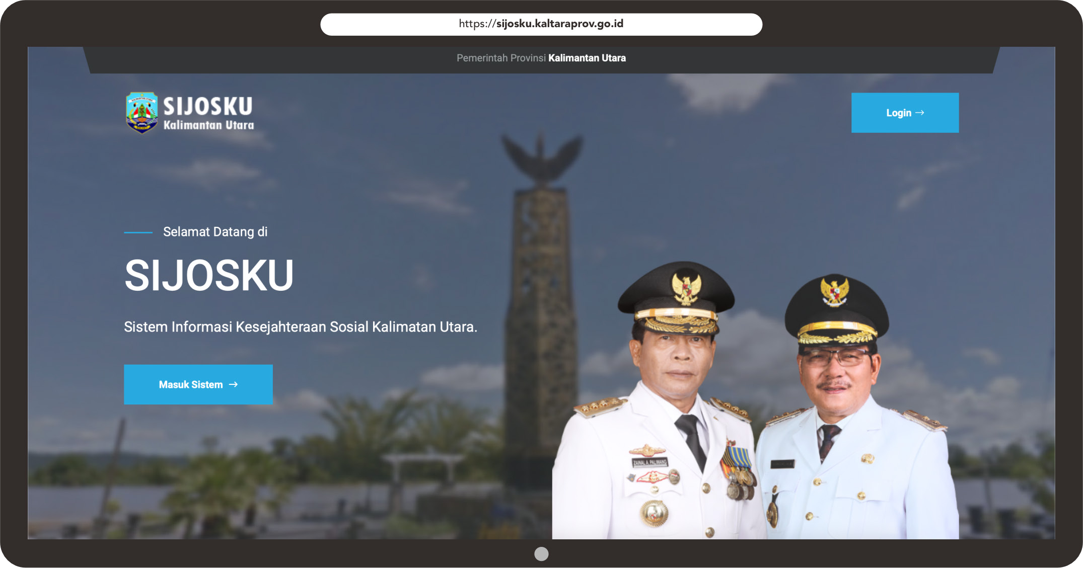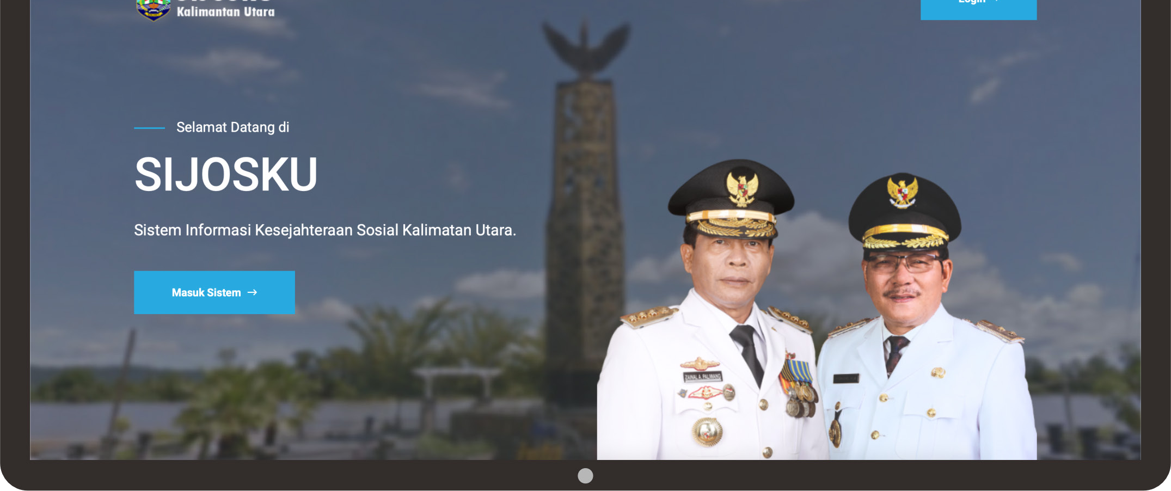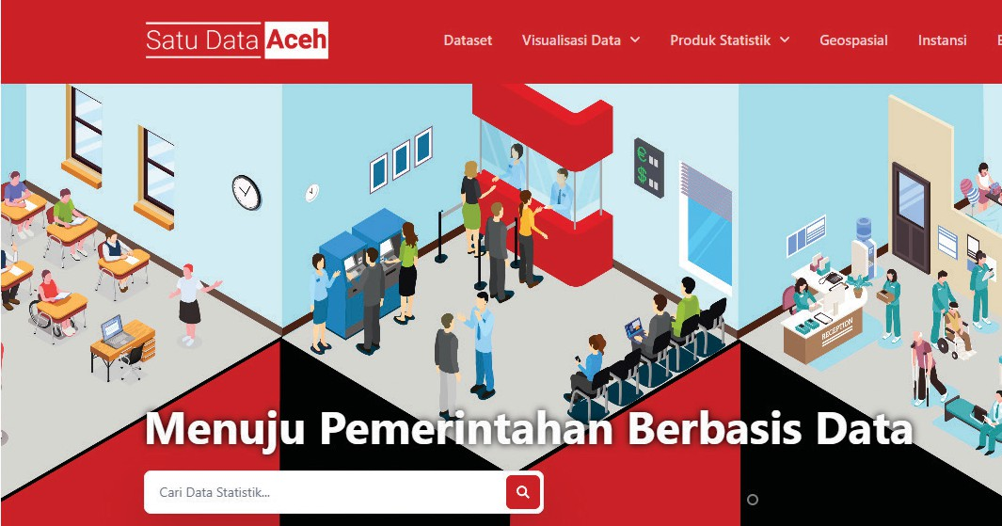
https://satudata.acehprov.go.id
The portal features a range of key functions, including:










An interactive dashboard to

monitor development indicators in real time.

Infographics and video graphics that present technical data in easily understood formats for the public.

An interactive spatial map displaying development data geographically.

Satu Data Aceh
Open datasets in formats suitable for both academic and practical analysis.

A data release calendar, demonstrating
transparency in publication schedules.

As of April 2025, the portal had compiled 10,841 datasets from the provincial and subprovincial levels. This figure places Aceh among the provinces with the highest number of datasets in Indonesia. The provincial government contributed 3,430 datasets, while Aceh Tamiang was recorded as the most progressive regency, with 1,700 datasets.
The launch of the portal has also attracted national attention. Bappenas recognised SDA as a model of best practice that could be replicated elsewhere, while Kemendagri commended Aceh’s commitment to strengthening data-driven planning.
Aceh’s success has also been reinforced by close collaboration with national and international partners. Bappenas ensures that Aceh’s data integration aligns with the National Medium- Term Development Plan (RPJMN – Rencana Pembangunan Jangka Menengah Nasional) and national development targets. Kemendagri safeguards regulatory consistency and encourages synchronisation with regencies and cities. SKALA, the Australia–Indonesia Partnership Program, has also provided technical support, regulatory strengthening, and capacity building. SKALA’s collaboration with partners in Aceh has been instrumental in accelerating the implementation of SDA.

Hannah Derwent, Counsellor for Human Development at the Australian Embassy, noted in one forum:
“This platform aligns with the national One Data Indonesia policy. The SKALA Program is proud to support this initiative, ensuring that development truly reaches all communities.”
In addition, the Aceh Government has established a partnership with Syiah Kuala University through an internship program for statistics students. This collaboration not only provides students with practical learning opportunities but also strengthens human resources within the SDA office, coordinated by Diskominsa. The presence of interns has helped accelerate data processing and verification and foster a generation of young people well-versed in modern data governance practices.

This collaboration has enabled Aceh to advance more rapidly than many other provinces.

Real Achievements on the Ground
Beyond the number of datasets, SDA has demonstrated tangible impacts on development planning:

Education: Data on school participation has informed scholarship policies and led to more even deployment of teachers.
;
Health: Data on stunting prevalence and the availability of facilities have guided more targeted nutrition interventions.

Village Level Development: Data on village potential and conditions have informed community empowerment programs.

The portal’s accessibility allows diverse groups, including academics, journalists, the private sector, and other communities, to easily access information. This transparency strengthens government accountability while increasing citizen participation in monitoring development.
At the launch of SDA, a specially produced video was screened, explaining how the portal works and highlighting the benefits for both government and society. The portal opens access to data that was previously limited, enabling more stakeholders to use it for research, planning, and policy advocacy.







Sinergi dan Kolaborasi untuk Akselerasi Layanan Dasar (SKALA) is an Australia-Indonesia Partnership Program aimed at supporting the Government of Indonesia’s efforts to reduce poverty and inequality by improving basic-service provisions to poor and vulnerable communities in less-developed regions.
CONTACT US
IFC Tower 2, Level 17
Jl. Jendral Sudirman Kav. 22-23 Jakarta 12G20
communications@skala.or.id
https://s.id/Channel-SKALA
SKALA.or.id

 Future Challenges
Although Aceh has become a frontrunner in implementing SDA, several challenges remain:
- Equal contributions from districts and municipalities: Some areas have yet to contribute datasets to their full potential.
- Ongoing updates: Existing data must be updated regularly to remain relevant.
- Human resource capacity: Further training is required to ensure data management standards are applied consistently across Aceh.
- Broader utilisation: Data must be applied more intensively in policy formulation and budgeting, not merely accumulated without use.
Aceh’s experience in building SDA otters valuable lessons. Three key takeaways can serve as guidance for other regions:
- Clear political commitment: Strong support from regional leadership is decisive.
- Robust institutional arrangements: A well-defined structure enables smoother cross-agency coordination.
- Multi-stakeholder collaboration: Support from central government, development partners, and civil society accelerates implementation.
Д
With more than 10,000 datasets now publicly available, Aceh has proven that data does not belong solely to the government. It belongs to everyone. SDA stands as a national example of how data-driven governance can strengthen public services, enhance transparency, and drive more equitable and inclusive development.
Aceh demonstrates that with commitment, collaboration, and innovation, the vision of evidence- based governance can be transformed into a lived reality – with policies guided by data rather than left to the winds of chance.

