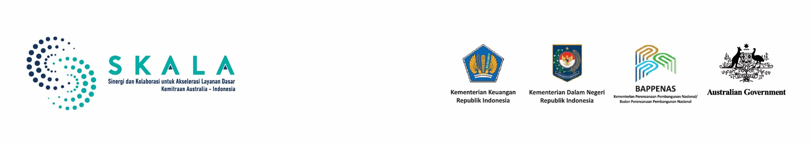

Lessons Learned

Data System Governance and Use for Inclusive Services:

Lessons from SEPAKAT and Regional One Data

July 2025

# Executive Summary

This document is for planners and decision makers at national and subnational levels, as well as development partners working to strengthen data governance and basic services. It draws lessons from the use of SEPAKAT (Integrated Planning and Poverty Analysis System) and the improvement of Regional One Data to support development planning and budgeting, particularly in meeting Minimum Service Standards.

Experiences from SKALA partner provinces show that improving system interoperability and matching socio-economic data can increase the accuracy of program targeting, optimise budget allocation, and strengthen community participation in planning processes. To support wider adoption of these practices, this document recommends four strategic steps: (1) strengthen cross-sector coordination across all levels of government; (2) improve technical capacity and data literacy; (3) introduce interoperability in phases and establish data-sharing systems; (4) incentivise regions that actively update their data.

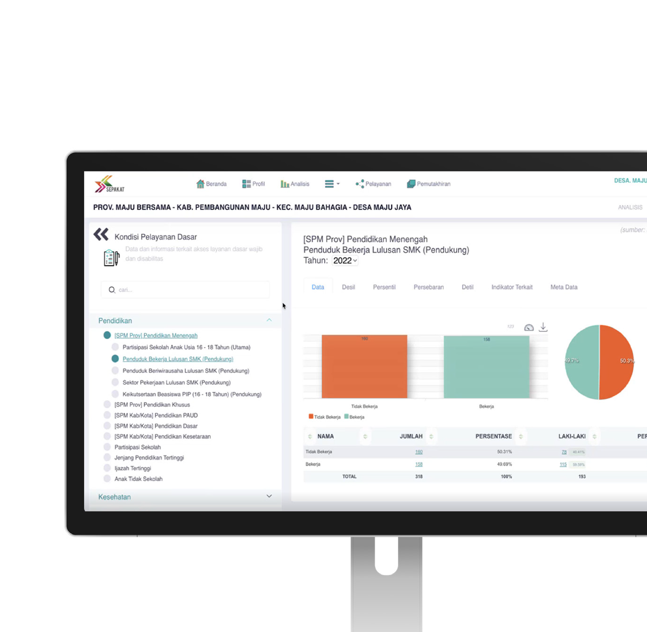

**1**

Lessons Learned - Data System Governance and Use for Inclusive Services: Lessons from SEPAKAT and Regional One Data

# SEPAKAT and Regsosek: Transforming Data Systems for Evidence-Based Policy

Indonesia is stepping up efforts to transform its development information systems as part of a broader push to close gaps in basic service delivery. This reflects the ongoing challenge that local government spending has yet to significantly improve service quality, particularly in education and health. One of the main challenges is the lack of reliable, accurate, up-to-date, and disaggregated data systems that can

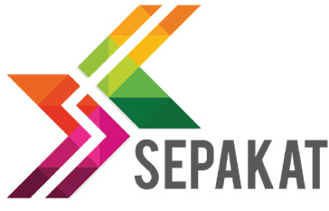

be used across sectors and levels of government. In response, the government introduced SEPAKAT as an analysis system and the Socio-Economic Registry (Regsosek) as a source of socio-economic data.

SEPAKAT is a system developed to help the government carry out socio-economic analysis as a foundation for evidence-based planning. It includes features such as decile and percentile calculations, along with metadata agreed across institutions. As of August 2025, SEPAKAT has been accessed by 35 out of 38 provinces and 187 out of 514 regencies and cities. It is used by governments at the national, provincial, regencies and village levels. The analysis in SEPAKAT uses various data sources, including Statistics Indonesia (National Socioeconomic Survey and National Labour Force Survey), Regsosek, INARISK, Dibi, and Dapodik. The system produces outputs on socio-economic conditions such as poverty, health, education, employment, housing, progress toward Minimum Service Standards, gender-based development measures, and budget analysis. SEPAKAT is an important tool to ensure that basic services reach vulnerable groups.

The SEPAKAT application uses Regsosek data, a national dataset that covers more than 251 million people. The data is available at the level of individual names and addresses and includes disaggregated information by sex and age, as well as disability status, welfare level, and geographic location. Regsosek data can be accessed through SEPAKAT and is a primary source for microdata-based analysis to support planning and budgeting. SEPAKAT and Regsosek show how systems and data can support more accurate policies. The use of SEPAKAT and Regsosek is a good example of how multiple data sources can support the One Data agenda. The formal designation of Regsosek as the official socio- economic dataset was established through Presidential Instruction Number 4/2025 on the National Single Socio-Economic Data (DTSEN). This dataset is built on the Regsosek architecture and integrates other data systems such as the Unified Database for Social Welfare (DTKS), the Targeting Data for the Acceleration of Extreme Poverty Elimination (P3KE), and other identified sources. The use of SEPAKAT and Regsosek provides a foundation to improve system interoperability and ensure data is used meaningfully in development programs.



The SEPAKAT system has been under development since 2017 with support from DFAT through the KOMPAK program, and it was officially launched in May 2018.

The use of the Regsosek was introduced and integrated through SEPAKAT on June 20, 2024

# Strengthening Data Governance in Indonesia: Lessons from SKALA

Over the past two decades, Indonesia has made steady progress in strengthening its data governance systems, with longstanding support from the Australian Government. Through the SKALA Program, support focuses on strengthening policies and institutions for Regional One Data and improving system interoperability. This approach enables data from different sectors and systems to connect and be used to support planning and targeting of development priorities at the regional level. SKALA aims to create systemic impact at the subnational level by promoting the use of the One Data cycle. This helps ensure the availability and use of accurate, up-to-date, and disaggregated data as a basis for planning and budgeting, especially to achieve Minimum Service Standards. Key areas of support include:

* Expanding the use of socio-economic data, including Regsosek, and piloting mechanisms for community- and village-based data updating.
* Facilitating the integration and management of data systems which cover the entire cycle from analysis and planning to budgeting, monitoring, and evaluation.
* Strengthening the regulations and institutions that support Regional One Data, including reinforcing the Regional Secretariat’s role in leading cross-agency data coordination forums.

|  |  |  |  |
| --- | --- | --- | --- |
| **SKALA’s Support for Partner Provinces in Data Governance** | | | |
|  |  |  | Icon |
| **Technical capacity building and data literacy** | **Institutional coordination** | **Participatory data collection practices** | **System integration pilots** |
| Supporting local government agencies (OPD) and villages through training and mentoring, particularly  in using SEPAKAT for evidence-based planning documents such as Regional Government Work Plan (RKPD) and Regional Medium-Term Development Plan (RPJMD). | Facilitating the establishment of cross- agency technical teams and coordination forums to strengthen and sustain subnational data  governance mechanisms. | Promoting bottom-up data collection by integrating inputs from village development planning forum (Musyawarah Desa) into SEPAKAT and the Village Information System (SID). | Testing and refining system interoperability between SEPAKAT, SIPD, and SID in  Papua, Aceh, and Gorontalo, to improve data use for targeting and planning. |
| **Best Practices** | | | |
| **Nusa Tenggara Timur** | | **Gorontalo** | |
| **Initiative** | **Results** | **Initiative** | **Results** |
| Data matching from Regsosek, DTKS, and P3KE was used to identify  inaccuracies in the targeting of social assistance programs, including both inclusion and exclusion errors. | Based on improved data, the provincial government reallocated approximately AUD1 million to address stunting and extreme poverty. | Provincial and regency governments used SEPAKAT’s welfare decile data to inform budget allocations for a health insurance program. | The provincial government committed around AUD1.5 million, while regency governments contributed an additional AUD3.6 million to cover households in deciles 1 to 4 (the most socioeconomically vulnerable groups). |

**Lesson 1:**

Lessons Learned - Data System Governance and Use for Inclusive Services: Lessons from SEPAKAT and Regional One Data

**4**

# Interoperability Can Start with Specific Development

**Priorities**

Experience with the use of Regsosek through the SEPAKAT platform shows that data system interoperability can begin by focusing on specific cases. In several regions, data analysis has been directed toward preparing Medium-Term Development Plan (RPJMD) and Regional Government Work Plan (RKPD) documents, identifying poverty patterns, and mapping vulnerable groups based on welfare deciles and disability status. These activities rely on both micro and macro data and require systems that can analyse variables in a disaggregated way.

Local practices show how this approach works in the field. SEPAKAT processes disaggregated microdata from Regsosek and produces analysis based on welfare rankings. This helps governments target their interventions more accurately. In Jakarta, spatial coordinates from Regsosek were combined with data on slum areas to support program targeting. In West Nusa Tenggara, similar data was used to provide insights on populations and areas at risk of coastal flooding.

SEPAKAT brings together statistical data, sector data, and geospatial data shared across institutions to generate analysis used in various regional planning documents, such as RPJMD, RKPD, the Regional Action Plan for Persons with Disabilities, and the Action Plan for Minimum Service Standards. This type of analysis depends on agreed metadata across agencies, such as criteria for identifying uninhabitable housing based on physical elements like roof or floor type.

The key lesson is that interoperability does not require full system readiness from the start. It can be built step by step, beginning with clearly defined use cases and data that is already available and usable.

**Lesson 2:**

Lessons Learned - Data System Governance and Use for Inclusive Services: Lessons from SEPAKAT and Regional One Data

**5**

# Data Matching for Accurate Targeting of Basic Services

One of the key challenges in targeting poverty programs in Indonesia is the overlap between datasets used to identify beneficiaries. Currently, three datasets are used to support poverty reduction: Regsosek, DTKS and P3KE. Each of these is collected and processed using different methods. As a result, assessments of household or individual welfare levels may vary, and some households may not appear in any of the three datasets.

One approach to improve data quality and consistency is data matching. This process helps ensure the accuracy of the data used to support more precise targeting of programs. In East Nusa Tenggara Province, data matching based on national ID numbers was carried out across Regsosek, DTKS and P3KE. The results revealed inclusion and exclusion errors in the distribution of social assistance. These findings became the basis for the local government to adjust budget allocations for stunting reduction and extreme poverty programs. This case shows that data matching can improve the accuracy of policy design and the effective allocation of public resources.

Despite this progress, several challenges remain:

* Variations in data quality at the local level, where many villages still rely on manual data or lack systems for regular updates
* Inconsistent definitions across systems. For instance, the criteria used to define poverty differ between datasets
* Limited analytical capacity at the local level, including the ability to identify indicators and data requirements

To help address these issues, SEPAKAT offers features that make it easier for local governments to identify their data needs and indicators, and to use available analysis or select analytical tools directly without having to run manual processes. For program targeting, SEPAKAT provides disaggregated microdata by welfare level to help government agencies direct programs such as health insurance, conditional cash transfers, or scholarships more accurately.

**Lesson 3:**

# Governance and Institutional Support Are Key to Sustainable Data Systems

Without strong institutional foundations, efforts to transform how data is used in planning and budgeting are unlikely to last. Although many digital systems are well designed by governments, they often fall out of use. This highlights the absence of systematic data governance in day-to-day public administration.

Presidential Regulation Number 39/2019 on Satu Data Indonesia and Ministry of Home Affairs Regulation Number 5/2024 on Regional Data Governance (SDPDN) provide the policy and institutional framework for data governance. However, implementation at the regional level still depends on local capacity and commitment. The Regional Secretary, as the Coordinator for Regional One Data, plays a central role in bringing together government offices and guiding cross-sector data updating policies. In regions where the Regional Secretary is actively involved, data governance has shown significant progress.

SKALA’s experience shows that institutionalisation is most effective when supported by three key elements:

* A formal structure that includes the One Data Forum (across offices), Main Data Authorities, Supporting Data Authorities, Data Producers, and Data Supervisors
* Standard operating procedures (SOPs) that define the process and mechanisms for the data cycle, including updating and verification
* Village-level forums where communities can validate data and participate in data building

A functioning data cycle, supported by strong institutions for Regional One Data, produces accurate, timely, and valid disaggregated data. When combined with a reliable analysis system such as SEPAKAT, both the data and the results can be used directly to support the preparation of planning documents.

Involving the community during data collection or data updating at the village level also improves the accuracy and validity of socio-economic data. This approach creates a data cycle that is not only technical but also socio-political, in which communities participate in decision-making based on data.

# Conclusion and Recommendations

The introduction of SEPAKAT and Regsosek creates new possibilities for the meaningful use of data in development planning and budgeting. However, experiences from various regions show that success depends heavily on institutional collaboration, local capacity building, and a consistent data cycle. Based on these lessons, four strategic recommendations are proposed:

## Strengthen coordination across sectors and levels of government, especially among those responsible for managing Regional One Data

**1.**

This includes aligning policies across ministries and agencies to establish a clear foundation for local government efforts.

## Improve technical capacity and data literacy at the local level

**2.**

This involves developing technical training, practice-based learning modules, and regional knowledge centres to support continuous learning.

## Introduce interoperability in phases

**3.**

Encourage data sharing across systems and promote the use of data in planning and budgeting for programs that target poor and vulnerable groups.

## Incentivise regions that update and share their data

**4.**

Incentives may include additional funding, national recognition, or continued technical assistance.

With strong data governance and connected information systems, Indonesia has a real opportunity to deliver more inclusive and effective policies, especially for communities that have long been underserved.



**IFC Tower 2, Level 17**

**Jl. Jendral Sudirman Kav. 22-23 Jakarta 12920 skala.or.id** [**communications@skala.or.id**](mailto:communications@skala.or.id)

**WA Channel SKALA:**

**Website SKALA:**