POLICY BRIEF
Strengthening the Social Welfare Information System to Improve Services and Wellbeing for Vulnerable Groups in North Kalimantan

Ahmad Fadil Barkah Tallamma, S.E
North Kalimantan Social Affairs Office

September 2025

Executive Summary
CONTEXT: In North Kalimantan (Kaltara), inaccurate data on Individuals Requiring Social Welfare Services (PPKS – Pemerlu Pelayanan Keseįahteraan Sosial) remains a major obstacle to achieving social welfare program targets managed by the Kaltara Social Affairs Office (Dinsos – Dinas Sosial Provinsi Kalimantan Utara). Data from regencies and cities is often inaccurate or outdated, making it unsuitable for preparing the evidence-based policies necessary to improve the efficiency and effectiveness of government expenditure on Kaltara’s social welfare programs.

CHALLENGES: Key issues include the absence of clear guidelines regulating data collection standards and verification and validation procedures, limited human resources, and the inefficient use of the Social Welfare Information System (SIJOSKU – Sistem Informasi Keseįahteraan Sosial) as a data collection tool.

RECOMMENDATIONS: This policy brief proposes strengthening technology-based data governance to accelerate poverty reduction and address social inequality, including revising SIJOSKU’s regulations and coast-sharing rules, and integrating it with other government databases through real-time sharing tools.





Keywords: PPKS Data Collection, SIJOSKU, Data Validity

Introduction
Since 2020, Kaltara’s Dinsos has faced significant challenges in collecting PPKS data. Compilations of data from regencies and cities often reveal inconsistencies and inaccuracies. Excessively uniform data sets and outliers render the data unfit for in-depth analysis to support sound policymaking.

The absence of a comprehensive baseline of PPKS data, due to a lack of systematic data collection over the past five years, has created a critical information gap. As a result, regional development planning documents lack a strong empirical foundation. Consequently, social policies and programs have often been ineffective and inefficient in achieving their intended outcomes.

Table 1. Sample Numbers of PPKS, 2020-2024
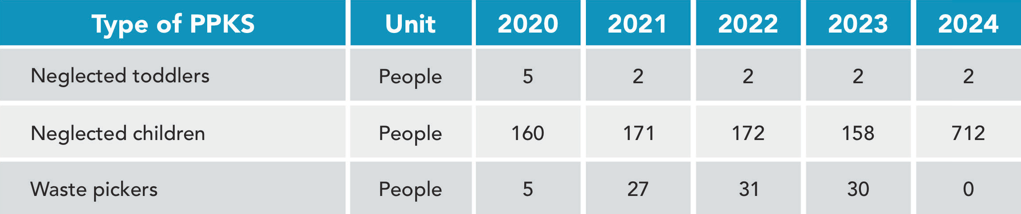
Source: Dinsos, processed by One Region One Data (SDD - Satu Data Daerah) North Kalimantan, 2025

Based on PPKS data compiled from the regencies and cities, irregularities and inaccuracies are evident. As shown in Table 1, the number of neglected children under five years of age from 2021 to 2024 did not change significantly. However, the number of neglected children in 2024 increased sharply from 158 to 712, while the number of waste pickers dropped drastically from 30 to
- These anomalies indicate that proper data validation and verification processes have yet to be applied.

Cross-agency data integration within the provincial government is also far from optimal. As illustrated in Graphs 1 and 2, inconsistencies are evident between data published by Dinsos and data from other regional government agencies.

Graph 1. Comparison of Data on Child Victims of Violence
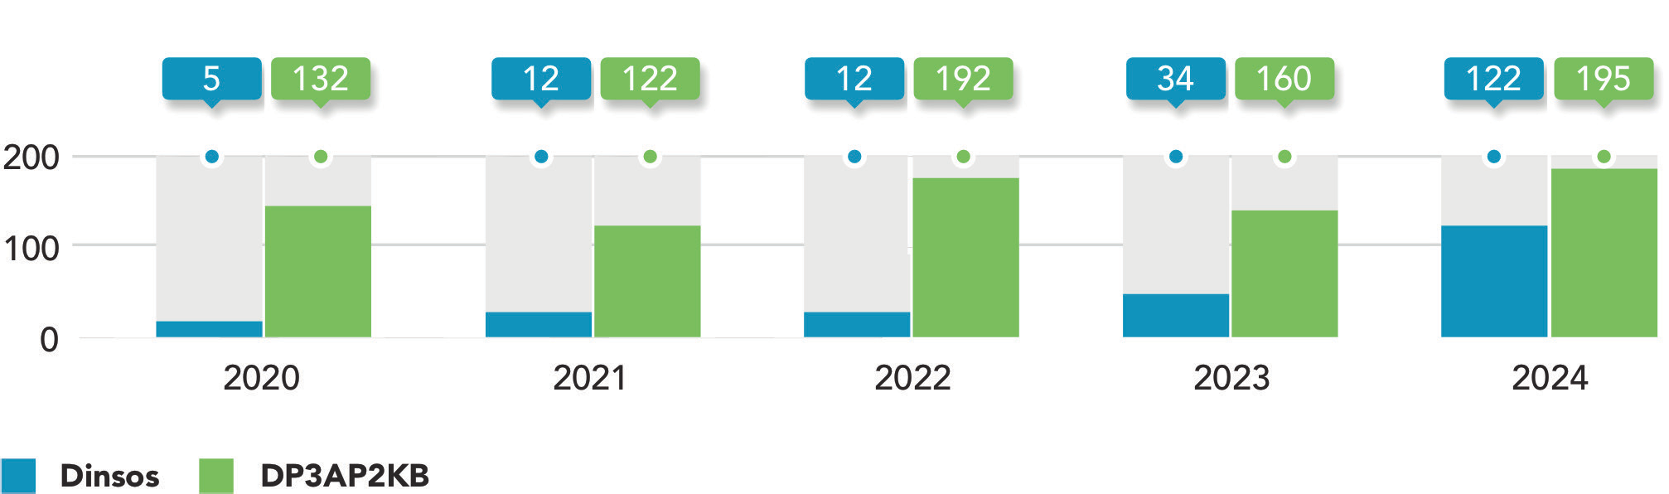
Source: Dinsos and Office of Women’s Empowerment, Child Protection, Population Control and Family Planning (DP3AP2KB - Dinas Pemberdayaan Perempuan, Perlindungan Anak, Pengendalian Penduduk dan Keluarga Berencana), processed by SDD, 2025

Graph 2. Comparison of Data on People Living with HIV/AIDS (ODHA - Orang Dengan HIV/AIDS)
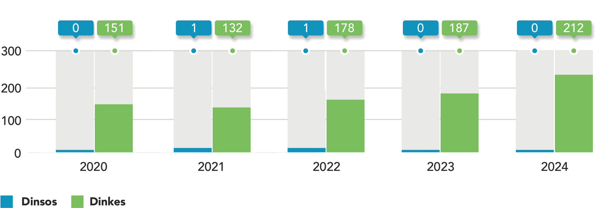
Source: Dinsos and the Health Office (Dinkes – Dinas Kesehatan), processed by SDD, 2025

To address these issues, in 2023, Dinos developed SIJOSKU, an online database containing information on poverty, PPKS, and Social Welfare Potentials and Resources (PSKS). However, the system still requires
further development, particularly regarding data updating, verification and validation, and interoperability with national and regional data systems.

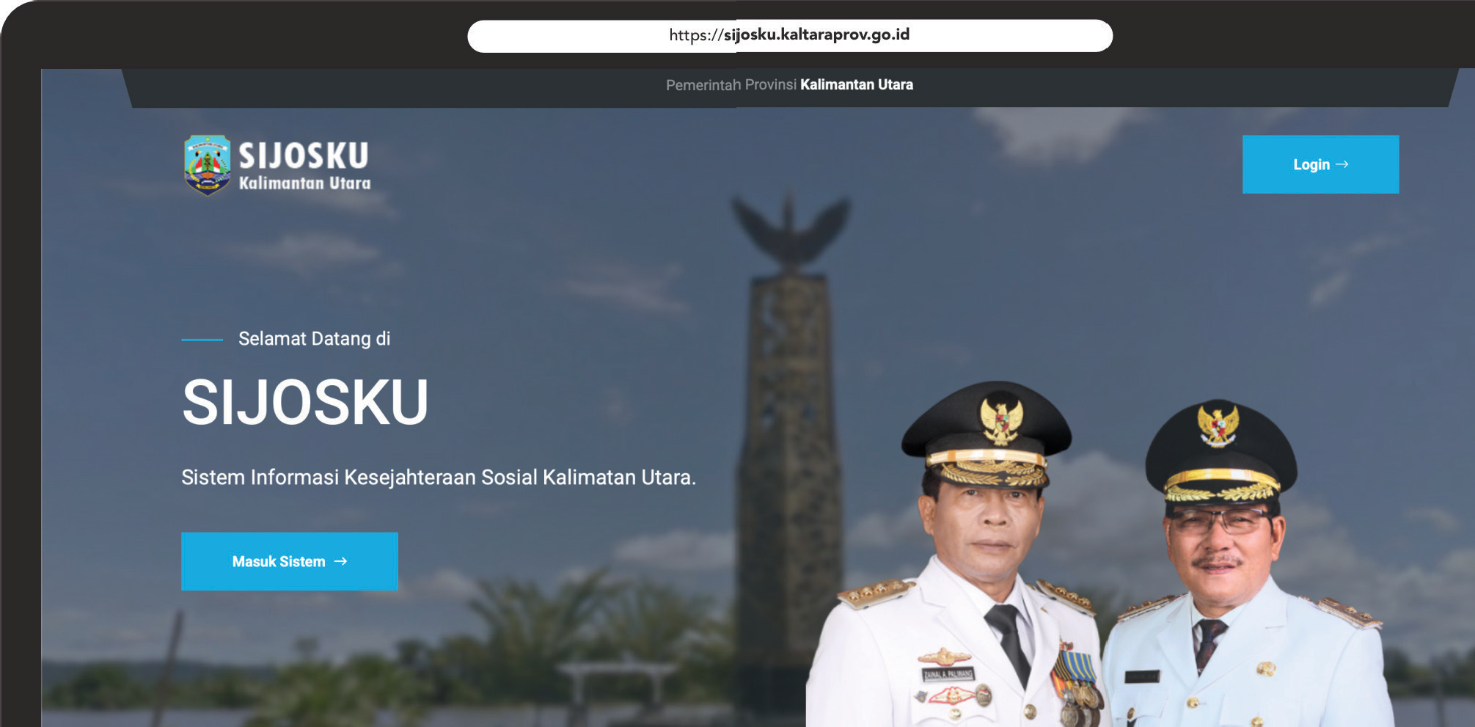

Problem Description
- The absence of unified guidelines regulating standards for data collection, verification, and validation, as well as the systematic updating of Kaltara’s PPKS data, including incentives for updating and using this data.
- Inadequate and insufficiently trained human resources within Dinsos to collect PPKS data accurately and effectively, resulting in flawed outcomes.
- Limited use of SIJOSKU as the primary tool for PPKS data management.
- Lower prioritisation of PPKS data collection within Dinsos programs.

Targeted Policies
  - Law No. 11 of 2009 on Social Welfare (Undang-Undang Keseįahteraan Sosial 2009).
  - Law No. 13 of 2011 on the Handling of the Poor (Undang-Undang Penanganan Fakir Miskin 2011).
  - Presidential Regulation No. 39 of 2019 on One Data Indonesia (Peraturan Presiden No. 39 Tahun 2019 tentang Satu Data Indonesia).
  - Minister of Social Affairs Regulation No. 8 of 2012 on Guidelines for the Collection of Data on Social Welfare Problems and Social Welfare Potentials and Resources (Peraturan Menteri Sosial No. 8 Tahun 2012).
  - Regulation of the Minister of Social Affairs No. 3 of 2021 on the Management of the Integrated Social Welfare Data (Peraturan Menteri Sosial No. 3 Tahun 2021).

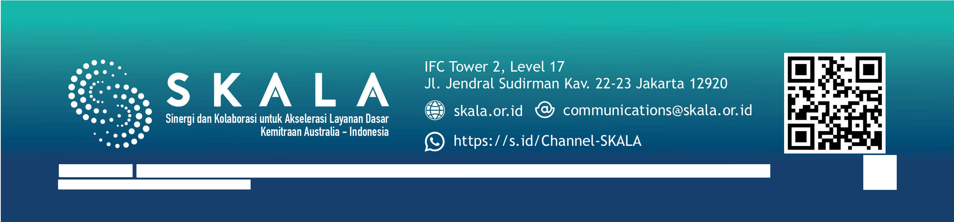


Policy Recommendations
4
Policy Brief |
Strengthening the Social Welfare Information System to Improve Services and Wellbeing for Vulnerable Groups
in North Kalimantan
Disclaimer: This policy brief was prepared by policy analysts and participants of a policy brief writing workshop, organised in collaboration with the Provincial Government of North Kalimantan, the Agency of Policy Development (BSKDN – Badan Strategi Kebiįakan Dalam Negeri) of the Ministry of Home Affairs, and the SKALA Program. The views expressed are those of the authors and do not necessarily represent the official positions of the organising institutions.
Policy Brief | Strengthening the Social Welfare Information System to Improve Services and Wellbeing for Vulnerable Groups in North Kalimanta

Data Governance
The Provincial Government of North Kalimantan, through Dinsos, should develop regional or Governor regulations that define the required PPKS data variables, operational guidelines, and the roles and availability of operators and analysts.

These regulations should also ensure interoperability between SIJOSKU and related data systems, set out incentives and disincentives for regency and city governments to use PPKS in SIJOSKU, and clarify cost- sharing responsibilities between provincial and regency and city governments to strengthen the system.

Data Collection, Verification, Validation, and Updating
The Provincial Government of North Kalimantan should establish uniform cross-regency-city guidelines and instruments for data collection, implement a tiered system of verification and validation at all levels of government with clear standard operating procedures, and carry out regular data updates on a quarterly or semi-annual basis. The government should also involve SDI in data verification and undertake annual reconciliation of PPKS data to ensure accuracy and consistency.

Enhancing the capacity of human resources for data management
The Provincial Government of North Kalimantan should strengthen the capacity of SIJOSKU operators by developing operational manuals and guidance modules, providing training at the regency and city levels with a focus on data input and verification, and offering incentives to support their performance.

Optimising the use of SIJOSKU
The Provincial Government of North Kalimantan should optimise SIJOSKU by establishing a dedicated management unit at the provincial level with clear structures and responsibilities, integrating it with the Civil Registry (Dukcapil – Kependudukan dan Catatan Sipil) for national ID synchronisation and with DTKS and regency and city databases, as well as developing an application programming interface to facilitate data exchange across government institutions.

