POLICY BRIEF

Illegal Alcohol and The Fulfilment of Minimum Service Standards

in Public Order and Community Protection in North Kalimantan

Sabathino H. Handoko, Rifaldi, dan Andi Rachmat H.
North Kalimantan Municipal Police Unit (Satpol PP – Satuan Polisi Pamong Praja)

September 2025

Executive Summary
CONTEXT: North Kalimantan (Kaltara) is facing serious challenges from rising public order, peace, and decency violations (K3 - Ketertiban, Ketentraman, dan Kesusilaan). These are largely driven by the circulation and misuse of illegal alcoholic beverages. Data from the Provincial Municipal Police Unit (Satpol PP – Satuan Polisi Pamong Praįa), processed by One Region One Data (SDD - Satu Data Daerah) in 2025, show a 7.2% increase in public order violations in 2024 compared with 2023. Beyond disrupting public order, this trend has also heightened the risk of crime and violence targeting women, children, and other vulnerable groups.

CHALLENGES: Alcohol-related violations in Kaltara persist due to weak supervision of local production, widespread illegal distribution, low public awareness, and poor cross-sector coordination. The absence of provincial regulation, weak reporting and monitoring systems, and a lack of regional rules on alcohol sales further constrain effective control.

RECOMMENDATIONS: This brief proposes several policy options to address alcohol-related challenges. These include socialising the health risks of alcohol consumption, optimising the role of Satpol PP, and evaluating and revising regional regulations on alcohol distribution. Strengthening regulations and their enforcement will help ensure the fulfilment of Minimum Service Standards (MSS – Standar Pelayanan Minimal) in public order, public peace, and community protection (Trantibumlinmas – Ketenteraman, Ketertiban Umum, dan Perlindungan Masyarakat).

Keywords: illegal alcohol, cross-sector synergy, minimum service standards

Background

Kaltara’s 2025–2045 Regional Long-Term Development Plan (RPJPD– Rencana Pembangunan Jangka Panįang Daerah) identifies reducing local and cross-border crime through enhanced security measures as a key policy
direction. Satpol PP is mandated to enforce regional regulations and head-of-region decrees to maintain Trantibumlinmas.






Policy Brief | Illegal Alcohol and The Fulfilment of Minimum Service Standards in Public Order and Community Protection in 1

Graph 1. Number of Public Order, Peace, and Decency (K3) Violations in North Kalimantan, 2022-2024
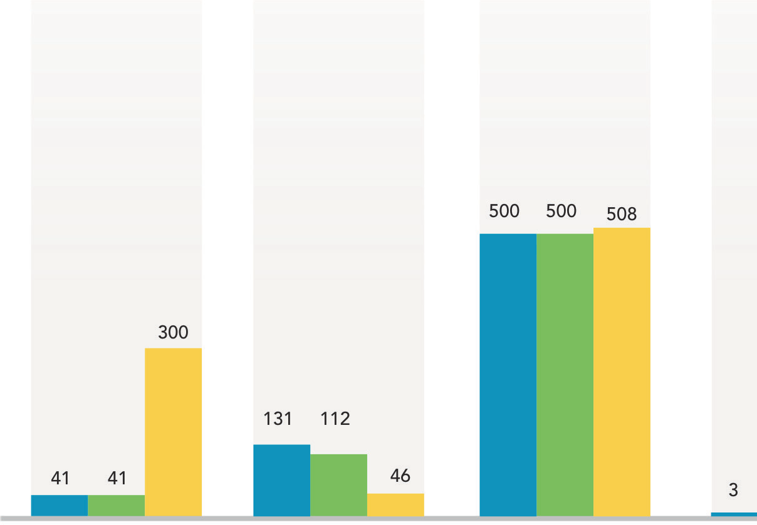
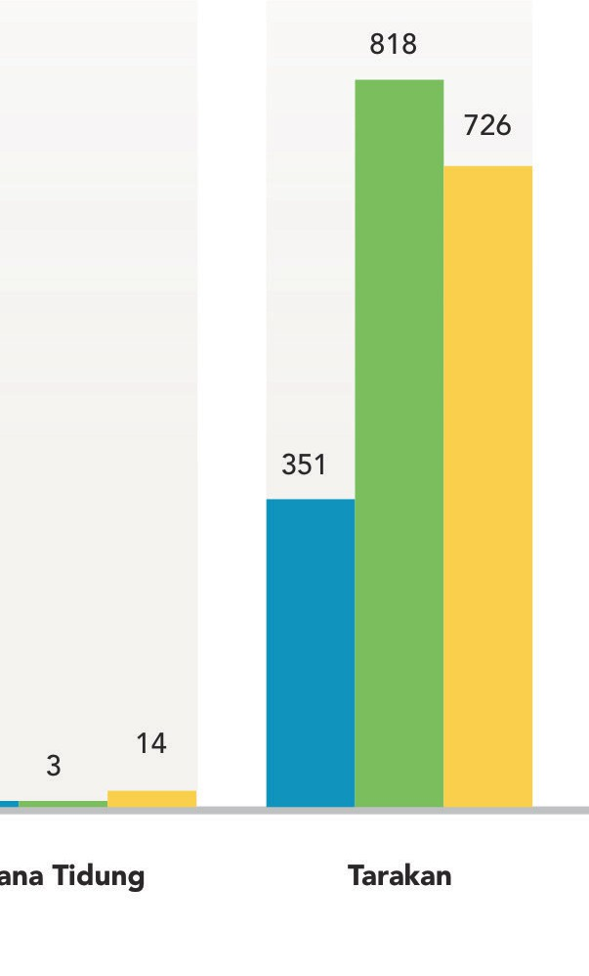
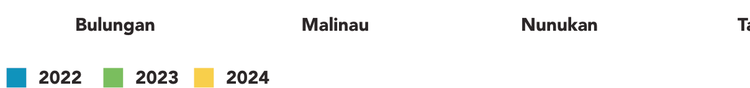
Source: Satu Data Daerah, North Kalimantan, 2025

As a border province, Kaltara frequently faces persistent
Tugas Pengamanan Perbatasan).1
Meanwhile, Kompas

challenges in maintaining public order and community reported a rape case in Malinau Regency on New Year’s

peace. A key factor is the growing circulation and
Eve that was linked to alcohol consumption.2
In March

consumption of illegal alcoholic beverages smuggled internationally through unofficial channels. Sporadic criminal incidents across the province have accompanied the increasing supply of illicit alcohol in the province.
2025, the Borneo News (Berita Borneo) highlighted the success of the North Kalimantan Police in securing 907 bottles and 51 cans of illegal alcohol during its Kayan 2025 Public Order Operation (Operasi Pekat Kaya) in

Bulungan and Tarakan.3 Alcohol-related criminal cases

In 2023, Kaltara recorded 1,474 K3 violations. This figure increased by 7.2 per cent in 2024, reaching 1,594 cases, as illustrated in Graph 1. The types of K3 violations handled by Satpol PP included immoral acts, unlicensed night entertainment venues, underage guests in hotels, and the circulation of illegal alcoholic beverages.

Law enforcement against alcohol users and drinkers in Kaltara remains suboptimal. In the first half of 2025, alcohol-related criminal cases were a major focus of local and national media reports. In January 2025, the local newspaper Tribun Kaltara reported the seizure of 96 cans of illegal alcohol originating from Malaysia in Nunukan by the Border Security Task Force (Satgas Pamtas - Satuan
resulting in fatalities also occurred in June 2025.4

These reports indirectly confirm findings from several studies demonstrating a correlation between alcohol consumption and aggressive behaviour, including acts of violence and criminality. Chermack and Taylor (1995) found that alcohol consumption increases physical aggression through both pharmacological effects and social expectations. Sontate et al. (2021) reviewed evidence linking alcohol use to heightened aggression and violence from public health and neuroscience perspectives. Meanwhile, Steele and Josephs (1990)
concluded that alcohol consumption significantly increases aggression levels through reduced self-control
and biased situational interpretation.

1 Tribunkaltara.com. (2025, January 18). Border Task Force Seizes 96 Cans of Illegal Alcohol from Malaysia in Nunukan Smuggling Route (96 kaleng miras ilegal asal Malaysia berhasil digagalkan Satgas Pamtas di Nunukan lewat įalan tikus). Tribunkaltara.com. Diakses dari https://kaltara. tribunnews.com/2025/01/18/96-kaleng-miras-ilegal-asal-malaysia-berhasil-digagalkan-satgas-pamtas-di-nunukan-lewat-jal Hyperlink ini tidak lagi berfungsi
2 Kompas.com. (2025, tikus 16). Police Arrest Teen Rape Suspect in Malinau After Drinking Party. (Polisi tangkap pelaku pemerkosaan remaįa di Malinau, berawal dari pesta miras). Kompas.com. https://regional.kompas.com/read/2025/01/16/160759378/polisi-tangkap-pelaku- pemerkosaan-remaja-di-malinau-berawal-dari-pesta
3 Berita Borneo. (2025, March 2). Polda Kaltara sita 907 botol miras dalam Operasi Pekat Kayan 2025. Berita Borneo. https://beritaborneo.com/ main/polda-kaltara-sita-907-botol-miras-dalam-operasi-pekat-kayan-2025/
4 Tribunkaltara.com. (2025, June 2). Man in Mangkupadi Village, Bulungan, Dies After Fight With Friend Following Drinking Session.(Gegara kelahi dengan rekannya usai minuman keras, pria di Desa Mangkupadi Bulungan meninggal dunia). Tribunkaltara.com. https://kaltara.tribunnews. com/2025/06/02/gegara-kelahi-dengan-rekannya-usai-minuman-keras-pria-di-desa-mangkupadi-bulungan-meninggal-dunia

Policy Brief | Illegal Alcohol and The Fulfilment of Minimum Service Standards in Public Order and Community Protection in 2

Alcohol consumption in society cannot be completely eradicated, but it can be controlled through regional regulations (Perda – Peraturan Daerah). Such regulations could restrict distribution, designate special sales zones, and regulate permissible alcohol content levels. With strict supervision, public education, and law enforcement, regional regulations would serve as an effective instrument for maintaining public order and social welfare while
recognising the reality of alcohol consumption in society.

Most Kaltara regencies and cities already have regional regulations governing the circulation of alcoholic beverages, as listed in Table 1. These regulations are crucial to enabling Satpol PP, particularly Civil Service Investigators (PPNS - Penyidik Pegawai Negeri Sipil), to enforce regional regulations in the community.

Table 1. Regional Regulations (Perda) Governing the Circulation of Alcoholic Beverages in North Kalimantan Province

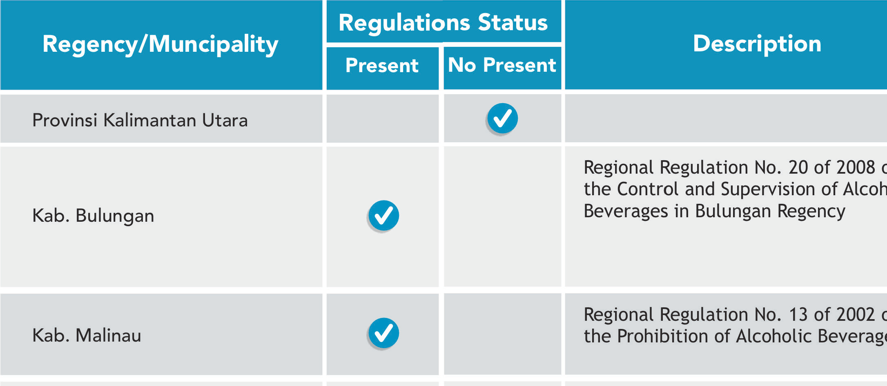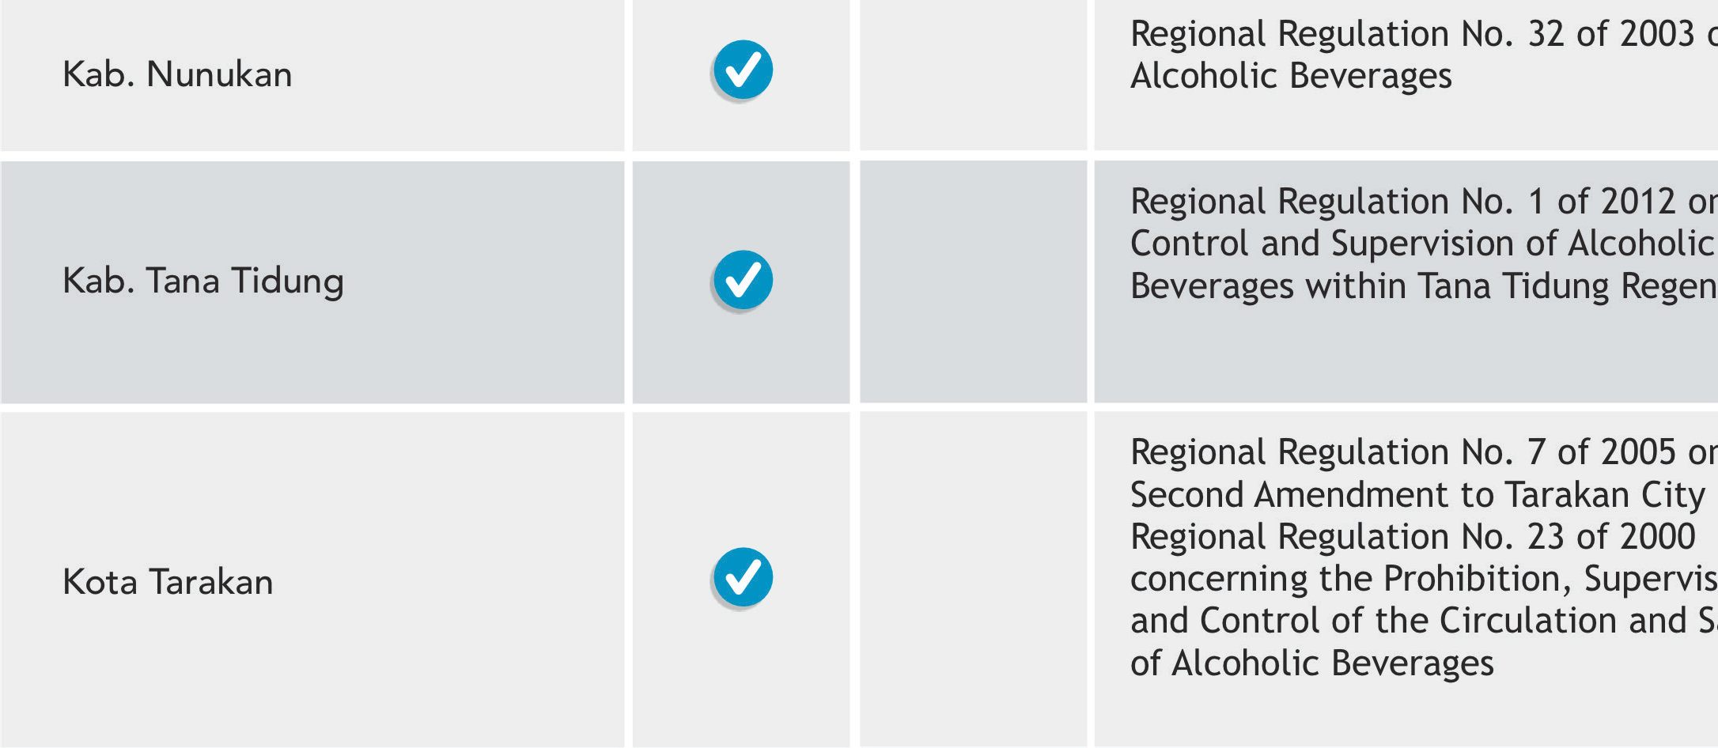

Problem Statement
Source: Processed data, 2025

- The long-standing culture of alcohol consumption within society cannot be eliminated but must be controlled.
- Supervision of locally produced alcohol remains limited, regulation is weak, and illegal distribution is widespread.
- Public education and awareness-raising about the harmful impacts of alcohol misuse remain inadequate.
- Cross-sector coordination between Satpol PP, the Police, the Health Office, and women’s and children’s protection agencies is weak in addressing alcohol-related issues.
- Provincial-level regulation on the control of alcohol circulation and misuse is absent.
- Reporting and monitoring systems, which are essential for achieving sustainable public order and comprehensive community protection, remain weak.
- egional regulation addressing the retribution of alcohol sales permits is lacking.

Policy Brief | Illegal Alcohol and The Fulfilment of Minimum Service Standards in Public Order and Community Protection in 3

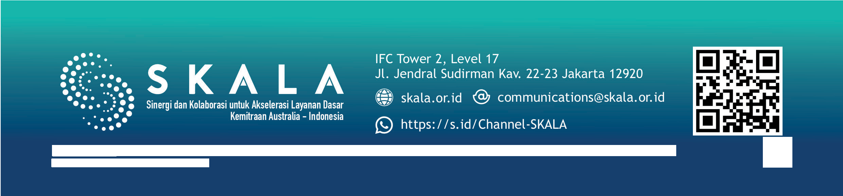


Targeted Policies
4
Policy Brief
Illegal Alcohol and The Fulfilment of Minimum Service Standards in Public Order and Community Protection in
North Kalimantan
Disclaimer: This policy brief was prepared by policy analysts and participants of a policy brief writing workshop, organised in collaboration with the Provincial Government of North Kalimantan, the Agency of Policy Development (BSKDN – Badan Strategi Kebiįakan Dalam Negeri) of the Ministry of Home Affairs, and the SKALA Program. The views expressed are those of the authors and do not necessarily represent the official positions of the organising institutions.
Policy Brief | Illegal Alcohol and The Fulfilment of Minimum Service Standards in Public Order and Community Protection in North Kalimanta
- Law No. 23 of 2014 on Regional Government.
- Government Regulation No. 16 of 2018 on Satpol PP, which provides the operational framework and service standards for public order enforcement.
- North Kalimantan Provincial Regulation No. 8 of 2019 on the implementation of public order, peace, and community protection

Policy Recommendations

Public Education and Awareness
District Education Offices (Disdik - Dinas Pendidikan Kabupaten), in collaboration with educational and religious institutions, should disseminate information on the harmful effects of alcohol on health, public order, and security to increase awareness and promote behavioural change.

Enforcement and Supervision
The Social Affairs Office (Dinsos – Dinas Sosial), Satpol PP, and the Police should play an active role in supervising distribution and enforcing laws against alcohol violations, including controlling alcohol circulation and managing permit fees for alcohol sales in supermarkets.

Collaboration and Community Engagement
The provincial government should encourage collaboration between the local government, the police, and community leaders to create an environment free from illegal alcohol circulation.

Evaluation of Regulations
The provincial government, through its coordination, guidance, and supervision functions (Korbinwas - Koordinasi, Pembinaan, dan Pengawasan), should evaluate and revise regional regulations in regencies and cities on alcohol distribution to strengthen prevention and enforcement.

Public Awareness and Complaints Mechanism
Satpol PP should raise awareness through social media and establish a call centre to accommodate public complaints related to order, comfort, and public decency.

Youth Engagement
The provincial government should appoint Youth Ambassadors against Smoking, Alcohol, and Narcotics, led by the Office of Women’s Empowerment, Child Protection, Population Control, and Family Planning (DPPPAPPKB – Dinas Pemberdayaan Perempuan, Perlindungan Anak, Pengendalian Penduduk dan Keluarga Berencana), the Office of Education and Culture (Disdikbud – Dinas Pendidikan dan Kebudayaan), the Health Office (Dinkes – Dinas Kesehatan) and Satpol PP.

