POLICY BRIEF

Promoting More Effective Slum Area Management Strategies in North Kalimantan Province
Hendri Fauzi, ST; Desy Trisna Dharmayanti, SE; Fauzan Azhari, S. Si North Kalimantan Office of Public Works and Public Housing – Settlement and Housing Division

September 2025

Executive Summary
CONTEXT: In 2024, slum areas in North Kalimantan (Kaltara) covered approximately 750 hectares. Of this, the provincial government directly manages 9.38%, well short of the national target of 0%. This situation calls for stronger action from Kalatara policymakers in exercising the province’s authority to improve slum management and fulfil the national mandate.

CHALLENGES: Slum area management remains persistently low, constrained by limited budget allocations and the absence of socioeconomic impact assessments of slum growth under different economic and budget scenarios.
RECOMMENDATIONS: This brief proposes strengthening slum management through mapping the size and distribution of slum areas, identifying cross-sector budget allocations for basic services, and establishing a provincial coordinator for the design and strategy of slum management. Taken together, these measures will help Kaltara accelerate progress towards meeting the national target of eliminating slum areas by 2030.

Keywords: slum areas, economic growth, population growth, migrants

Background





According to Law No. 1 of 2011 on Housing and Settlement Areas and Law No. 23 of 2014 on Regional Government, responsibility for slum management is divided by area size: regency and city governments manage slum areas of less than 10 hectares, provincial governments manage 10–15 hectares, and the central government manages more than 15 hectares. The purpose of this framework is to enhance efficiency and effectiveness in housing and settlement development and to foster a decent, healthy, safe, and orderly living environment for citizens.

Economic growth strongly influences migration and the expansion of slum areas. In 2024, Kaltara’s economic growth was 4.57%, well below the national target of 8%.
Despite this modest growth, slum areas in the province had already reached 750 hectares, largely driven by inward migration. Alarmingly, although the province’s slum areas had not yet reached thousands of hectares, less than 10% of those under provincial authority had been addressed. This highlights the need for the provincial government to re-examine the effectiveness of its current strategies.

Kaltara’s slum management also requires a framework that anticipates the potential impacts of achieving the 8% national economic growth target, particularly increased migration, the spread of new settlements, and the expansion of slum areas.

Problem Statement
- Slum area management remains limited. Based on decrees issued by Kaltara’s regents and mayors, the total slum area in the province in 2025 was 756.27 hectares. Of that total area, slum settlements under the jurisdiction of the provincial government covered 101.35 hectares, yet the government has only addressed 9.38% of this area. Consequently, 90.62% of slum settlements still require accelerated efforts for improvement, as shown in Table 1.
Table 1. Slum Areas in North Kalimantan by Level of Authority
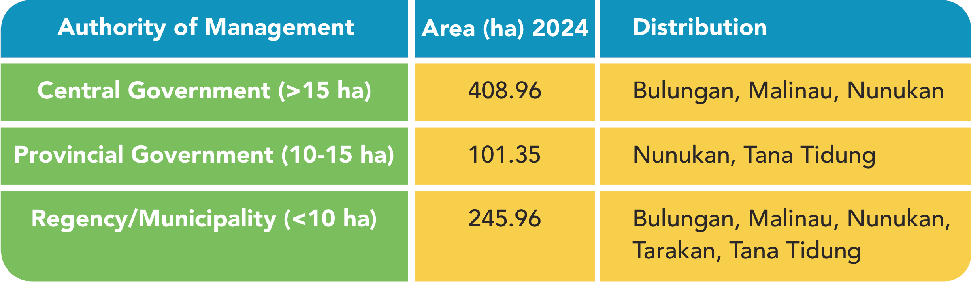
Source: Ministry of Public Works and Public Housing (PUP– Pekerįaan Umum dan Perumahan Rakyat), processed by Kaltara’s One Region One Data (SDD – Satu Data Daerah), 2025.
In 2022, Kaltara’s budget (APBD – Anggaran Pendapatan dan Belanįa Daerah) allocated IDR 1.2 billion, or 0.3% of the total budget, to slum area management. With that funding, only 3.3% of the total slum area under provincial authority was addressed. By 2024, the provincial government had allocated IDR 6.6 billion, or 0.9% of the provincial budget, to slum area management. As a result, coverage rose to 9.38%. These figures indicate a clear correlation between higher budget allocation and slum management coverage.

- No study has yet been conducted on the mitigation of the socioeconomic impacts of slum area growth based on economic growth scenarios and budget allocations. Even with economic growth not yet reaching 8%, Kaltara already faces net migration of up to 182,000 people, as detailed in Table 2. This figure is relatively high, representing 26.02% of the province’s total population of 699,725.

Targeted Policies
  - Law No. 1 of 2011 on Housing and Settlement Areas.
  - Law No. 23 of 2014 on Regional Government (Pemda – Pemerintah Daerah).
  - Government Regulation No. 14 of 2016 on the Implementation of Housing and Settlement Areas.
  - North Kalimantan Provincial Regulation No. 17 of 2019 on the Housing and Settlement Development Plan 2019– 2039 (RP3KP – Rencana Pembangunan dan Pengembangan Perumahan dan Kawasan Permukiman).

Policy Recommendations
The central government has set a medium-term target of reducing slum areas to 0%. Assuming the annual coverage of treated slum areas increases by 20%, Kaltara could potentially eliminate slums entirely by 2030. To achieve this, this policy brief makes the following recommendations:

1. Mapping and Estimation
The Provincial Government of North Kalimantan should map and estimate the size and distribution of slum areas under different economic growth scenarios of 6% and 8% at the regency-city level. In addition, the provincial government should assess the impact of rising migrant numbers and the budgetary needs for basic service infrastructure.




Cross-sector budgeting
3
Policy Brief |
Promoting More Effective Slum Area Management Strategies in North Kalimantan Province
Disclaimer: This policy brief was prepared by policy analysts and participants of a policy brief writing workshop, organised in collaboration with the Provincial Government of North Kalimantan, the Agency of Policy Development (BSKDN – Badan Strategi Kebiįakan Dalam Negeri) of the Ministry of Home Affairs, the National Institute of Public Administration (LAN – Lembaga Administrasi Negara), and the SKALA Program. The views expressed are those of the authors and do not necessarily represent the official positions of the organising institutions.
Policy Brief | Promoting More Effective Slum Area Management Strategies in North Kalimantan Province
The Provincial Government of North Kalimantan should map and assess cross-sector budget allocations for basic service providers that are directed towards communities living in slum areas. The aim would be to determine if there are significant gaps in cross-sector budgeting that constrain accelerated slum management. This work should also evaluate the current state of cross-sector and inter-agency collaboration and define the conditions needed to achieve systemic impact.

Private sector regulation
The Provincial Government of North Kalimantan should introduce regional regulations that set clear obligations and criteria for private companies and investors operating in the province, particularly in extractive industries such as coal mining. These regulations would help ensure that revenue from profit-sharing funds (DBH – Dana Bagi Hasil) derived from extractive activities is not used solely to address the industry’s negative impacts but instead supports accelerated development, improved welfare, and long-term benefits for local communities and regional development. In addition, the regulations would support interregional collaboration by defining roles, responsibilities and resources, including budgets.

Coordination and Leadership
The Regional Secretary of North Kalimantan should appoint a coordinator to oversee the development of a medium-term provincial strategy for slum area management. This strategy would clarify the division of roles across regional government agencies (OPD – Organisasi Perangkat Daerah) and accelerate the reduction of slum settlements.

