

# Aceh and East Nusa Tenggara Drive Inclusive Development Through Policies and Action Plans for Persons with Disabilities

August 2025

Indonesia’s Law No. 8 of 2016 on Persons with Disabilities was drafted to reflect the United Nations Convention on the Rights of Persons with Disabilities, ratified by Indonesia in 2011. To put the law into ettect, the government introduced Government Regulation No. 70 of 2019 on the Planning, Implementation, and Evaluation of Respect, Protection, and Fulfilment of the Rights of Persons with Disabilities. This regulation provides the foundation for the Rencana Aksi Daerah Penyandang Disabilitas (RAD PD), or Regional Action Plan for Persons with Disabilities, a strategic document that sets out clear goals and concrete actions to ensure disability rights are upheld across all major policy sectors, from education, health and social protection to transport and employment.

Realising inclusive policy at the regional level takes more than regulation and technical capacity. It demands a genuine commitment to creating space for voices that have long been marginalised. In this spirit, provincial governments have promoted the development and adoption of RAD PDs through participatory and data-driven approaches. SKALA – the Australia-Indonesia Partnership for Decentralisation and Basic Services – has supported this work by providing technical assistance, facilitating collaborative processes, and advocating for policy to ensure each region produces a RAD PD that is inclusive and responsive to real needs on the ground.

**2 Aceh and East Nusa Tenggara Drive Inclusive Development Through Policies and Action Plans for Persons with Disabilities**

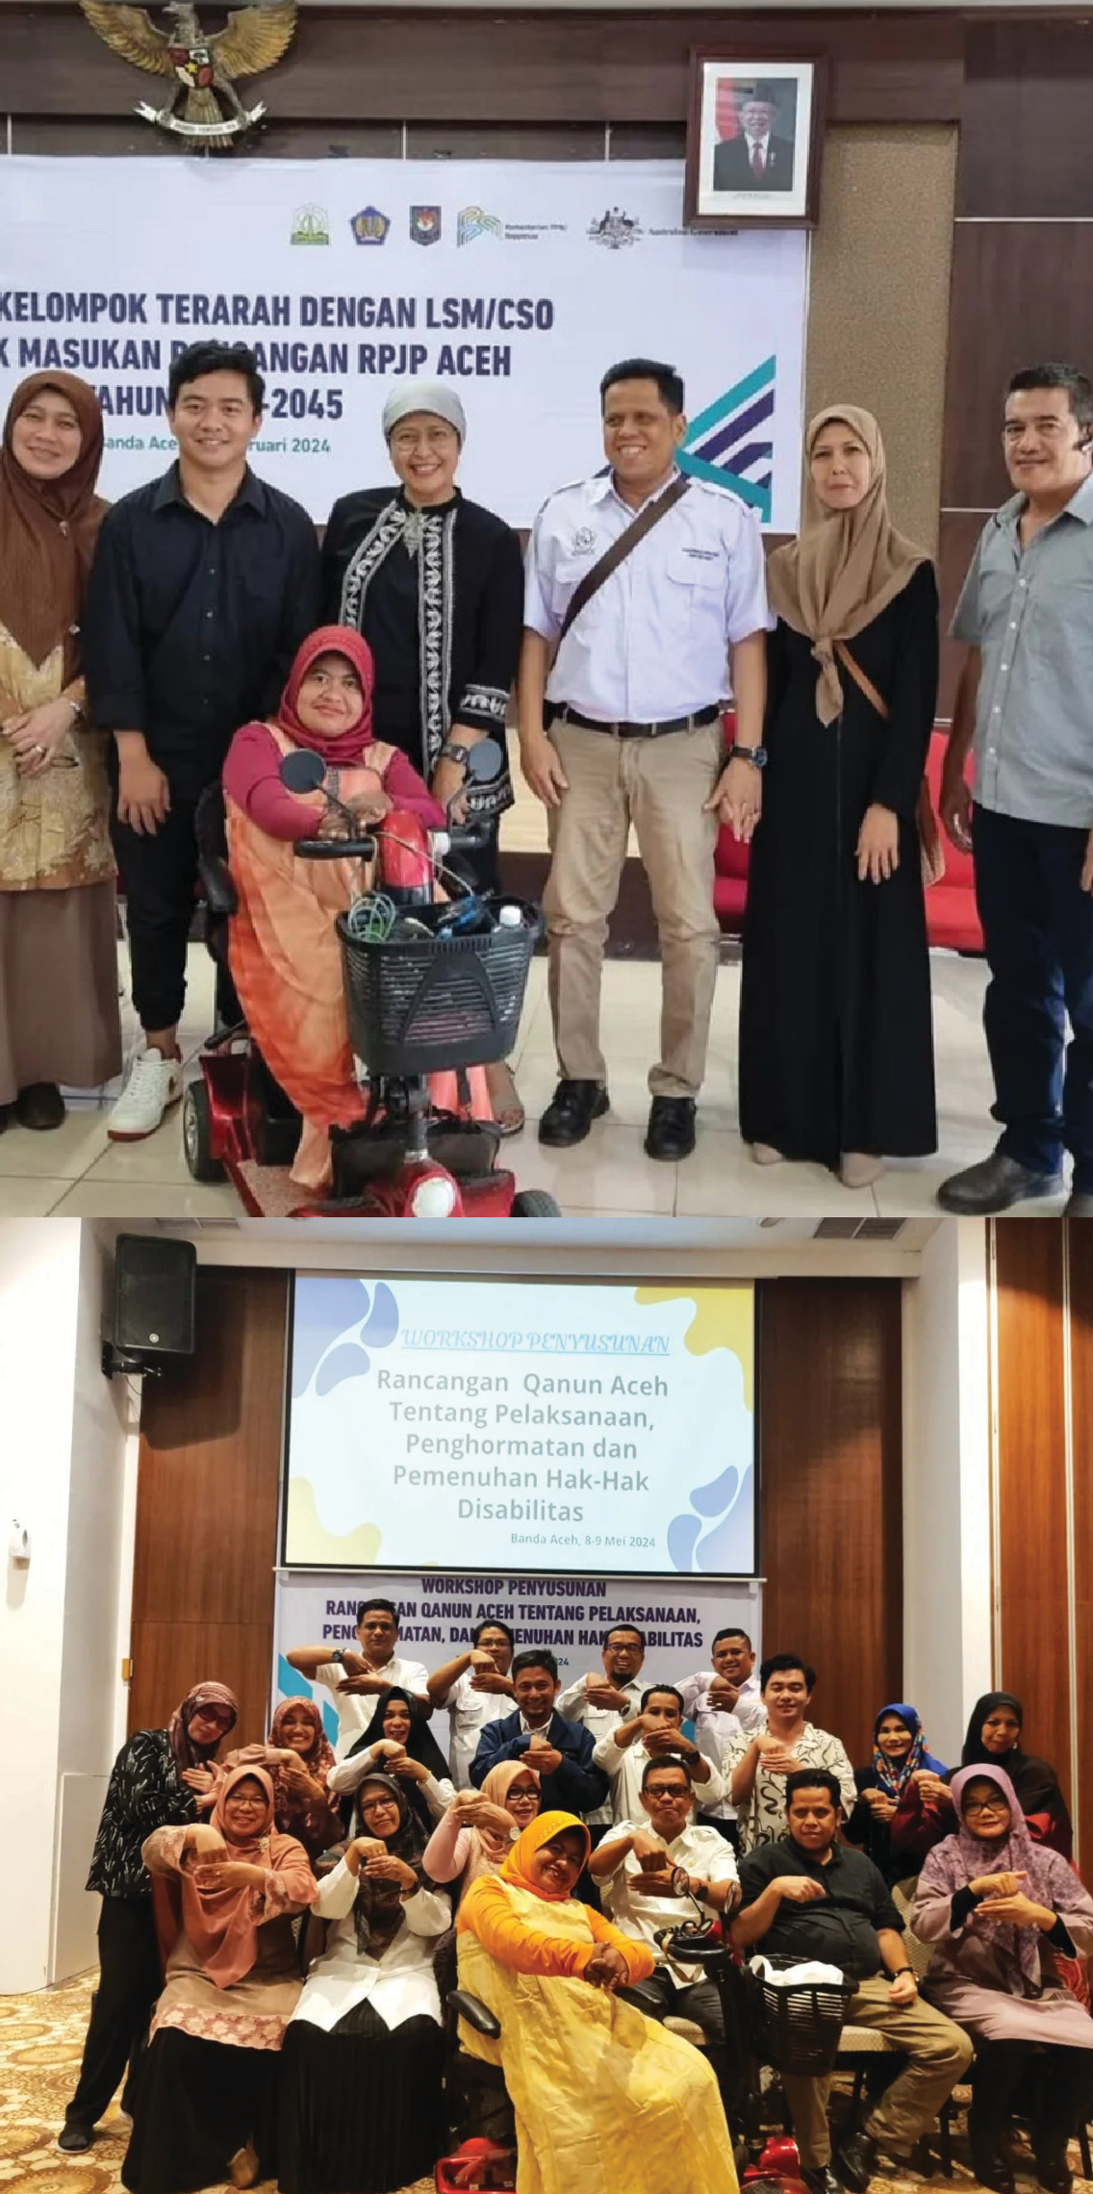

## The RAD PD Process in Aceh

The Province of Aceh began developing its RAD PD by forming a cross-sector working team coordinated by the Regional DevelopmentPlanningAgency(*BadanPerencanaanPembangunan Daerah* – Bappeda Aceh). This team brought together technical Regional Apparatus Organisations (*Organisasi Perangkat Daerah* – OPD), disability organisations, and development partners. Its first was to collect data on the needs of persons with disabilities through a participatory approach. SKALA supported the process from start to finish, providing technical assistance on data collection methods, conducting needs analysis, and ensuring alignment with Regulation 70’s seven strategic goals.

**Upaya Aceh dan NTT**

**Wujudkan Pembangunan Inklusif**

**Melalui Kebijakan dan Rencana Aksi Daerah Penyandang Disabilitas (RAD PD)**

“This process opened our eyes: statistical data alone is not enough. We needed to go into the field and hear directly from people with disabilities.”

**Rizka Mahfud** *(a representative from Bappeda Aceh)*

The data revealed that many persons with disabilities in Aceh lacked access to quality education, adequate health care services, and inclusive job opportunities. These findings became the foundation for a targeted and practical RAD PD.

Another key voice in the RAD PD process was Erlina Marlinda, a blind woman from Banda Aceh who joined consultation forums with Bappeda and the Social Attairs Office, supported by SKALA. “*In the past, we were only invited as participants. But in developing the RAD PD, we sat together as key contributors and co-creators of policy,”* Erlina said.

Following technical workshops, inter-OPD harmonisation, and public consultations, Aceh finalised its RAD PD document by the end of 2023. One of its key breakthroughs was integrating disability issues into the Regional Medium-Term Development Plan (RPJMD) and OPD Strategic Plans (Renstra), along with establishing measurable inclusivity indicators.

This process not only strengthened trust between the government and the disability community but also built a shared understanding of the importance of responsive planning that addresses the needs of all groups in society.

Bappeda Aceh has stated that the RAP PD will guide planning and budgeting through 2026. With SKALA’s support, the provincial government is also promoting the development of a monitoring and evaluation mechanism involving the disability community, ensuring the process continues beyond planning through to implementation. This initiative positions Aceh as a pioneer in inclusive and sustainable regional development.

**Aceh and East Nusa Tenggara Drive Inclusive Development Through 3**

**Policies and Action Plans for Persons with Disabilities**

## The RAD PD Process in East Nusa Tenggara (NTT)

Meanwhile, in eastern Indonesia, the Province of East Nusa Tenggara (NTT) has demonstrated an equally strong commitment. The formulation of RAD PD NTT began between 2020 and 2022, led by the Regional Development, Research, and Innovation Planning Agency (*Badan Perencanaan Pembangunan, Riset, dan Inovasi Daerah* – Bapperida NTT). This process involved collaboration with the Ministry of National Development Planning (Bappenas) and the Forum for Monitoring an Inclusive Indonesia for Persons with Disabilities (*Forum Pemantau untuk Indonesia Inklusif Disabilitas*–FORMASI Disabilitas), which included the local organisation Garamin NTT.

In 2023, the RAD PD process in NTT gained further momentum with support from SKALA and another Australia-Indonesia partnership, INKLUSI. A significant milestone was the organisation of a coaching clinic for RAD PD facilitators in August.

The clinic aimed to:

Strengthen facilitators’ capacity in drafting the RAD PD

Optimise the role of local government officials and stakeholders in ensuring the fulfilment of fundamental rights for persons with disabilities

Support inclusive regional development through active participation of the disability community

One of the driving forces behind the gender- responsive and inclusive RAD PD process is **Dinna Noach**, a woman with a disability who now serves as Special Statt to the Governor of NTT. “*I was never invited to participate in*

*development planning forums (Musrenbang), but since the RAD PD process, I’ve been able to voice the needs of our group directly,*” Dinna said.

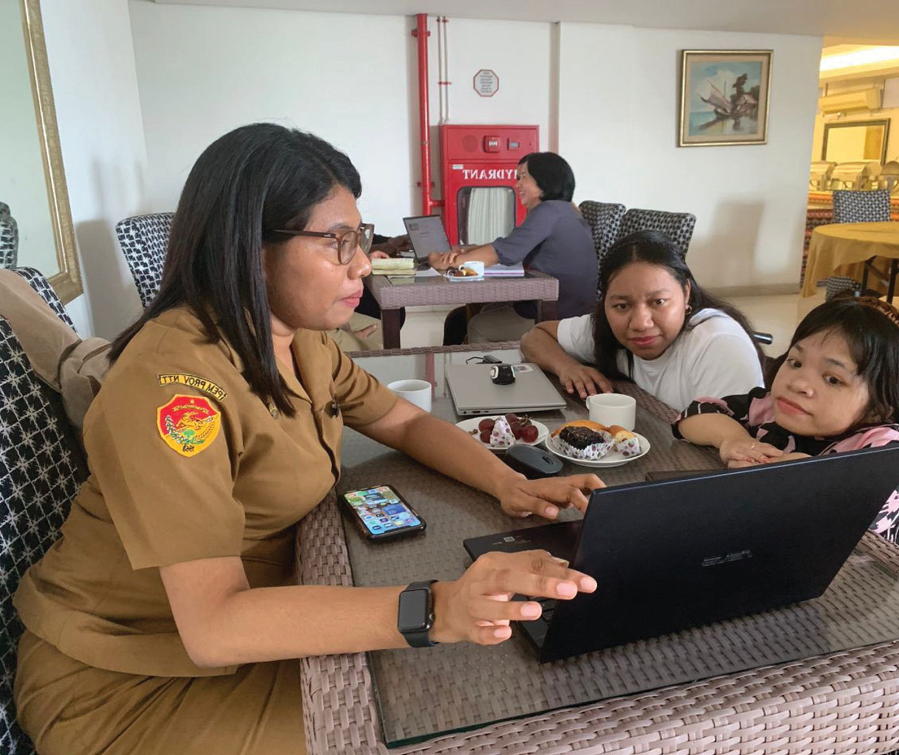

The training brought together 14 facilitators and featured experienced speakers from Bappenas, the Ministry of Home Attairs, and the Ministry of Finance. With SKALA’s facilitation, the NTT Provincial Government collected data from 22 districts and cities, as well as 21 disability organisations.

What set NTT’s process apart was the high level of civil society involvement, not only as contributors, but as policy co-creators. More than 20 disability organisations participated in every stage, from thematic discussions and public consultations to validation of the final RAD PD draft. SKALA also supported the development of disability organisation profiles, mapped sectoral regulations, and helped integrate the RAD PD into the regional development information system.

**4 Aceh and East Nusa Tenggara Drive Inclusive Development Through Policies and Action Plans for Persons with Disabilities**

The collaboration between the NTT Provincial Government, INKLUSI and SKALA culminated in a tangible achievement when, in October 2024, the Governor of NTT enacted Governor Regulation (Pergub) No. 4 of 2024 on the Regional Action Plan for Persons with Disabilities (RAD PD), outlining strategic actions for 2024–2026.

The Pergub is more than an administrative document. It serves as a strong legal foundation for budgeting and implementing tangible programs across multiple sectors. The NTT RAD PD has even gained national recognition and is being used as a reference by other provinces.

The NTT Government has also integrated the RAD PD into the Regional Government Information System (SIPD) and opened monitoring mechanisms through a digital platform. This marks a new chapter in local governance that is evidence-based, transparent, and respectful of its population’s diversity.

## Lessons from Aceh and NTT: Realising Inclusive Decentralisation

The experiences in Aceh and NTT show how national policies can achieve a major impact when implemented inclusively and with genuine participation at the local level. The development of RAD PDs in both provinces has yielded more than just documents. It has created space for dialogue between governments and persons with disabilities, a transformation worthy of recognition and replication.

**‘**

These processes have strengthened local government technical capacity while reinforcing democratic values that amplify the voices of vulnerable groups. The next challenge is to safeguard implementation, secure disability- sensitive budgeting, and build transparent monitoring systems that actively involve the disability community. With strong partnerships, the vision of an Inclusive Indonesia is no longer a distant dream, but a journey being steadily advanced through commitment and concrete action.

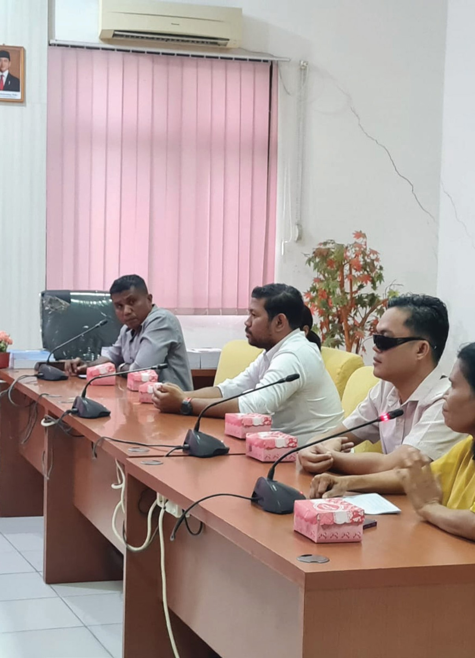

**‘**

*The experiences of Aceh*

*and East Nusa Tenggara demonstrate that the true success of a policy lies in its participatory implementation at the local level—engaging persons with disabilities from the planning stage through*

*to decision-making. This inclusive approach builds a shared commitment that extends beyond written*

*agreements, translating into tangible actions that advance inclusivity across all areas of development.*

Sinergi dan Kolaborasi untuk Akselerasi Layanan Dasar (SKALA) is an Australia-Indonesia Partnership Program aimed at supporting the Government of Indonesia’s efforts to reduce poverty and inequality by improving basic-service provisions to poor and vulnerable communities in less-developed regions.

**CONTACT US**

**IFC Tower 2, Level 17**

**Jl. Jendral Sudirman Kav. 22-23 Jakarta 12G20**

[**communications@skala.or.id**](mailto:communications@skala.or.id)

https://s.id/Channel-SKALA

**SKALA.or.id**