POLICY BRIEF

Enhancing The Competencies of Senior/Vocational High School and University Graduates in North Kalimantan

Riska Ayu Sylviani, Elvi Yanti, Hidayatul Laily
North Kalimantan Provincial Education and Culture Office

September 2025

Excecutive Summary
CONTEXT: Aligning the competencies of human resources developed by senior secondary schools, vocational high schools, and higher education institutions in North Kalimantan (Kaltara) with labour market needs is a strategic priority for the provincial government. This alignment is crucial given the persistent mismatch between the competencies of graduates and the needs of the business and industrial world (DUDI – Dunia Usaha dan Dunia Industri), which in turn affects the province’s open unemployment rate (TPT – Tingkat Pengangguran Terbuka).

CHALLENGES: Vocational curricula do not fully address workplace needs, and teachers and trainers have limited skills, knowledge and abilities.

RECOMMENDATIONS: This brief sets out policy recommendations such as revising curricula to better reflect workplace requirements, strengthening partnerships with DUDI, and piloting programmes that link education outcomes with labour market needs. These measures will help align human resource development with labour market demand, enhancing competitiveness, reducing poverty, and lowering unemployment in North Kalimantan.

Keywords: Satu Data Indonesia, planning documents, strengthening, human resources

Background





The success of efforts to improve the competencies of young people in Kaltara, particularly graduates from senior secondary schools, vocational high schools and universities, depends on several key factors (Ministry of Finance - Kementerian Keuangan, 2024). First, conducting studies or mapping labour market potential to identify opportunities for short- and medium-term employment. Second, aligning school and university curricula with the minimum knowledge and skills required by the workforce. And third, establishing strong relations between industry and education to create “link and
match” approaches. Such partnerships do not emerge automatically. The provincial government must take the lead in supporting initiatives to foster mutually beneficial collaboration between the private and education sectors. These partnerships should also encourage students to develop entrepreneurial skills, enabling them to innovate and create new jobs.

In line with the eight priority agendas, known as Asta Cita, set by the previous national government, strengthening human resources through quality education is key to

improving regional competitiveness, creating decent jobs, and reducing social inequality. Secondary education

Problem Statement
The curriculum implemented by vocational high schools (SMK – Sekolah Menengah Keįuruan) has not yet fully responded to technological developments and DUDI’s changing needs. In parallel, the senior high school (SMA– Sekolah Menengah Atas) curriculum requires adjustment to better prepare students for academic challenges at the
is likely to be the main driver of inclusive, equitable, and sustainable regional development.

university level, such as critical thinking, problem-solving, research, and information literacy. These curriculum gaps contribute to Kaltara’s relatively high open unemployment rate (TPT– Tingkat Pengangguran Terbuka) in Kaltara, as illustrated in Graphs 1 and 2.

Graph 1. Open Unemployment Rate (TPT) In North Kalimantan
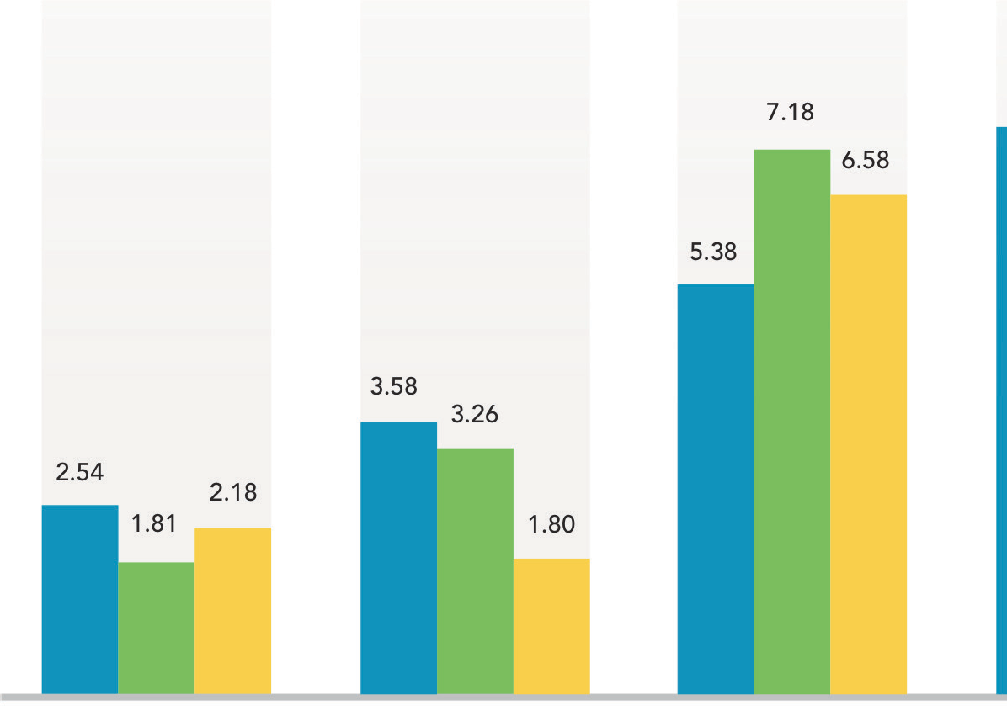
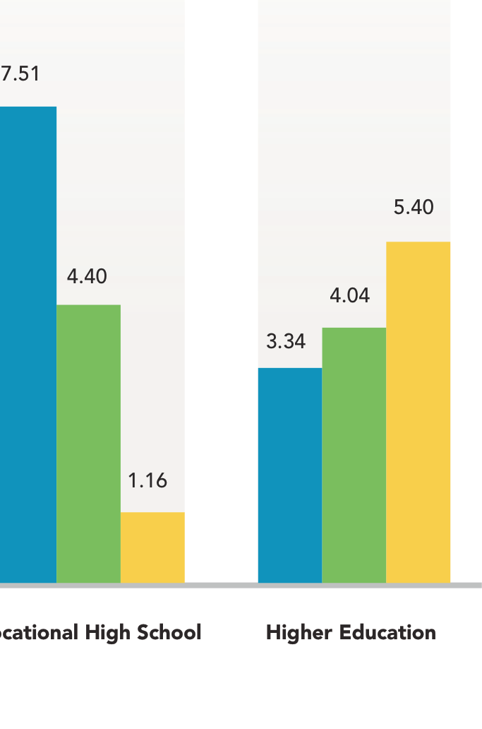

Source: Statistics Indonesia (BPS – Badan Pusat Statistik), 2025

Graph 2. Senior Secondary Graduates in Employment and Pursuing Higher Education
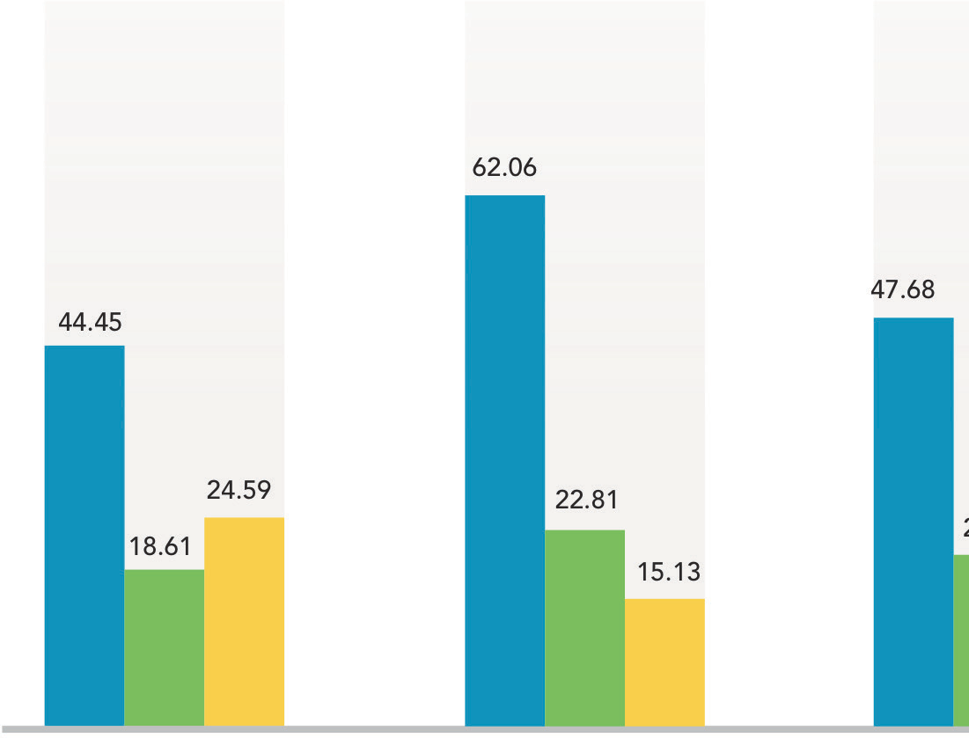
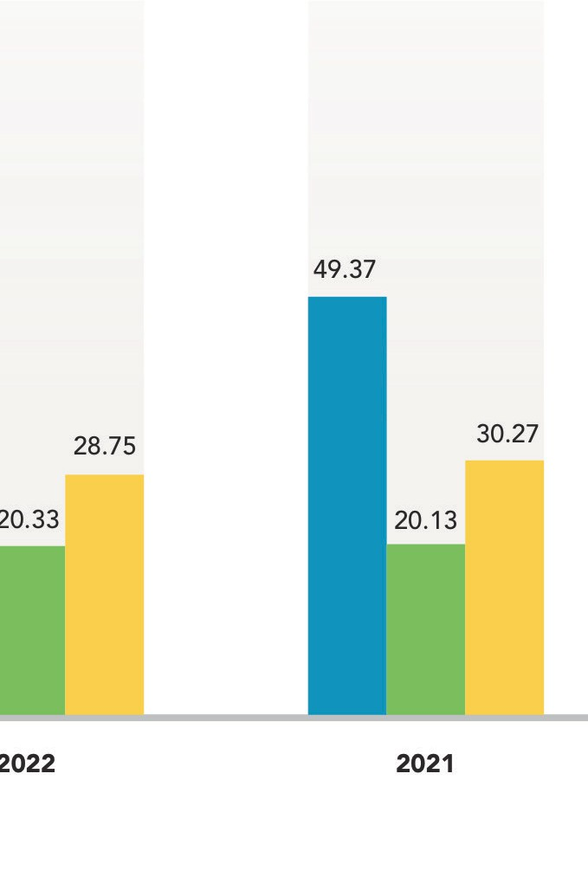

Source: BPS, 2025

The competencies of teachers and education personnel, particularly productive teachers in vocational high schools, do not yet fully align with the demands of the labour market. As a result, graduates’ competencies and practical skills remain limited due to the lack of high-
quality internship programs (Prakerin – Praktik Kerįa Industri). Consequently, the level of satisfaction among companies employing vocational high school graduates in North Kalimantan remains low, as shown in Graph 3.

Graph 3. Absorption Rate of Vocational High School Graduates and Employer Satisfaction
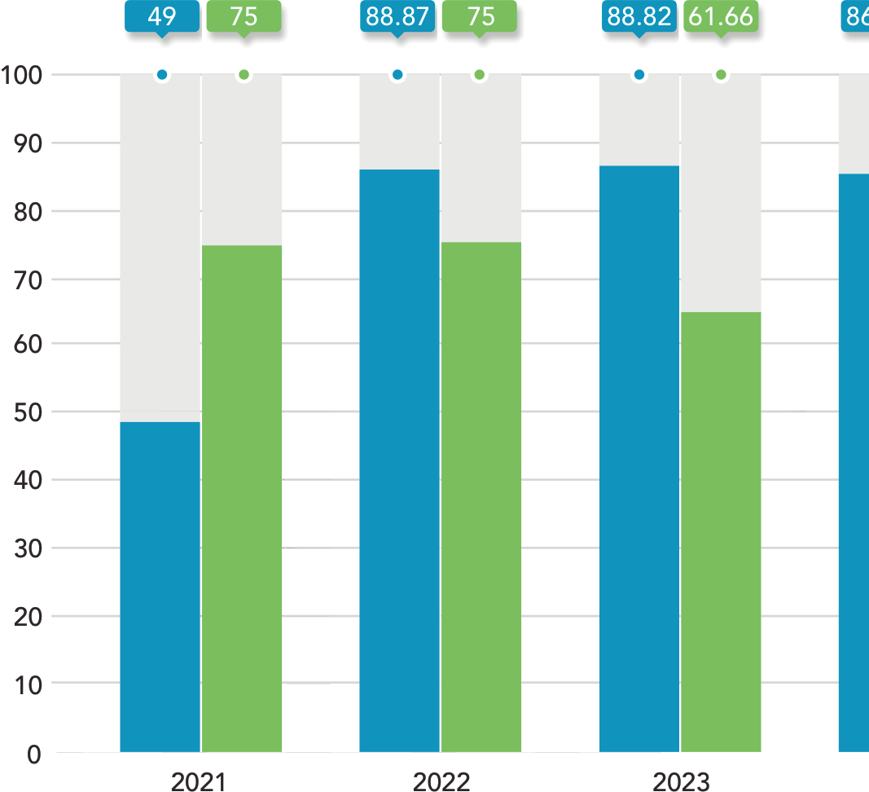



Source: North Kalimantan Provincial Department of Education and Culture (Disdikbud – Dinas Pendidikan dan Kebudayaan), processed by Kaltara’s One Region One Data (SDD – Satu Data Daerah), 2025.

Targeted Policies
- Provincial Regulation No. 6 of 2023 on the Provision of Education in North Kalimantan.
- Provincial Regulation No. 2 of 2016 on the 2016–2021 Regional Medium-Term Development Plan (RPJMD -
Rencana Pembangunan Jangka Menengah Daerah)) of North Kalimantan.
- Governor Regulation No. 2 of 2022 on the Regional Action Plan for Sustainable Development Goals (TPB - Tuįuan Pembangunan Berkelanįutan) in North Kalimantan.
- Coordinating Ministry for Human Development and Cultural Affairs Kemenko PMK – Kementerian Koordinator Bidang Pembangunan Manusia dan Kebudayaan) Regulation No. 6 of 2022 on the National Strategy for Vocational Education and Training.

Policy Recommendation
- Research and Mapping
The Provincial Government of North Kalimantan, together with the Regional Development Planning Agency (Bappeda – Badan Perencanaan Pembangunan Daerah) and other relevant institutions, should undertake research and mapping of key or influential actors within DUDI, including private companies, government institutions, and think tanks.

- Partnership Development
The Provincial Government of North Kalimantan should develop partnerships based on the identification of key actors, problems, and root causes. These partnerships could enhance investment opportunities and facilitate the recruitment of more SMK and university graduates in Kaltara. At the same time, stakeholders would share roles and resources through collaboration in education and investment sectors.

- Curriculum Design
The Provincial Education Office, along with other government institutions, should design curricula that incorporate input from the DUDI.




4
Policy Brief
Enhancing The Competencies of Senior/Vocational High School and University Graduates in North Kalimantan
Disclaimer: This policy brief was prepared by policy analysts and participants of a policy brief writing workshop, organised in collaboration with the Provincial Government of North Kalimantan, the Agency of Policy Development (BSKDN – Badan Strategi Kebiįakan Dalam Negeri) of the Ministry of Home Affairs, the National Institute of Public Administration (LAN – Lembaga Administrasi Negara), and the SKALA Program. The views expressed in this brief are those of the authors and do not necessarily represent the official positions of the organising institutions.
Policy Brief | Enhancing The Competencies of Senior/Vocational High School and University Graduates in North Kalimantan
- Piloting Initiatives
The Provincial Education Office should pilot training and education curricula. These pilots could begin with a limited group of beneficiaries, followed by outcome monitoring and scaling up collaboration between private companies and SMKs, as well as universities and training centres (BLK – Balai Latihan Kerįa). Collaboration between private companies and universities could include strengthening certification training curricula, setting company quotas for graduate recruitment, and providing universities with direct access to promote themselves to senior high schools (SMA) without burdening the regional budget (APBD).

- Ensuring sustainability
To ensure sustainability, the Provincial Government of North Kalimantan should implement regular evaluation and monitoring strategies. These evaluations would determine if a collaborating party is willing to expand the scope of cooperation or withdraw, should the partnership fail to make a significant contribution to company productivity and profit. A dedicated forum established by the provincial government would be necessary to advocate for the policies outlined in these five recommendations, as explained in Figure 1.
Figure 1. Strategy for the Development and Implementation of Secondary and Vocational High School Curricula in North Kalimantan
