Executive Summary
CONTEXT: The development of North Kalimantan’s (Kaltara) industrial zone, envisioned as a major driver of regional economic growth, faces a systemic risk: the rising incidence of HIV/AIDS, which threatens the sustainability of a healthy investment climate in the province. Epidemiological data show a steady increase in cases, from 151 in 2020 to 212 cases in 2024. Tarakan City, the province’s main industrial hub, accounted for the largest share with 118 cases.

CHALLENGES: Limited education and outreach, restricted access to health services, stigma and discrimination against people living with HIV/AIDS (PLHIV) and the absence of specific regulations.

RECOMMENDATIONS: This policy brief proposes the following actions to address these challenges. The Provincial Health Office (Dinkes – Dinas Kesehatan Provinsi Kalimantan Utara), in collaboration with ‘One Region One Data’ (SDD – Satu Data Daerah), recommends introducing regional regulations, expanding access to screening, counselling and treatment, and strengthening HIV/AIDS awareness and education in industrial areas and the wider community.
These efforts require collaboration among local government, the private sector and civil society networks. This strategic initiative is designed to maintain a resilient and conducive industrial ecosystem that supports sustainable economic growth.
Keywords: HIV/AIDS, transformation, investment attractiveness

Background





Kaltara is not immune to the risks of HIV/AIDS transmission. The burden this disease puts on public health may undermine the provincial government’s ability to achieve the vision set out in its 2025–2029 Regional Medium- Term Development Plan (RPJMD), which emphasises the need to build strong foundations for social and economic transformation.
POLICY BRIEF
Ensuring a Safe Work and Investment Environment in North Kalimantan in The Context of HIV/AIDS
Famas Noverley, SKM
North Kalimantan Provincial Health Office
September 2025

Kaltara’s industrial development is currently concentrated in Tarakan City, which hosts 22 companies, followed by Bulungan District with 12, Nunukan District with 11, and
Tana Tidung District with one. Investment from these 44 companies has supported economic growth, but it has also had negative impacts, most notably a surge in HIV/ AIDS cases.

According to 2025 SDD data, the number of people living with HIV/AIDS in Kaltara increased from 151 in 2020 to 212 in 2024. As shown in Figure 1, the highest concentration of cases is in Tarakan City, followed by Bulungan and Malinau.

Graph 1. The Trend of HIV/AIDS Patients 2020–2024
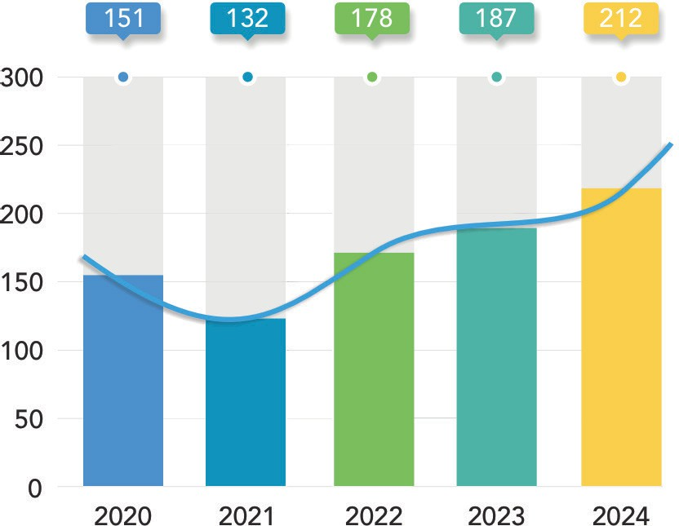
Source: North Kalimantan Provincial Health Office, compiled by SDS, North Kalimantan, 2025

Figure 1. Number of HIV/AIDS patients in North Kalimantan Province, 2020-2024
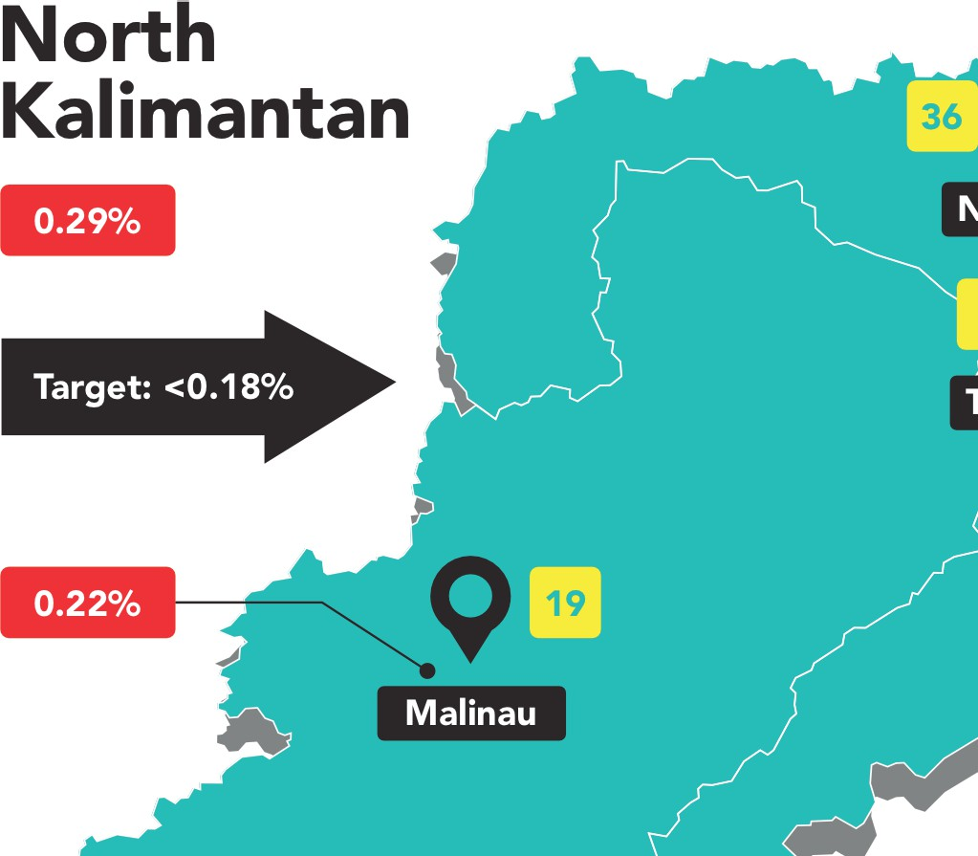
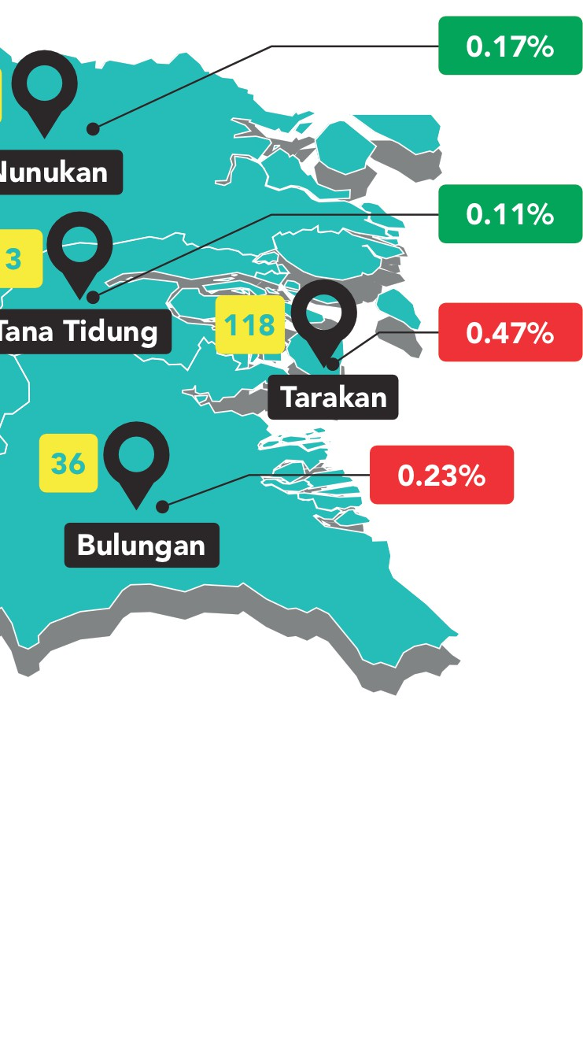
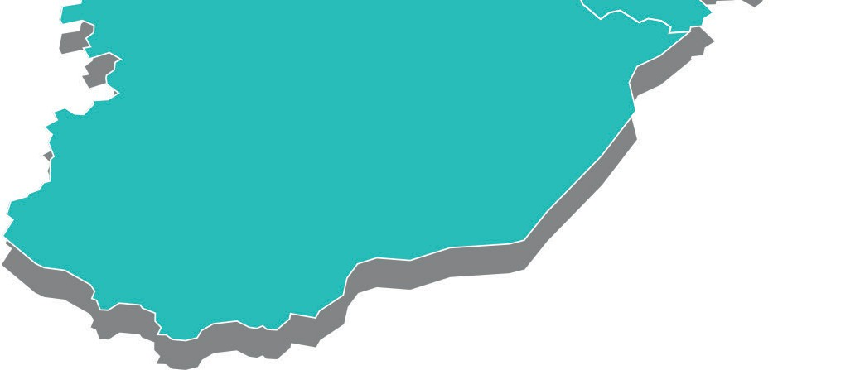
Source: North Kalimantan Provincial Health Office (2024)

Problem Statements
- The growing risk of HIV/AIDS transmission in industrial areas is driven by urbanisation, the influx of migrant workers, and high-risk behaviours. Screening conducted by the Provincial Health Office in 2024 confirmed an increase in cases among industrial workers.
- HIV/AIDS education and outreach remain limited among workers and surrounding communities, as preventive and promotive initiatives have not yet been targeted at areas with the highest concentration of cases.

Targeted Policies

- Access to essential health services remains inadequate, including screening, counselling and treatment within workplace settings.
- Stigma and discrimination against people living with HIV/AIDS (PLHIV) hinder early detection and effective treatment.
- No specific regulations are in place to ensure the management and prevention of HIV/AIDS in industrial zones.

- Presidential Regulation No. 124 of 2026 amending Presidential Regulation No. 75 of 2006 on the National AIDS Commission.
- Minister of Health Regulation No. 23 of 2022 on the Mitigation of HIV and AIDS.
- National Action Plan on the Mitigation of HIV and STIs.
- Minister of Manpower Regulation No. 5 of 2018 on Occupational Safety and Health in the Workplace.
- Corporate Social Responsibility (TSJL – Tanggung Jawab Sosial Perusahaan) policies of industrial companies concerning employee health.

Policy Recommendations

Strengthen Regulatory Frameworks
    - Dinkes, the Regional Development Planning Agency (Bappeda – Badan Perencanaan Pembangunan Daerah), and other relevant institutions should initiate the drafting of regional or Governor regulations to foster an industrial environment that actively prevents HIV/AIDS transmission. These regulations would provide a binding legal basis for structured prevention and control efforts in industrial zones, covering both health promotion initiatives to raise awareness and to ensure curative measures.
    - b. The Provincial Government should encourage the private sector to integrate HIV/AIDS into Occupational Safety and Health (K3 – Keselamatan dan Kesehatan Kerįa) indicators and TSJL programs. Embedding HIV/AIDS in workplace safety policies and TSL initiatives would help strengthen corporate responsibility for employee health.

Expand Education and Training
    - Dinkes should conduct regular HIV/AIDS education and awareness programs within industrial zones. Incorporating this information into induction programs for new employees would increase understanding and reduce workplace stigma.
    - The Provincial Government of North Kalimantan should encourage companies to appoint HIV/AIDS prevention ambassadors from among their employees. These ambassadors would act as peer educators, raising awareness and encouraging behavioural change among workers.

Improve access to services
    - Dinkes should encourage companies to establish HIV Centres, including Voluntary Counselling and Testing (KCT – Konseling dan Tes Sukarela) within industrial clinics. These services would improve workers’ access to confidential, voluntary, and safe HIV counselling and testing.
    - Dinkes should implement periodic HIV/AIDS screening, particularly for prospective employees. Regular screening would support early detection and help prevent transmission in industrial work environments.




4
Policy Brief
Ensuring a Safe Work and Investment Environment in North Kalimantan in The Context of HIV/AIDS
Disclaimer: This policy brief was prepared by policy analysts and participants of a policy brief writing workshop, organised in collaboration with the Provincial Government of North Kalimantan, the Agency of Policy Development (BSKDN – Badan Strategi Kebiįakan Dalam Negeri) of the Ministry of Home Affairs, the National Institute of Public Administration (LAN – Lembaga Administrasi Negara), and the SKALA Program. The views expressed are those of the authors and do not necessarily represent the official positions of the organising institutions.
Policy Brief | Ensuring a Safe Work and Investment Environment in North Kalimantan in The Context of HIV/AIDS

c. The Provincial Government should strengthen multisectoral collaboration and establish a task force for HIV prevention. Effective coordination between government, companies, and civil society organisations (OSM – organisasi masyarakat sipil) would reinforce integrated efforts through a dedicated task force in industrial zones.

- Increase public awareness and support
  - The Provincial Government of North Kalimantan should provide incentives or awards to companies that actively promote HIV/AIDS education and prevention in the workplace. Recognition from local authorities would encourage stronger corporate engagement in creating HIV/AIDS-free workplaces.
  - b. The private sector and community groups should establish support networks for industrial workers living with HIV/AIDS. These networks would create safe spaces and provide peer support for workers to share information, receive emotional assistance, advocate workplace rights, reduce stigma, encourage voluntary screening and foster a more inclusive and healthy work environment.

