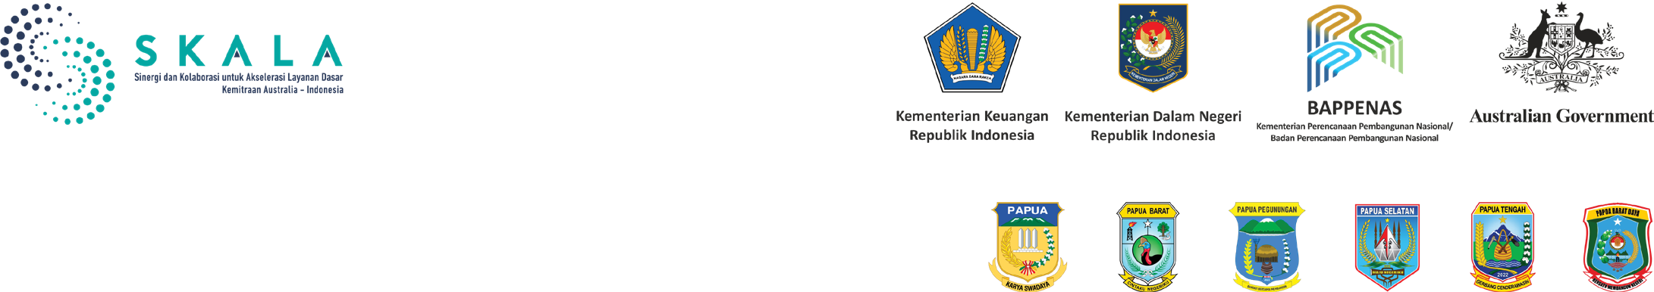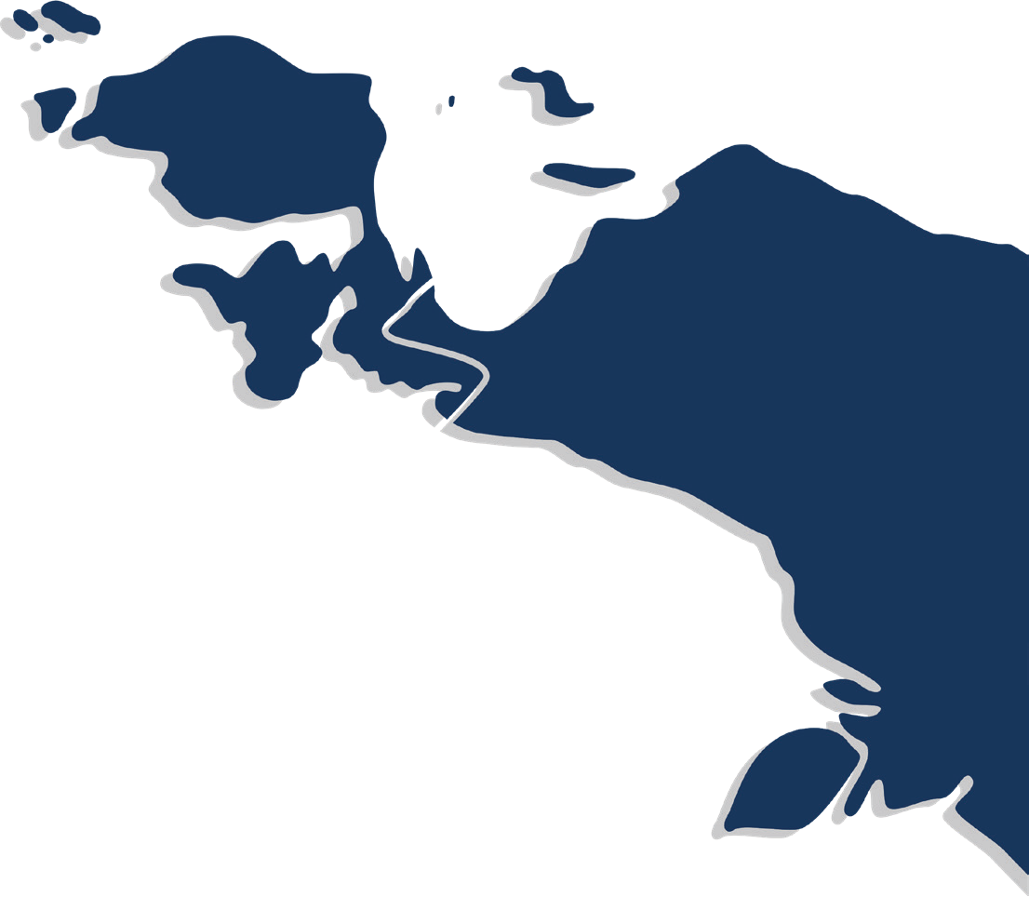

Collaboration for the Acceleration of Basic Services in Tanah Papua

July 2025

The six newly elected provincial governments in the Papua region—Papua, Central Papua, Highlands Papua, South Papua, West Papua, and Southwest Papua—are entering a pivotal moment to strengthen regional autonomy and governance, drive economic growth, and advance inclusive development for the people of Papua, including Indigenous communities.

Provincial government priorities across the Papua region include enhancing economic self-reliance, strengthening human resources, developing sustainable livelihoods, and promoting equitable and just social development. To support these efforts, provincial governments in Papua have established a collaboration with the SKALA Program, the Australia-Indonesia Partnership for Decentralisation and Local Governance. This collaboration includes technical assistance, capacity building, data integration, and policy support to strengthen economic governance, improve public financial management, and expand inclusive basic service delivery.

1



2

# Key areas of alignment

 Governance and Public Financial Management

Provincial governments across four regions in Papua are committed to strengthening governance, promoting evidence-based policymaking, and improving public financial management. A range of strategic efforts has been undertaken to support these objectives, with the aim of fostering inclusive economic growth and ensuring the effective implementation of Special Autonomy (Otsus). These efforts include:

* Capacity building for government officials in the four Papuan provinces on the preparation of Budget and Program Plans (RAP), the use of the Regional Financial Information System (SIKD), and the allocation of Special Autonomy funds to improve budget execution and address challenges related to unspent funds.
* Facilitation of the implementation of the One Data initiative, strengthening data-driven governance, and formalising the role of the One Data Forum to coordinate and identify key data sets.
* Training of trainers in the use and analysis of national socio-economic data and the Integrated Regsosek-Based Development Planning System (SEPAKAT), to support evidence-based planning and policymaking.

Delivery of Inclusive Basic Services

Strengthening the capacity of provincial governments in reporting on Minimum Service Standards (SPM), integrating service delivery into development strategies, and aligning Regional Medium- Term Development Plans (RPJMD) with provincial development priorities are key agenda items for Governors across the Papua region. To support this agenda, provincial governments are committed to advancing inclusive basic service delivery, including through:

* Completion of SPM reporting in the provinces of Papua, West Papua, Southwest Papua, and Central Papua, in collaboration with the Ministry of Home Affairs, achieving compliance rates of over 80%.
* Capacity building for civil servants and provincial staff (Pokja PUG/Gender Mainstreaming Working Groups and Driver Institutions) in Gender-Responsive Planning and Budgeting (PPRG), including the development of technical modules and implementation guidelines in Papua Province. In South Papua, the provincial government is promoting the institutionalisation of gender mainstreaming through the development of relevant policies and working groups. Institutionalising gender mainstreaming enables provincial governments to plan, budget, and manage basic services that are gender-sensitive.
* Training for civil servants in the four provinces to strengthen their capacity in implementing SPM, with a focus on evaluation, coordination, and improving the delivery of basic services. In Southwest Papua, the training also includes SPM monitoring and evaluation to improve access, quality, and service provision.
* Preparation of RPJMDs in the provinces of Papua, West Papua, and Central Papua, with a focus on inclusive basic services, SPM implementation, gender equality, community participation, and data-driven socio-economic planning that is responsive to poverty and disability inclusion.

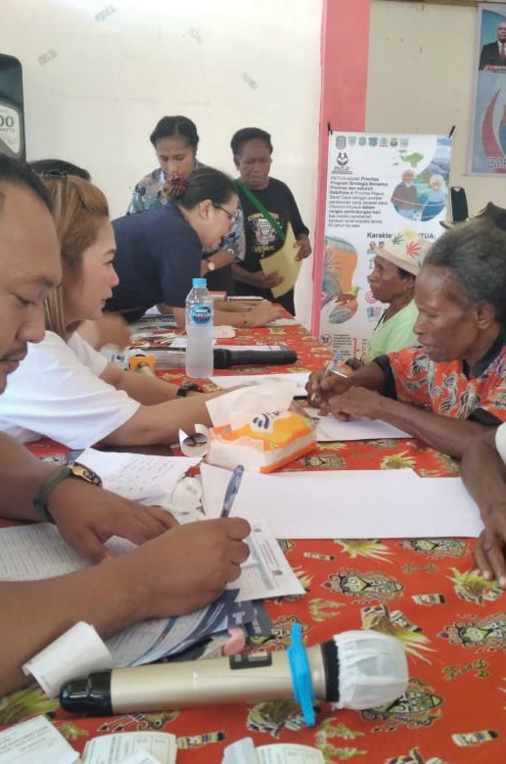

Equity, Dignity, and Community Welfare

As part of the Governors’ priorities in the Papua region to ensure that public services, social protection, and policy planning are responsive to the needs of Indigenous Papuans, vulnerable groups, and the wider population, provincial governments have strengthened their efforts through a range of initiatives, including:

* Implementation of the Elderly Social Protection Program (PAITUA) in Southwest Papua Province, an initiative funded through the Special Autonomy Fund (Otsus), which provides monthly assistance of IDR 250,000 to residents aged 65 and above to address poverty and improve wellbeing.
* Development of data platforms, including the Indigenous Papuan Information System (SIO Papua) in Papua Province, the South Papua Indigenous Research and Information System (SIRIOS) in South Papua Province, and the Welfare Administration and Information System Plus (SAIK+) in West Papua and Southwest Papua. These platforms aim to strengthen demographic data on Indigenous peoples and vulnerable groups, as well as socio-economic data, to support inclusive policymaking and targeted programs.
* Facilitation of collaboration with government officials to discuss gender mainstreaming approaches in social protection programs and promote the involvement of vulnerable groups in the development of Regional Action Plans for Persons with Disabilities.
* Enhanced monitoring of Minimum Service Standards (SPM) via the electronic SPM system (e-SPM) in Central Papua Province, through the recruitment and training of additional data operators within sectoral government agencies, to ensure accurate, inclusive reporting on service provision across all segments of the population.

# Alignment with Tanah Papua’s Upcoming Challenges

One of the initial challenges faced by the newly elected governments in Papua’s provinces is the implementation of budget efficiency policies in 2025. This situation has prompted provincial governments to adjust their spending and focus resources on the Governors’ priority programs. To support these efforts, a range of measures has been introduced, including:

* Building government capacity in data-driven planning, enabling more accurate, timely, and responsive decision-making based on reliable and up-to-date information.
* Optimising budget allocation by improving financial management practices, ensuring that limited resources are directed towards the most essential services.
* Integrating Minimum Service Standards (SPM) into regional development plans to maintain the quality of services amid fiscal constraints.

3





4

# Sustaining Collaboration in Supporting the Vision of Provinces in Tanah Papua

Aligned with the development vision of the newly elected Governors in the Papua region, the collaboration between provincial governments and the SKALA Program is directed toward supporting three key priority areas:

1. Improving Development Planning



Enhancing public financial management and integrating strategic planning into the provincial development framework. Support includes gender-responsive budgeting, community engagement in planning processes, and the completion of key strategic documents such as the SPM Action Plan, Disability Action Plan, Gender Mainstreaming Action Plan, and One Data Action Plan.

1. Improving Financial Management

Completion of regional revenue studies and the development of revenue policy in Papua Province. In addition, the provinces of Papua, West Papua, and Southwest Papua will establish Special Autonomy Advisory Forums to improve the governance of Otsus (Special Autonomy) funds and support the implementation of priority Otsus programs.

1. Data Management for Evidence-Based Development

Finalisation of the 2024 regional data inventory and the strengthening of evidence-based policy through the optimisation of the One Data Forum’s role across Papua, West Papua, Southwest Papua, Central Papua, and South Papua. Provincial governments will also expand the SIO Papua, SIRIOS, and SAIK+ platforms to the district level to enhance data collection, monitor Indigenous Papuan demographics, social wellbeing, and development outcomes—ensuring that policies are more responsive to local needs.

IFC Tower 2, Level 17

Jl. Jendral Sudirman Kav. 22‑23 Jakarta 12920

 skala.or.id  [communications@skala.or.id](mailto:communications@skala.or.id)

https://s.id/Channel‑SKALA