


Collaboration for the Acceleration of Basic Services in the NTB Province

July 2025
Effective governance and inclusive development play an importantrole in realising the vision of Nusa Tenggara Barat Province (NTB) over the next five years: “Rising Together Towards a Prosperous and Globally Recognised Island Province.” The NTB Government is committed to strengthening the regional economy, enhancing infrastructure, and promoting inclusive and sustainable development.

The Government of NTB continues to strengthen governance, financial management, data integration, and social inclusion as part of its efforts to achieve its development vision. This efforts are particularly through the province’s flagship programs: Bureaucratic Reform and Public Services (PU#3), NTB Inclusive (PU#9), and support for the Empowered Village program (PU#2). To support these efforts, the NTB Government collaborates with and is supported by SKALA, the Australia- Indonesia Partnership Program for Accelerating Basic Services, through technical assistance, capacity building initiatives, and policy support. This collaboration reflects f a joint commitment to supporting the new leadership vision of the NTB Government.


Key Areas of Alignment
2

Data-Driven Policy Making and Good Governance

In line with the priorities of the Governor of NTB, the Provincial Government, in collaboration with the SKALA Program, has undertaken various strategic initiatives to strengthen data-driven policy and governance that is inclusive, transparent, and sustainable, as outlined below:
- Development of a regulatory framework for data governance, including the drafting of a Governor’s Regulation on the NTB One Data Action Plan, and the expansion of the NTB regional data catalogue to 921 datasets through collaboration with 49 regional government agencies (OPD).
- Strengthening the NTB One Data Forum to serve as a more robust coordination platform for regional data governance, enabling regular data exchange, integration of service provision data, and a broader scope for evidence-based policymaking.
- Enhancement of the NTB One Data Portal 2.0, which now features accessibility options (language adjustments, contrast settings, reading guides, and dyslexia-friendly fonts) to accommodate persons with disabilities.
- Support for inter-agency collaboration among Bappeda, Diskominfo, the Central Statistics Agency (BPS), and sectoral work units to improve data integration for planning and service delivery.
- Improvement of regional development planning by supporting the alignment of the 2025– 2045 Long-Term Regional Development Plan (RPJPD) and the 2025–2029 Medium-Term Regional Development Plan (RPJMD) of NTB with national fiscal policies and performance- based budgeting requirements.

Stronger Regional Economic Development through Public Financial Management

In line with NTB’s priorities, the Provincial Government is working to enhance the public financial management system and optimise fiscal policies, including:
- Support for the Regional Government Budget Team (TAPD) in guiding policies on the allocation of fiscal transfers for health, education, and infrastructure.
- Optimisation of budget allocation by enhancing the use of national socio-economic data in planning the Minimum Service Standards (SPM).
- Improvement of inclusive fiscal policies by facilitating tax exemptions for modified vehicles used by persons with disabilities.
- Strengthening of budget oversight and fiscal transparency through collaboration with provincial auditors to develop monitoring and evaluation instruments that assess the implementation of the SPM.
- Development of a roadmap to increase regional own-source revenue (PAD) through Public Expenditure and Revenue Analysis, enabling NTB to better manage fiscal transfers and tax revenues for infrastructure and economic growth.

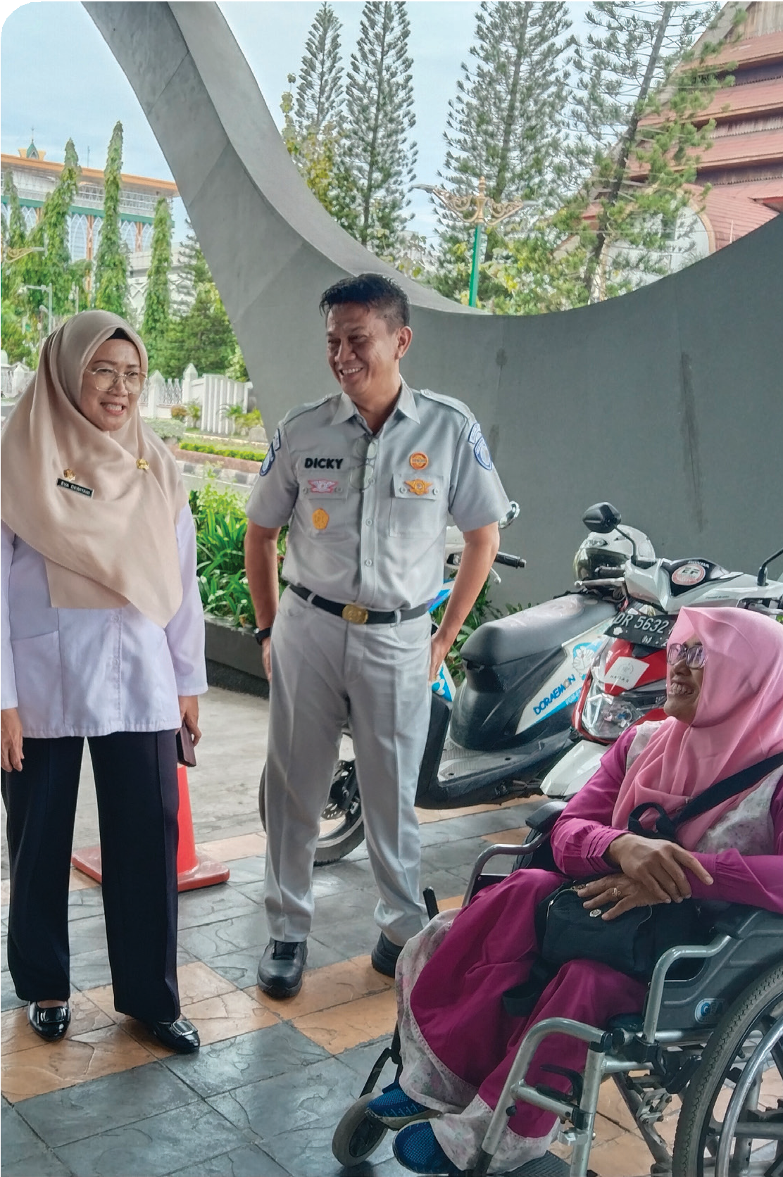

Inclusive NTB and Social Equity

In line with the priorities of NTB Inclusive (PU#9), the program collaboration supports various efforts as follows:
- Strengthening and implementation of gender-responsive planning and budgeting, with all 49 government work units having completed the Gender Analysis Pathway and Gender Responsive Budgeting.
- Facilitation of inclusive governance by training community-based organisations (OMS) in the use of national socio-economic data and advocating for community participation in policy planning.
- Preparation of the NTB Regional Action Plan for Persons with Disabilities to ensure disability inclusion is incorporated into provincial policies.
- Support for the Housing and Settlement Agency and the Health Agency in utilising spatial data to identify disaster-prone housing areas in order to meet the Minimum Service Standards (SPM).

Alignment with the Governor’s Upcoming Challenges

One of the main challenges facing the NTB government moving forward, following the issuance of Presidential Instruction No. 1 of 2025, is the implementation of budget efficiency measures totaling IDR 471.4 billion in 2025, which has the potential to impact the implementation of priority programmes. In this context, the SKALA Program is supporting the government through the following efforts:
  - Strengthening data-driven planning to enable the government to make decisions based on accurate and up-to-date information.

  - Optimising budget allocation through improved fiscal management so that limited resources can be directed towards essential services.

  - Ensuring the integration of Minimum Service Standards (SPM) into NTB’s regional development plans to maintain service quality despite financial constraints.

3


Sustainability of Collaboration in Support of NTB’s Vision

In alignment with the Governor’s vision and flagship programs, SKALA will continue to provide strategic support in the following areas:

Data-Driven Policy Making and Good Governance
    - Support for the implementation of NTB’s Medium-Term Regional Development Plan (RPJMD) and Long-Term Regional Development Plan (RPJPD), aligned with national and provincial priorities.
    - Preparation of the NTB One Data Action Plan and support for its implementation.
    - Expansion of access to national socio-economic data across all regions and ensuring effective data utilisation capacity.
    - Strengthening data governance mechanisms, including the integration of E-Walidata into the SIPD system to enhance the planning process.
    - Expansion and utilisation of information systems at the village level to strengthen governance across village, regency, and provincial administrations.
Stronger Regional Economic Development through Public Financial Management
    - Evaluation of tax revenue policies and the development of a roadmap to increase regional income through improved tax collection and better allocation of fiscal transfers.
    - Facilitation of sustainable funding for Minimum Service Standards (SPM) by assisting NTB in integrating fiscal allocation policies with regional priorities.
    - Capacity development for budget monitoring and evaluation to enable the region to effectively meet expenditure and service delivery targets.
    - Strengthening synergy in the implementation of Regional Regulation No. 2 of 2024 on Regional Own-Source Revenue (PDRD) between the provincial and regency/city governments, particularly in the governance of motor vehicle tax collection and the enhancement of human resource capacity.
Inclusive NTB and Social Equity
    - Institutionalisation of gender-responsive budgeting by ensuring inclusive financial planning at all levels of government.
    - Facilitation and implementation of participatory Musrenbang (development planning meetings) to ensure the involvement of marginalised communities in regional development planning.
    - Development and implementation of the new NTB Gender Action Plan, aligned with the province’s inclusive development goals.
    - Capacity building for community-based organisations (OMS) and local communities to actively engage in policy advocacy and public service monitoring.



IFC Tower 2, Level 17
Jl. Jendral Sudirman Kav. 22‑23 Jakarta 12920
 skala.or.id  communications@skala.or.id

https://s.id/Channel‑SKALA

