Collaboration for the Acceleration of Basic Services in the Gorontalo Province

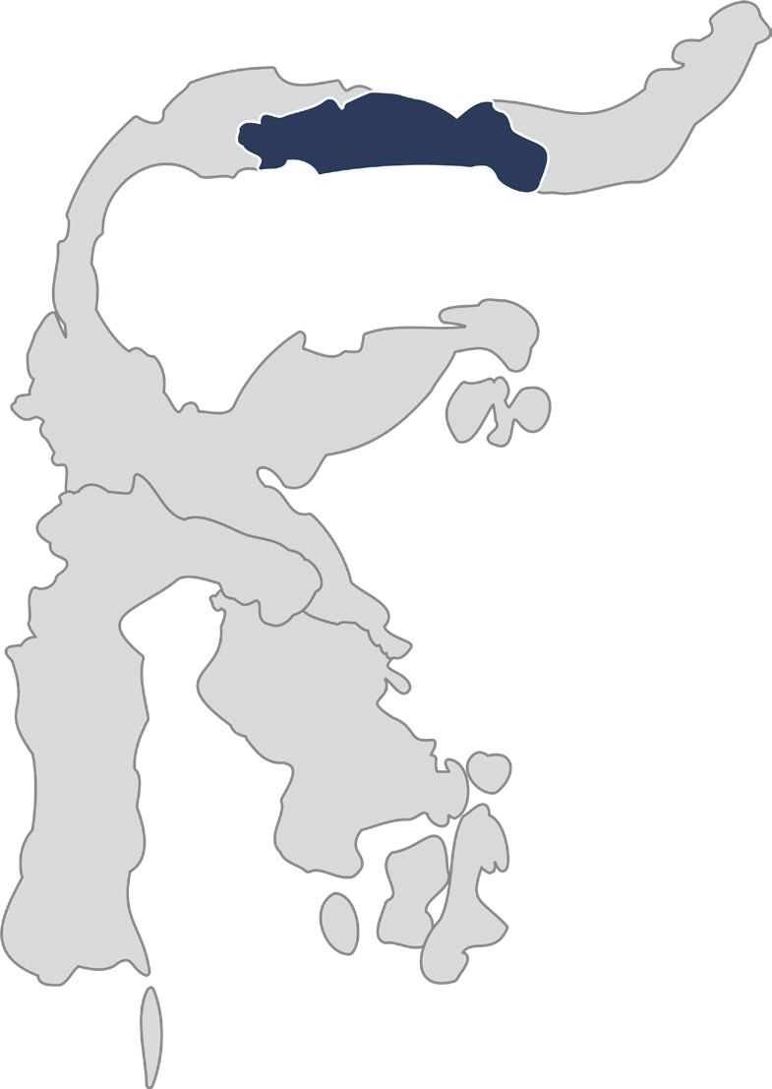

July 2025

The Provincial Government of Gorontalo has a vision to create a more just and prosperous province by eradicating poverty, increasing income, ensuring equitable access to public services and infrastructure, as well as strengthening community skills, supporting micro, small and medium enterprises (MSMEs), and enhancing the welfare of its citizens.

To support the achievement of this vision, the Provincial Government of Gorontalo is collaborating with and receiving support from the SKALA Program, the Australia-Indonesia Partnership for Accelerating Basic Services. This collaboration is focused on strengthening governance, regional financial management, data-driven planning, and fostering development that is inclusive and responsive to vulnerable groups. The forms of support include technical assistance, capacity building, and policy facilitation that encourages the participation of all segments of society.

1



2

# Key Areas of Alignment

 Governance and Public Financial Management

The government is working to build a more prosperous province, reduce poverty levels, and improve the quality of public services through a range of initiatives aimed at strengthening governance and public financial management. These efforts include, among others:

* Supporting the development of cooperation agreements between the province and all districts/ cities for revenue sharing, along with a dedicated allocation of local tax revenues to improve compliance and tax collection.
* Supporting synergy between provincial and regency/municipal governments in optimising the collection of Motor Vehicle Tax (PKB) and Motor Vehicle Title Transfer Fee (BBNKB).
* Supporting the Provincial Government in formulating strategic designs to increase Regional Original Revenue (PAD) as an effort to enhance the region’s fiscal capacity.
* Providing strategic inputs to develop regulations and agreements aimed at implementing Regional Regulation 1/2024 on Regional Tax and Levies.
* Training provincial, district and city officials in budget preparation, focusing on economic growth, fiscal efficiency, poverty alleviation and aligning regional budget planning processes (KUA-PPAS) with National Fiscal Policy (KEM PPKF).
* Enhancing the role of coordination, guidance, and supervision (korbinwas) teams in the implementation of Minimum Service Standards (SPM) through a WhatsApp group managed by the Regional Governance Bureau which enables frequent discussions and sharing of best practices.

 Data-Driven Governance, Planning and Development

The efforts of the Gorontalo Provincial Government to improve income, skills, and the development of micro, small and medium enterprises (MSMEs) rely heavily on accurate data regarding community needs and the role of government services in supporting them. These efforts are pursued through the following initiatives:

* Supporting the development of Gorontalo’s One Data Action Plan to include monitoring, evaluation, and infrastructure components, aligned with the Ministry of Home Affairs’ national One Data for Regions (SDPDN) policies.
* Facilitating the launch of Gorontalo’s One Data Portal (PENTAGON), which now hosts 323 datasets that meet standards, metadata, and reference codes for easier sharing and use.
* Supporting finalisation of the Gorontalo Regional Data List 2024 which enables 32 local government agencies to collect priority data per One Data standards, with approved raw data integrated into the Gorontalo Data Portal (PENTAGON).
* Integrating REGSOSEK data and local datasets from the Education, Health, and Social Affairs Offices to improve targeting accuracy and provide essential data for planning and policymaking.
* Supporting the continuous management of data from the village/kelurahan level within the GSD (Gorontalo Satu Data) platform.
* Supporting the integration of the Gorontalo Satu Data Portal with the SDI and SDPDN Portals as a platform for the utilisation and dissemination of data.
* Enhancing data literacy capacity for Civil Society Networks (JMS) in advocating for the needs of vulnerable and marginalised groups within regional planning documents.

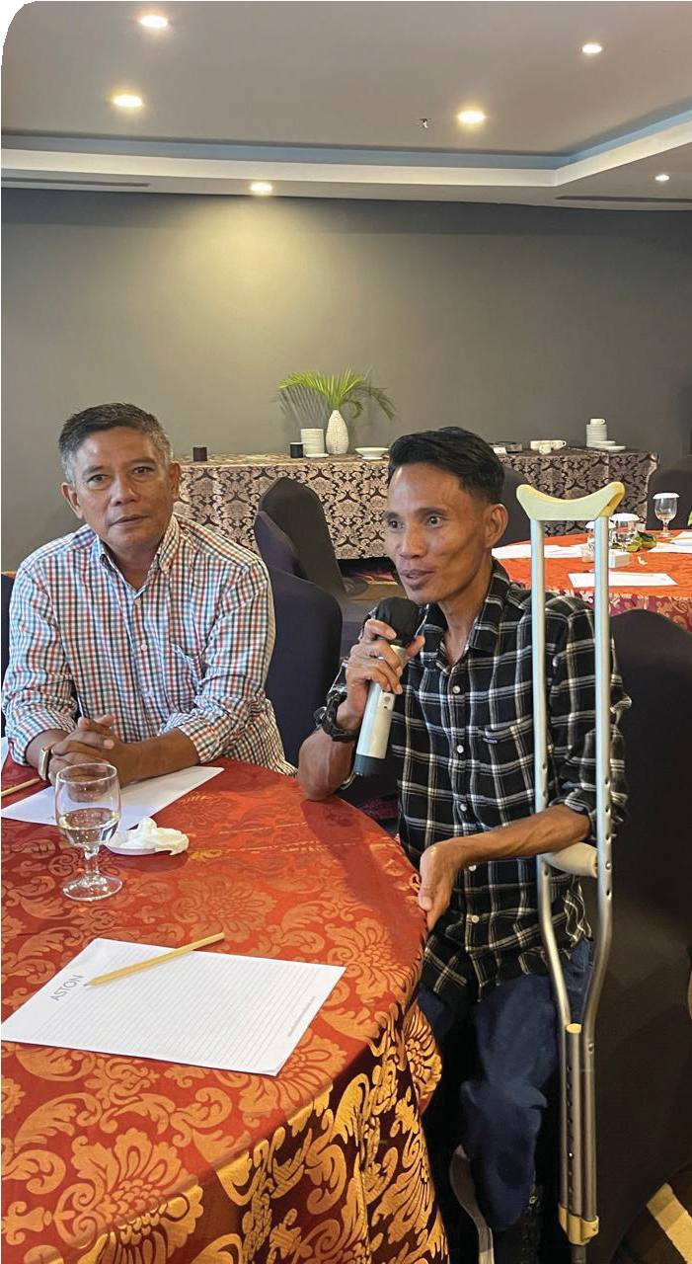

Equitable and Inclusive Communities

The Provincial Government of Gorontalo is committed to building an inclusive future for all members of society through a range of collaborative efforts and initiatives, including:

* Facilitating the finalisation of the draft Regional Action Plan for Persons with Disabilities, as well as the preparation of Regional Regulations on Gender Mainstreaming, in collaboration with the Office for Women’s Empowerment and Child Protection, and involving civil society networks.
* Supporting the development of the Inclusive Musrenbang Guidelines through the Gorontalo Inclusive Forum DULOHUPA, which forms part of the Planning Stages to be institutionalised through a Governor’s Regulation.
* Training regional civil servants from 21 local government agencies in Gender-Responsive Planning and Budgeting.
* Strengthening the role of CSOs in policy planning, particularly their participation in formulating the Regional Regulations on Gender Mainstreaming.
* Supporting the gathering of aspirations and needs of vulnerable and marginalised groups through the Regional House of Representatives (DPRD) POKIR (Key Issues) channel, making it more inclusive with the enhanced POKIR KEREN initiative.

 Delivery of Inclusive Basic Services

The government is ensuring inclusive access to basic public services and supporting infrastructure through the following collaborative efforts and initiatives:

* Supporting the development of MSS Action Plans by the Provincial Task Force and training provincial and district officials in how to cost them.
* Utilising national socio-economic data (Regsosek) to identify and verify the eligibility of participants for the government-subsidised Health Insurance Contribution Assistance (PBI), with a focus on non-wage workers and the unemployed.
* Emphasizing the importance of inclusion in development planning, extending social protection for older people and people with disabilities (PwD).

# Alignment with the Governor’s Upcoming Challenges

One of the key challenges faced by the new administration is ensuring budget efficiency for the 2025 fiscal year. To address this, the Provincial Government of Gorontalo, with support from the SKALA Program, is undertaking the following initiatives:

Strengthening data-driven planning so the government can make informed decisions based on accurate, up-to-date information.



Optimising budget allocations through improved fiscal management so that limited resources are directed towards basic services.



Ensuring the integration of Minimum Service Standards (MSS) into Gorontalo’s regional development plans to maintain service quality despite financial constraints.



3





4

# Sustaining Collaboration in Supporting the Vision of Provinces in the Gorontalo Region

In line with the Governor’s vision, SKALA Program will focus on the following priorities:

Alignment of the Regional One Data Action Plan with the Indonesian One Data Policy (SDPDN), including the integration of e-Walidata into the Regional Government Information System (SIPD).

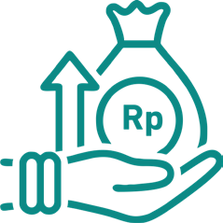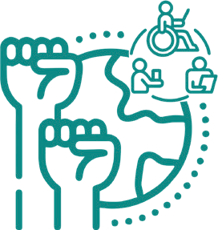

Strengthening the implementation of inclusive development planning forums (Musrenbang) by involving women, persons with disabilities, and the elderly, as well as integrating inclusivity principles into the planning process, including through the Regional Action Plan for Persons with Disabilities and regulations on Gender Mainstreaming.

Providing assistance in formulating strategies to increase revenue and in drafting regulations on taxation and levies. Supporting the preparation of the 2025–2029 development plan (RPJMD), including the integration of the Minimum Service Standards (SPM) action plan.

Integrating the SPM action plan into the regional planning process and aligning SKALA objectives with government priorities.

IFC Tower 2, Level 17

Jl. Jendral Sudirman Kav. 22‑23 Jakarta 12920

 skala.or.id  [communications@skala.or.id](mailto:communications@skala.or.id)

https://s.id/Channel‑SKALA