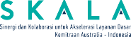


Pemerintah Provinsi Maluku
Kementerian Keuangan Republik Indonesia
Kementerian Dalam Negeri Republik Indonesia

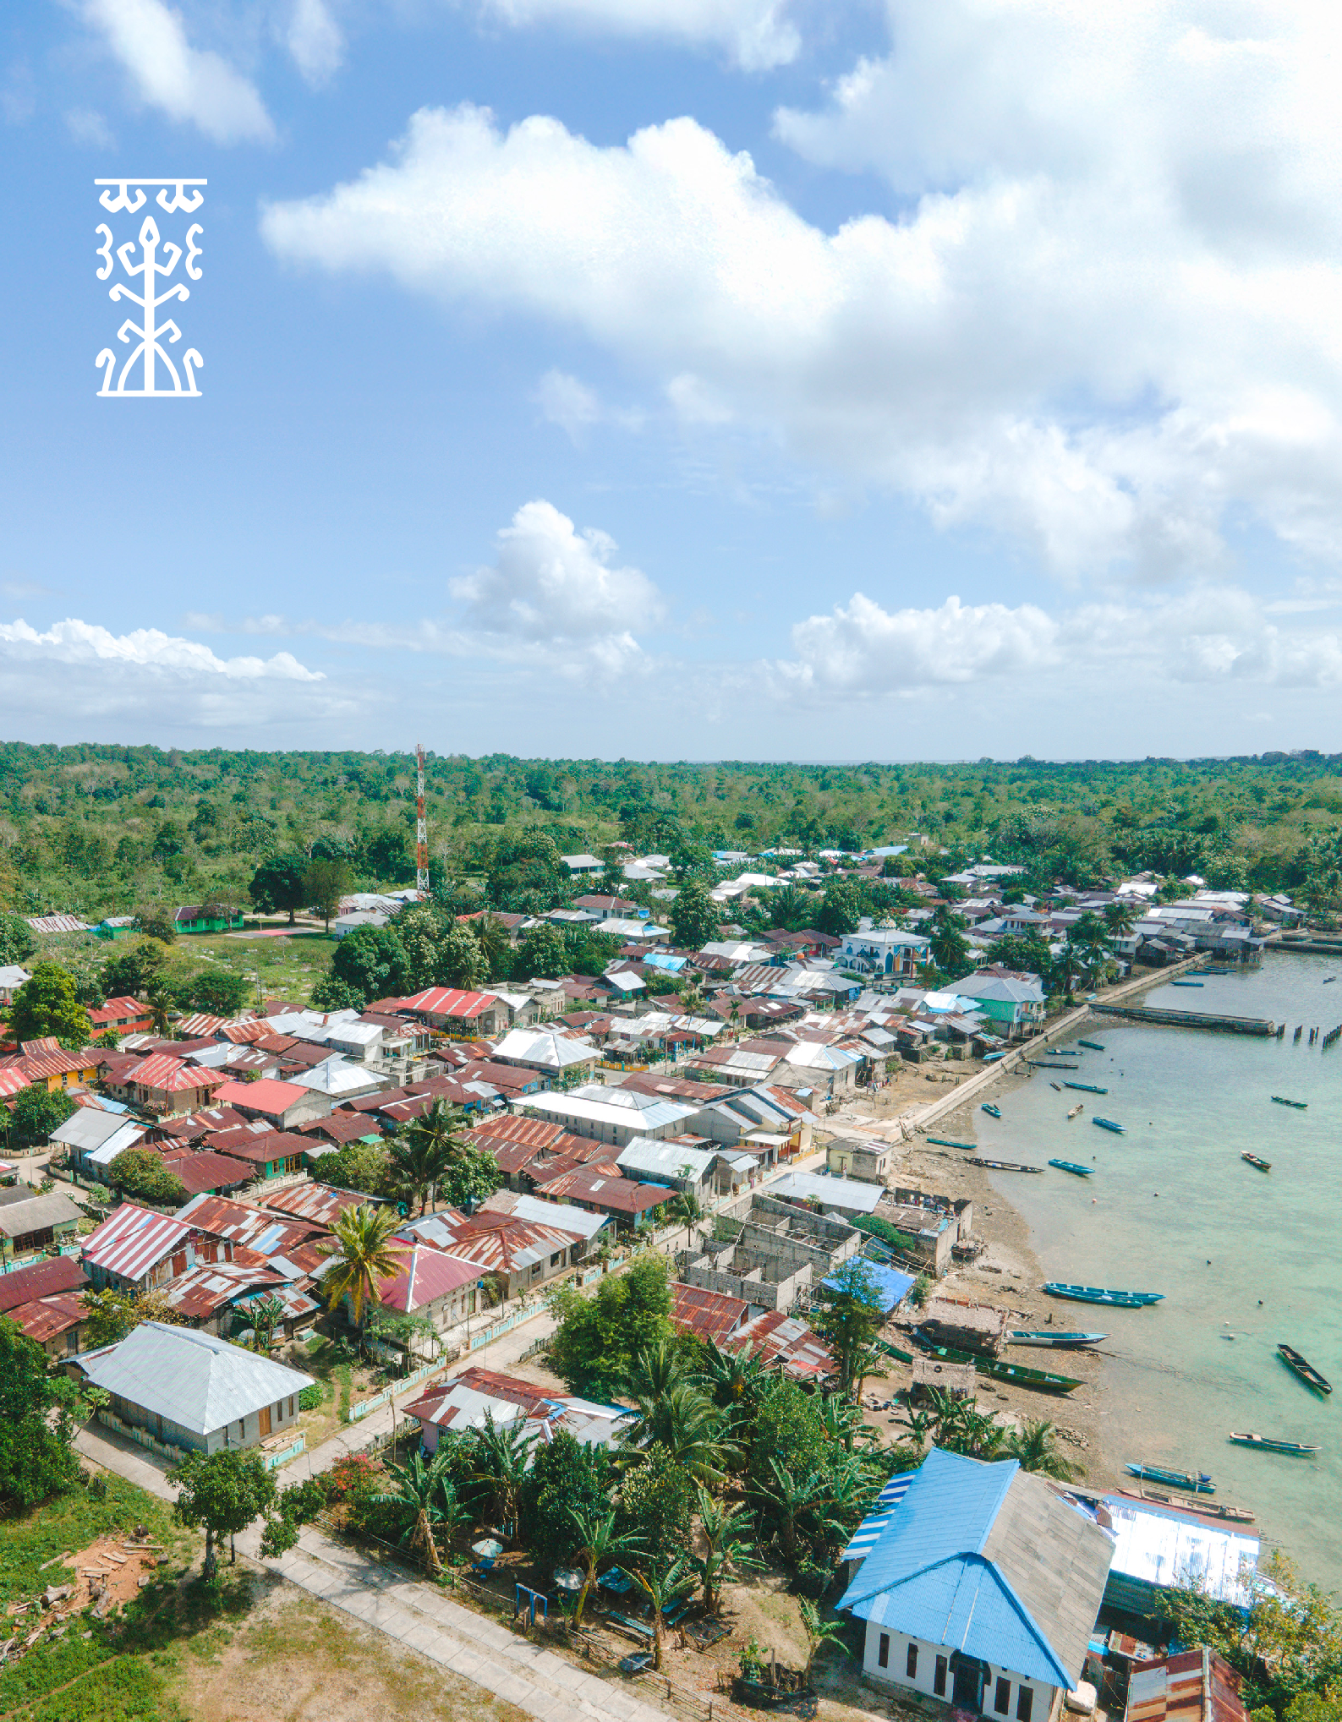

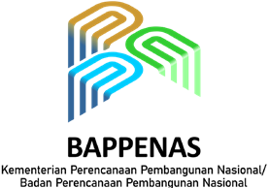

Bacarita Manise
Strengthening Voices of Communities for Inclusive Development in Maluku

The Province of Maluku, known for its cultural diversity and chain of islands, continues to face serious challenges in achieving equitable development. Regional disparities, high poverty rates, and limited access to basic services such as education, health, and social protection remain a daily reality for many residents. These conditions are felt most acutely by vulnerable groups such as women, people with disabilities, elderly, and children.

Bacarita Manise
Strengthening Voices of Communities for Inclusive Development in Maluku

Yet amid these challenges, new hope has emerged through Bacarita Manise.1 Bacarita Manise is Maluku’s unique version of Indonesia’s Thematic Development Planning Forum, known in Indonesian as Musrenbang Thematic. It represents an important innovation in the drafting of the Maluku Province Medium-Term Development Plan (RPJMD) 2025–2029. Bacarita Manise is more than a consultative meeting – it provides a space where civil society and government come together, listen, and jointly plan more inclusive development.

Giving Voice to the Unheard
The name Bacarita Manise reflects a spirit of openness and equality. Bacarita means ‘story’ or ‘discussion,’ while Manise is an acronym for Maluku Inklusif dan Sejahtera, translated as ‘Inclusive and Prosperous Maluku’. Manise is also a local word meaning sweet, pleasant and friendly. Together, these meanings symbolise dialogue aimed at building an inclusive Maluku and a prosperous society, especially for vulnerable groups.

The forum grew from the realisation that truly just development can only be achieved if women, people with disabilities, older people, youth, and Indigenous peoples are given meaningful opportunities to speak and be heard.
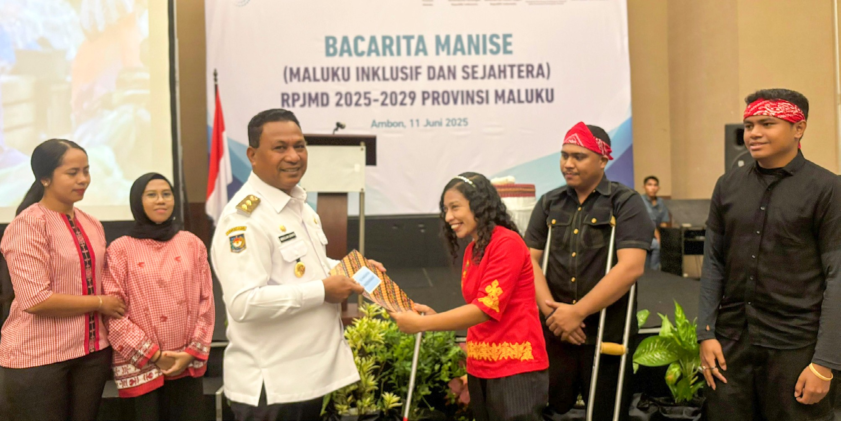

1 Bacarita Manise is the local name for the Thematic Development Planning Forum (Musyawarah Perencanaan Pembangunan Tematik/ Musrenbang Tematik). While Musrenbang is a standard planning mechanism in Indonesia, Bacarita Manise is Maluku’s distinctive version, emphasising dialogue, inclusion, and equality.

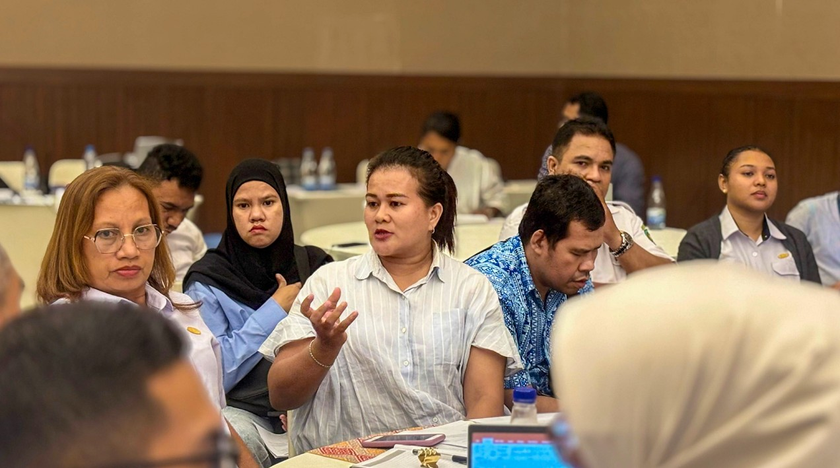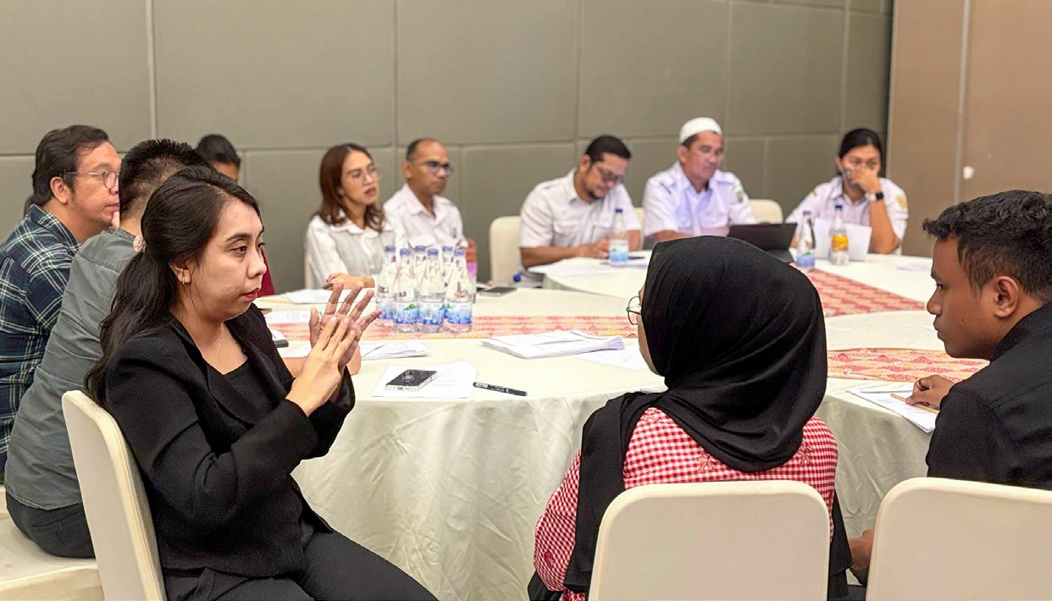Preparation for the forum began in January 2025. The Maluku Provincial Development Planning Agency (Bappeda), in collaboration with the Australia-Indonesia Partnership program, SKALA, organised a series of discussions to develop guidelines for implementing the Thematic Musrenbang. Once finalised, the collaboration brought in the BaKTI Foundation and Rumah Generasi to help fund and facilitate the pre-Musrenbang process.

Bacarita Manise Strengthening Voices of Communities for Inclusive Development in Maluku

The goal was to gather gap analyses from civil society organisations (CSOs). These inputs were organised into three working desks within Bappeda: Regional Infrastructure Development, Economy and Natural Resources, and Human and Community Empowerment. Each desk was led directly by the relevant division head at Bappeda, giving CSOs a rare opportunity to speak directly with officials.

The process applied GEDSI principles (gender equality, disability, and social inclusion). This was supported by research from Yayasan Arika Mahina on the lives of coastal women in Ambon Island. As explained by the Yayasan’s Director, Ruth Saiyan, the study found that women fishers are often regarded only as ‘assistants,’ even though they work alongside men with just as much effort. She noted that their identity documents list their occupation as ‘housewife,’ preventing them from getting government assistance intended for fishers. This case illustrates how applying a GEDSI lens can reveal hidden inequalities.

Connecting Aspirations to the Planning System
The aspirations voiced by the community in the pre-Musrenbang process were captured in a document titled ‘Our 10 Hopes.’ These ‘hopes’ emerged from community-driven activities, including drafting the Regional Action Plan for People with Disabilities, developed together with local government agencies and disability organisations.

During the forum, people with disabilities, women and young people presented ‘Our 10 Hopes’ through poetry, offering a powerful reflection on the inequalities in Maluku’s basic services.

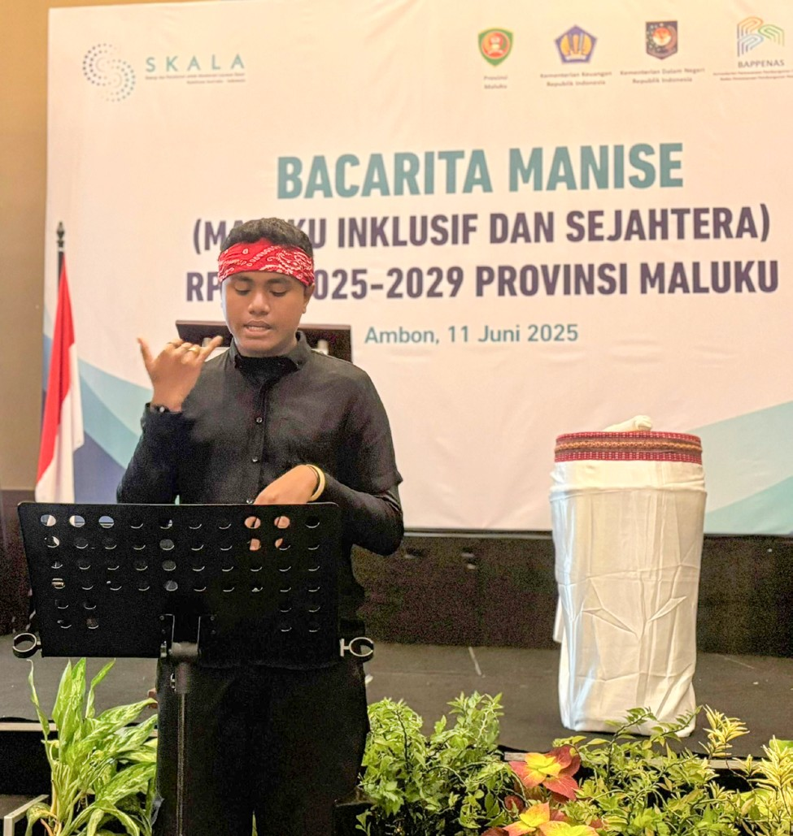
Their hopes included:

Bacarita Manise
Strengthening Voices of Communities for Inclusive Development in Maluku

- Scholarships for children from remote areas to pursue studies in health-related fields.
- Dormitories for students from small islands to enable them to continue their education in towns.
- Access to digital financial services and entrepreneurship training for women and people with disabilities.
- Free health insurance for households in extreme poverty not yet covered by Indonesia’s national health insurance program (JKN - Jaminan Kesehatan Nasional).
- Permanent health workers in villages and free health services for the poorest families.

These aspirations were backed by hard evidence: 34.7% of young people aged 16–18 in Maluku are no longer in school, and only about 7% of people with disabilities have access to a bank account. Such data strengthened the case for more inclusive policies.

Crucially, communities not only raise problems but also offer solutions. CSOs contributed their experiences, which were discussed with Bappeda and relevant agencies during the Bacarita Manise forum. Through this dialogue, citizens and government officials worked side by side to agree on the next steps. At the national level, this initiative is coordinated by the Directorate of Families, Parenting, Women and Children (KPPA), the Ministry of National Development Planning (Bappenas). Although implemented at the subnational level, the initiative is formally endorsed by the national government.

As one CSO representative, Ibu Otte, said:

‘Having a space like this where we can meet directly with government stakeholders gives us hope that our voices will truly be heard. It also allows us to act as watchdogs over the policies being made. We hope more spaces like this will be created across the province.’

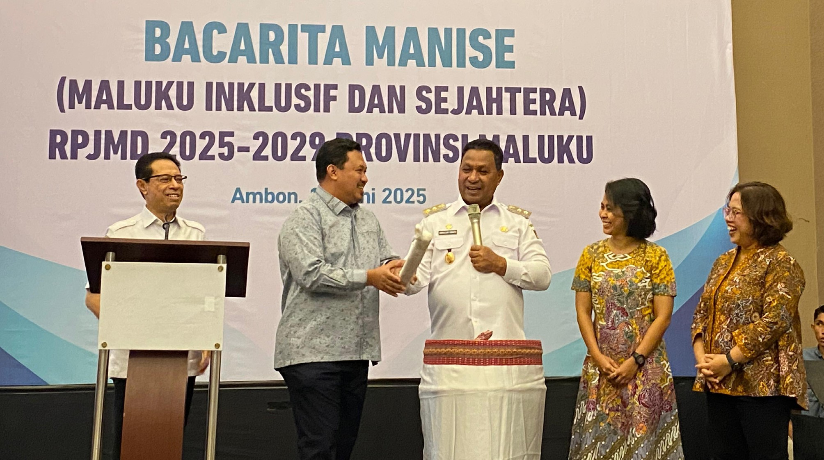From Practice to System: Challenges and Opportunities

Bacarita Manise Strengthening Voices of Communities for Inclusive Development in Maluku
While the participatory approach has been welcomed, institutional challenges remain. One key issue is ensuring that forum outputs do not stop at reports but are translated into the planning language governments actually use. Bappeda, with support from SKALA and the fellow Australia-Indonesia Partnership program, INKLUSI,2 is integrating proposals from Bacarita Manise into the RPJMD and Regional Apparatus Organisations Strategic Plans (Rencana Strategis Organisasi Perangkat Daerah).

Another challenge is sustainability. Forums like these need to be institutionalised so they do not depend on short-term projects or external funding. This will require the Provincial Government to include the Thematic Musrenbang in its annual agenda, backed by policy and budgetary support.

Maluku’s Deputy Governor, Abdullah Vanath, underscored this commitment:

‘The Governor and I strongly support participatory governance. That’s why forums like this must continue, so that we can hear directly from communities about their needs. People must also remain watchdogs, ensuring we are accountable for every step we take as government.’

2 INKLUSI – the Australia–Indonesia Partnership program Towards an Inclusive Society.

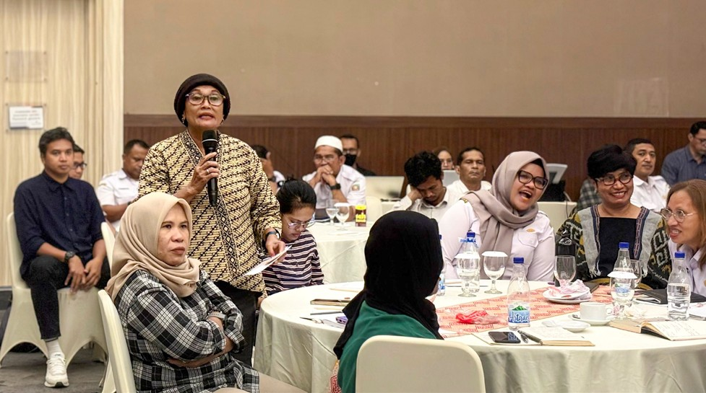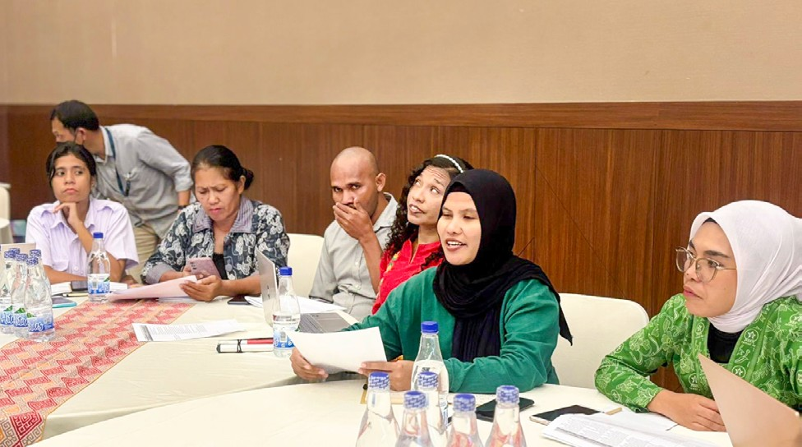Towards a More Inclusive Maluku

Bacarita Manise
Strengthening Voices of Communities for Inclusive Development in Maluku
The Bacarita Manise Thematic Musrenbang is a living example of how development planning can become a social process rooted in humanity. By creating spaces to meet, listen, and plan together, development becomes more inclusive and just.

The forum shows that communities are essential to inclusive and effective development, helping to shape policy alongside government. If strengthened over time, Bacarita Manise will not only remain a ‘sweet story,’ but also signal a new chapter in Maluku’s governance – one that is inclusive, participatory, and fair for all.

As Reza Marasabessy, Head of Bappeda’s Human and Community Empowerment Division, concluded:

‘This is the first thematic musrenbang of its kind in Maluku Province. We hope it will continue, so the government can hear directly from communities about their needs and integrate them into our planning.’


www.skala.or.id communications@skala.or.id Whatsapp Channel SKALA

SKALA Office
IFC Tower 2, Level 17
Jl. Jendral Sudirman Kav. 22-23 Jakarta 12920

