# Executive Summary

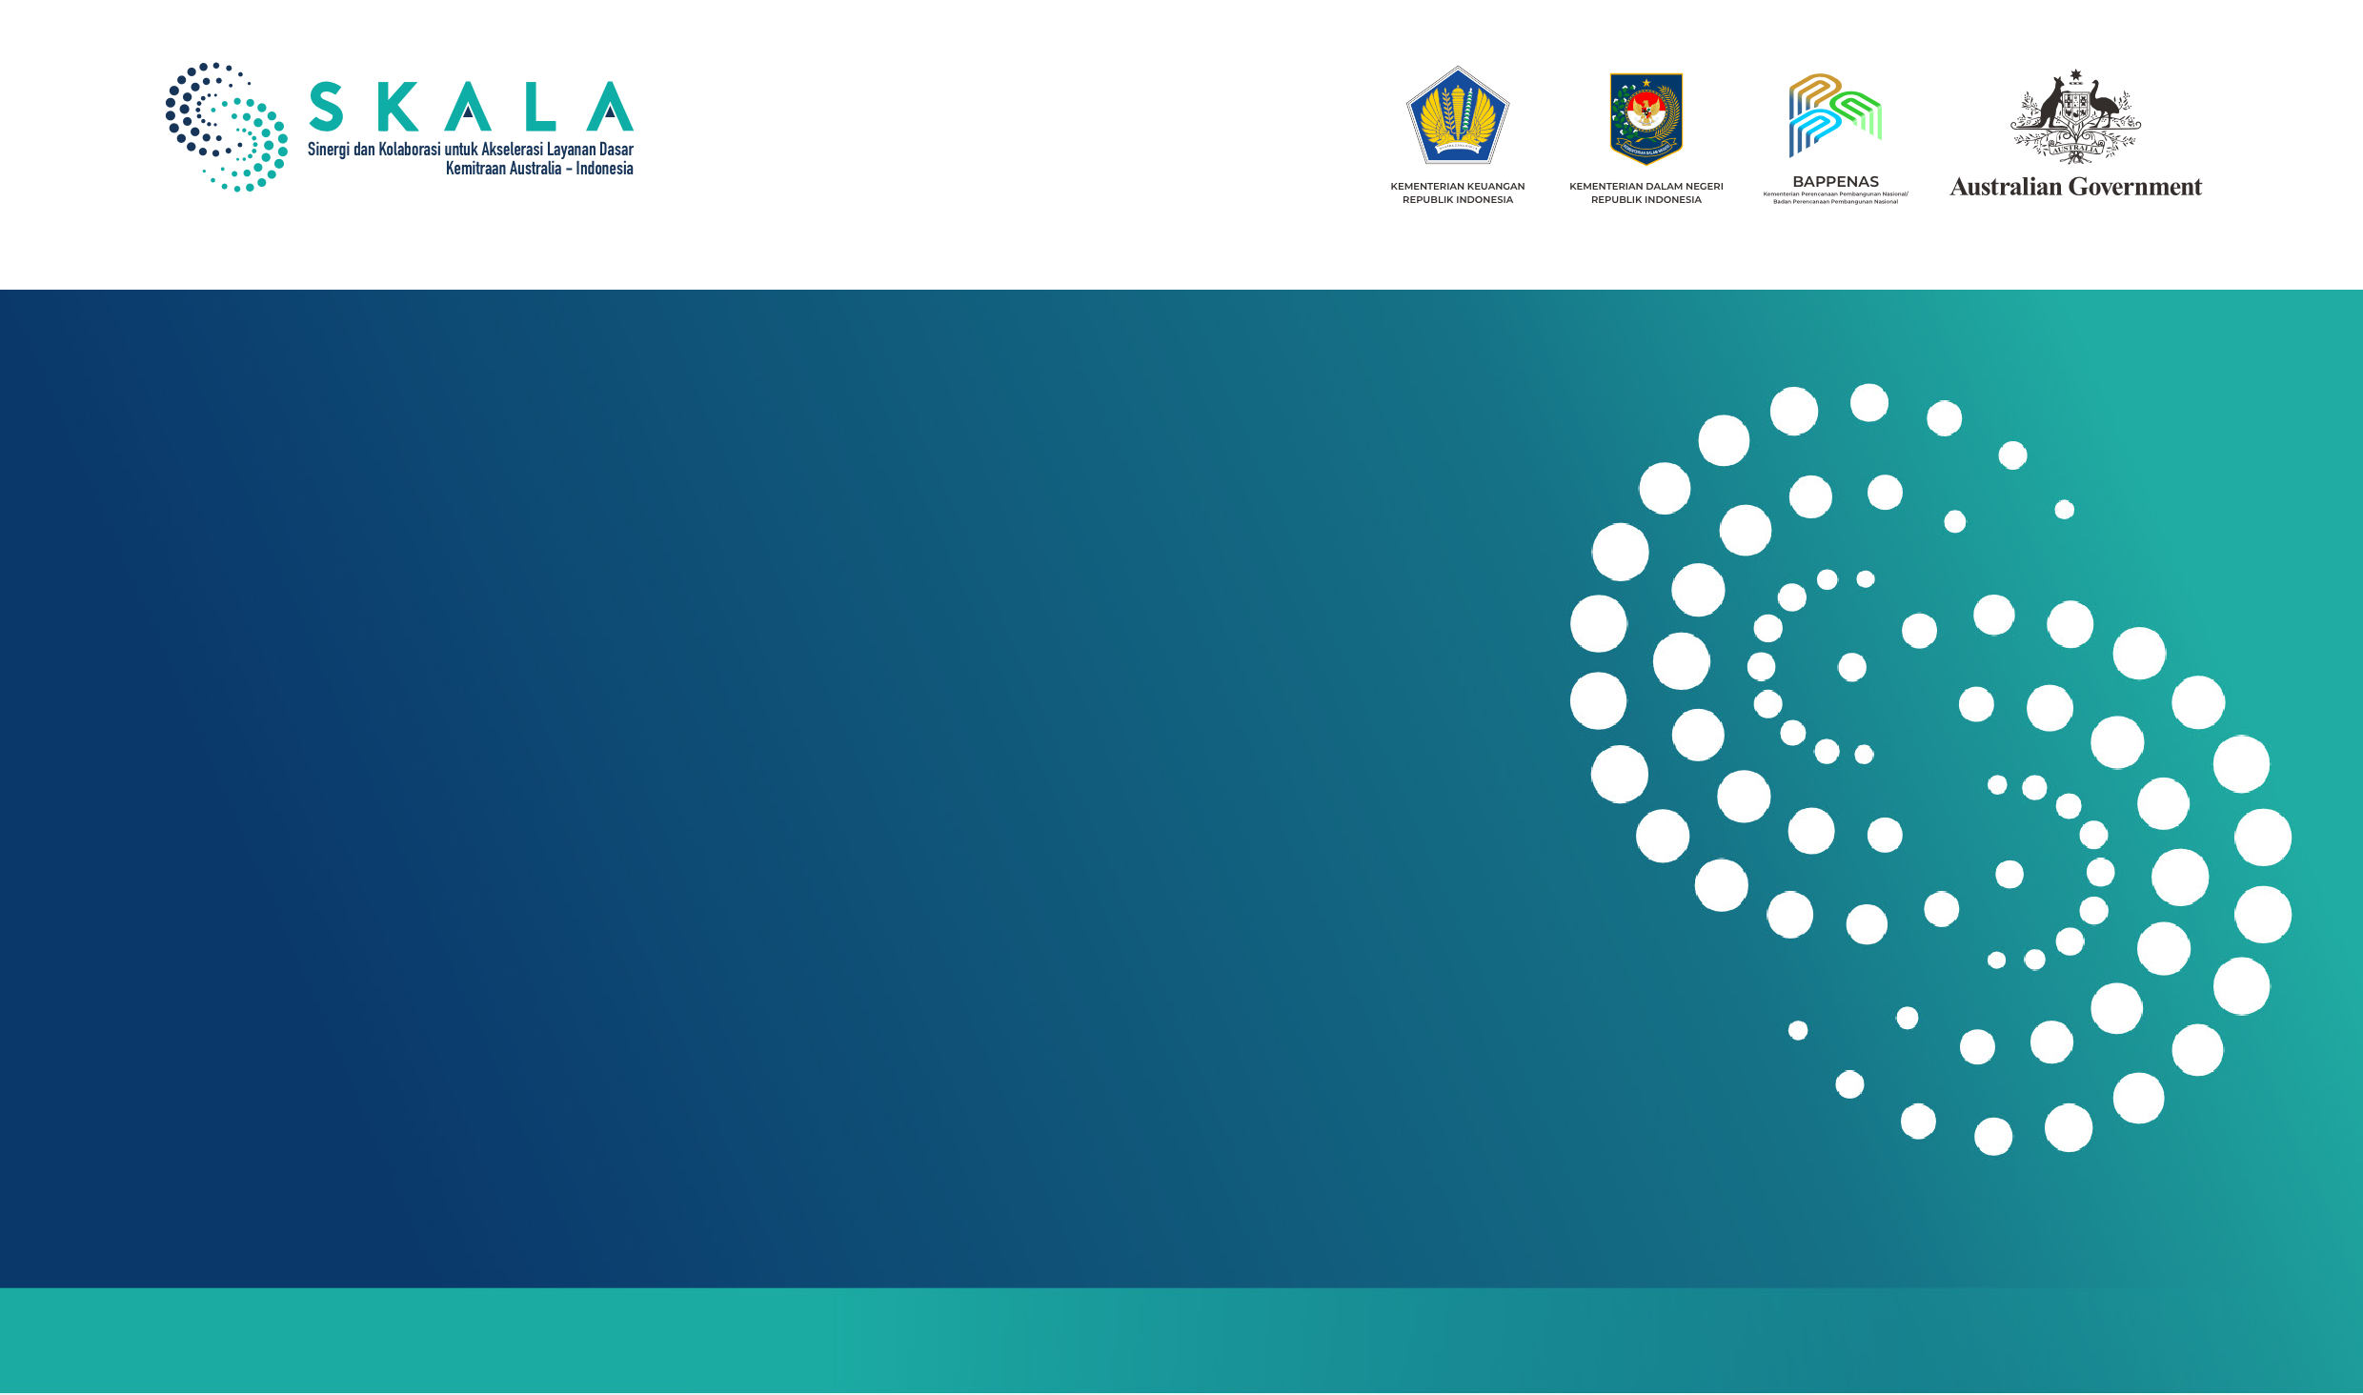

POLICY BRIEF

**Using the National Socio-Economic Single Data for Poverty Reduction & Inclusive Social Protection:** Lessons from Regsosek

**July 2025**

Presidential Instruction No. 4 of 2025 on the National Social and Economic Single Data (DTSEN) is a strategic initiative designed to strengthen the quality of planning and budgeting for inclusive poverty alleviation and social protection programs. The use of DTSEN is also emphasised in Inpres No. 8 of 2025 on the Optimisation of Poverty Reduction and the Elimination of Extreme Poverty. Interventions based on DTSEN and other socio-economic data can generate systemic impact if designed to protect poor populations, prevent the middle-income group from falling into vulnerability, and support the utilization of DTSEN at the subnational level. This policy brief identifies two key challenges: the numerous administrative requirements and slow data access procedures for granting data access, particularly “shapefiles” showing the distribution of poor and vulnerable populations, and the uneven capacity across local governments to analyse and use data for planning and budgeting purposes. It also complements the SKALA program’s recent policy brief on strengthening DTSEN updating processes, which emphasises the importance of timely, coordinated data updating across all levels of government.

**Keywords:** *Utilisation, DTSEN, data access rights, human resource competencies*

# Background

**Strengthening the accuracy of socio-economic data remains critical for advancing the national agenda to eliminate extreme poverty, as outlined in Presidential Instruction No. 4 of 2022.** An analysis of 2023 Susenas data, combined with insights from the Directorate of Poverty Alleviation and Community Empowerment, Bappenas, revealed that only 32% of eligible households received food assistance. A major contributing factor is the limited effectiveness of data updating systems at the subnational level. To address these challenges and minimise future risks, the government introduced

Presidential Instruction No. 4 of 2025 on DTSEN. The governance and oversight of DTSEN are coordinated across multiple ministries, including the Coordinating Ministry for Human Development and Cultural Affairs; the Coordinating Ministry for Economic Affairs; Bappenas; the Ministry of Social Affairs; the Ministry of Villages, Development of Disadvantaged Regions, and Transmigration; as well as the Ministry of Home Affairs. DTSEN is expected to enhance the impact of planning and budgeting for poverty reduction and social protection, contributing to the achievement of Indonesia’s Vision

2045. DTSEN aims to improve data completeness and accuracy, thereby strengthening the impact of planning and budgeting processes on poverty reduction and social protection, in support of Indonesia’s Golden Vision 2045.

1

Graph 1. Percentage of Poor-Vulnerable Population and Middle Class, 2019–2023

into poverty have not yet been fully optimised (Graph 1). *Third,* budgetary limitations, institutional governance constraints, and human resource capacity gaps at the local level continue to hinder the effective implementation of employment creation and expansion programs, particularly those involving collaboration with the private sector.

|  |  |  |  |  |  |  |  |  |
| --- | --- | --- | --- | --- | --- | --- | --- | --- |
| 53 |  |  |  |  |  |  | 25 | Given these challenges, the availability of regularly |
| 48  43 | 21,45  48,2 | 20,85  47,78 | 48,17  19,82 | 49,21  18,06 | 49,47  17,44 | 49,22  17,13 | 20  15 | updated, disaggregated socio-economic data down to the village level is essential. Such data can facilitate: (i) private sector risk assessments for investments in new areas; and  (ii) local government efforts to design employment creation initiatives for poverty reduction through partnerships with the private sector. |

38

33

28

2019 2020 2021 2022 2023 2024

**International research confirms the critical link between**

**data accessibility and investment climate.** The OECD

10 (2019) notes that valid and disaggregated socio-economic data can generate gains equivalent to 0.1 to 1.5% of GDP by reducing inefficiencies caused by information

32,64

33,26

31,05

31,61

32,34

29,97

5 asymmetry.2 Frontier Economics (2021) highlights that the

private sector perceives restrictions on non-confidential data access as obstacles to lowering operational costs

0 and connecting investments to downstream economic

activities.3 In the Indonesian context, ensuring that socio-

 Poor and Vulnerable  Aspiring Middle Class  Middle Class

*Source: Susenas, BKF-Ministry of Finance (analysed data)*

**The design and utilisation of DTSEN must be responsive to the dynamic movement between income groups.** Lessons from the implementation of Presidential Instruction No. 4 of 2022 through the end of 2024 highlight three key observations. *First,* social protection interventions have remained narrowly focused on previously recorded poor and vulnerable groups, while local governments have made limited progress in updating targeting data. *Second,* strategies to safeguard and empower middle-income and vulnerable groups and prevent their downward mobility

economic data is accessible and used appropriately will be important for aligning subnational investment promotion efforts with the broader objectives of job creation, unemployment reduction, and poverty alleviation.

**From a social protection perspective, the Asian Development Bank (ADB, 2003) recommends an inclusive framework that includes five key components (see Table 1)**4 : (i) active labour market policies to support employment creation, (ii) social assistance for the most vulnerable, (iii) social insurance mechanisms to mitigate risks related to job loss, health, disability, work accidents, and old age, (iv) micro and area-based schemes for remote and vulnerable communities, and (v) child protection programs for boys and girls under the age of 18.

1 Indonesia’s Golden Vision 2045 refers to the national aspiration to become a high-income, inclusive, and sustainable country by its centenary of independence in 2045.

2 OECD. (2019). Economic and social benefits of data access and sharing. Retrieved from [https://www.oecd.org/en/publications/enhancing-access-to-and-sharing-of-](http://www.oecd.org/en/publications/enhancing-access-to-and-sharing-of-) data_276aaca8-en/full-report/economic-and-social-benefits-of-data-access-and-sharing_836734cb.html

3 Frontier Economics. (2021). Increasing access to data across the economy: A report prepared for the Department for Digital, Culture, Media and Sport. Retrieved from

https://assets.publishing.service.gov.uk/media/6062e149d3bf7f5cde260991/Frontier-access_to_data_report-26-03-2021.pdf

4 Asian Development Bank. (2003). Social Protection Strategy. Manila, Philippines: Asian Development Bank. (Original policy approved on September 13, 2001). Retrieved

from [https://www.adb.org/sites/default/files/institutional-document/32100/social-protection.pdf](http://www.adb.org/sites/default/files/institutional-document/32100/social-protection.pdf)

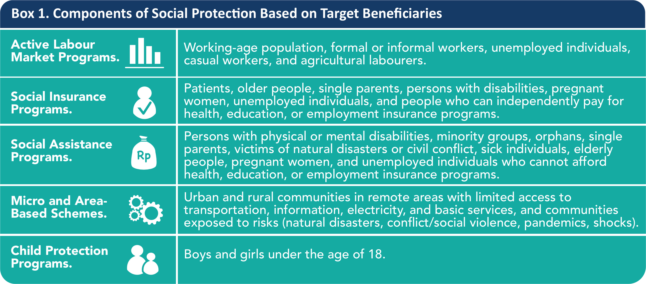

*Source: Adapted from ADB 2003*

**Lesson 2. During the Regsosek pilot (2023–2024), delayed data access prevented the regional government from using the data** to prepare its 2024 medium-term and annual development plans as well as regional budgets (RPJMD, RKPD, and APBD), and to design data-driven social protection programs.

**Lesson 3. The experience from Regsosek highlights the value of individual and household-level point data in *shapefile* formats.**5 Such data enable local governments and relevant ministries and agencies to conduct multidimensional analyses of poverty and socio- economic vulnerability, perform density mapping, design more climate-responsive social protection plans, allocate budgets more effectively, and enhance the monitoring and evaluation of program outcomes. To maximise DTSEN’s potential, the integration of individual and household point data should be prioritised.

**Lesson 4. The integration between DTSEN and sectoral data, can be optimised. This is particularly important in agriculture, livestock, and fisheries sectors, which are the primary sources of employment for poor and vulnerable populations.** Strengthening this integration is critical, as it would enable national and subnational planners to access individual-level poverty data based on:

(i) land ownership size, (ii) type and number of livestock owned, and (iii) seasonal patterns such as the onset and end of rainy or dry seasons. This, in turn, would support more accurate planning and more efficient targeting of agricultural and fisheries input subsidies.

**The SEPAKAT Regsosek platform has proactively incorporated variables needed to support these program components.** As of March 2025, Regsosek data contributed to 82% of the DTSEN variables, and SEPAKAT is positioned to serve as a key platform for DTSEN utilisation. This creates an opportunity for 26 provinces and 230 districts and cities already accessing SEPAKAT to leverage DTSEN, subject to any additional requirements that may be established.

**Lessons from the Use of Regsosek**

**Lesson 1. The Regsosek experience shows how access to disaggregated data has enabled regions to develop innovative social assistance and poverty reduction initiatives.** For example, disability data disaggregated by age, income, and disability type allowed One-Stop Administration (SAMSAT) offices in Aceh and NTB to match individuals with ownership data of three-wheeled vehicles starting in 2024. The resulting data matching supported the issuance of Governor Regulations that provided tax reductions for vehicles owned by persons with disabilities. Similarly, North Kalimantan Province was able to apply comparable policies within the same timeframe. The availability of Regsosek data has also enabled Gorontalo Province to integrate it with BPJS Health data, improving the accuracy of health insurance budget allocations for populations in deciles 1 to 4. This integration has enhanced budget efficiency, saving nearly IDR7 billion, through an innovative program introduced in 2025 called the Regsosek-Based Eligibility Assessment System for Achieving Universal Health Coverage (SPIKER UHC)

5 The latitude-longitude data available from Regsosek offers advantages not found in conventional tabular formats. This geospatial data can be converted into shapefile (.shp) format using geographic information system applications, enabling density- and distance-based analysis. Such analyses are invaluable for planners, as they complement the Construction Cost Index in designing budgets or incentive schemes for delivering basic services, from facilities to beneficiaries, particularly in remote areas or those far from growth centers; for example, through performance- based school operational grants and similar programs.

**Policy Brief |** Using the National Socio-Economic Single Data for Poverty Reduction and Inclusive Social Protection: **4**

Lessons from Regsosek



**Lesson 5. Experience from Regsosek shows that effective data updating at the local level depends on several key factors:** (i) strong alignment between the selected data variables and the operational needs of local agencies, (ii) the presence of clear evaluation and accountability mechanisms, and (iii) the existence of appropriate budget classifications to support data management activities and provide related incentives. DTSEN implementation would benefit from ensuring that these enabling conditions are in place to sustain regular and high-quality data updates.

**Lesson 6. The Regsosek experience highlights that human resource structures at the local level impact data use.** This challenge stems from the ongoing issue faced by civil servants (ASN) regarding the limited number and capacity of human resources. Functional personnel—including policy analysts, statisticians, planners, and others—often lack adequate competencies, particularly in data analysis, information interpretation, and the application of analytical results in planning and public policy formulation. Functional staff within regional government offices (OPDs), who are expected to serve as the government’s internal think tanks, continue to face capacity gaps. These limitations hinder the optimal use of DTSEN as a foundation for evidence-based policymaking, leading to a reliance on external parties for data processing and analysis.

# Policy Recommendations

1. **Encourage the integration of DTSEN with other sectoral data sources,** particularly the Basic Education Data (Dapodik), Satu Sehat, SAMSAT, and other technical/sectoral data sources, including data from the agriculture and fisheries sectors.
2. **Facilitate access to aggregate data down to the village/sub-district level** for officers designated as DTSEN operators in regional areas. This is intended to enable these operators to respond swiftly to ad hoc data and analysis requests from local leaders. The current requirement to request data access from central-level operators at all times has led regional areas to rely on alternative data sources that are more accessible and still verifiable.
3. **Adopt all existing data variables from Regsosek,** particularly geospatial data points such as latitude/longitude/ shapefiles from BNBA, into the DTSEN platform. This would enable local governments to utilise such data in formulating social protection programs aimed at addressing multidimensional poverty, given that the root causes of poverty vary across regions.
4. **Clarify the budget nomenclature** that may be utilised by regional governments, including village/sub-district

administrations, to provide incentives for DTSEN data updating activities.

1. **Enable regional governments to clarify the governance structure of functional positions** so they can optimise the use of DTSEN in supporting policy planning and analysis. To this end, there needs to be clarity regarding the units and supervisory duties responsible for functional officers in the regions, enabling them to serve as think tanks that provide evidence-based policy recommendations – including those based on DTSEN – as well as research requested by regional leaders.

*Disclaimer:* The views, findings, interpretations, and recommendations presented in this publication do not necessarily represent the official policy or position of the Government of Indonesia, the Government of Australia, or DT Global. The SKALA Program is supported by the Australian Department of Foreign Affairs and Trade (DFAT) and is managed by DT Global.