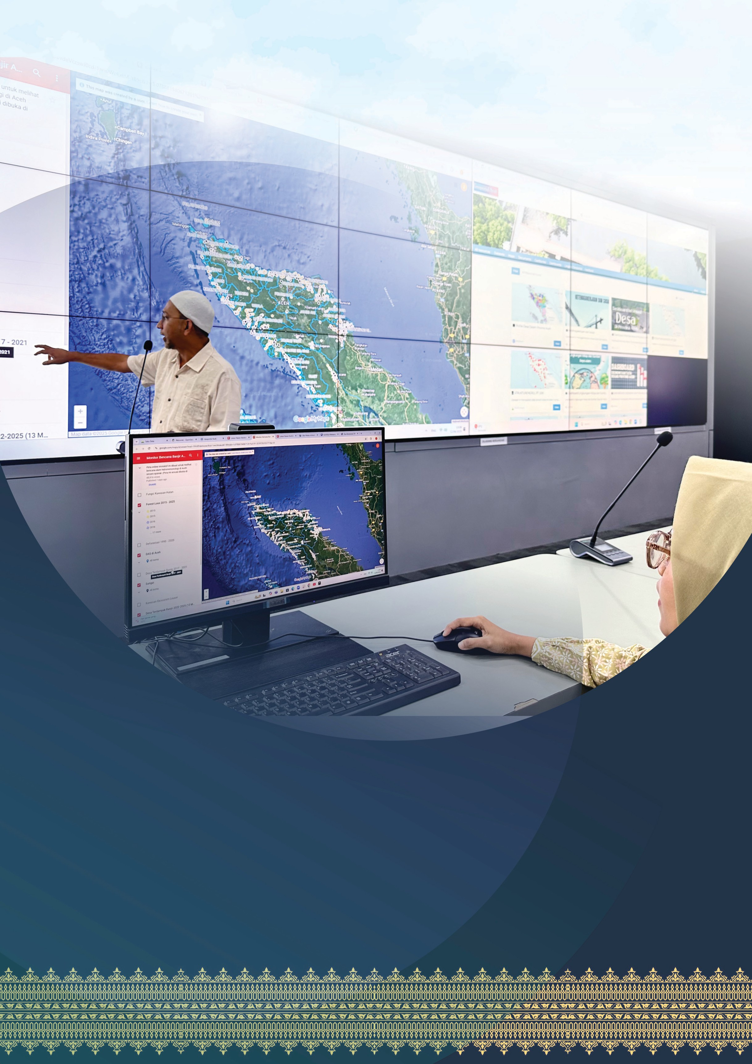

Aceh Synergy:

A Model of Government– University Collaboration to Advance One Data Aceh

The Aceh Provincial Government and the Statistics Study Program at Syiah Kuala University (USK), supported by the SKALA Program, are working together to accelerate the implementation of One Data Aceh. This partnership addresses shortages in skilled personnel

and supports Ministry of Home Affairs Regulation No. 5 of 2024 on One Data for Domestic Government (SDPDN), which requires subnational governments to share and use data.

Through an internship program, USK students take part in data cleaning, validation, migration, and processing. Their involvement strengthens the province’s data management capacity and contributes to public policies that are more targeted, responsive, and evidence-based.

In an era of increasingly evidence-based development, accurate, integrated, and accessible data form the foundation for planning, decision-making, and policy evaluation. Recognising this, the Government of Indonesia is continuing to advance the implementation of One Data Indonesia (SDI) as a national framework for strengthening cross-sector and cross-agency data governance.

Aceh has taken a progressive step by strengthening One Data Aceh through a strategic collaboration with USK’s Statistics Study Program. Supported by SKALA, the Australia–Indonesia Partnership for Decentralisation to Improve Basic Services, the collaboration gives students the chance to engage directly in subnational government data management. This model initiative shows how academia can contribute meaningfully to data governance reforms while enriching students’ learning through practical involvement in regional development processes.

Highlighting its role in improving data coordination, Marwan Nusuf, Head of the Aceh Communication, Informatics and Encryption Agency (Diskominsa) said, “The Aceh One Data Portal aims to strengthen coordination among government agencies in providing accurate, relevant data that is accessible to all.” The portal is available at satudata.acehprov.go.id.

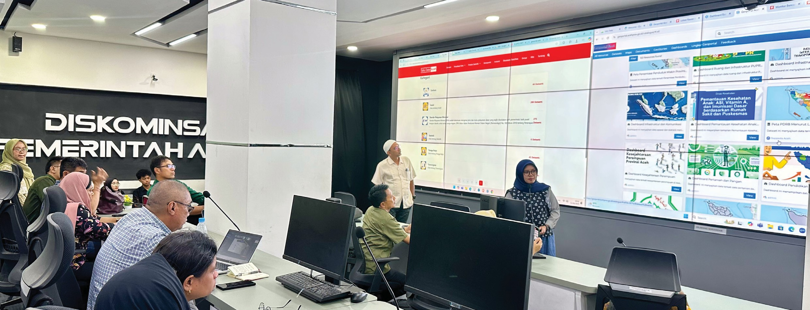This partnership connects the government’s technical needs with the academic capacity of students through internships and the Merdeka Belajar Kampus Merdeka (MBKM) scheme. It also helps address shortages of skilled personnel in data and statistics management that have hindered integration ettorts.

**Sinergi Aceh:**



2

Praktik Baik Kolaborasi Pemerintah dan Universitas untuk Akselerasi Satu Data Daerah

The collaboration is aligned with the Ministry of Home Attairs (MoHA) Regulation No. 90 of 2019 on the classification, codification, and nomenclature of subnational development planning and finance, which defines statistics as a mandatory local government function. Dedicated resources and orderly, standardised data management systems are therefore required. The initiative is designed not only to meet present needs but also to build a resilient and inclusive data ecosystem for the future.

# The Role of Students in Supporting Strategic Policies and Programs

In the Academic Year 2024–2025, 52 students joined the internship program: 12 in Cohort 1 and 20 each in Cohorts 2 and 3. Among them, two sixth-semester USK students, Tasya Ulhusna and Muhammad Firdausi Nuzula, undertook Thematic Community Service (KKN) while also participating in MBKM. Their work focused on One Data Aceh’s implementation.

Over four months, these students undertook technical tasks that had previously been handled only by government statt. Working with the Statistical Technical Implementation Unit (UPTD Statistics), they cleaned and validated data, including handling incomplete, invalid, or confidential information, and helped classify and organise datasets according to national metadata standards.

A key task was facilitating the migration of data from various ministry and agency applications to the Open Data Aceh Portal, a prerequisite for full integration into the One Data Aceh system. The datasets included sectoral data from multiple provincial agencies (SKPA) as well as Minimum Service Standards (SPM) data, both of which are crucial for assessing public service performance.

In addition to strengthening the data steward *(walidata)*, which in this case is Diskominsa via UPTD Statistics, the USK–Government collaboration also supported the village information system (SIGAP). In this multi-stakeholder partnership, USK and other universities mobilise students and supervisors, provide training, and oversee field activities. The Aceh Provincial Village Community Empowerment Agency (DPMG) acts as the provincial policy lead for community empowerment, issuing technical guidance for SIGAP and administrative support. SKALA provides the framework and technical assistance needed for success, while district and city governments facilitate implementation in their areas, ottering logistical support and coordinating with village authorities.

Commitment from the heads of regions, provision of student facilities such as lodging and meals, and structural backing that includes the involvement of the Regional Secretary, subdistrict heads, and village heads, are critical to implementation. Through the Campus with Impact *(Kampus Berdampak)* scheme, participating students receive formal recognition equivalent to 20 credit points (SKS) for four months of village placement.

SIGAP’s impact and success in Aceh are clearly evident, with South Aceh achieving the highest percentage of SIGAP data input in 2022. With SIGAP, communities and governments can more ettectively monitor village administration, while village planning becomes more focused and inclusive through the use of disaggregated data, leading to higher-quality Village Medium-Term Development Plans (RPJM Gampong).

SIGAP also strengthens collecting and aggregating data for district, city and provincial levels through the One Data cycle, with DPMG serving as a data producer drawing on village sources.

**Sinergi Aceh:**



3

Praktik Baik Kolaborasi Pemerintah dan Universitas untuk Akselerasi Satu Data Daerah

# Regulation as Foundation, Collaboration as the Key

This work aligns with the latest MoHA Regulation No. 5 of 2024 on One Data for Domestic Government (SDPDN), which reinforces the role of local governments in managing development data and highlights the need for dedicated resources for the data cycle, including verification and validation.

In practice, students helped compile the 2024 Aceh Government data inventory, an essential first step in organising the sectoral data map, verifying and validating datasets, and publishing data. They also participated in the Aceh One Data Ecosystem Workshop hosted by Diskominsa, gaining an end-to-end understanding of the regional data ecosystem.

An Implementation Agreement between the Faculty of Mathematics and Natural Sciences (FMIPA), USK’s Statistics Study Program, and Diskominsa clarifies the roles of each party. From hands- on student participation in data reform to institutional collaboration, this partnership shows that integrating academia and bureaucracy is not only possible but also urgent and strategic.

# What Was Done

This MBKM activity went beyond a conventional internship. The placement was formally converted to 20 credit points, reflecting the workload and the significance of learning outcomes. Students did more than process data. They also learned how data informs public policymaking. Their key contributions included:

Cleaning and processing raw datasets from provincial agencies (SKPA), including managing missing fields and confidential information.

Supporting data migration from multiple national ministry and agency applications into the Open Data Aceh Portal, harmonised with the One Data Aceh structure.

Mapping and aligning sectoral datasets and Minimum Service Standards (SPM) data to ensure consistent formats, metadata, and update frequencies.

Assisting with entry and validation of the 2024 Aceh Government data inventory as part of comprehensive provincial-level data collection.

Participating in the Aceh One Data Ecosystem Workshop to deepen understanding of open data and system interoperability.

For One Data Aceh internship students, Tasya Ulhusna and Muhammad Firdausi Nuzula, the placement provided valuable lessons in collaboration and problem-solving.

**Sinergi Aceh:**



4

Praktik Baik Kolaborasi Pemerintah dan Universitas untuk Akselerasi Satu Data Daerah

“The learning facilitated by the SKALA Program was highly beneficial,” Tasya said

For both, the experience also ottered new insights into the importance of cross-sector collaboration and the real-world challenges of data management in the field.

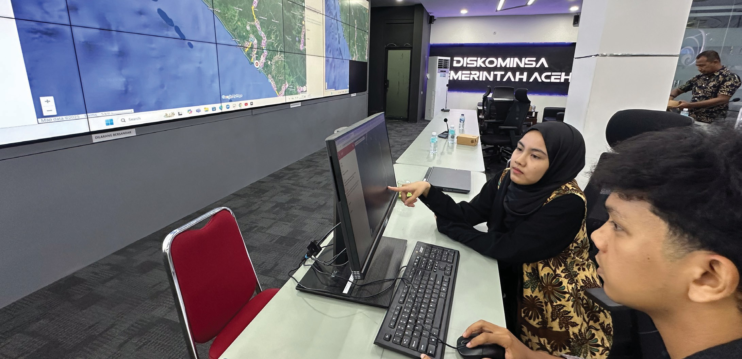

# A Relevant and Replicable Multi-Stakeholder Collaboration

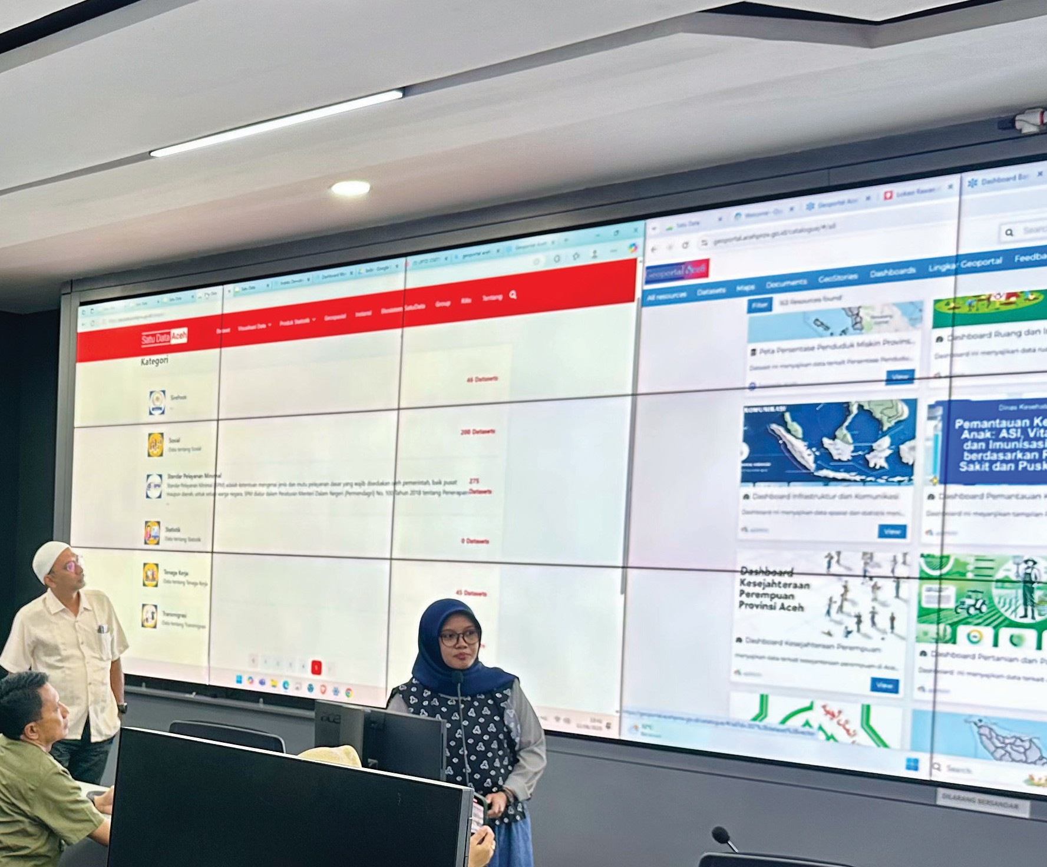This government–university collaboration shows that engaging academia not only meets short-term technical needs but is also a strategic investment in long-term bureaucratic reform. Students gain direct field experience, while the government receives tangible support to strengthen more orderly, standardised data systems.

The Aceh initiative has already inspired other regions. This model for engaging universities in improved data governance has been studied first-hand by representatives from three other SKALA partner provinces through study visits facilitated by MoHA’s Data and Information Centre (Pusdatin). The strong interest shown during these visits indicates significant potential for scaling nationally as a good practice.

**Sinergi Aceh:**



5

Praktik Baik Kolaborasi Pemerintah dan Universitas untuk Akselerasi Satu Data Daerah

# Looking Ahead to One Data Aceh

Through multi-stakeholder approaches like this, the Aceh Provincial Government demonstrates that accelerating One Data is more ettective when academia is engaged as a strategic partner. Students

not only gain technical skills – they are part of the solution, building systems that are more open, measurable, and impactful.

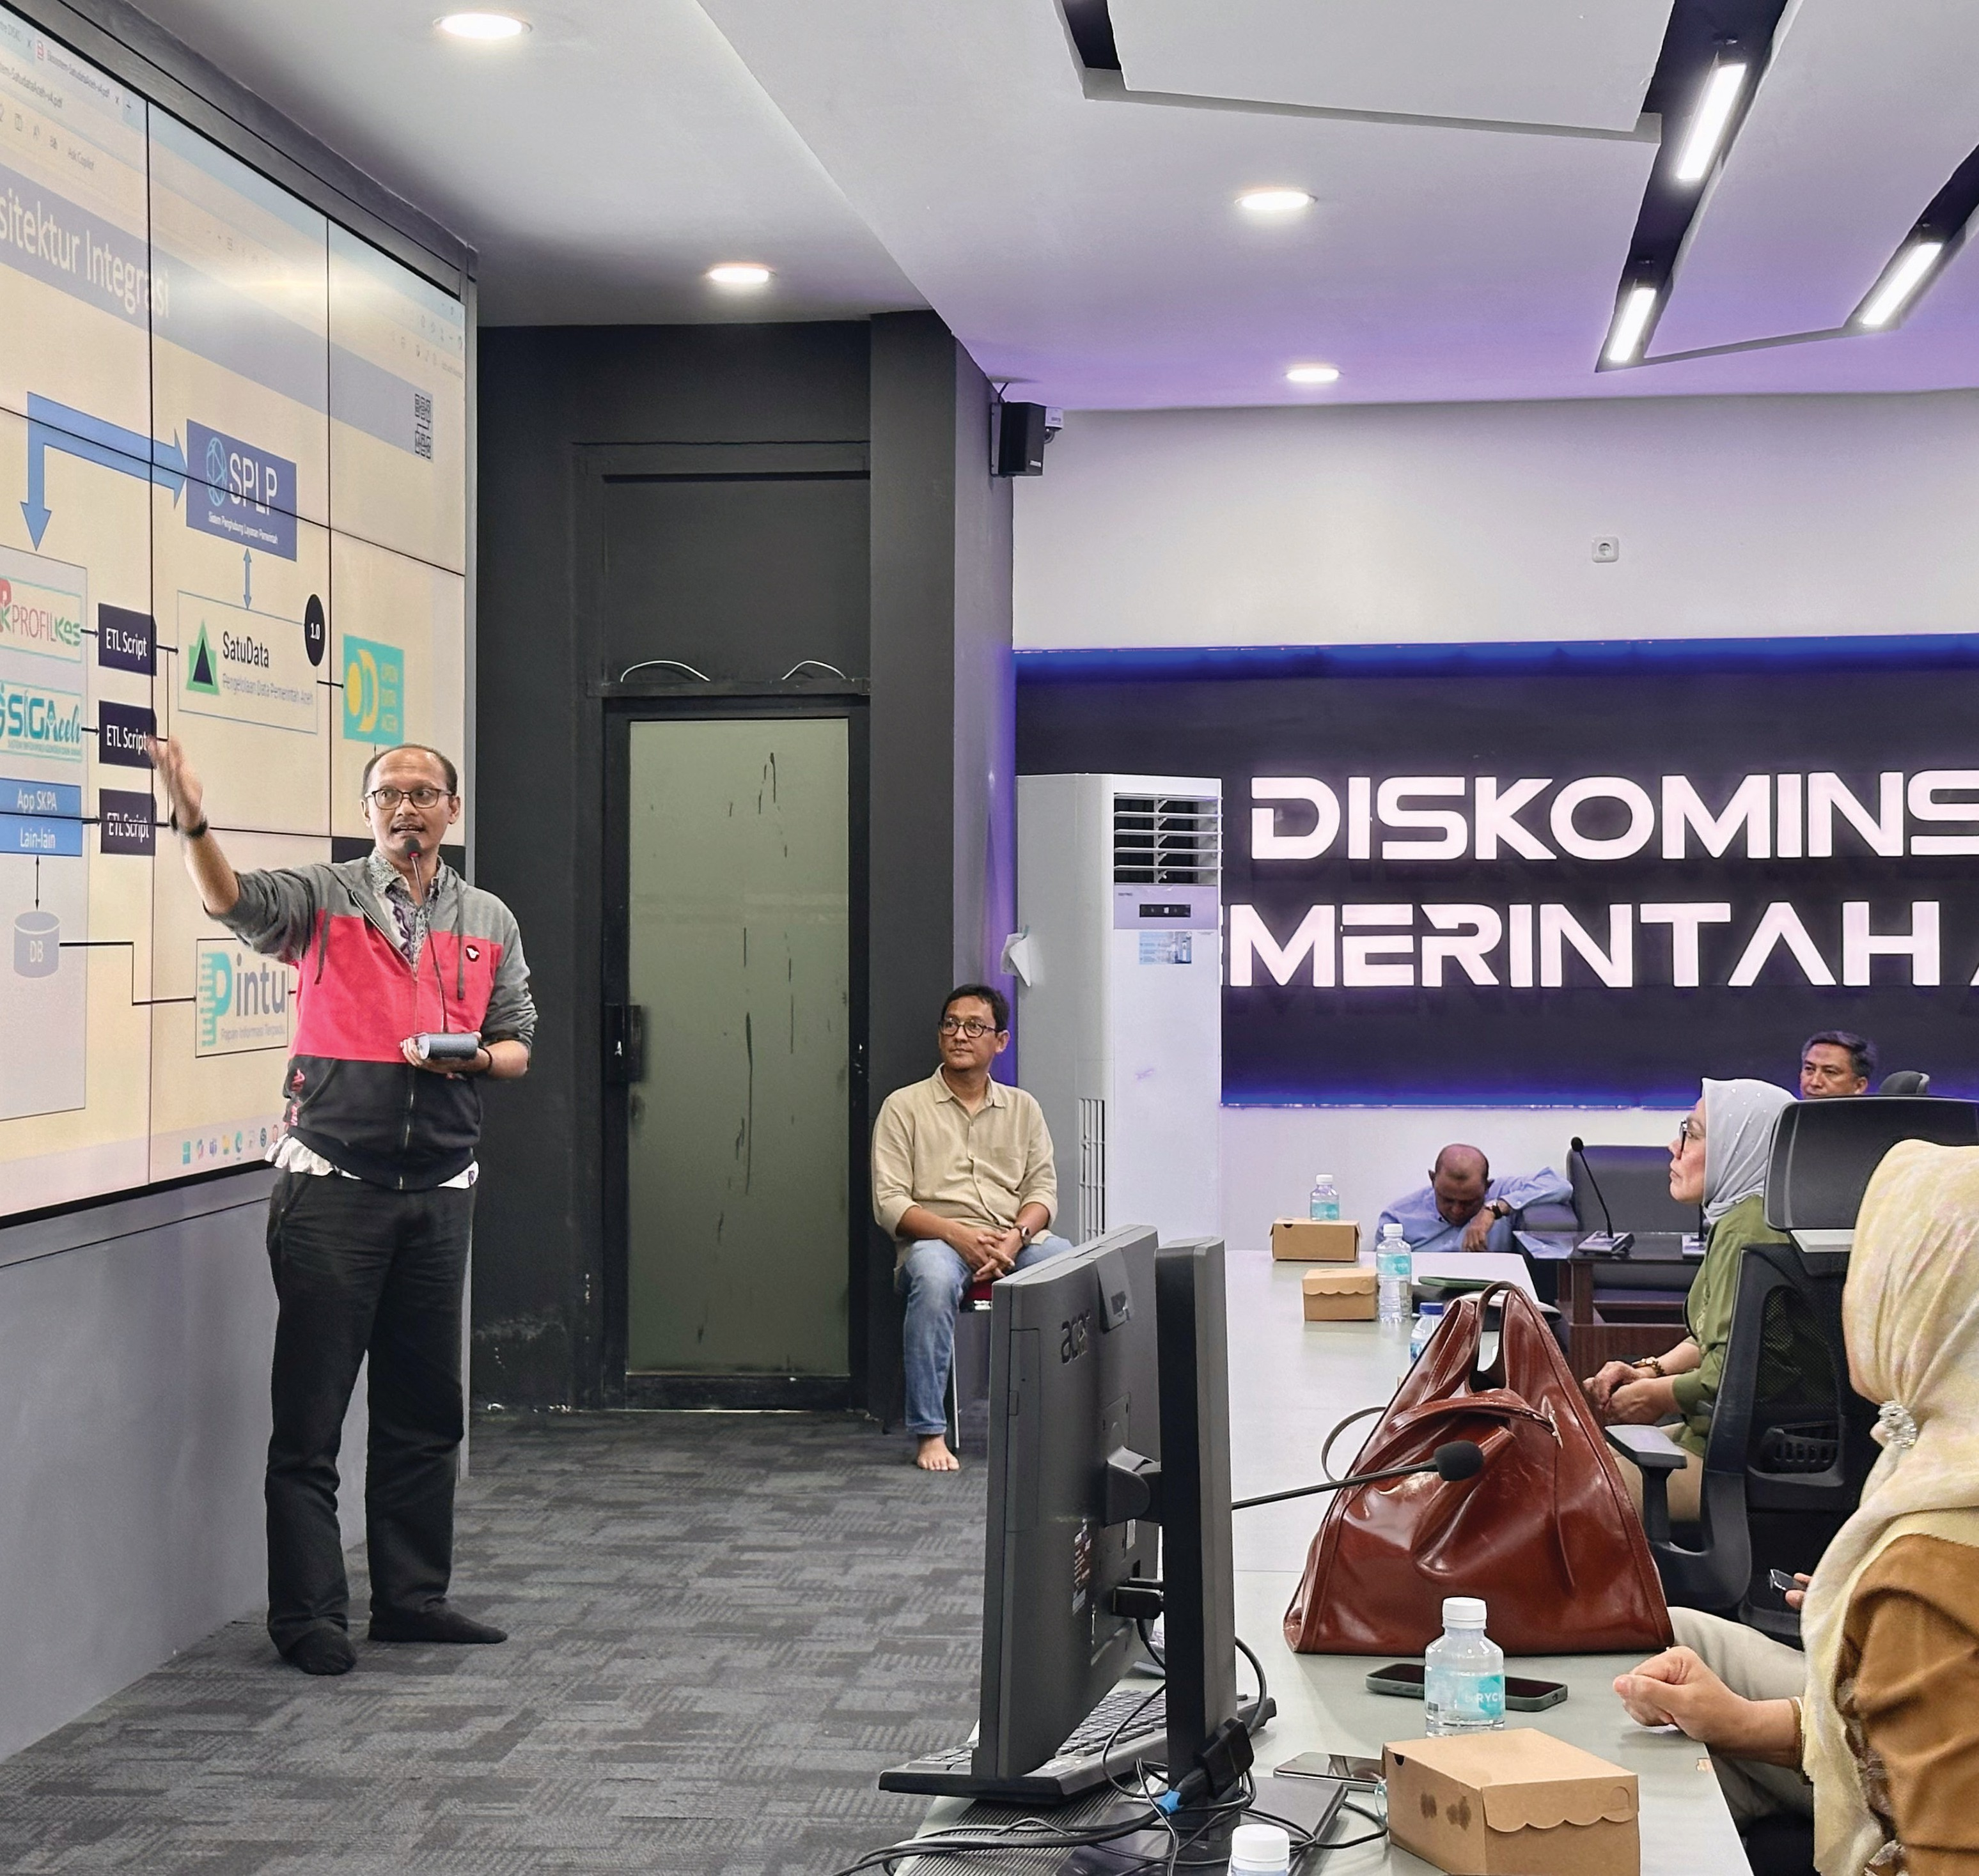

*Sinergi dan Kolaborasi untuk Akselerasi Layanan Dasar (SKALA)* is an Australia-Indonesia Partnership Program aimed at supporting the Government of Indonesia’s efforts to reduce poverty and inequality by improving basic-service provisions to poor and vulnerable communities in less-developed regions.

**CONTACT US**

**IFC Tower 2, Level 17**

**Jl. Jendral Sudirman Kav. 22-23 Jakarta 12G20**

[**communications@skala.or.id**](mailto:communications@skala.or.id) **s.id/Channel-SKALA**

**SKALA.or.id**