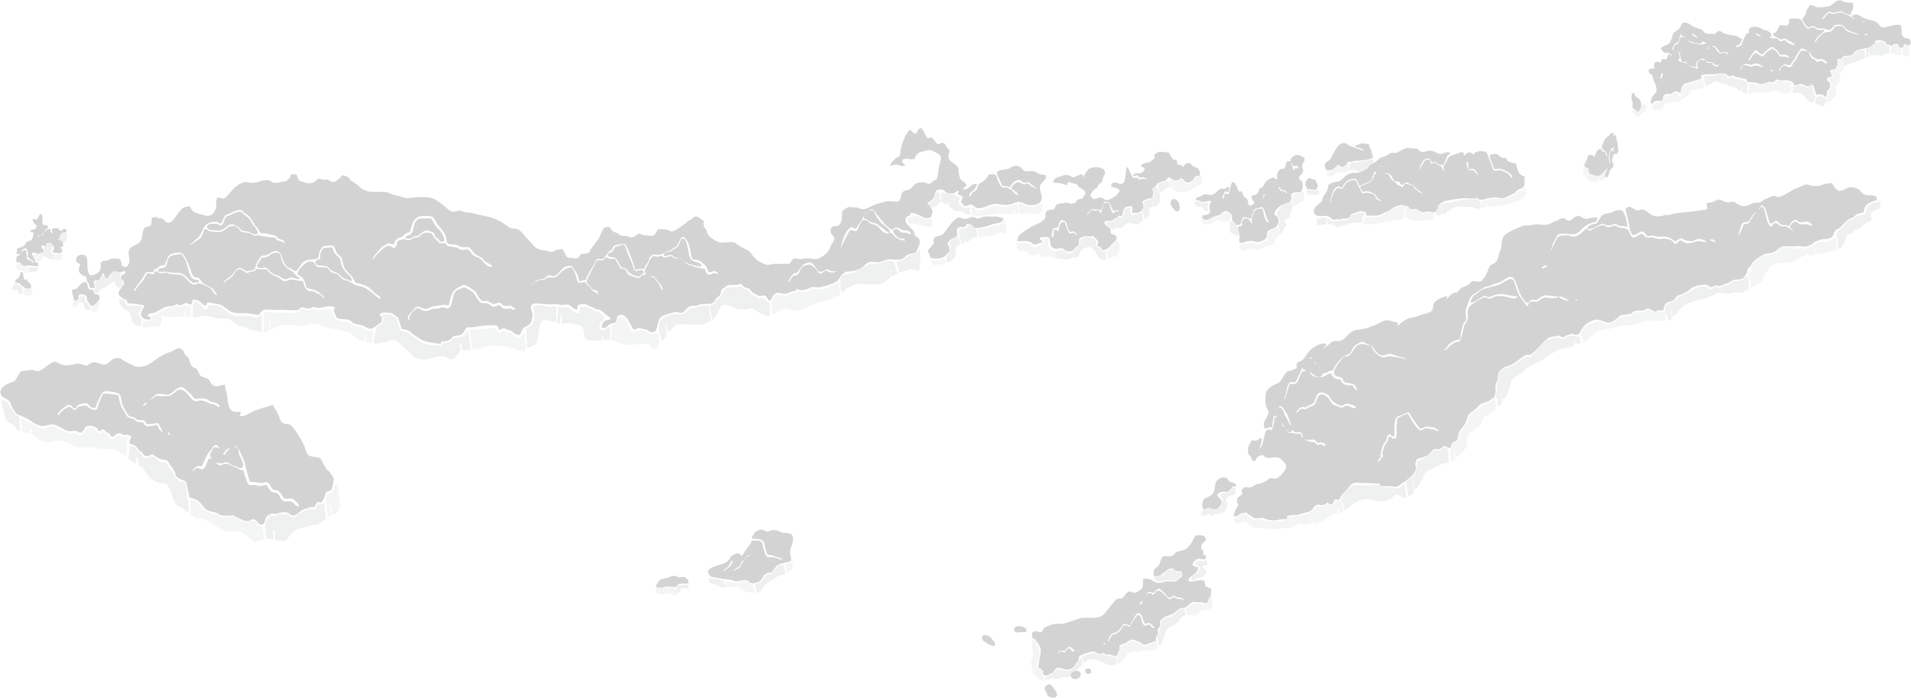

Collaboration for

the Acceleration of Basic Services in the NTT Province

June 2025

Nusa Tenggara Timur’s government envisions a healthy, smart, advanced, and prosperous province. To achieve this goal, the government is expanding inclusive and accessible health and social security services, ensuring equitable quality education, strengthening sustainable infrastructure to build a competitive economy, and promoting social welfare and equal opportunity for a dignified life.

To support these efforts, the Provincial Government of Nusa Tenggara Timur is collaborating with SKALA, the Australia–Indonesia Government Partnership Program, with a focus on strengthening governance, data integration, public financial management, and the delivery of inclusive basic services. Through capacity-building initiatives, policy support, and technical assistance, the NTT Government is working to realise its vision of a more inclusive and prosperous province.

1


Key Areas of Alignment
2


Stronger Governance and Regional Fiscal Capacity

Good governance, a competent civil service, optimisation of regional revenue, and the utilisation of digital technology are key elements in the mission and programs of the elected Governor of East Nusa Tenggara (NTT). The Provincial Government of NTT pursues these objectives through the following strategic initiatives:

- Providing capacity-building support on regional budget policy, fiscal planning, and mandatory spending on public service infrastructure to enhance government preparedness in budgeting and financial management.

- Capacity building for regional civil servants and village officials in using the SEPAKAT application (Integrated Planning, Budgeting, and Performance Evaluation System)
to carry out macro and micro data-based analysis, ensuring that planning and budgeting processes are more evidence-based and responsive to community needs.

- Coordinating with the MoHA, MoF, and BAPPENAS to better align local and national regulations, including support for developing regional regulations such as standard operational procedures and guidelines for NTT Satu Data and Regional Taxes and Levies.

- Improving data use in decision making through training for civil servants from 16 districts in using E-SPM, a system for tracking and reporting Minimum Service Standards (MSS).

- Enhancing regional tax management across 22 districts to strengthen local revenue collection and ensure smooth policy implementation.

- Conducting community outreach to raise awareness of new vehicle taxes which resulted in a 25% increase in Motor Vehicle Tax (PKB) revenue in early 2025 compared to early 2024.

 Delivery of Inclusive Basic Services
The Government of East Nusa Tenggara (NTT) is strengthening basic services through improved regional financial management and public service delivery. The NTT Government has undertaken various strategic efforts to ensure better, more inclusive, and sustainable basic services for all community groups. These efforts include:

- Supporting integration of data for social assistance in 22 districts by partnering with the Social Service Agency to benefit 24,560 vulnerable individuals.
3

- Working with the Provincial MSS Implementation Team and providing support and oversight to improve the quality of MSS across West Timor and Sumba.

- Contributing to improvements in service quality, with all previous worst-performing districts now at the Tuntas Pratama status or higher.

- Supporting regulatory development, capacity building, and dissemination across 22 districts, strengthening local revenue collection as a sustainable funding source for basic service delivery.


Advancing Social Well-Being, Equity, and Quality Of Life

Promoting social welfare, equal access, and a dignified quality of life is central to the Governor’s vision of NTT’s future by:

- Implementing gender equality, disability, and social inclusion (GEDSI) strategies by collaborating with civil society organizations (CSOs) focused on older people, women, and people with disabilities to draft the Provincial Action Plan on Aging.

- Ensuring accessibility in policymaking and public participation by facilitating accessible venues and sign language interpreters at government events.

- Strengthening inclusive planning by supporting local governments and CSOs in policy development and capacity building for gender-responsive budgeting, including training 40 Regional Government Budget Team staff.

Penguatan Kolaborasi antara Pemerintah dan Masyarakat Sipil
The Collaboration Pillar, which is the seventh pillar of the Governor of East Nusa Tenggara’s (NTT) Priority Program, to enhance civil society participation, particularly in service delivery for vulnerable groups through:

- Facilitation of Inclusive Development Planning Forums for Vulnerable Groups (Musik Keren): Initiating a collaborative model between government and civil society in
the form of Musik Keren in NTT Province. This initiative has been institutionalized through Governor Regulation No. 2 of 2025 on the Implementation of Inclusive Development Planning Forums for Vulnerable Groups.

- Capacity Building for Civil Society Organizations (CSOs) and Civil Servant Facilitators: Providing training to 15 CSOs and 10 regional civil servant facilitators to ensure effective implementation of inclusive planning forums. This platform enables vulnerable groups, including women, children, persons with disabilities, the elderly, and remote Indigenous communities, to meaningfully express their aspirations in local planning and budgeting processes.

Alignment with the Governor’s Upcoming Challenges

One of the main challenges for the new administration is the efficiency of the NTT Provincial Budget (APBD). This situation demands more frugal financial management and a sharper focus on priority programs, particularly through the General Allocation Fund (DAU) amounting to IDR
2.03 trillion. The NTT Provincial Government is working to address this challenge through:

- Strengthening Data-Based Planning: Developing more accurate and up-to-date policies based on data, in alignment with the NTT Development Policy Directions for 2025–2029.

- Optimizing Budget Allocation: Enhancing fiscal management so that limited resources can be used more effectively for basic services.

- Facilitating SPM Integration: Aligning Minimum Service Standards (SPM) with regional development plans to maintain the quality of public services despite budget constraints.

4

Next Steps and Continued Support
5

In line with the Governor’s vision, SKALA aims to prioritize the following areas:

Strengthen Development Planning: Provide technical input to expand the Regional Medium-Term Development Plan (RPJMD) to include GEDSI, data, and MSS policy goals, as well as supporting adjustments to Regional Government Work Plans (RKPD).

Enhance Fiscal Management: Assess local revenue
Rp potential, upskill Provincial Revenue Office staff in local tax collection, and provide technical assistance on
adjusting regional expenditure in line with Presidential Instruction 1/2025 on budget efficiency.

Promote Data Use: Advocate for enacting NTT’s One Data Action Plan through Governor Regulations, a Decree on the Data List, and developing the One Data Portal (SASANDO).

Improve Coordination and Efficiency: Continue to support Coordination, Guidance, and Supervision (Korbinwas) activities and regular reflections to enhance service delivery.

Strengthen Social Welfare Systems: Continue developing the Inclusive Community Poverty Service System Portal to streamline data verification and validation for poor and vulnerable groups.

6




IFC Tower 2, Level 17
Jl. Jendral Sudirman Kav. 22‑23 Jakarta 12920
 skala.or.id  communications@skala.or.id

https://s.id/Channel‑SKALA

