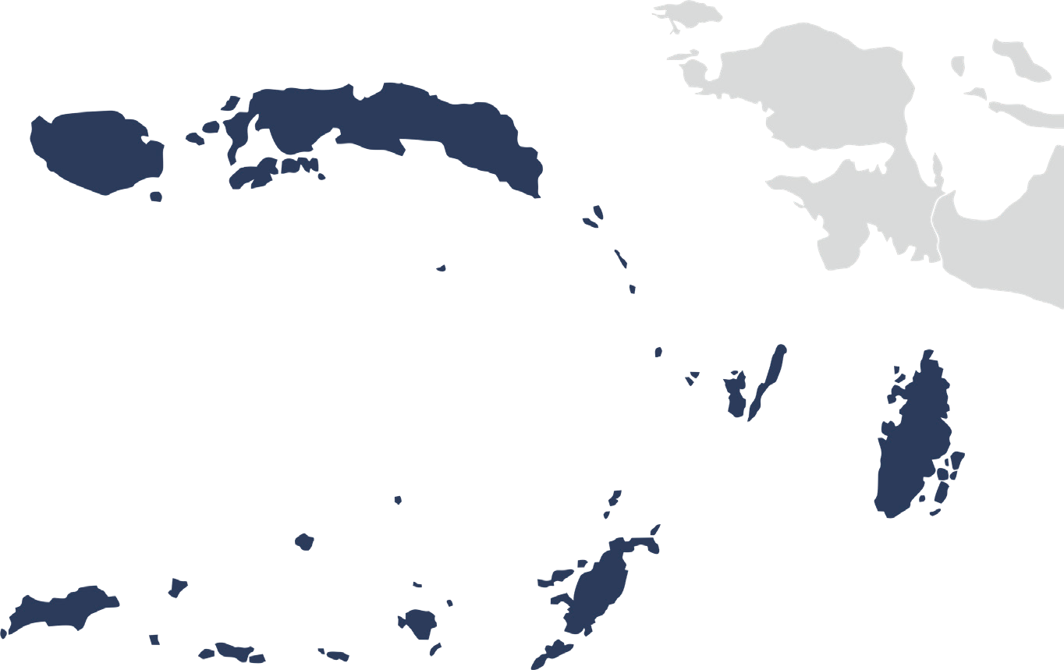


Collaboration

for the Acceleration of Basic Services in Maluku Province

July 2025

The challenging geographic conditions, coupled with limited local government budgets, affect both the reach and quality of basic services in Maluku Province, particularly for vulnerable groups such as the poor, women, children, and persons with disabilities. Effective governance and inclusive development are key to improving community welfare.

To address these challenges, the newly elected leadership of the Maluku Provincial Government has adopted a vision of Transforming Maluku towards a progressive, just, and prosperous province in anticipation of Indonesia Emas 2045. The development vision for Maluku 2025–2029 focuses on strengthening governance and public service delivery, eradicating poverty through targeted policies, enhancing human resource development, promoting gender equality and the empowerment of women and persons with disabilities, increasing the quantity and quality of infrastructure and interregional connectivity, fostering inclusive economic growth, and revitalising social community institutions.

To realise this vision, the Maluku Provincial Government is strengthening governance, data systems, inclusive planning, and the provision of basic services, including through collaboration with SKALA, the Australia–Indonesia Partnership Program for Synergy and Collaboration in Accelerating Basic Services. This collaboration continues as part of a shared commitment to support the new leadership of the Maluku Provincial Government.

1

2

Key Areas of Alignment
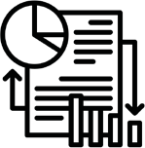 Governance and Regional Fiscal Capacity
Aligned with the Governor of Maluku’s priorities to strengthen governance and regional fiscal capacity, the Provincial Government has implemented several strategic initiatives, including:
- Supporting the enhancement of local taxing powers to increase fiscal independence, through:
  - Drafting Regional Regulation No. 2 of 2024 on Regional Taxes and Levies;
  - Drafting Gubernatorial Regulations No. 35 and No. 36 of 2024 on Procedures for Collecting Regional Taxes and Levies;
  - Synergy between 11 district/city governments and the provincial government in implementing regulations on revenue sharing between the province and districts/cities.

- Initiating studies to increase Regional Own-Source Revenue (PAD) by:
  - Identifying new taxes from waterborne vehicles;
  - Optimising the collection of surface water taxes;
  - Optimising regional levies through the development of business processes for collecting agencies.

- Enhancing capacity and governance in regional planning and budgeting, including:
  - Training provincial, district, and city officials to align planning and budgeting with national fiscal policies;
  - Strengthening the technical meeting model of the Provincial Minimum Service Standards (SPM) Implementation Team as a means of technical assistance for setting service recipient targets and calculating SPM budget needs for 2026;
  - Initiating policy practice communities that bring together policy analysts, academics, and civil society organisations to support more accurate, evidence-based decision-making.

 Data-Driven Planning and Development
Evidence-based, sustainable, and equitable development is a top priority for the Maluku Provincial Government. To strengthen data-driven policy, various efforts have been undertaken to enhance the capacity of government at provincial, district, and city levels in data collection, management, and analysis. Key initiatives include:

- Strengthening the implementation of the Regional One Data initiative to support evidence- based planning and budgeting by:
  - Reinforcing the institutional framework of the Maluku One Data Forum, including improved governance through enhanced coordination, accountability, and cross-agency data management at the provincial level;
  - Developing a One Data Action Plan and Standard Operating Procedures (SOPs) for the data cycle;
  - Revitalising the Maluku One Data portal.
- Enacting Gubernatorial Decrees to strengthen accountability for each agency in providing complete, accurate, and timely data. This initiative has increased the number of reported datasets from 280 to 1,470 and encouraged 21 regional agencies to submit key metadata to the central government.

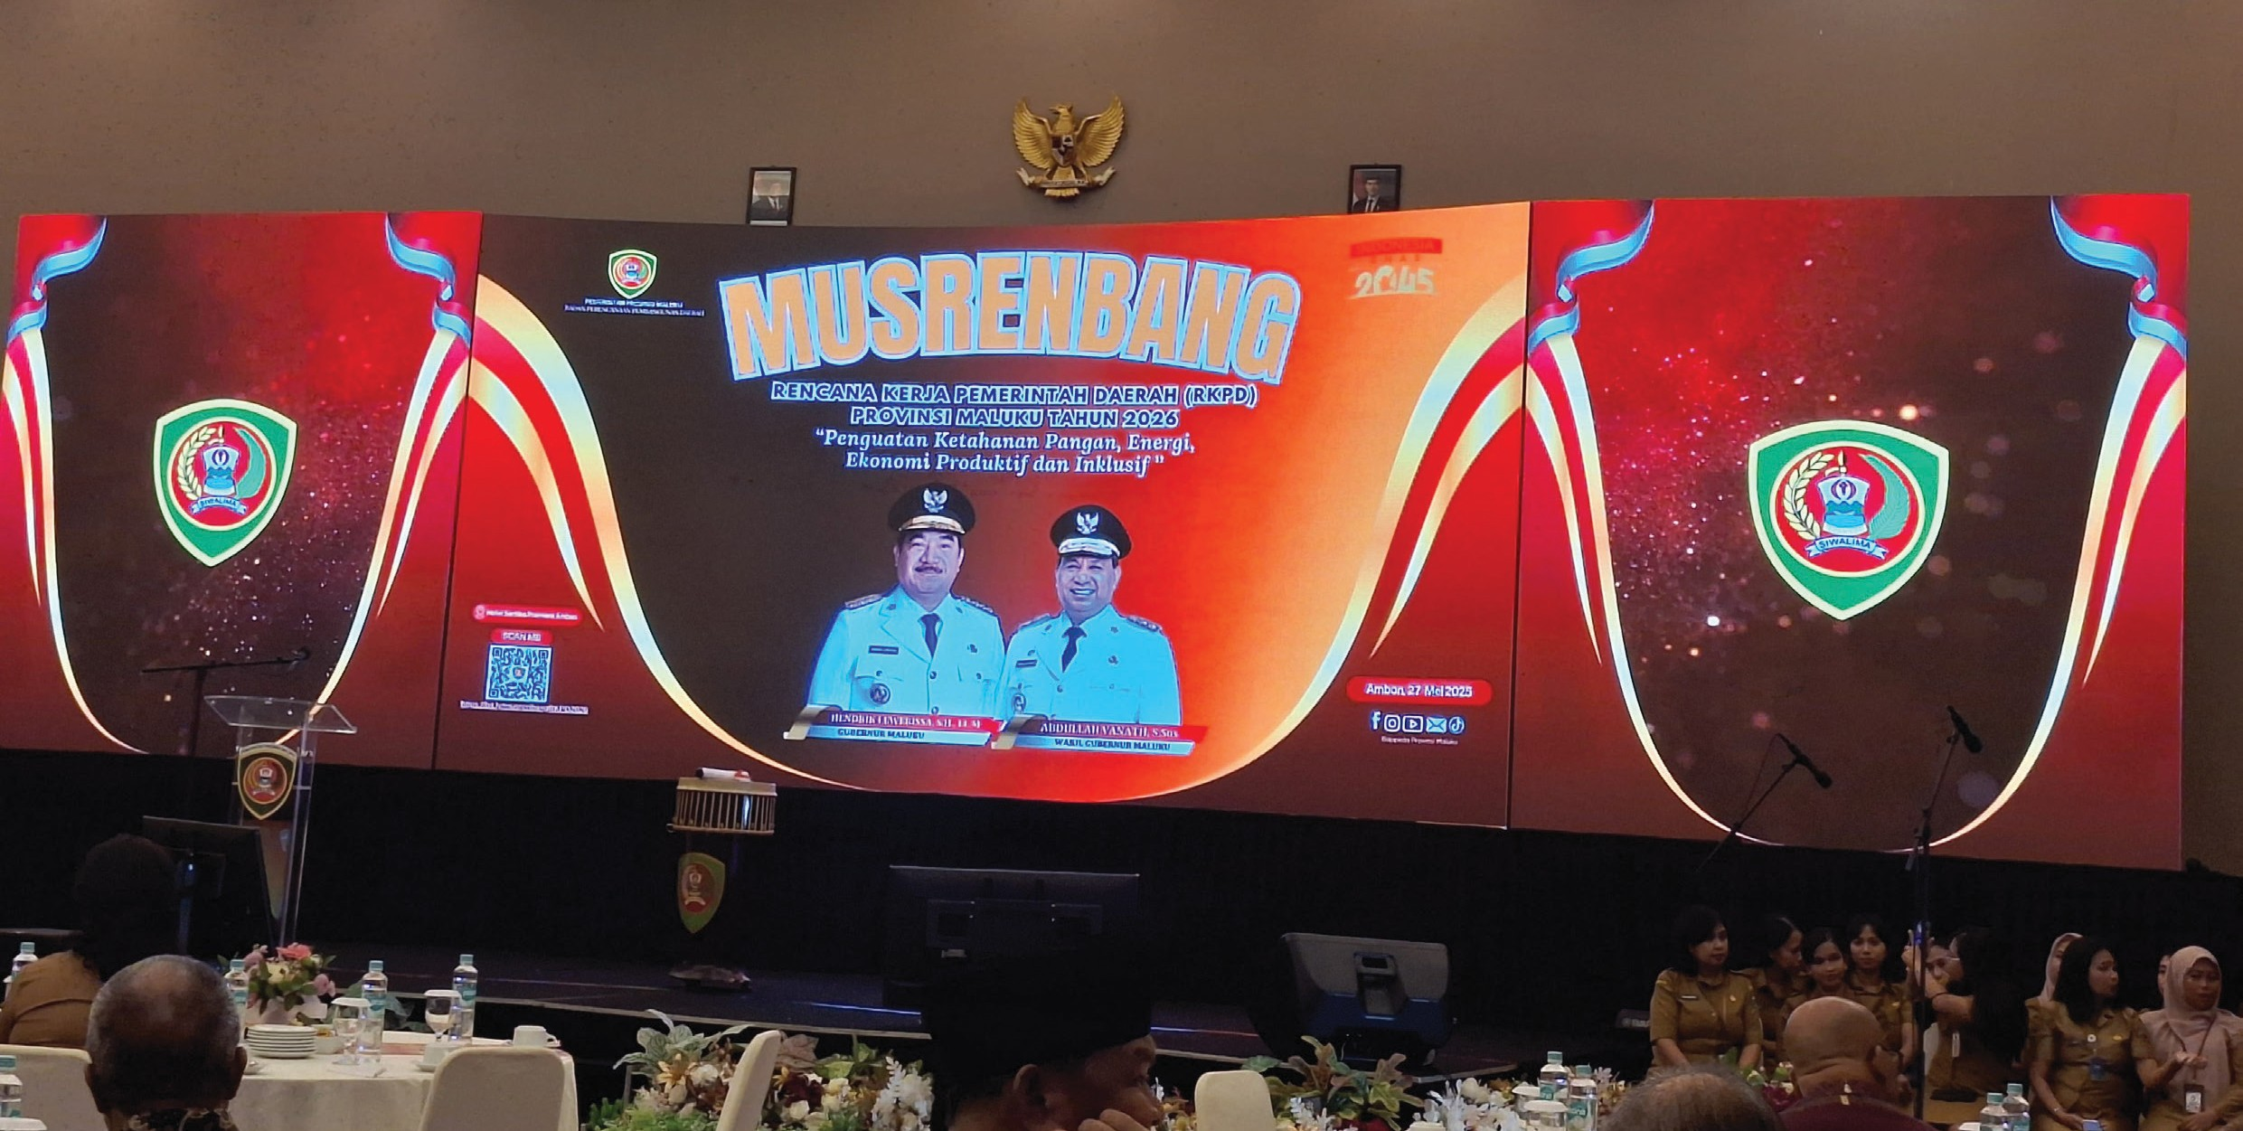
3

- Training civil servants from Bappeda and the Department of Communication and Informatics (Diskominfo) as facilitators in utilising e-Walidata and the Regional Government Information System (SIPD) for development planning. Strengthening the capacity of civil servants to train their peers in using national socio-economic data to support regional planning, preparing Minimum Service Standards (SPM) Action Plans, compiling gender profiles, and planning poverty alleviation efforts. These activities have directly benefited civil servants in five districts/ cities in Maluku.


Inclusive Provision of Basic Services

A core commitment of the Maluku Provincial Government is to ensure the effective and inclusive provision of basic services. Strategic initiatives include:

- Implementing four stages of Minimum Service Standards (SPM) and integrating them into planning and budgeting for more targeted basic service delivery.

- Strengthening the SPM Implementation Team’s capacity in planning, data collection, and reporting on SPM activities.

- Enhancing the use of diverse data sources—ranging from socio-economic and sectoral data to By Name by Address (BNBA) data—as a basis for more targeted program planning;
  - Supporting the Housing and Settlement Office and the Public Works Office in improving service quality through more accurate household data in disaster-prone areas and for clean water beneficiaries.
  - Utilising disaggregated data analysis (including disability) in drafting regulations/policies on Gender Mainstreaming (Regional Regulation No. 7/2024) and the Disability Action Plan.

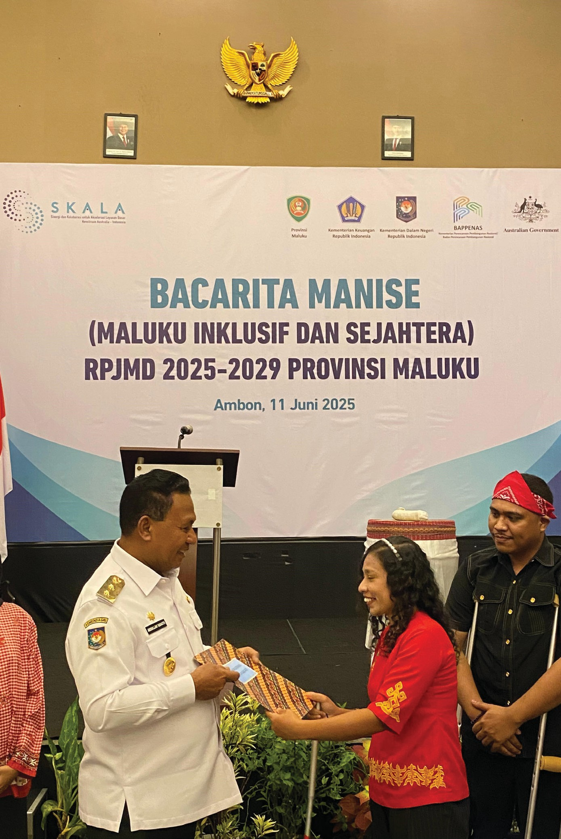


Inclusive and Equitable Social Transformation

As part of the vision to create a just and progressive society, the Maluku Provincial Government promotes strengthened collaboration among communities, civil society organisations, and government agencies. Initiatives to address the needs of women, persons with disabilities, and vulnerable groups include:

- Facilitating the integration of gender perspectives into local policies through collaboration between civil society organisations and government officials in drafting and enacting Regional Regulation No. 7 of 2024 on Gender Mainstreaming.

- Fostering meaningful collaboration between civil society organisations and government to ensure inclusive development that supports vulnerable groups, through:
  - Revitalising the PUSPA Forum as a joint civil society network serving as a government partner in inclusive planning and budgeting.
    - Close collaboration between civil society organisations and government in drafting various gender, disability, and inclusion- related regulations and policies, such as Regional Regulation No. 7/2024 on Gender Mainstreaming (PUG) and the Regional Disability Action Plan (RAD PD).
    - Ensuring improved services and the fulfilment of the needs of persons with disabilities are accommodated in regional planning through the preparation of the RAD PD.

- Strengthening the capacity of civil servants in gender-inclusive governance through Gender Responsive Planning and Budgeting training. As a result, nine regional agencies have revised their work plans to integrate Gender Action Budgeting into their sub-activities.

- Initiating the first thematic Musrenbang at the provincial level through the Bacarita Manise forum, providing a dialogue platform to explore the ideas and needs of vulnerable groups in line with regional development priorities.

4

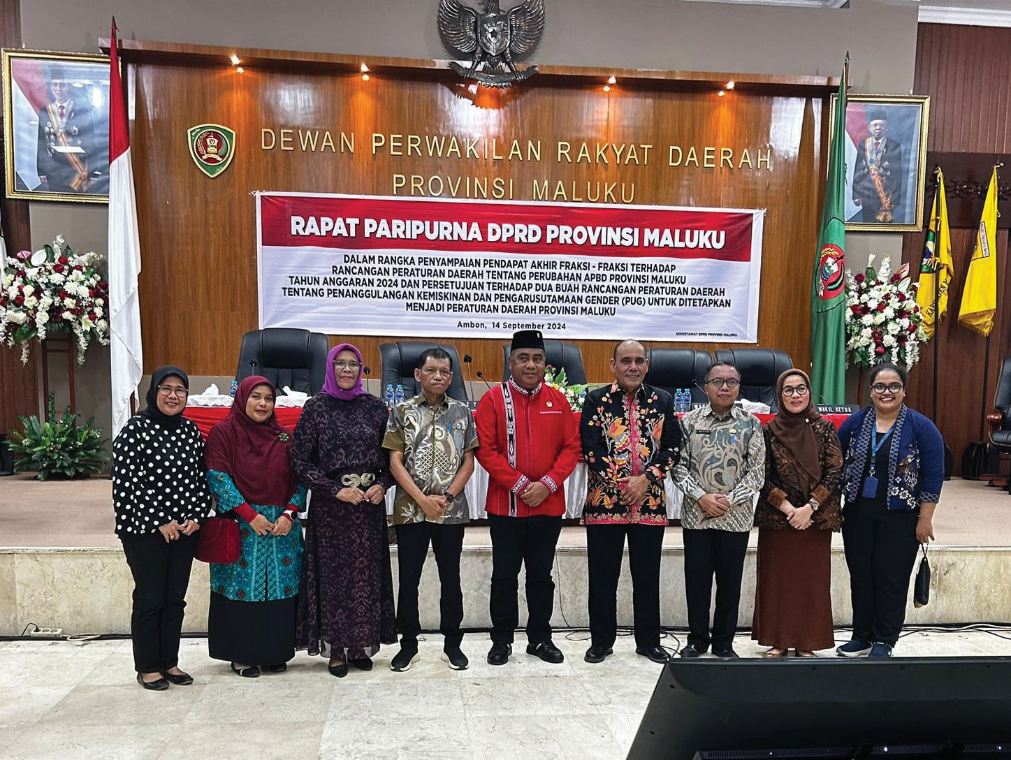

Alignment with the Governor’s Upcoming Challenges

The Maluku Provincial Government faces budget constraints in delivering basic services as a result of Presidential Instruction (Inpres) No. 1 of 2025. The SKALA Program is supporting the provincial government to:

Improve the quality of basic services through accurate and integrated data-driven planning, utilising up-to-date and disaggregated data to ensure targeted interventions.

Assist the Maluku Provincial Government in accurately setting Minimum Service Standards (SPM) targets, identifying priority target groups, and designing more efficient and measurable interventions. This approach encourages more effective and impactful resource allocation.

5

6

Sustaining Collaboration in Supporting the Vision of Maluku

Sejalan dengan visi Gubernur Maluku, Pemerintah Provinsi terus memperkuat upaya pembangunan melalui kolaborasi berkelanjutan dengan Program SKALA. Kemitraan ini difokuskan pada penguatan di sejumlah bidang prioritas, antara lain:

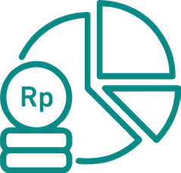In line with the Governor’s vision, the Provincial Government continues to strengthen development efforts through ongoing collaboration with the SKALA Program. This partnership focuses on strengthening several priority areas, including:
Strategic Planning, SPM Implementation, and Fiscal Optimisation
Promoting data-driven SPM planning for 2026, including the use of national socio-economic data and other sources in setting service targets, and strengthening collaboration within the SPM team by involving Bappeda and the Regional Financial and Asset Management Agency (BPKAD) in planning and budgeting.

For fiscal optimisation, SKALA, with support from local government, will identify new sources of regional revenue and intensify existing revenue streams.

Data Collection, Management, and Analysis
Strengthening institutional coordination and collaboration within the One Data Forum to support timely data cycles, finalise SOPs and guidelines for One Data, revitalise the Maluku One Data Portal, and complete business processes and strategic roadmaps for Electronic-Based Government Systems (SPBE).

Gender, Disability, and Social Inclusion

Ensuring meaningful and inclusive Development Planning Forums (Musrenbang) are conducted by enhancing civil society organisations participation, particularly from disability organisations, through improved data analysis and advocacy, and assisting civil society organisations to align their proposals with the Regional Medium-Term Development Plan (RPJMD) and local government programs.



IFC Tower 2, Level 17
Jl. Jendral Sudirman Kav. 22‑23 Jakarta 12920
 skala.or.id  communications@skala.or.id

https://s.id/Channel‑SKALA

