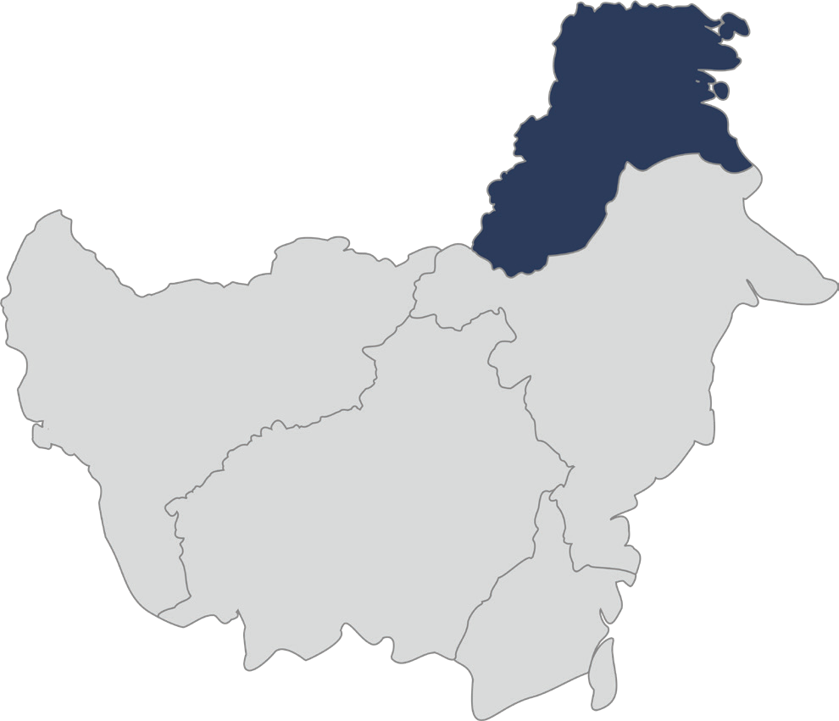

Collaboration for the Acceleration of Basic Services in

the North Kalimantan Province

July 2025

Collaborative governance, equitable and sustainable economic development, as well as protection for vulnerable groups, form the principal foundations of the vision for the Government of North Kalimantan Province (Kaltara) moving forward. The new administration is committed to accelerating inclusive development through the strengthening of public financial systems, the utilisation of data for planning, and the expansion of access to basic services for all members of the community, including women, children, and persons with disabilities.

As part of a strategic partnership, the Government of North Kalimantan Province is collaborating with and receiving support from the SKALA Program , the Australia-Indonesia Partnership Program, to enhance regional capacity in governance, financial management, and the formulation of inclusive policies. Through technical assistance, capacity building, policy advice, and support for the engagement of vulnerable groups, SKALA provides expertise and a collaborative approach that reinforces the government’s strategic steps in realising its vision.

1

2

Key Areas of Alignment
 Regional Governance and Economic Transformation
The Provincial Government of North Kalimantan is focused on sustainable growth by strengthening fiscal management and subnational public financial governance to support effective public service delivery and regional development, through:
- Providing technical assistance to the Government of North Kalimantan Province in the preparation of a study on the potential of Regional Own-Source Revenue (PAD) as a basis for strategies to increase revenue through both intensification and extensification of potential sectors, as well as the preparation of PAD projections for 2025.
- Promoting the enhancement of PAD by strengthening regional tax governance, including the implementation of tax options, reinforcing the collection of Heavy Equipment Tax and Surface Water Tax, and preparing technical Decrees (SK) from Bapenda as operational guidelines.
- Facilitating North Kalimantan to become the first province to establish a policy on Waterborne Vehicle Tax as an innovation to broaden the regional revenue base.
- Contributing to the development of intensification and extensification programmes for regional levies by setting 15 priority levy targets for 2025, covering the optimisation of key sectors such as mining, plantations, fisheries, and tourism, as well as the utilisation of regional assets through Public-Private Partnership (PPP) schemes.
- Facilitating 40 tax option development programmes that have been agreed to commence implementation from 5 January 2025. Significant fiscal impacts are projected, such as an increase in revenue from Motor Vehicle Tax (PKB) by 207.81% and Vehicle Transfer Fee (BBNKB) by 241.59% in Bulungan Regency.
- Organising technical guidance on planning and fulfilling mandatory basic infrastructure expenditure for 105 participants from 28 provincial and district/city agencies (OPD). In 2024, North Kalimantan allocated 39.02% of expenditure to basic infrastructure. Five districts/cities exceeded the 40% target, with Tana Tidung Regency reaching 53.90%, reflecting a commitment to inclusive and gender-responsive development.
- Facilitating the preparation of a policy brief concerning the distribution of Transfer to Regions (TKD) budget allocation for financing the implementation and fulfilment of Minimum Service Standards (SPM), as well as other strategic development issues in the context of implementing Presidential Instruction No. 1 of 2025.


Data-Driven Governance, Planning and Development

The Provincial Government of North Kalimantan is promoting the effective use of data as a key foundation for achieving sustainable and equitable development. Inclusive, data-informed planning and policymaking are being advanced through:
- Facilitating the organisation of a series of thematic coordination meetings and the One Data Forum sessions.
- Providing input and recommendations regarding the revision of the One Data Implementation Decree, the Data List Decree, and the Circular Letter on the Utilisation of Regsosek Data.
- Offering input and recommendations on the development of Standard Operating Procedures (SOP) for the One Data Cycle and the One Data Action Plan.
- Facilitating the capacity building of civil servants in data governance and utilisation through One Data technical guidance, data-based policy brief analysis and preparation, as well as the use of Regsosek data.

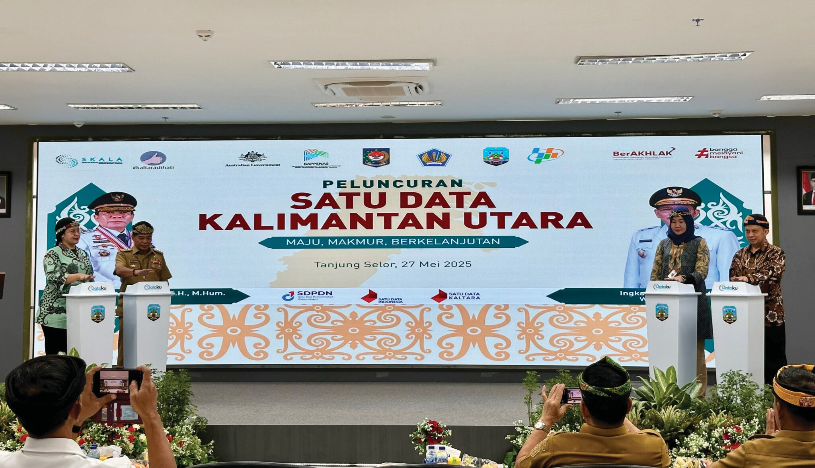
3
- Facilitating and providing technical input in the planning, collection, verification, and dissemination processes for 1,961 data sets in 2025.
- Initiating the redesign of the One Data portal, “E-Dataku Sidara Cantik 2.0”, to be more inclusive and to accommodate data on vulnerable groups.


Inclusive and Equitable Social Transformation

The Provincial Government of North Kalimantan places strong emphasis on collaborative governance and enhancing civic participation in inclusive and responsive development processes, through:
- Supporting Mentari Kaltara or Inclusive Musrenbang by developing guidelines to help establish similar inclusive forums across all districts and inviting community organisations, including OPDIS and civil society organisations (CSOs) to participate in the planning process. This serves to strengthen local development planning.
- Facilitating the institutionalization of the CSO Network through the revitalization of the PUSPA BENUANTA Forum which establishes a communication platform to gather and submit community input to regional government.
- Training civil servants from 34 local government agencies on gender-responsive planning and budgeting to ensure women’s needs and priorities are reflected in government plans and budgets.
- Training CSOs in infrastructure spending and gender-aware planning so they can engage in regional planning, provide input on tax and service standards and promote sustainable policies.
- Leveraging the expertise of Australia-Indonesia-supported programs like INOVASI and INKLUSI to develop inclusive policies such as the Out-of-School Children and Disability Action Plans.

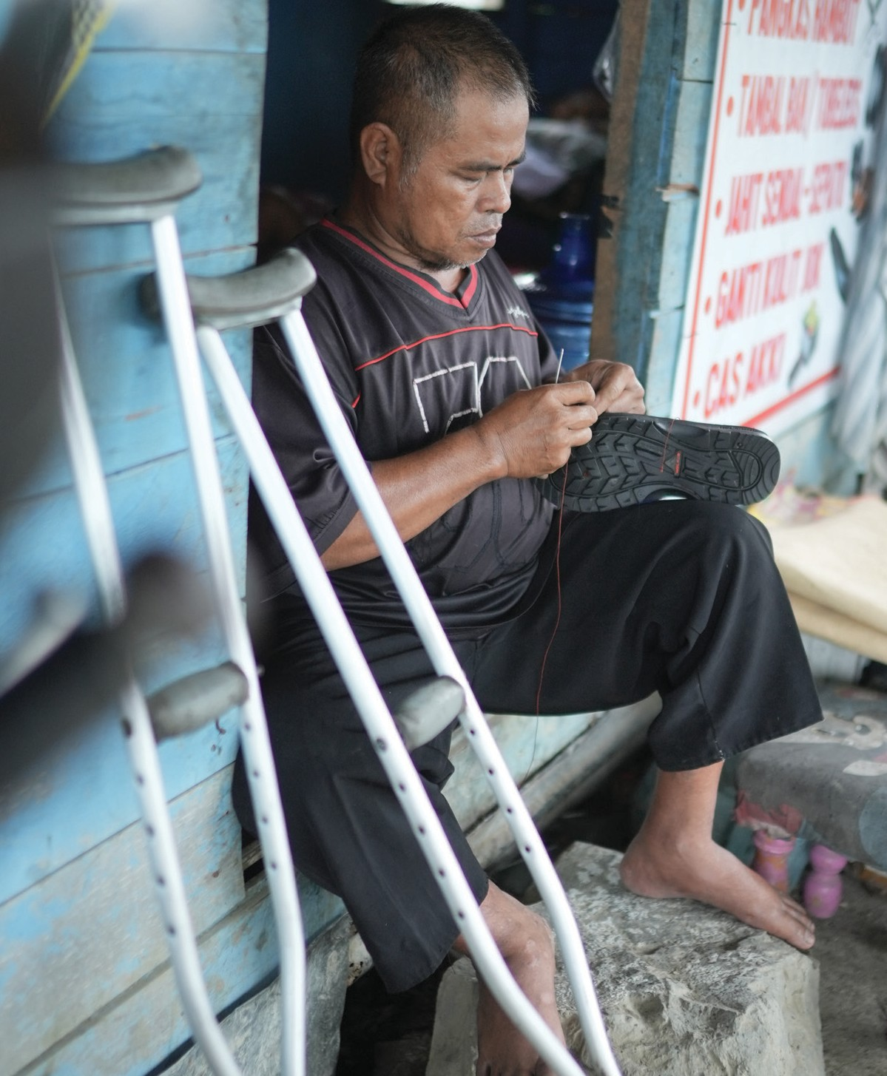

Empowering Vulnerable People through Inclusive Basic Services

The Provincial Government of North Kalimantan is committed to ensuring social protection for women, children, and vulnerable groups through collaborative initiatives aimed at strengthening inclusive and equitable basic services, such as:
- Contributing to the enactment of Regional Regulation Number 17 of 2024 concerning the Respect, Protection, and Fulfilment of the Rights of Persons with Disabilities.
- Supporting the government to reduce vehicular taxes for people with disabilities by providing technical input for the Decree of Inclusive Tax and Levy Service Standards under the SADAR BENUANTA initiative.
- Conducting monitoring and evaluation with the MSS Secretariat, Bureau of Regional Autonomy, and national agencies for effective tracking of Minimum Service Standards (MSS) implementation.
- Supporting the preparation of policy recommendations (policy briefs) for regional leaders across various focus areas (education, health, social services, and basic infrastructure) to enhance essential service delivery.


Strengthening the Implementation and Planning of Minimum Service Standards (SPM)

The Government of North Kalimantan Province (Pemprov Kaltara) is systematically enhancing the implementation of Minimum Service Standards (SPM) and promoting their integration into regional development planning documents through the following measures:
- Conducting monitoring and evaluation (M&E) for Quarters I–IV of 2024 by the SPM Secretariat Team, involving six provincial and five district/city coordinators, with participation from Bappeda, BKAD, the Inspectorate, and the Directorate General of Regional Development at the Ministry of Home Affairs;
  - Supporting the preparation of the Long- Term Regional Development Plan (RPJPD), Medium-Term Regional Development Plan (RPJMD), and Annual Regional Development Plan (RKPD) by integrating SPM indicators and strategies, as well as Gender Equality, Disability, and Social Inclusion (GEDSI) considerations from the outset;
  - Developing a cost-based and gap analysis- informed SPM implementation action plan through cross-agency workshops, coaching clinics, and assistance in preparing performance trees;
  - Facilitating technical training for civil servants in preparing annual SPM action plans and utilising REGSOSEK data for basic service planning;
  - Advocating for the establishment of an e-SPM Coordination Team and the legalisation of revisions to supporting regulations;
  - Assisting Pemprov Kaltara in achieving 4th place nationally and the highest ranking in the Kalimantan region in the SPM Award, with a Fulfilment Index (IP) of 100%.

4

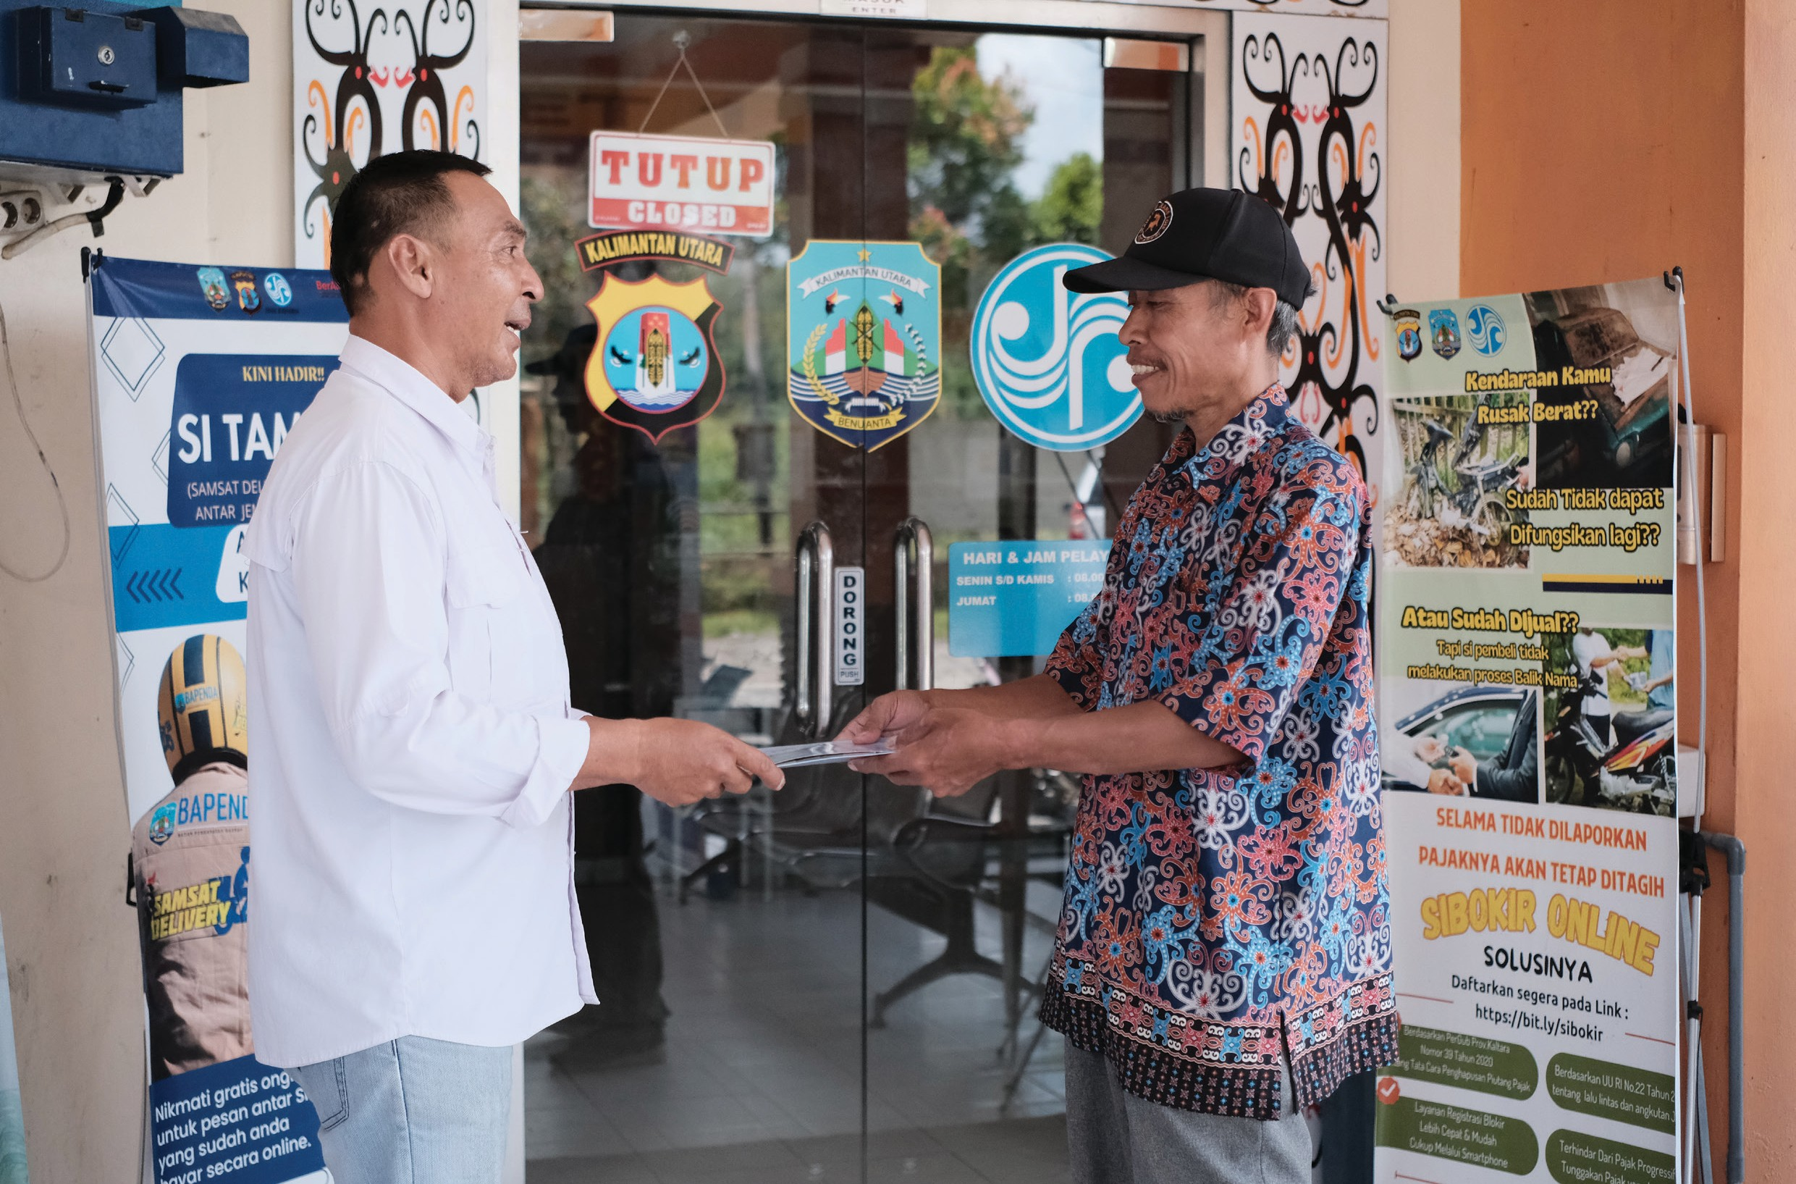

Alignment with the Governor’s Upcoming Challenges

One of the main challenges for the new administration is ensuring budget efficiency for the 2025 fiscal year. To address this, the Provincial Government of North Kalimantan, with support from the SKALA Program, is undertaking the following efforts:

Strengthening data-driven planning so the government can make informed decisions based on accurate, up-to-date information.

Optimising budget allocations through improved fiscal management so that limited resources are directed towards basic services.

Ensuring the integration of Minimum Service Standards (MSS) into Kaltara’s regional development plans to maintain service quality despite financial constraints.

5

6

Sustaining Collaboration in Supporting the Vision of Provinces in the Kaltara Region

In line with the vision of the Governor of Kaltara, the provincial government will continue to strengthen various development initiatives through collaboration with the SKALA Program, which includes:

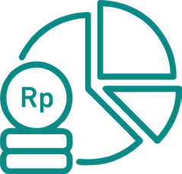Strengthening data-driven planning to support informed decision-making that is responsive to fiscal conditions;

Optimising the allocation of public budgets to ensure greater accuracy and direct impact on the community;

Integrating Minimum Service Standards (SPM) into all regional planning and budgeting documents;

Enhancing the capacity of the Provincial SPM Implementation Team to provide supervision and technical assistance to district and municipal levels;

Integrating the SIDARA CANTIK 2.0 platform with the National One Data Hub (SDPDN) to reinforce planning and reporting systems;

Developing more inclusive policies through the revitalisation of the Gender Mainstreaming Working Group, strengthening of Musrenbang forums, and building the capacity of civil society organisations (CSOs) to advocate for fair and inclusive basic services.



IFC Tower 2, Level 17
Jl. Jendral Sudirman Kav. 22‑23 Jakarta 12920
 skala.or.id  communications@skala.or.id

https://s.id/Channel‑SKALA

