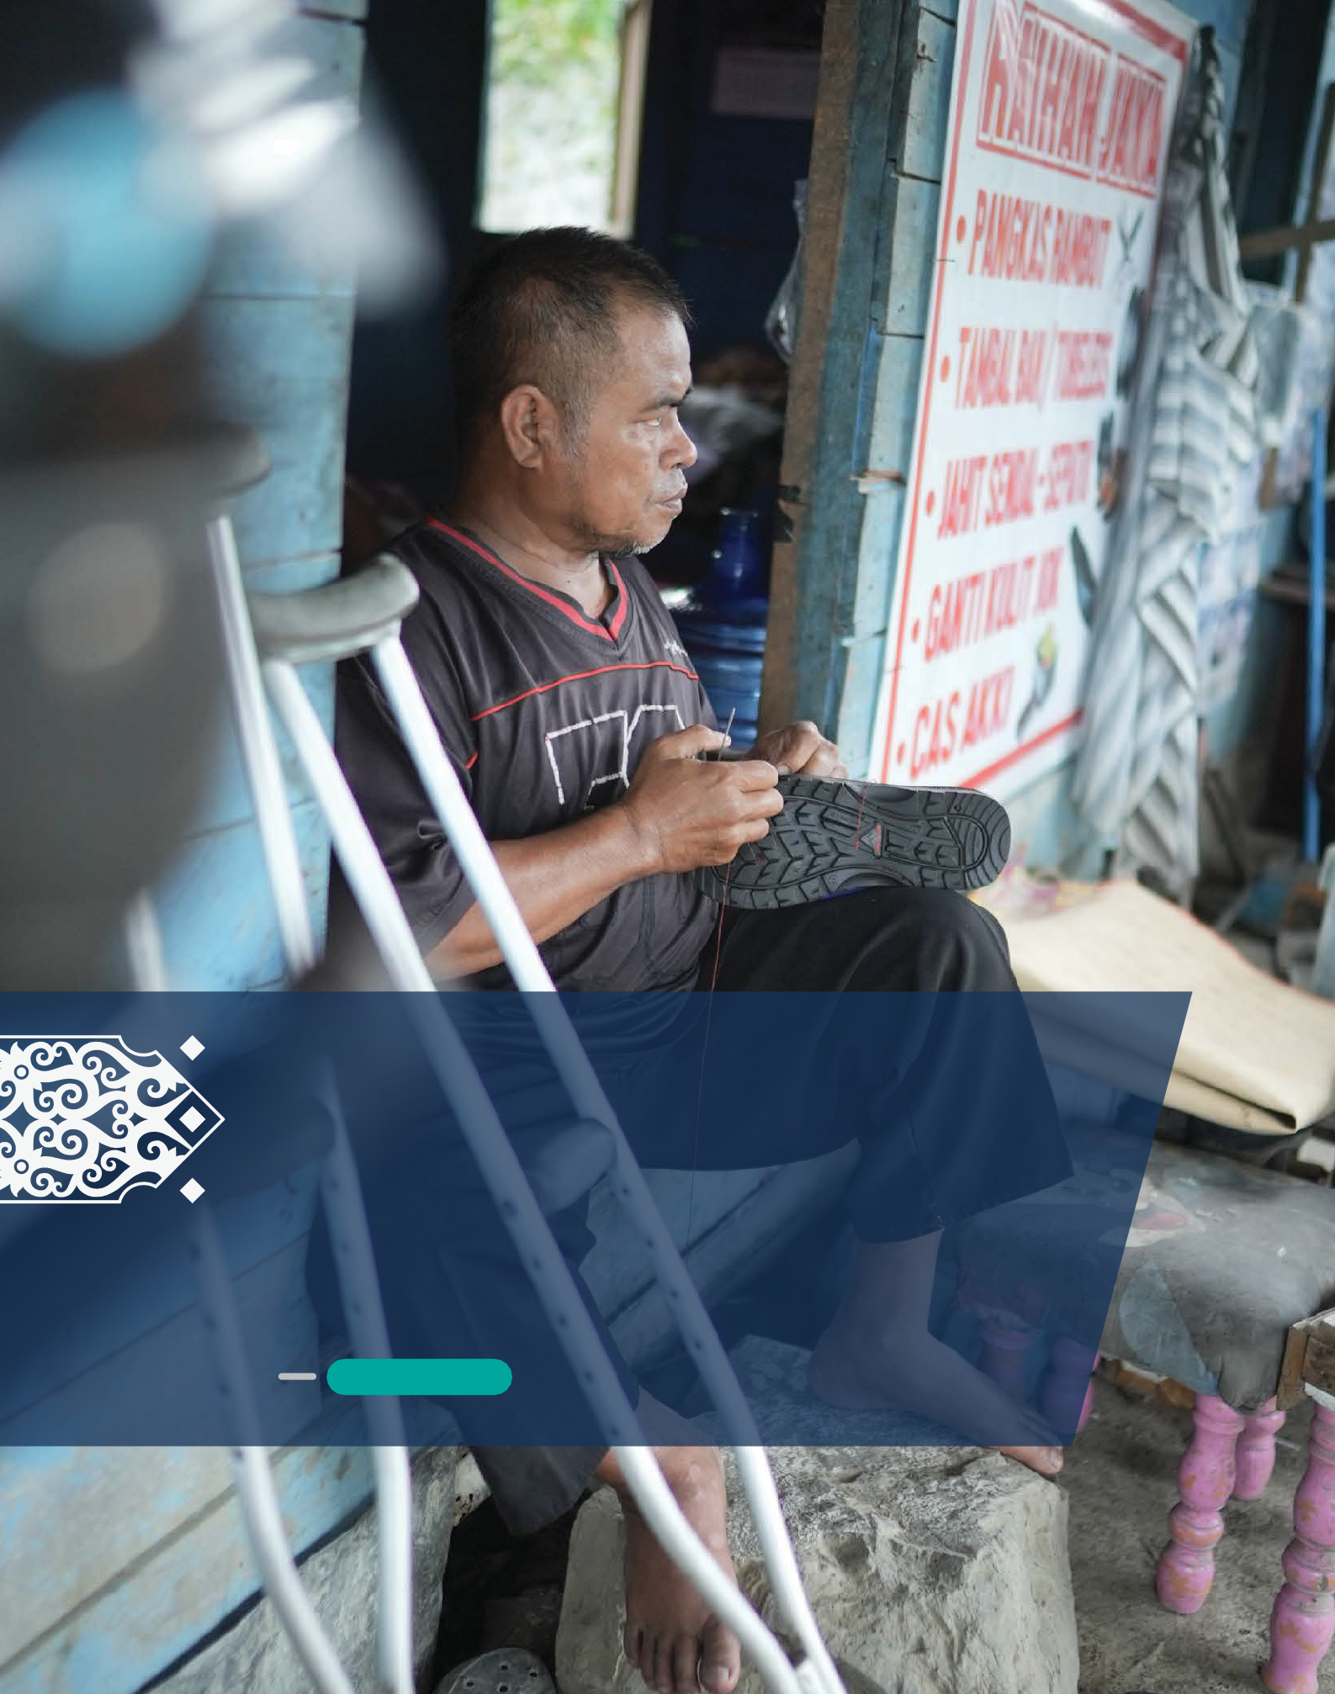

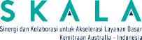

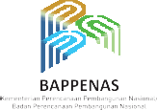
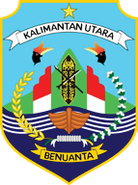
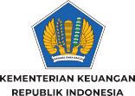
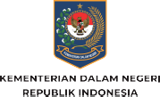

Inclusive Development:
HOW NORTH KALIMANTAN IS LISTENING TO ITS PEOPLE
June 2025

Hanafi
(Picture by: SKALA)

The promise is simple but bold: no one should be left behind.

Inclusive development is at the heart of Indonesia’s commitment to building a fairer, more resilient, and socially just future. This commitment is reflected in the 2025–2045 National Medium-Term Development Plan (RPJMN) and echoed in the United Nations Sustainable Development Goals.

For many, that means access to education, healthcare, and livelihood opportunities. But for vulnerable groups — women, children, Indigenous communities, older people, and persons with disabilities — it also means being seen, heard, and counted in decisions that shape their lives.

The Ministry of Home Affairs' regional planning guidelines also support inclusive development planning by emphasising the importance of public participation at every stage – from Regional Long-Term Development Plans (RPJPD) and Regional Medium-Term Development Plans (RPJMD) to Regional Government Work Plans (RKPD).

In North Kalimantan (Kaltara), the promise to include all levels of society without exception begins with a commitment from the local government, strengthened by the support of civil society. Yet the challenge is not simply about ensuring local plans and budgets refer to inclusion issues. The challenge is much greater than that.
“We want to realise an inclusive North Kalimantan, where every citizen has an equal opportunity to contribute to development, free from discrimination.”
Deputy Governor Ingkong Ala.

- 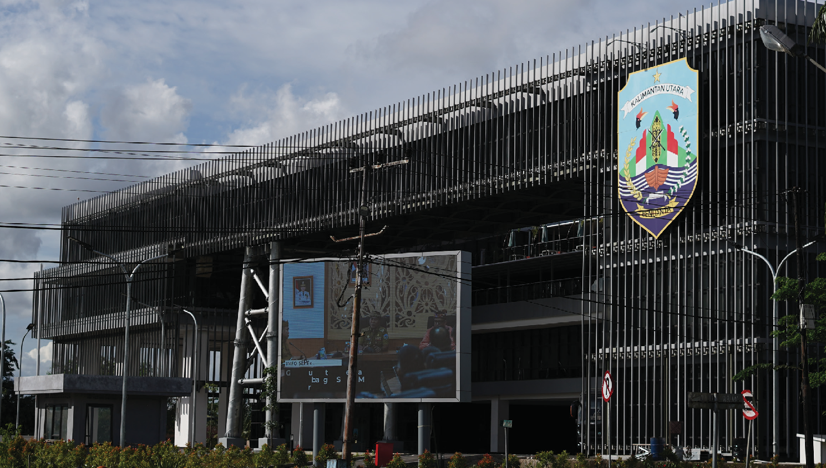Inclusive Development: How North Kalimantan is Listening to Its People
Lorem ipsum
Governor's Office of North Kalimantan
(Picture by: SKALA)

WHY INCLUSIVE DEVELOPMENT MATTERS

Although the Provincial Government of North Kalimantan is committed to supporting inclusive development, data indicates that many in the community still face discrimination and marginalisation. While Kaltara’s poverty rate compares well nationally – recorded at 5.38% in September 2024, below the 8.57% national average – gender inequality remains a significant concern. Kaltara’s Gender Empowerment Index in 2023 was 58.86%, well below the national figure of 76.90%. Its 2024 Gender Development Index was also lower than the national average, at 88.77% compared to 91.85%.
The province also records the highest rate of child marriage in Indonesia. In 2022, data from the Ministry of Women’s Empowerment and Child Protection showed that 17.04% of women in Kaltara were married between the ages of 17 and 18, while 12.68% were married before turning 16.

Kaltara also has a relatively high number of people with disabilities, with 2022 Regsosek data recording 36,558 individuals with mild disabilities and 9,889 with severe disabilities.

The numbers are important. But behind them are
people.

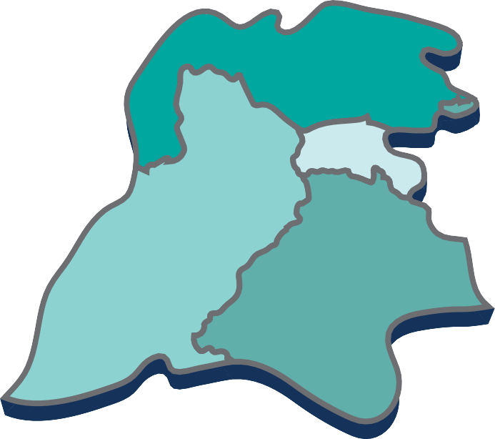

POVERTY
Poverty rate : 5.38% National average : 8.57%
source: BPS 2024

GENDER INEQUALITY
Gender Empowerment Index (2023): 58.86%
(National: 76.90%)
Gender Development Index (2024): 88.77%
(National: 91.85%)
source: BPS 2023

CHILD MARRIAGE
Age 17–18: 17.04%
Under 16: 12.68%
(Highest in Indonesia)
source: Ministry of Women's Empowerment and Child Protection

DISABILITIES (2022)
Mild disabilities: 36,558 people Severe disabilities: 9,889 people
source: Regsosek 2022

The North Kalimantan Province Area

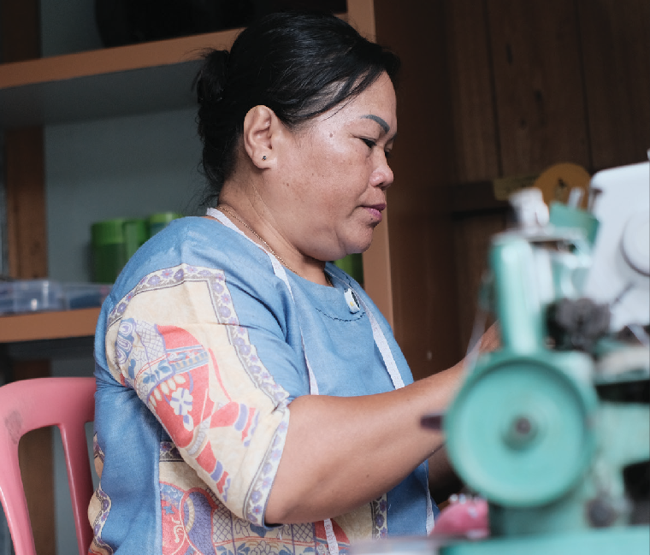Like Alice Juliana, a widowed mother of four in Bulungan Regency, who supports her family through a small tailoring business. Although Juli learned to sew by watching her mother, she still feels unprepared to take orders for traditional Indonesian garments like the kebaya.

Alice Juliana (Picture by: SKALA)

“I hope the government can provide training so I can earn more, I’d love an overlock machine to make my work neater.” Alice Juliana.

- Inclusive Development: How North Kalimantan is Listening to Its People

Markus Ipun and Yasing, members of the Bulusu Dayak community in Bunau Village, share experiences similar to Juli’s. They also feel overlooked in efforts to secure their traditional lands.
For generations, their families have depended on shifting cultivation, but their land now lies within a Forest Concession managed by a private company.

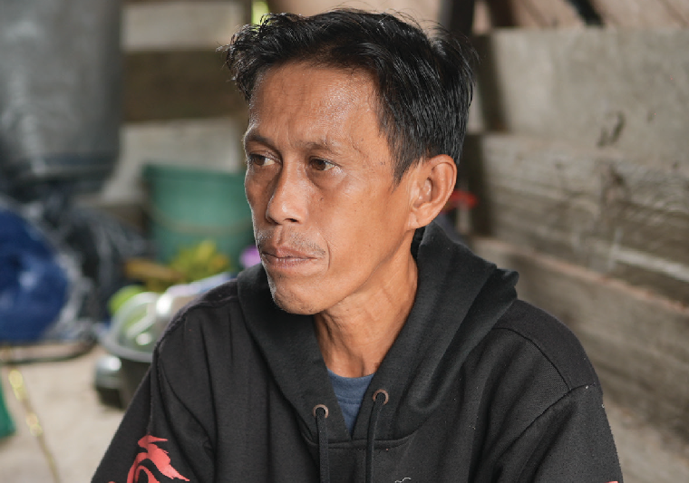
A farmer from the Bulusu Dayak Tribe, Markus Ipun, relies on his harvest to support his family.
(Picture by: SKALA)

“Our ancestors farmed here long before Indonesia existed, Now we face restrictions – unable to move to new plots and barred from burning fields.” Ipun.

They are not asking for assistance, they say, only for clarity and formal recognition of their rights to the land.

Muhammad Yosta Novthami (35), Chair of the Tarakan branch of the Indonesian Association of Persons with Disabilities (PPDI), also tells a similar story.
Since joining PPDI, Yosta has regularly advised the Tarakan City Government on inclusion. Some proposals have been taken up, but progress remains slow. He notes that disability is still a relatively new issue for both the government and society and that they often continue to look down on people like him.

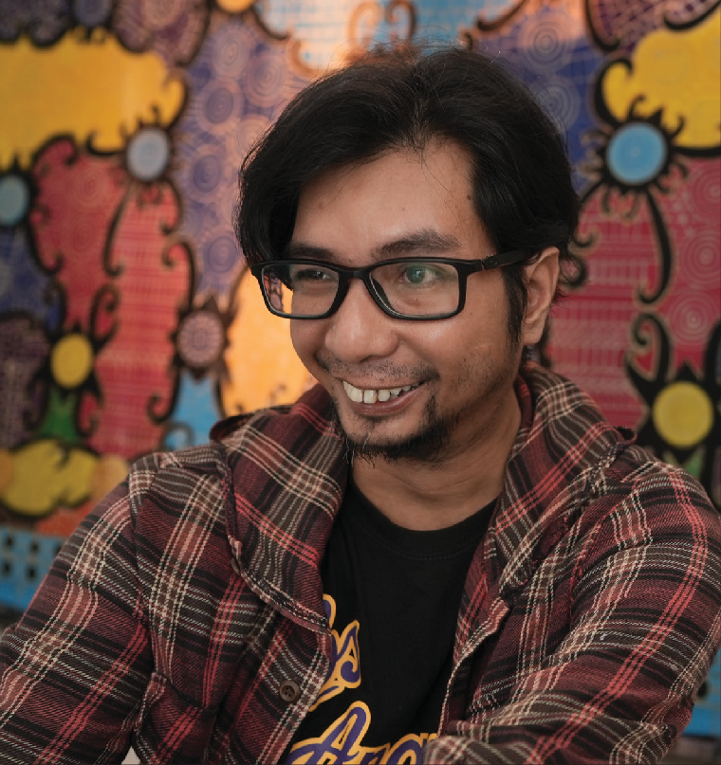

“It will take time for Tarakan to become truly inclusive.” Yosta.

Muhammad Yosta Novthami
(Picture by: SKALA)

- Inclusive Development: How North Kalimantan is Listening to Its People

A PLATFORM FOR PARTICIPATION

The Australian Government is proudly supporting Indonesia through the SKALA Program in facilitating and launching the Mentari Kaltara Forum, which aims to promote inclusivity with the tagline.“ This forum is designed to amplify the voices of vulnerable groups and ensure their aspirations are reflected in the local planning and budgeting process for the 2026 RKPD.

Held for the first time in April 2024, the forum brought together women, persons with disabilities, Indigenous leaders, older people, civil society organisations (CSOs), and government representatives.

Their task: to turn lived experience into evidence-based proposals for inclusion in the 2026 regional planning cycle.

According to Bertius, Head of the Regional Planning Agency (Bappeda), the Mentari Kaltara
Forum represents a major shift in the government’s planning approach, placing greater emphasis on listening to the voices of its people. “It’s not just about hearing people—it’s about ensuring their priorities are formally reflected in planning documents and linked to budgets,” he said.

The Kaltara government is integrating their inputs into official planning documents to ensure regional policies reflect the forum’s recommendations. This process involves coordination between Bappeda and local government agencies (OPDs) to align proposals with provincial and national development priorities, including the 2025–2029 RPJMN, which emphasises social protection and equal access for vulnerable groups. Including proposals from these groups in official planning documents increases their likelihood of receiving budget support and being implemented.

THE ROLE AND PERSISTENCE OF CIVIL SOCIETY

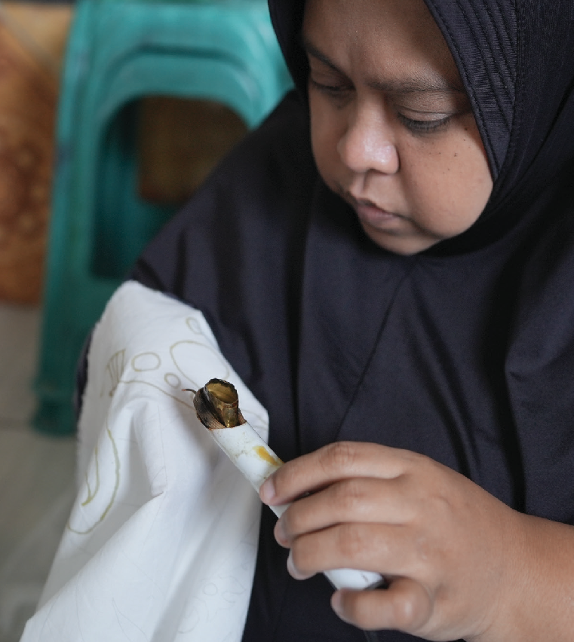CSOs play a vital role in fostering inclusive regional planning and cooperation, representing diverse voices from across the community. Since 2024, a broad range of CSOs, including those focused on women, people with disabilities, children, older persons, and Indigenous communities, have united under a common platform: the Civil Society Network (Jaringan Masyarakat Sipil, or JMS).

A member of the Indonesian Association of People with Disabilities (PPDI) of Tarakan City
is learning how to make batik to improve her skills.
(Picture by: SKALA)

Development: How North Kalimantan is Listening to Its People

- Inclusive

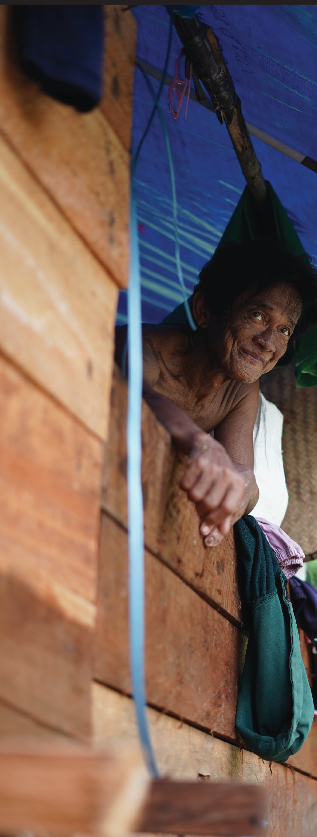To support joint action and coordination, the Network appointed focal points for each sector. Fanny Elizabeth Sumajouw from Puspa Benuanta serves as the women’s representative; Hasan of the Faqih Hasan Center (FHC) Foundation oversees disability inclusion; Muhammad Zulfunun from Yayasan Almarhamah advocates for the elderly; and Yohanes from Aliansi Masyarakat Adat Nusantara (AMAN) leads engagement with Indigenous communities. Coordination for child-focused groups is channelled through the Children’s Forum (Forum Anak). AMAN is also an implementing partner of INKLUSI, the Australia–Indonesia Partnership Program Towards an Inclusive Society.

Civil society leaders, many with long-standing commitments to inclusive development in Kalimantan, have been central to the Network’s formation and coordination. Among them is Fanny, a psychologist, founder of the Bening Hati Foundation and Chair of Puspa Benuanta, a forum for women and children’s welfare. Since 2000, she has supported survivors of violence and worked closely with marginalised groups.

Working through its sector representatives, the JMS brought together a wide array of civil society organisations to exchange ideas, share community insights, and shape common goals. These contributions were carefully integrated into a unified proposal that reflects the collective voice of Kaltara’s civil society.

Through the JMS, these shared aspirations were conveyed to the provincial government during the Mentari Kaltara Forum. The Network played a key role in advocacy and facilitation so that community perspectives were acknowledged and embedded in planning and budgeting processes.

Yasing managed to send his children to college with the proceeds of farming on his ancestral land.
(Picture by: SKALA)

- Inclusive Development: How North Kalimantan is Listening to Its People

TURNING VOICES INTO POLICY

Mentari Kaltara has already produced tangible outcomes. Recommendations from the forum were integrated into the RKPD, and several were accepted for further review. Coordination between provincial planners and local government agencies is ongoing to ensure alignment with national priorities, especially around social protection and inclusive basic services.

But challenges remain. Regional capacity to address inclusivity is uneven. Data on vulnerable
populations is sometimes patchy. Budget constraints, infrastructure gaps, and political shifts can stall progress.

As Muhammad Zulfunun notes, “Sometimes everything is ready, but politics gets in the way.” Still, the shift is unmistakable. With Mentari Kaltara in place, inclusive planning is no longer just an ideal. It is standard practice. It’s bureaucrats and civil society in the same room. It’s evidence and empathy in the same proposal.

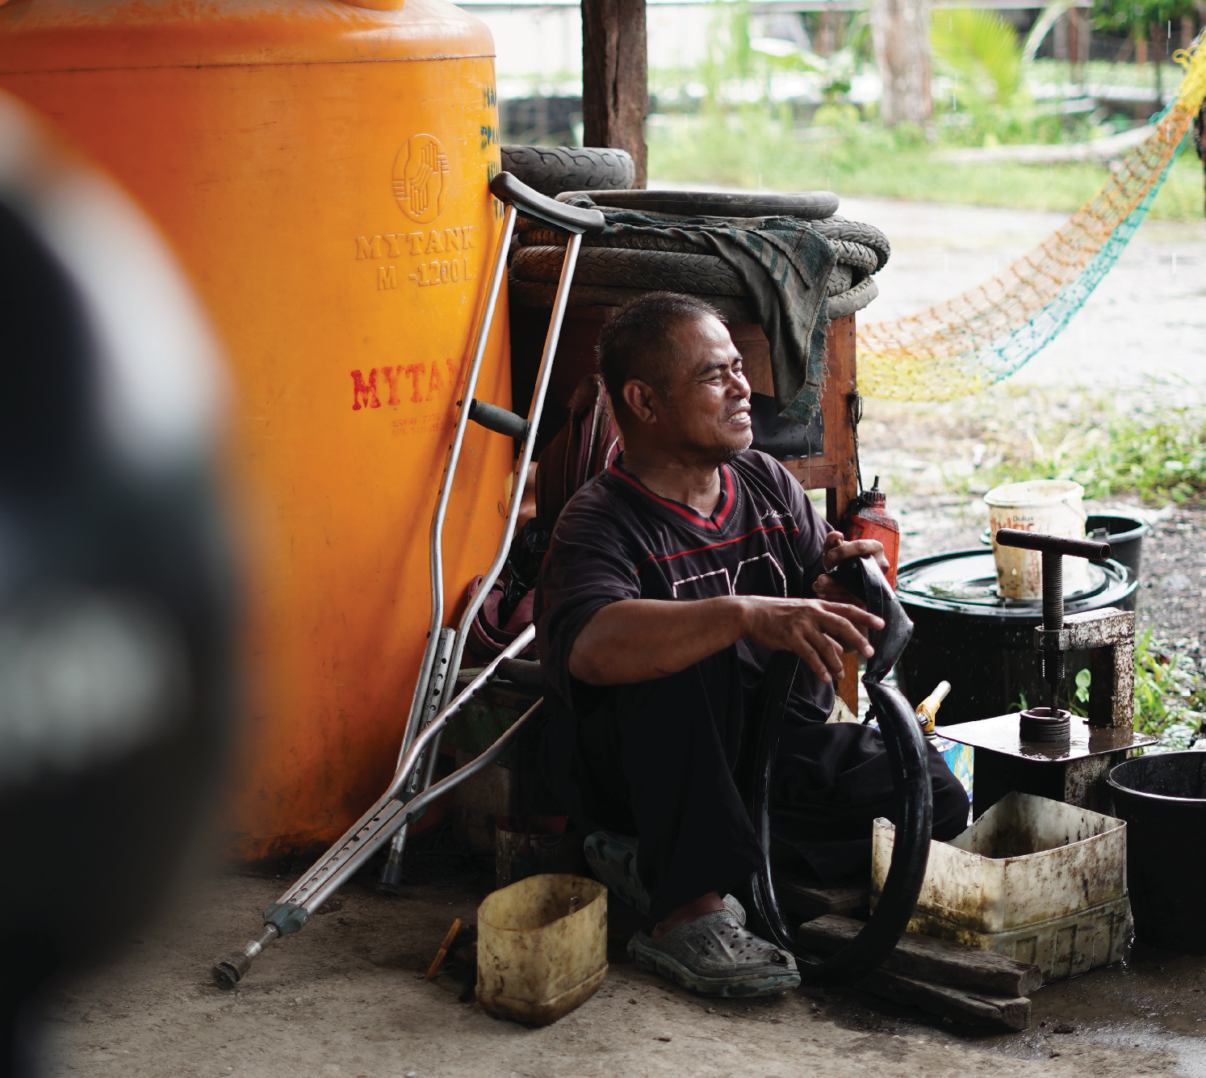
Hanafi runs various businesses, including tire repair, to earn a living.
(Picture by: SKALA)

- Inclusive Development: How North Kalimantan is Listening to Its People

A MODEL FOR THE FUTURE

Kaltara’s experience shows that inclusive development is not a one-off initiative. It’s a practice of listening, of designing spaces for dialogue, and of embedding those voices into the heart of planning.

Kaltara’s experience also shows what’s possible when partnerships work.

Government commitment, civil society persistence, and external facilitation, like SKALA’s role, can create a multiplier effect. It gives bureaucrats tools and frameworks. It gives citizens a voice. It also provides planners with a direct line to the realities they are trying to shape.
Several proposals and community priorities from the Mentari Kaltara Forum have been taken up and incorporated into official planning documents, including the 2026 RKPD. These include public awareness initiatives on preventing violence and promoting gender equality, training and mentoring in entrepreneurship for vulnerable groups, and improved access to information, counselling, education, and family support services.

As Indonesia moves forward with its national vision for 2045, the experience of North Kalimantan offers a compelling lesson: policy making that listens creates policies that work.

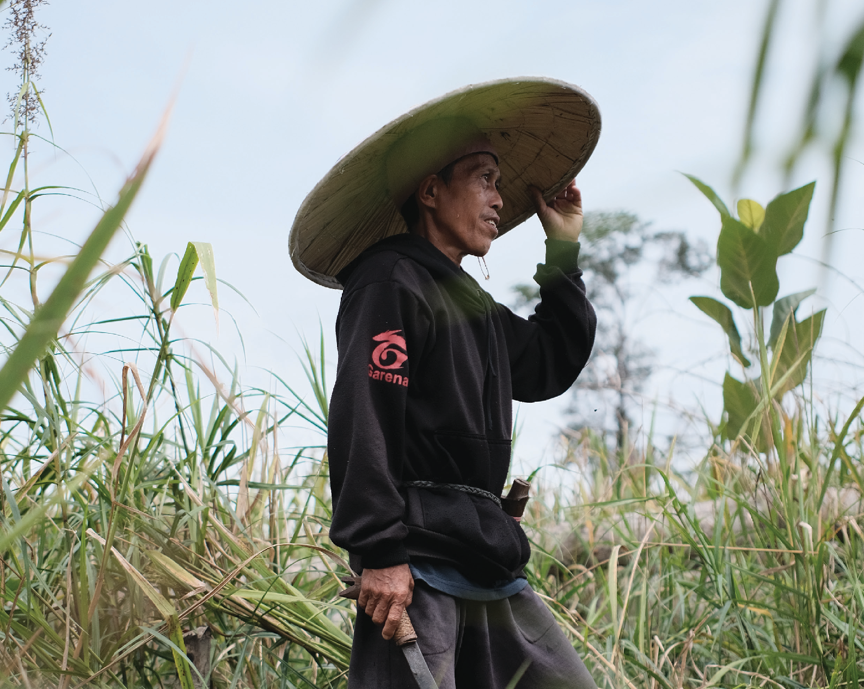

Markus Ipun (Picture by: SKALA)

IFC Tower 2, Level 17
Jl. Jendral Sudirman Kav. 22-23 Jakarta 12920 skala.or.id communications@skala.or.id

