**POLICY BRIEF**

Bridging the Gender Gap in Maluku: The Case for a Regional Action Plan on Gender Equality***\*)***

Lisa Noor Humaidah, Odie Seumahu, Tissa Soumokil, Iskhak Fatonie ***\*\*)***

May 2025

# Executive Summary

Indonesia’s National Medium-Term Development Plan (RPJMN) 2025–2029, enacted through Presidential Regulation (Perpres) No. 12 of 2025, sets clear goals and indicators for achieving national priorities in gender equality. Achieving these targets requires sustained efforts at the subnational level, both to support the national agenda on gender equality and to strengthen governance and institutionalization for implementation. This includes better understanding of gender disparities through gender mainstreaming efforts. Additionally, Minister of Home Affairs Regulation (Permendagri) No. 67 of 2011 on General Guidelines for the Implementation of Gender Mainstreaming in the Regions mandates local governments to develop gender-responsive policies, programs, and activities, reflected in their planning documents. This policy brief highlights key challenges in advancing the gender equality agenda, including limited familiarity with gender mainstreaming among work units, low implementation capacity, and frequent staff rotations. To address these challenges, the brief recommends the revitalization of the Gender Mainstreaming Working Group, strengthening the regional Satu Data forum, and initiating the development of a Regional Action Plan for the Development of Gender Equality.

Keywords: *Regional Action Plan for the Development of Gender Equality (RAD PKG), gender mainstreaming, basic services*

# Introductions

On October 7, 2024, the Government of Maluku Province enacted Regional Regulation (*Peraturan Daerah* or Perda) No. 7 of 2024 on the Implementation of Gender Mainstreaming (*Pelaksanaan Pengarusutamaan Gender* or PUG).

The regulation aims to strengthen gender equality in development across the province. Aligned with Minister of Home Affairs Regulation No. 67 of 2011 and Circular Letter No. 1 of 2024 from the Minister of Women’s Empowerment and Child Protection



*) The authors are grateful to Qurrota A’yun, Director for Family, Parenting, Women, and Children (KPPA), Bappenas for her insightful review of this policy brief.

**) Lisa Noor Humaidah (GEDSI Lead), Odie Seumahu (Provincial Lead - Maluku), Tissa Soumokil (GEDSI Provincial Coordinator - Maluku), Iskhak Fatonie (Policy Partnerships Lead)

Policy Brief | Bridging the Gender Gap in Maluku: The Case for a Regional Action Plan on Gender Equality

1

on the Acceleration of Gender Mainstreaming in Regional Development, this Perda provides clear direction and guidance for all local government officials to take strategic steps to integrate gender perspectives throughout the entire planning, budgeting, implementation, monitoring, evaluation, oversight, and reporting processes for policies, programs, activities, and sub-activities in regional development.

To accelerate implementation and institutionalization across all Provincial Work Units, a Regional Action Plan (*Rencana Aksi Daerah* or RAD) for gender mainstreaming is required. This process ideally begins with the revitalization of the existing Gender Mainstreaming Working Group (Pokja PUG).

In accordance with Presidential Regulation No. 12 of 2025, national and subnational efforts are needed to meet the gender equality development targets set out in the RPJMN. The RAD for the Development of Gender Equality (*Pembangunan Kesetaraan Gender* or PKG) will serve as a roadmap to align and optimize local resources towards achieving these targets,

primarily through the accelerated implementation of gender mainstreaming.

The RAD PKG focuses on strengthening local policies to address persistent gender gaps, integrate gender perspectives in all phases of the regional development cycle, enhance institutional capacity and budget support for gender mainstreaming, and bolster community participation in these efforts.

This policy brief offers several recommendations, including the development of an RAD PKG to address gender inequality challenges in Maluku Province and to advance gender equality in regional development.

Gender Equality in Maluku Province

In 2023, Maluku Province recorded a Gender Development Index (*Indeks Pembangunan Gender* or IPG)1 score of 93.73, which is higher than the national average of 91.85. However, this figure does not fully reflect the disparities that persist between male and female Human Development Index (HDI)2 scores, which remain imbalanced. See Chart 1.

Chart 1: Human Development Index, Maluku Province

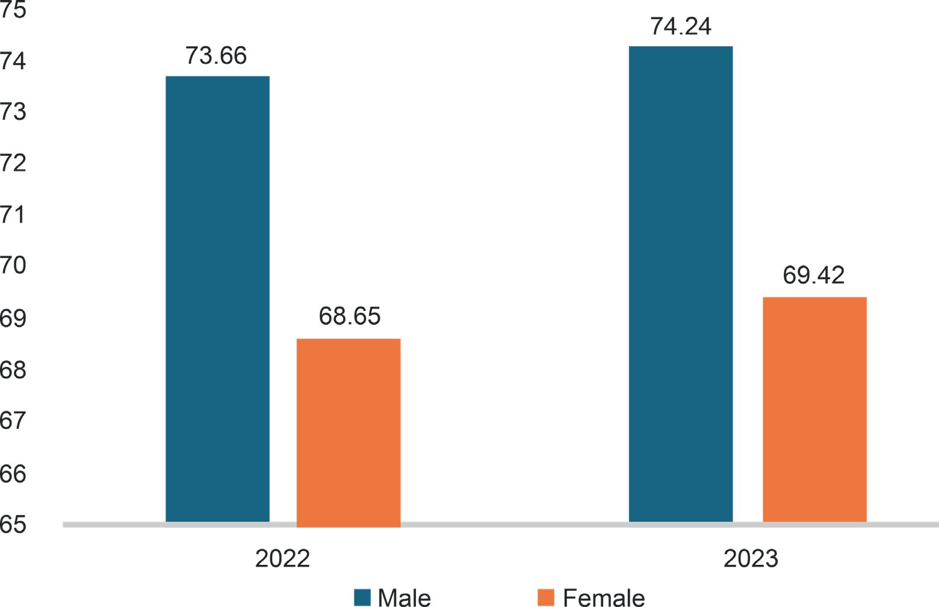

Source: BPS, 2024

1 The components of the IPG include: life expectancy at birth, average years of schooling, expected years of schooling, and per capita expenditure for both men and women.

2 The HDI measures the quality of life in a given region based on three fundamental dimensions: a long and healthy life, access to knowledge, and a decent standard of living (BPS, 2021).

In 2024, Maluku Province recorded a Gender Inequality Index (*Indeks Ketimpangan Gender* or IKG)3 of 0.538, higher than the national level of 0.447. Key challenges include improving reproductive health, empowering women, and expanding women’s access to and opportunities in the labour market.

## Maternal Mortality Rate

The maternal mortality rate in Maluku remains high at 261 per 100,000 live births, exceeding the

national average of 189 per 100,000 (BPS, 2022). Limited access to and availability of health services presentsa major barrier to reducing maternal deaths.

## School and Labour Force Participation

In line with national trends, the School Participation Rate (*Angka Partisipasi Sekolah* or APS) for boys and girls in Maluku from primary to senior secondary levels is nearly equal. See Table 1.

Table 1: School Participation Rate

|  |  |  |  |
| --- | --- | --- | --- |
| Age Group | Boys (%) | Girls (%) | Total (%) |
| 7-12 years | 99.52 | 99.66 | 99.59 |
| 13-15 years | 97.91 | 98.04 | 97.97 |
| 16-18 years | 79.79 | 80.01 | 79.90 |

Source: BPS, 2024

However, the labour force participation rate in Maluku shows a significant gender gap, with 52.47 percent for women compared to 78.33 percent for men (BPS, 2023). The per capita expenditure ratio between women and men also remains relatively unchanged, ranging between 0.55 and 0.59, indicating that women’s per capita expenditure does not reach 60 percent of that of men (BPS, 2023). This disparity in labour participation is largely attributed to geographic isolation and limited infrastructure in the archipelagic province, which restricts women’s mobility, access to knowledge and skills, and economic opportunities.

## Women’s Representation in Parliament

Women’s representation in the Maluku Provincial Parliament has declined sharply, from 26.67 percent in the 2019 legislative elections to 13.33 percent in the 2024 elections (BPS, 2024). There is currently no study to understand the reasons behind this decline. It is therefore important to draw lessons on the challenges to women’s political participation at the provincial level.4

## Gender-Based Violence

According to the Maluku Province Office for Women’s Empowerment and Child Protection (*Dinas Pemberdayaan Perempuan dan Perlindungan Anak*

or DP3A), data from the Women and Children Information System (SIMFONI PPA)5 indicates a concerning trend in gender-based violence cases. In 2022, a total of 449 cases were recorded (363 involving women and 86 involving men), increasing to 483 cases in 2023 (415 women and 68 men),

before decreasing slightly to 448 cases in 2024 (378 women and 70 men). See Chart 2.

A 2024 study by the SMERU Research Institute also highlights the high cost and difficulty of reporting cases of violence.6 Victims often struggle to access service units such as the police, prosecutor’s office, or safe houses, which are typically located in district

3 The IPG consists of three key components used to measure disparities between women and men: reproductive health, empowerment, and participation in politics and the labour market. Maluku Province’s IPG should be updated, particularly in light of the decline in women’s representation. See explanation on women’s representation for further details.

4 At the time of writing this policy brief, official data on women’s representation at the district and municipal levels was not yet available.

5 The Online Information System for the Protection of Women and Children (SIMFONI PPA) is a platform developed by the Ministry of Women’s Empowerment and Child Protection (PPPA) of the Republic of Indonesia.

6 The baseline study *Multi-Stakeholder Collaboration for GEDSI Mainstreaming in Planning and Budgeting* is currently pending publication.

Chart 2: Gender-based Violence, Maluku Province Cases of Violence

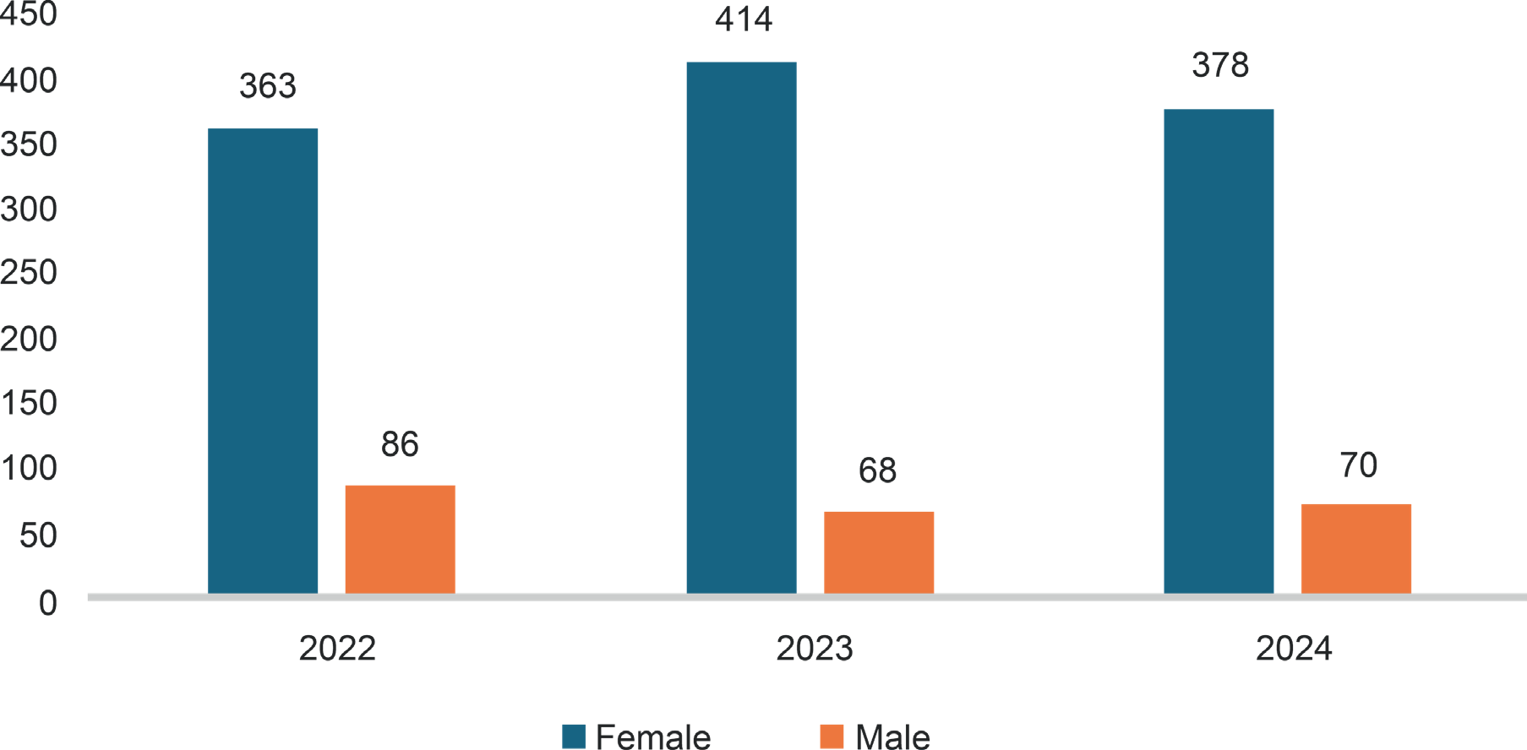

Source: SIMFONI PPA, 2024

capitals on different islands, requiring costly sea transportation. In many cases, informal mechanisms such as customary fines are used to resolve incidents of violence. The decline in reported cases may be linked to the high cost and difficulty of accessing services, as well as response mechanisms that fail to deliver justice for victims.

Poverty Rate and Spatial-Economic Conditions The poverty rate in Maluku Province stands at 15.78 percent, significantly higher than the national average of 8.57 percent (BPS, 2024). The province’s spatial characteristics, comprising numerous islands and remote areas, exacerbate the situation by limiting access to basic services, education, and economic opportunities.7 A 2022 study by the Ministry of

Finance’s Fiscal Policy Agency emphasized that spatial gender disparities have a direct impact on regional economic development. Therefore, it is critical for Maluku Province to accelerate gender- responsive human development, with attention to territorial disparities.

The data presented illustrates the persistent gender gap between men and women. These challenges are further compounded by the province’s archipelagic geography, which affects access, participation, control, and the distribution of benefits between men and women in various stages of regional development. To address this, effective coordination among stakeholders is essential to maximize efforts in closing persistent gender gaps.

# Problem Description

The Gender Mainstreaming Working Group (Pokja PUG) in Maluku Province was established through Governor’s Decree No. 200 of 2018. It comprises four key Regional Government Organizations (OPDs) as lead implementers of gender mainstreaming8, along with gender focal points from 31 OPDs. However, the group has not functioned optimally due to:

7 Jumlah penduduk Provinsi Maluku sebanyak 1.419.229 jiwa (L: 720.187 dan P: 699.042). Provinsi Maluku terdiri dari 11 Kabupaten Kota. Maluku merupakan gugusan kepulauan yang terdiri lebih dari 1.000 pulau. Akses transportasi tergantung pada jalur laut dan udara juga kondisi cuaca dengan waktu yang dibutuhkan bervariasi mulai dari 12 – 48 Jam menggunakan kapal.

8 Bappeda, DP3A, Badan Pengelola Keuangan Daerah (BPKD), dan Kantor Inspektorat Daerah.

1. Limited familiarity with gender mainstreaming (PUG) among OPDs. PUG is often viewed as the sole responsibility of the Office for Women’s Empowerment and Child Protection (DP3A). As a result, tools such as the Gender Responsive Budget (*Anggaran Responsif Gender* or ARG), Gender Analysis Pathway (GAP), and Gender Action Budget (GAB) have not been fully implemented. Also, the availability of sex- disaggregated data to support gender analysis remains limited.
2. Insufficient implementation capacity. Overall, there is a lack of understanding in preparing planning documents, programs, and activities that incorporate gender analysis.
3. High turnover and frequent reassignment of government staff, coupled with the absence

of an institutionalized knowledge management system, hinder coordination, capacity-building, and the transfer of knowledge on gender mainstreaming.

1. The Pokja PUG operating largely as a formality. Activities are limited to meetings, without adequate budget allocation to support implementation.
2. Lack of multi-stakeholder collaboration. There is still no effective engagement involving government, civil society organizations, the private sector, academia, media, and other relevant actors in advancing the gender equality agenda.

# Relevant Policies

* Presidential Regulation (Perpres) No. 12 of 2025 on the 2025–2029 National Medium-Term Development Plan (RPJMN).
* Presidential Instruction No. 9 of 2000 on Gender Mainstreaming in Regional Development.
* Minister of Home Affairs Regulation No. 67 of 2011 (amending Regulation No. 15 of 2008) on General Guidelines for Gender Mainstreaming in the Regions.
* Circular Letter No. 1 of 2024 from the Minister of Women’s Empowerment and Child Protection on Accelerating the Implementation of Gender Mainstreaming in Regional Development.
* Regional Regulation No. 7 of 2024 on Gender Mainstreaming in Maluku Province.

Policy Recommendations

1. Revitalize the Gender Mainstreaming Working Group (Pokja PUG) in accordance with the mandate of Regional Regulation No. 7 of 2024. The Office for Women’s Empowerment and Child Protection (DP3A) should serve as the driving force behind this effort, with support from relevant development partners. This is a strategic opportunity to advance the vision and mission of the newly elected Governor and Vice Governor, particularly Mission 3 of *Sapta Cipta Lawamena*, which focuses on “Strengthening the development of human resources, science, technology, education, health, sports achievement, gender equality, and the empowerment of women, youth, and persons with disabilities.”

Policy Brief | Bridging the Gender Gap in Maluku: The Case for a Regional Action Plan on Gender Equality 6

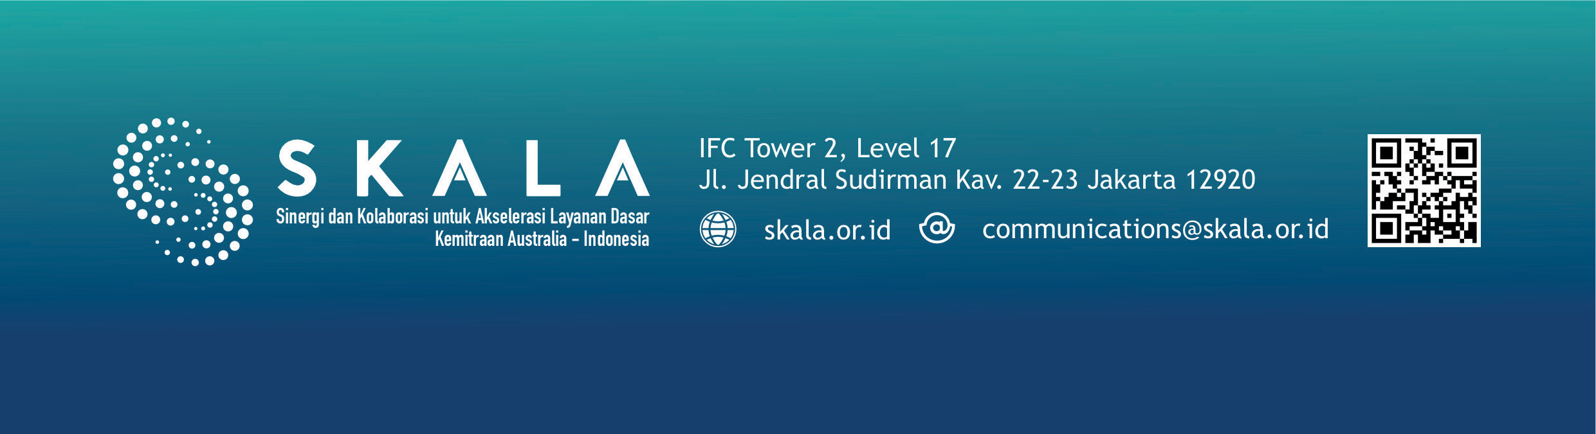

1. Strengthen the regional Satu Data forum to ensure a comprehensive and coordinated gender- disaggregated data cycle, covering data collection, analysis, and utilization. This will support more inclusive and gender-responsive planning and decision-making that addresses the differentiated needs of men, women, and other vulnerable groups.
2. Develop a Regional Action Plan for the Development of Gender Equality (RAD PKG) in Maluku Province. This process should begin with initial consultations with relevant national ministries, particularly, but not limited to, the Ministry of Women’s Empowerment and Child Protection (KPPPA), Bappenas, and the Ministry of Home Affairs. The RAD PKG aims to guide the local government in the consistent use of gender mainstreaming strategies to integrate gender perspectives into all programs and policies. It should also ensure the allocation of adequate resources across the entire planning, budgeting, implementation, monitoring, evaluation, oversight, and reporting cycle. Additionally, the RAD PKG serves as a cross- sectoral coordination mechanism to respond to persistent gender disparities, while ensuring the active involvement and participation of communities in advancing gender equality goals in Maluku Province.

***Disclaimer:*** The views, findings, interpretations, and recommendations presented in this publication do not necessarily represent the official policy or position of the Government of Indonesia, the Government of Australia, or DT Global. The SKALA Program is supported by the Australian Department of Foreign Affairs and Trade (DFAT) and is managed by DT Global.