

SKALA PROGRESS UPDATE:

KEY CONTRIBUTIONS AND INSIGHTS

December 2024

## Introduction

**SKALA is a partnership between Indonesia and Australia dedicated to strengthening Indonesia’s capacity to deliver inclusive and equitable basic services in less developed regions.** The partnership is built on strong collaboration and mutual commitment to decentralised governance. A key sign of this is Indonesia’s growing investment, with 56% of SKALA’s activities between July-December 2024 co-financed by the Government of Indonesia, a 12% increase from the previous semester. This growing financial commitment reflects Indonesia’s confidence in the program and its long- term sustainability. SKALA is also highly localised, with 98% of its staff Indonesian and all strategic partners are national organisations, ensuring local ownership and relevance. With strong engagement from Indonesian institutions and ongoing support from Australia, SKALA can contribute to practical, lasting improvements in governance and policy implementation.



of SKALA’s **5**activit**6**iesbe**%**tween July-

December 2024 co-financed by the Government of Indonesia

of SKALA staff are Indonesian and

all strategic partners are national organisations, ensuring local ownership and relevance.

**98%**

###### Between July-December 2024, SKALA pursued its goal

**to strengthen governance and service delivery by fostering collaboration between national and subnational governments, civil society, and marginalised groups.** Working across 10 provinces, SKALA aims to ensure better alignment between central policies and local implementation while also enabling civil society engagement so that women and marginalised groups have a voice in shaping policies and services. By building coordination, planning, and data-driven decision-making, SKALA enhances government capacity to deliver essential services. It provides technical assistance, supports data systems integration, and aids policy development to improve governance, budgeting, and service delivery. In 2024, SKALA’s priorities included data governance, inclusive planning, service delivery standards, and public financial management.

**Indonesia’s 2024 elections have reshaped governance, bringing both continuity and change.** While President Prabowo Subianto’s election ensures policy stability, cabinet expansion and shifting mandates present opportunities for adjustments and reform. At the subnational level, leadership transitions in SKALA-supported provinces make re-engagement crucial. SKALA works intensively with the Ministries of Home Affairs, Finance, and National Development Planning to align its efforts with national priorities for improving service delivery.

## Key Progress

Figure 1. SKALA’s Systems Approach to Improve Governance of Basic Service Delivery

Beneficiary mapping

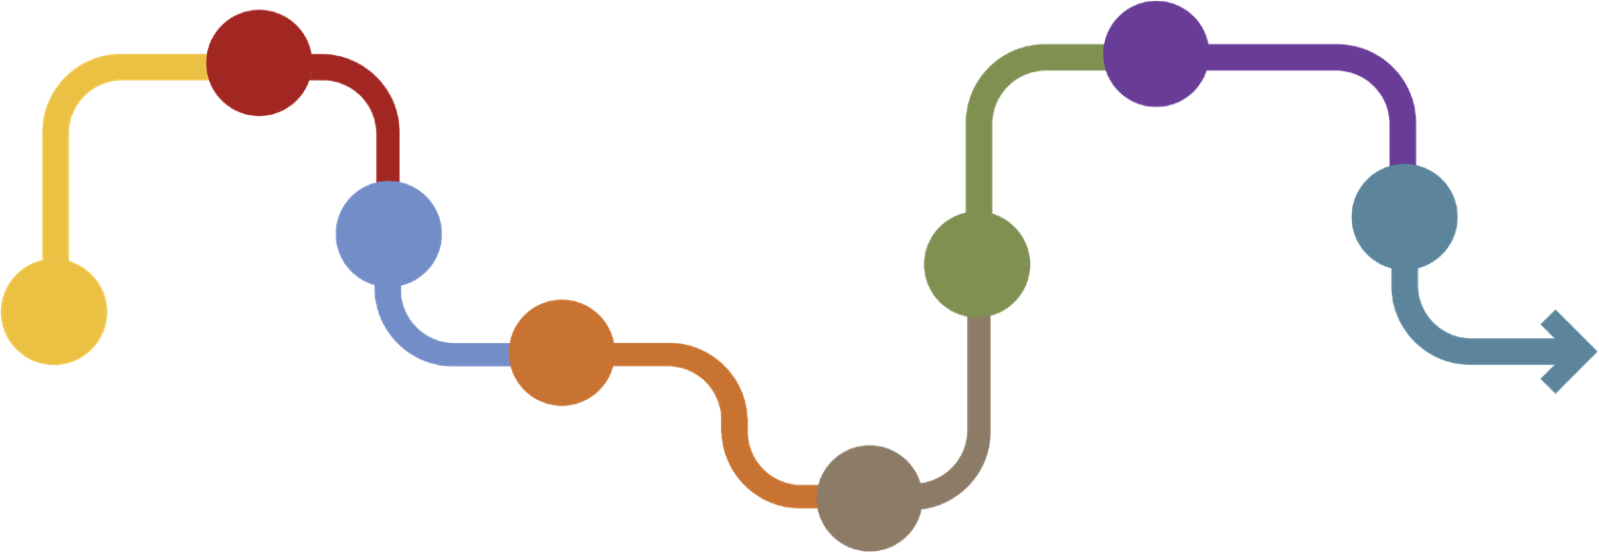

### 2

Follow up on service results

### 7

**1**

Data consolidation

**3** Planning

### 4

Budgeting

**6** Service results

### 5

**8** Updating data

Process repeats every budget year

Implementation of services

SKALA Progress Update: Key Contributions and Insights

3

#### Consolidated data for inclusive basic services



SKALA supports Indonesia’s efforts to enhance data governance, integration, and interoperability across

government levels to ensure evidence-based planning and decision-making.

**SKALA played a supporting role in advancing Indonesia’s One Data Policy by facilitating and enhancing coordination among national and subnational stakeholders.** As part of this effort, SKALA facilitated coordination between the Ministry of Home Affairs (MoHA), BAPPENAS, and Statistics Indonesia (BPS) to develop the Home Affairs Regulation, Permendagri No. 5/2024, on One Data for Domestic Governance. The regulation clarifies the roles and data management processes for regional governments. To support its implementation, SKALA conducted readiness assessments in Aceh and Maluku to identify capacity gaps and financial constraints that could

affect the policy’s rollout. These findings informed MoHA’s subnational data governance plan and will shape provincial efforts to enhance data systems and improve regulatory compliance. *SKALA further enhanced its subnational support* by providing technical assistance to One Data Forums and helping provinces establish regulatory frameworks, budgeting mechanisms, and data-sharing agreements. This collaboration helped Aceh, Nusa Tenggara Barat (NTB), and Gorontalo integrate datasets more effectively into planning and service delivery so that policies are based on accurate and accessible data.

**SKALA’s technical assistance supported the integration of financial, planning, and development data systems at national and subnational levels.** A key contribution was linking MoF’s regional financial information system (SIKD) with the National Development Planning Agency’s (BAPPENAS) analysis tool (SEPAKAT) to improve expenditure analysis for planning. Additionally, the program facilitated the interoperability of MoF’s Regional Financial Information System (SIKD), MoHA’s Regional Government Information System (SIPD), and Papua’sdevelopment acceleration information system for greater alignment between financial planning and regional development priorities. *At the subnational level*, SKALA provided technical assistance and training on SIPD to equip local governments with tools to improve budgeting and service delivery. These efforts have strengthened data integration across multiple government platforms, and will improve transparency, resource allocation, and evidence-based decision-making. By aligning financial and planning data, SKALA seeks to contribute to national and subnational governments efforts to coordinate, track expenditures more effectively, and support more responsive public services.

#### Mapping beneficiaries of basic services

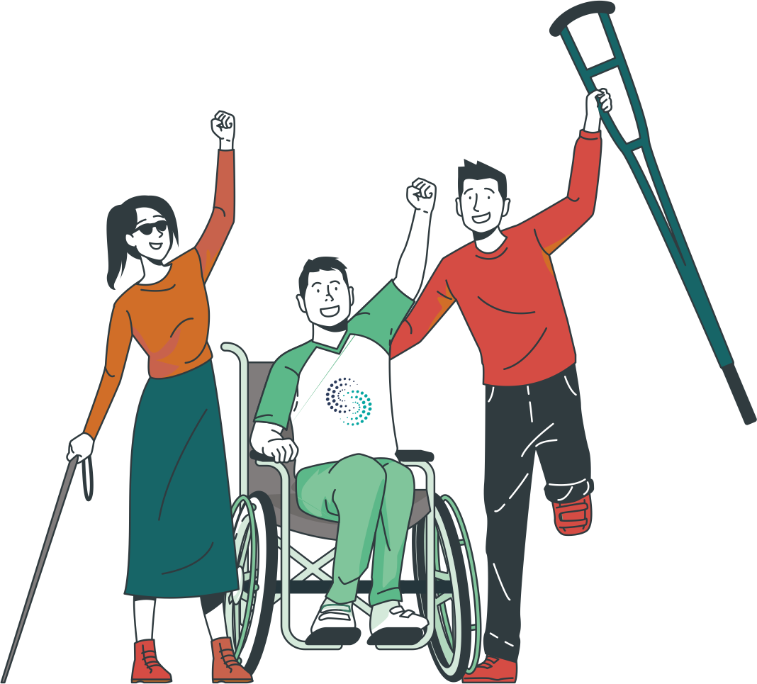

Improving the targeting of beneficiaries ensures that government resources effectively reach

the most vulnerable individuals and households. SKALA supports evidence- based planning and budgeting, helping

to reduce inclusion and exclusion errors in government programs and services.

**To this end, SKALA supported data analysis and use by strengthening the integration of national socioeconomic data for policy and budgeting decisions.** The program worked with national and subnational governments to integrate REGSOSEK data into decision-making processes for targeted resource allocation and service

delivery. It helped expand access to REGSOSEK for four

ministries, three provinces, and 18 districts, directly

Expand access to REGSOSEK for

training 584 staff while enabling the Government of Indonesia to train an additional 3,086 officials. *At the subnational level*, REGSOSEK was instrumental in refining key services, particularly in Nusa Tenggara Timur (NTT), Gorontalo, NTB, and Kalimantan Utara. Provincial governments have used the data to update Minimum Service Standards (MSS) records, enhance geospatial mapping for disaster-prone populations, and improve planning for education and housing programs. A data-

**4** ministries

**18**districts

# 3,086

**3** provinces

GoI staff

**584**

trained directly

officials trained.

matching exercise in NTT significantly strengthened poverty reduction targeting, correcting classification errors for over 1.7 million individuals. These improvements have resulted in more efficient budget allocations, including IDR 5.75 billion redirected towards stunting reduction and IDR 5.6 billion towards poverty alleviation, benefiting vulnerable groups such as older people, people with disabilities, and female-headed households.

**>1.7**

million individuals’

classification errors corrected

IDR

**5.75**

billion reallocated

for stunting reduction

IDR**5.6**

billion reallocated

for poverty alleviation



**To enhance the accuracy of government programs and services, SKALA contributed to Village Information Systems (SID) by improving local data collection processes.**



|  |
| --- |
| The program supported SID expansion across multiple provinces, working with BAPPENAS, MoHA, and the Ministry of Villages (MoV) to integrate standardised methodologies for household data collection. |
| A key enhancement has been the integration of national  socioeconomic data variables from REGSOSEK into SID. |
| In Papua and Papua Barat, SKALA supported the incorporation of REGSOSEK variables into SIO Papua and SAIK+ so that local governments can use standardised socioeconomic indicators to improve household assessments and program targeting.  This approach helped local governments identify vulnerable households more effectively, reducing inclusion and exclusion errors in program delivery. |
| Village As SID coverage grows, SKALA continues to refine data collection  **SID** Information protocols and strengthen links between village-level data systems  Systems and broader subnational data governance frameworks, further  supporting Indonesia’s One Data approach. |

SKALA facilitated CSO participation in

**30**

subnational planning processes

to help shape policies on gender equality, disability rights, and poverty reduction.

A survery of CSOs found

that SKALA strengthened their networks with

local governments, with engagement reaching

**75%**

in Aceh

**80%** in Gorontalo

**SKALA is also working to improve civil society access to policy-relevant data** by supporting provincial governments to ensure that disaggregated data on marginalised communities is consistently available through public data portals. In NTB, Aceh, and Kalimantan Utara, the program provided technical support to make online data portals accessible for visually impaired users, and is exploring partnerships to enhance CSOs’ ability to use data effectively in advocacy. To further integrate CSOs into policymaking, SKALA facilitated their participation in 30 subnational planning processes to help shape policies on gender equality, disability rights, and poverty reduction. A survey of CSOs found that SKALA strengthened their networks with local governments, with engagement reaching 75% in Aceh and 80% in Gorontalo. By expanding data access and use, SKALA is aiming to promote evidence-based advocacy and inclusive decision-making.

#### Planning basic services

**SKALA is helping to shape national guidelines and supporting subnational reforms to ensure planning reflects local needs and promotes equity.** It supported development of the National Inclusive Participatory Planning Guidelines (NIPPG) to strengthen subnational governance by drawing on its experience in Kalimantan Utara’s first participatory work planning process. The guidelines establish mechanisms for assessing participation quality, clarifying roles, and ensuring gender- responsive planning. While still under discussion, the guidelines are expected to enhance government responsiveness to vulnerable groups. To further institutionalize inclusive planning, SKALA supported MoHA and BAPPENAS in embedding inclusivity and data-driven decision-making into official planning guidelines. At the subnational level, it facilitated stakeholder input, including from civil society, to ensure policies reflect local needs. It helped revitalize provincial consultation forums to encourage meaningful participation in policy discussions. In Maluku, 19 disability organizations joined these forums which strengthened their influence on government decision-making. A survey found that 78% of persons with disabilities in SKALA-supported planning processes felt more engaged with the government. These efforts have led to concrete commitments across provinces, including NTB’s knowledge-sharing initiatives and Kalimantan Utara’s prioritization of accessible infrastructure and parenting support programs. SKALA also supported increases in regional income from taxes and levies while encouraging local governments to consider the needs of vulnerable groups. This ensures that public services in NTB, Aceh, and Kalimantan Utara are more inclusive and responsive to marginalised communities.

**19** disability organizations joined subnational

A survery found that

of persons with disabilities in

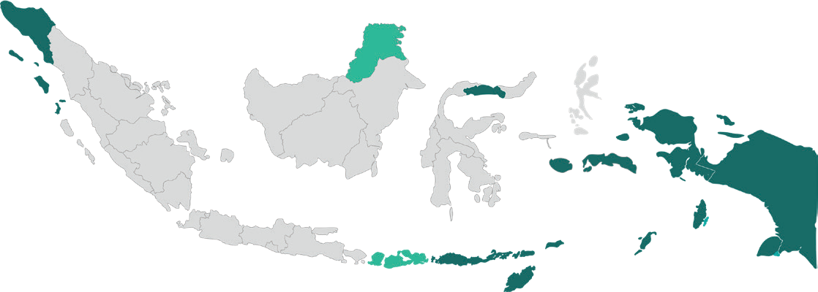

forums which strengthened their influence on government decision-making

**MALUKU**

**78%**

SKALA-supported planning processes felt more engaged with the government.

**The program also facilitated policy dialogue in NTB to strengthen climate resilience by integrating conventional and satellite data into planning.** In collaboration with MoHA and UN Global Pulse, the program is providing local leaders with tools to assess climate risks and develop targeted adaptation strategies in Maluku, North Kalimantan, and Gorontalo also. As part of these efforts, SKALA collaborated with BAPPENAS to explore a subnational cluster model which incorporates climate vulnerability into fiscal transfers and regional planning. This approach aims to support asymmetric decentralisation by identifying regions with shared development challenges.

#### Budgeting for basic services

Effective budgeting ensures that limited resources are allocated efficiently so that spending is aligned with national priorities and the needs of vulnerable communities.

**To strengthen budgeting processes, SKALA has supported gender-responsive budgeting, budget classification improvements, and tools to align local spending with national priorities.** Over the past year, SKALA supported the development of Indonesia’s first gender budget tagging model, assisted MoHA in revising the budget classification system, and supported the Ministry of Finance (MoF) refine the tagging model to inform a

new national regulation. This collaboration, involving MoF, MoHA, BAPPENAS, and the Ministry of Women’s Empowerment and Child Protection, enabled subnational governments to assess gender responsiveness in budgets and align spending with national gender targets. To further ensure national and subnational alignment, SKALA supported MoF to disseminate key fiscal requirements and develop a tool for provinces and districts to review spending. It also assisted MoHA to establish a mechanism to assess budget allocations so that MSS and GEDSI priorities continue to be addressed in subnational budgeting. These efforts have influenced local budgets, with NTB aligning its 2025 budget to national priorities, including student meal programs and stunting prevention. In Gorontalo, SKALA facilitated discussions between people with disabilities and parliamentarians, using REGSOSEK data to advocate for targeted funding. By supporting policy briefs and fiscal planning tools, SKALA is ensuring gender- responsive budgeting informs local parliamentary decisions for 2026 and beyond.

**SKALA supported the central government in its efforts to optimise fiscal transfers to subnational governments so that the IDR 714.37 trillion allocated is effectively utilized for essential services.** By working with national ministries and subnational governments, SKALA strengthened planning, budgeting, and governance structures across six key transfer mechanisms. Notable contributions include refining performance-based allocation formulas for the General Allocation Fund (DAU), improving the targeting of regional grants for infrastructure and social services, and supporting efforts to prepare for the establishment of Regional Endowment Funds in provinces with high fiscal capacity. SKALA also facilitated governance improvements in earmarked revenue-sharing transfers, village funds, and special autonomy (OTSUS) funds. In Aceh and Papua, the program supported the development of governance guidelines, trained local officials in OTSUS fund management, and facilitated monitoring missions to enhance transparency. These efforts are expected to streamline provincial budget planning, eliminate redundant expenditures, and strengthen accountability mechanisms. By improving fund allocation and financial governance, SKALA seeks to contribute to more efficient fiscal management and expanded access to inclusive public services across its partner provinces.

**SKALA supported the implementation of Indonesia’s Law on Financial Relations between the Central and Regional Governments (HKPD) by fostering local revenue systems to improve service delivery.** At the national level, SKALA facilitated collaboration between MoF and MoHA to ensure provincial governments received guidance on tax and levy policies. It also supported regulatory

improvements in tax administration by developing guidelines for subnational auditors and tax personnel. To enhance revenue forecasting, SKALA helped MoF develop a new provincial tax revenue calculation method that improves financial projections, data-sharing, and compliance, enhancing provinces’ fiscal capacity for essential services. *At the subnational level*, SKALA assisted provinces in aligning their tax regulations with national guidelines by mapping regional tax assets and providing quality assurance for provincial regulations. This accelerated regulatory approvals and improved tax oversight. A key contribution was SKALA’s advocacy for tax exemptions benefiting vulnerable groups, particularly people with disabilities, leading to reductions in vehicle taxes and levies in several provinces. In NTB, provincial authorities have already implemented these exemptions. SKALA also facilitated discussions between provincial and district administrations, resulting in memorandums clarifying tax allocations and responsibilities. Lessons from these reforms are being documented to guide other provinces and ensure sustainable improvements in local revenue management.

#### 5 & 6. Effective Service Delivery and Impactful Results

By improving coordination, data integration, and planning, SKALA seeks to help national and subnational governments ensure policies translate into meaningful outcomes for communities. Since inception, SKALA has helped contribute to the following results:



##### Stronger and Better Data, and its Analysis and Use for Basic Services

* MoHA’s 5 guidelines on the National SDPDN System (data governance framework, portal, MCE, and action plan) to improve data use in subnational planning.
* MoF Regulation 108/2024 which now integrates village

fund realisation data to improve 2025 allocations.

* SIPD tags gender mainstreaming activities, SIKD analyses gender-based spending, and SIKD-Aceh is under development for Special Autonomy funds.
* System linkages between SIPD Hub, SEPAKAT, SIKD, and SIPPP to enhance evidence-based decision- making at subnational levels.
* SIGAP in Aceh increased data coverage by **G%**, now capturing **47%** of the population for better service targeting.



##### More Participatory Policy Planning, Implementation, and Monitoring

* Three MoHA planning guidelines now integrate Regsosek data for gender and disability analysis in RPJPD, RPJMD, and RKPD.
* **51** CSOs actively participated, with **24** proposals from civil society accepted into 2025 local government work plans (Renja).
* NTB, NTT, Kaltara, Gorontalo, Maluku, and others are developing policies for more inclusive participatory planning processes.
* **81** revised and **5** new budget classifications proposed for gender and disability inclusion, pending discussions with MoF and Bappenas.
* Aceh and NTT ratified their Regional Action Plans (RAD)

for People with Disabilities.

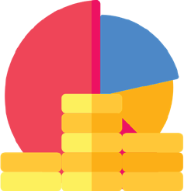

##### Better Spending at Subnational Levels on Basic Services

* Supported Aceh, NTT, NTB, Kaltara to issue regional tax and levy regulations, governor decrees, and SOPs for better revenue management.
* Supported NTB and Gorontalo to help districts develop MSS action plans and improve fiscal reporting and budget monitoring.
* Contributed to development of indices to track fiscal

performance in addressing poverty and service equity.

* Kaltara’s DAU allocation for education increased by

### 52%.



##### Achievement of Minimum Service Standards (MSS)

* + MoHA Regulation 15/2024 guides 2025 APBD, and a new e-review module enhances subnational budget evaluation.
  + MSS costing guidelines and instruments are being finalized to help provinces allocate adequate funds for essential services.
  + **23** districts/cities in Aceh and **3** in Tanah Papua successfully submitted their 2025 OTSUS plans within the national deadline.
  + **7** partner provinces increasing availability of service delivery data.
  + **7** provinces now provide structured support to districts on planning, budgeting, and service delivery coordination.

## Lessons Learned

**1 SKALA’s contributions extend beyond its partner ministries to improving coordination and capacity-building across key government agencies to enhance service delivery.** SKALA has worked with MoHA and sectoral ministries to improve MSS reporting through joint training while aligning national and subnational policies by facilitating collaboration between BAPPENAS and MoHA on subnational data governance. It also supported joint monitoring efforts, coordinating MoHA and MoF missions on OTSUS and MSS in Papua and assisting BAPPENAS and MoHA in evaluating the Special Allocation Fund(DAK) in Aceh, Gorontalo, Maluku, and NTT. *SKALA supported a nationally coordinated subnational implementation strategy* to accelerate impact, particularly through MoHA and BAPPENAS’ unified approach to the Regional One Data implementation plan. By clarifying ministerial roles and responsibilities under a single set of guidelines, SKALA is helping to streamline policy rollout and reduce administrative burdens on provinces. It also supported introduction of work-based training models to strengthen planning and budgeting, including a decentralized working group in Papua to enhance OTSUS planning and a joint capacity-building model between MoHA and Provincial Sector Offices to mentor MSS personnel. By leveraging program resources, these cost-efficient training solutions help government partners adapt to national travel restrictions while maintaining strong subnational capacity development.

**2 SKALA’s implementation generated valuable lessons for Indonesia’s decentralization framework, particularly in advancing subnational planning, budgeting, and service delivery through coordinated oversight and interministerial collaboration.** Coordination between MoHA, BAPPENAS, and MoF, demonstrated how harmonized socioeconomic data governance supports more effective policy decisions at the national and provincial levels. The program’s experience with OTSUS in Papua also offers insights applicable to other decentralised governance models, including Aceh. Moreover, joint monitoring and evaluation missions have shown that structured collaboration enhances governance outcomes. At the same time, SKALA’s capacity- building models for MSS implementation teams and social welfare management provide scalable solutions for improving subnational service delivery. SKALA is supporting ongoing reforms by integrating these lessons into national policy discussions to enhance decentralisation and government accountability.

**3 These gains will require continued collaboration between national, provincial, and district governments.** Bolstering coordination mechanisms and ensuring alignment across levels of government will be essential for maintaining policy coherence and boosting institutional capacity over time. By fostering long-term partnerships and reinforcing joint decision-making processes, SKALA’s approach can help integrate these reforms into broader governance systems, ensuring their lasting impact on Indonesia’s decentralisation efforts.

## Next Steps and Strategic Priorities

SKALA’s results extend beyond the direct implementing ministries by improving policy coherence, fiscal

decentralisation, and governance mechanisms that impact all levels of government and civil society

### Aligning SKALA’s activities with emerging national policies and fiscal frameworks.

**SKALA has contributed to Indonesia’s One Data Policy by coordinating national and subnational stakeholders to enhance data governance.** To build on past contributions, SKALA can deepen its support for One Data Forums by further clarifying roles, ensuring sustainable budgeting, and providing technical guidance on data management. Continued coordination with MoHA, BAPPENAS, and BPS remains crucial to translating this policy into tangible improvements at the provincial level. Strengthening these forums will help subnational governments manage data more effectively and integrate it into decision-making processes.

**SKALA can further deepen its support for data-driven governance by improving local government access to socioeconomic data.** Continued coordination with MoHA, BAPPENAS, and BPS is essential to effectively implement the government’s policy on subnational data governance. A key priority is integrating financial and planning systems, such as linking MoF’s financial data with SEPAKAT, to improve spending analysis and resource allocation. Expanding the use of national socioeconomic data through training and capacity-building will help local governments bridge data gaps and enhance accessibility. Improving these areas will ensure high-quality, disaggregated data informs inclusive policy decisions at both national and subnational levels.

### Mainstreaming GEDSI into national and subnational planning.

**To strengthen inclusive governance, SKALA will continue integrating GEDSI across its activities, aligning with evolving government priorities.** It will support the implementation of the NIPPG and, as newly elected provincial governments take office, facilitate greater civil society participation by equipping CSOs with data-driven tools for advocacy. SKALA will also improve the accessibility of provincial data portals, enabling people with disabilities to engage with public information. By encouraging partnerships and promoting data-driven advocacy, SKALA continues to foster a more inclusive policy environment at both national and subnational levels.

### Continuing provincial fiscal optimisation efforts to improve service delivery.

**SKALA will continue optimizing fiscal transfers for basic services to help subnational governments effectively manage centrally transferred funds under the HKPD Law.** To strengthen public fiscal management, SKALA will support subnational governments in implementing the Public Expenditure and Revenue Analysis findings, including developing tax regulations, levy collection procedures, and new revenue strategies. It also ensures MSS are embedded in local budgets, aligning fiscal planning with regional medium-term development goals (RPJMD 2025-2029). SKALA supports strategies to increase regional original revenue (PAD) to enhance local revenue mobilisation while balancing investment incentives and equitable taxation. It also explores opportunities to leverage public-private partnerships and innovative financing models that sustain infrastructure development and promote economic diversification. These efforts will strengthen financial sustainability at the subnational level while ensuring fiscal policies remain responsive to local development needs.

### Ensuring strategic prioritisation, effectiveness, and efficiency of program budget.

**SKALA’s considerations moving forward include tracking the Government of Indonesia’s co-financing trends** to assess the impact of government-wide budget cuts and ensuring a balance between programming and operational costs. SKALA is also refining its engagement approach by prioritizing lower-cost, high-policy-impact activities over high-visibility events. It also continues to assess whether its investment in Monitoring, Evaluation, Research, and Learning is sufficient to generate the necessary evidence by the end of Phase 1. Resourcing adjustments may be needed to strengthen evidence-based decision-making and support adaptive programming.



Sinergi dan Kolaborasi untuk Akselerasi Layanan Dasar (SKALA) is an Australia-Indonesia Partnership Program aimed at supporting the Government of Indonesia’s efforts to reduce poverty and inequality by improving basic-service provisions to poor and vulnerable communities in less-developed regions.

**CONTACT US**

**IFC Tower 2, Level 17**

**Jl. Jendral Sudirman Kav. 22-23 Jakarta 12G20**

[**communications@skala.or.id**](mailto:communications@skala.or.id)  **s.id/Channel-SKALA**

**SKALA.or.id**