

**Synergy and Collaboration for Basic Service Acceleration**

**Australia - Indonesia Partnership**

**ACEH PROVINCIAL GOVERNMENT**

**MINISTRY OF FINANCE OF THE REPUBLIC OF INDONESIA**

**MINISTRY OF HOME AFFAIRS OF THE REPUBLIC OF**

**INDONESIA**

**BAPPENAS**

**Ministry of National Development Planning/National Development Planning Agency**



Collaboration to Accelerate Basic Services Delivery in Aceh Province

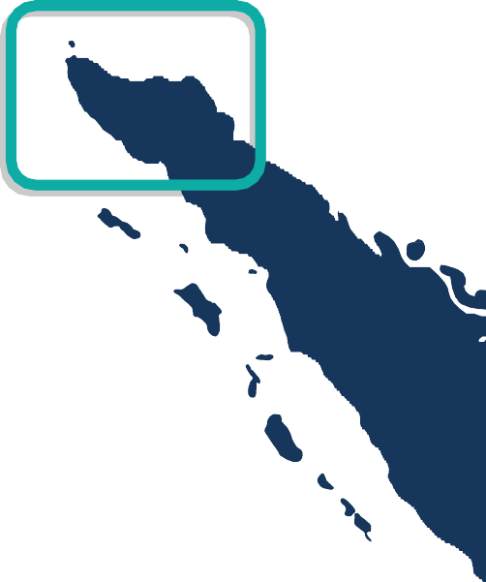

**April 2025**

**Effective governance and inclusive development are key to improving the well-being of people in Aceh.** Faced with fiscal constraints and evolving development needs, the government of Aceh for the period 2025-2030 sets out a vision that focuses on governance reform, economic independence, infrastructure development, human resource capacity building and environmental sustainability.

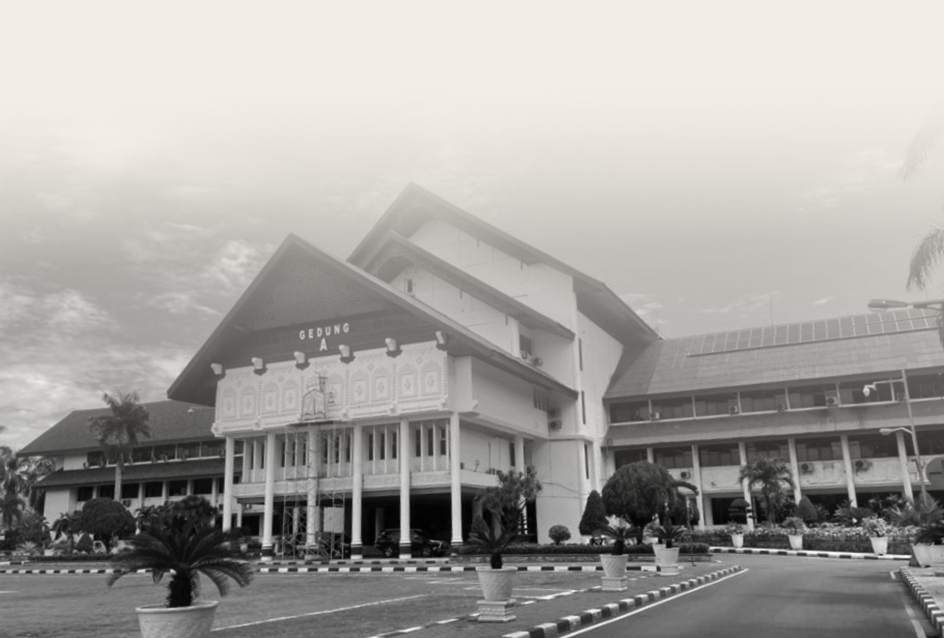

**The Government of Aceh continues to strengthen local governance, financial management, data integration and social inclusion** as part of measures to realise the province’s development vision. To support these efforts, the Government of Aceh collaborates with SKALA, the Australia-Indonesia Partnership Program for the acceleration of basic service delivery, on capacity building and policy development. This collaboration continues as part of a shared commitment to support the new leadership of the Aceh Provincial Government.

**1**



**2**



# Focus of Collaboration

## Governance and Public Financial Management

In line with the Governor of Aceh's priority of optimising local financial governance and accountability, the Government of Aceh in collaboration with the SKALA Program has made strategic efforts to strengthen an inclusive, transparent and sustainable financial management system. These efforts include:

* Passing of *Qanun* 4/2024 on Taxes and Levies in Aceh that emphasises the principle of fiscal justice and provides protection for persons with disabilities and other vulnerable groups.
* Management of the Palm Oil Revenue Sharing Fund (DBH) through the preparation of budget plans at the provincial and 23 district/city levels, to ensure effective utilisation of funds to support economic growth and social welfare.
* Strengthening the Minimum Service Standards (MSS) consultation clinic model as a means of technical assistance in planning, budgeting, and delivering basic services in a more targeted manner.
* Analysis and formulation of recommendations for the utilisation of Special Autonomy funds and development of a sustainable funding transition strategy going forward.

 **Natural Resources Management and Economic Development** Economic independence and sustainable management of naturalresources is one of the main missions of the Governor of Aceh. To support this mission, the Government of Aceh continues to encourage strategic initiatives, including the identification of new revenue streams and the optimisation of fiscal policy to drive long-term economic growth. The SKALA program acts as supporting partner in this process by providing technical support and capacity building.

## Human Resources and Population Development

Improving the quality and competitiveness of human resources is one of the Aceh Governor's top priorities. To support this, the Government of Aceh continues to enhance the capacity of government apparatus as well as more reliable data governance. This effort is also strengthened through collaboration with SKALA Program in the form of technical support and facilitation, among others through:

* Capacity building of 250 government officials in 23 districts/cities in data collection and management, to support evidence-based planning.
* Improved access to data for planning and service delivery by facilitating the mapping of 3,303 datasets in the Aceh Open Data Portal.
* Strengthening village governance and integrating community feedback mechanisms through the development of the *Gampong* Information System - SIGAP 1.75, which now covers 47% of Aceh's population.

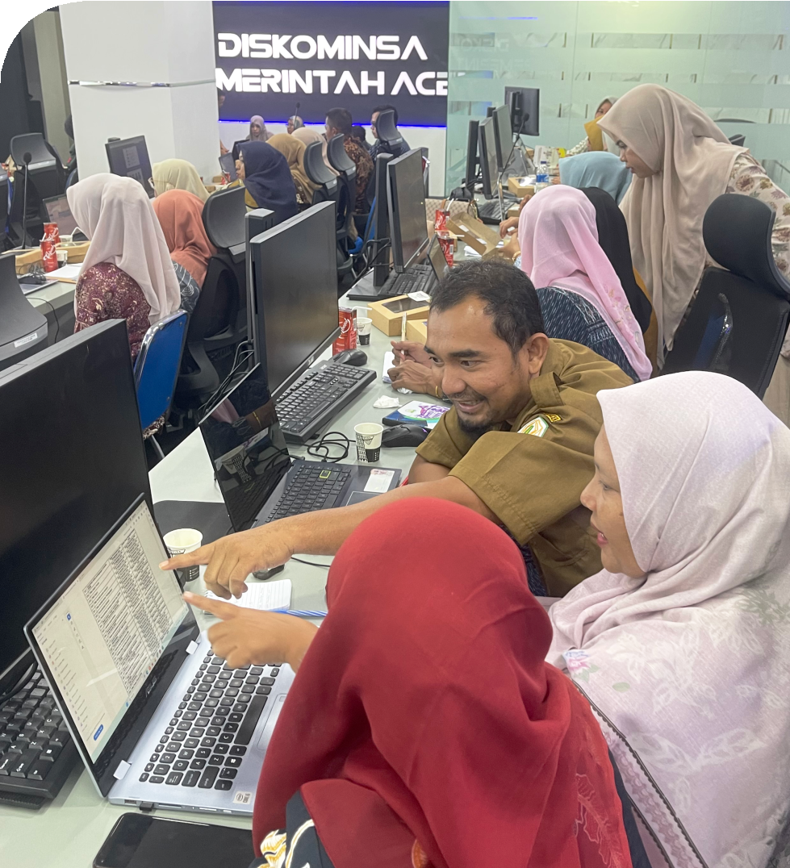

## Community Equality, Dignity and Prosperity

To realise an inclusive and dignified Aceh, the Government of Aceh encourages the participation of all community groups, especially women, people with disabilities and other vulnerable groups, as an important part of a fair and responsive governance system. This effort is also strengthened through collaboration with SKALA Program, which provides technical support, including through:

* Facilitating the drafting of Aceh Governor Regulation No. 53/2023 on the Regional Action Plan on Fulfilling the Rights of Persons with Disabilities, to ensure legal protection and access to services for persons with disabilities.
* Facilitating the drafting of the Aceh *Qanun* on Women's Protection, to strengthen gender-responsive policies.
* Facilitating the drafting of the Aceh *Qanun* on the Fulfilment of the Rights of Persons with Disabilities
* Strengthening the participation of civil society networks (CSNs) in development planning, so that community perspectives can be integrated in the long-term development strategy of Aceh Province.
* Training government officials in gender-responsive planning and budgeting, to ensure policies in Aceh Province are more inclusive and favourable to vulnerable groups.

# Budget Efficiency Challenges and SKALA Program Support

One of the main challenges facing the new government is ensuring budget efficiency, especially in the midst of a budget reduction of IDR 317.4 billion in 2025. In the face of this challenge, the Government of Aceh in collaboration with SKALA continues to strengthen efforts for more targeted planning and budgeting through:

Data-driven planning to ensure policies are based on accurate information.

Optimisation of budget allocations through improved fiscal management, ensuring limited resources are used effectively and on target.

Integration of Minimum Service Standards (MSS) in local development planning to ensure that the quality of service provision remains up to standard, despite budget constraints.

**3**

**Sustainability of Collaboration in Support of Aceh's Vision**

In line with the Aceh Governor's vision, the provincial government will continue to strengthen various development initiatives through collaboration with the SKALA Program, which include:

### 1. Governance and Public Financial Management

Strengthening local government capacity in implementing MSS regulations, calculating budget needs, and optimising local revenues through improved tax and levy policies, local financial transfers, and Electronic Local Government Transactions (ETPD) mechanisms.

**2. Human Resource Development**

Enhancing the technical capacity of the provincial MSS team to oversee district implementation, provide technical recommendations for key planning documents (RPJPD 2025-2045, RPJMD 2025-2029, RENSTRA), and strengthen collaboration with universities to support improved data governance and analysis.

**3. Natural Resource Management and Economic Development**

Improving the governance of special autonomy funds, to make their utilisation more sustainable and effective, and facilitating the review of public expenditure and revenue in Aceh.

### 4. Social Inclusion and Community Engagement

Strengthening more inclusive governance by providing technical recommendations on community participation regulations, as well as developing guidelines to strengthen CSN’s capacity to advocate for basic service delivery, with a focus on gender equality, disability inclusion, and vulnerable groups.

**Synergy and Collaboration for Basic Service Acceleration**

**Australia - Indonesia Partnership**

IFC Tower 2, Level 17

Jl. Jendral Sudirman Kav. 22-23 Jakarta 12920

scale.or.id [communications@skala.or.id](mailto:communications@skala.or.id)



4