HALO

SKALA

**Welcome to the inaugural edition of HALO SKALA**

Synergies and Collaboration to Accelerate Basic Service Delivery (SKALA) is an Australia-Indonesia Partnership Program to support the Government of Indonesia’s efforts to reduce poverty and inequality by improving basic-service provision to poor and vulnerable communities in less-developed regions.

This edition is on Data Integration, a foundation for effective, inclusive and evidence-based governance. Amid increasingly complex development challenges, data integration across sectors and levels of government is the key to more targeted public services.

Through Halo SKALA, we share stories, lessons, and good practices from our partners, and invite collaboration to strengthen governance in Indonesia.

HALO SKALA | May 2025

# POLICY BRIEF

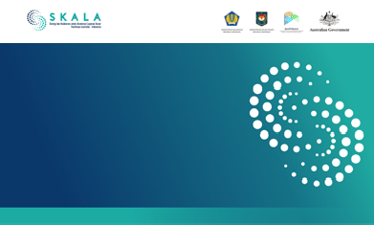

**POLICY BRIEF**

**Lessons from Regsosek Utilization across Indonesia: Inputs to Strengthen DTSEN**

**April 2025**

**Executive Summary**

Presidential Instruction (Inpres) Number 4 of 2025 on the National Socio-Economic Single Data (DTSEN) marks an important step in improving data management and the data ecosystem in Indonesia. DTSEN builds on the architecture of the Socio-Economic Registry (Regsosek), the Integrated Social Welfare Data (DTKS), the Targeting Data for the Acceleration of Extreme Poverty Eradication (P3KE), and other data systems. DTSEN can benefit from lessons that have emerged from previous data systems. These include the need for (i) a tested and effective mechanism to update a unified data system, (ii) complete regulations on guidelines, governance, and coordination mechanisms across institutions responsible for updating, verifying, and validating data at national and regional levels, (iii) skilled human resources, and

(iv) sufficient funding for data updating—especially in remote, underdeveloped, and island regions. This policy brief identifies key lessons from the Regsosek data updating pilot conducted by Bappenas and Statistics Indonesia (BPS), and provides recommendations for relevant policymakers to support and enhance future data updating processes.

**Keywords:** *DTSEN, data updating, Regsosek, mandatory reponsibilities, incentives*

**Background**

**Presidential Instruction Number 4 of 2025 on the The experience of managing, using, and updating National Socio-Economic Single Data (DTSEN) is an Regsosek data in the regions offers important insights important milestone in improving data management for the implementation of DTSEN,** particularly as some **in Indonesia.** One of the main foundations of DTSEN is of the challenges encountered during Regsosek’s rollout Regsosek, which was developed by Bappenas and Statistics are likely to persist. Lessons drawn from the Australia– Indonesia (BPS) and collected through a full population Indonesia Partnership Program – SKALA, which supports census in 2022. The data includes socio-economic and socio-economic data governance from the village to the demographic information, asset ownership, sanitation national level, suggest that effective updating and use and housing conditions, disability status, elderly and of Satu Data in Indonesia can be strengthened through child-related data, and geospatial information. Regsosek coordination and collaboration among key stakeholders. data is standardised, disaggregated, and ranked. By This includes efforts to clarify data design, strengthen early 2025, it had been accessed and used by at least 26 regulations on governance and cross-institutional provinces and 153 districts/cities. coordination, ensure the availability of skilled human

**Policy Brief |** Optimising Socio-Economic Data Updating for Inclusive Development: Lessons from Regsosek Implementation **1**

Lessons from Regsosek Utilization across Indonesia: Inputs to Strengthen DTSEN

Presidential Instruction (Inpres) Number 4 of 2025 on the National Socio-Economic Single Data (DTSEN) marks an important step in improving data management and the data ecosystem in Indonesia. DTSEN builds on the architecture of the Socio-Economic Registry (Regsosek), the Integrated Social Welfare Data (DTKS), the Targeting Data for the Acceleration of Extreme Poverty Eradication (P3KE), and other data systems. DTSEN can benefit from lessons that have emerged from previous data systems, including Regsosek. These include the need for (i) a tested and effective mechanism to update a unified data system, (ii) comprehensive regulations on guidelines, governance, and coordination mechanisms across institutions responsible for updating, verifying, and validating data at national and regional levels, (iii) skilled human resources, and (iv) sufficient funding for data updating, especially in remote, underdeveloped, and island regions. This policy brief identifies key lessons from the Regsosek data updating pilot conducted by Bappenas and Statistics Indonesia (BPS) and provides recommendations for policymakers to support and enhance future data updating processes.

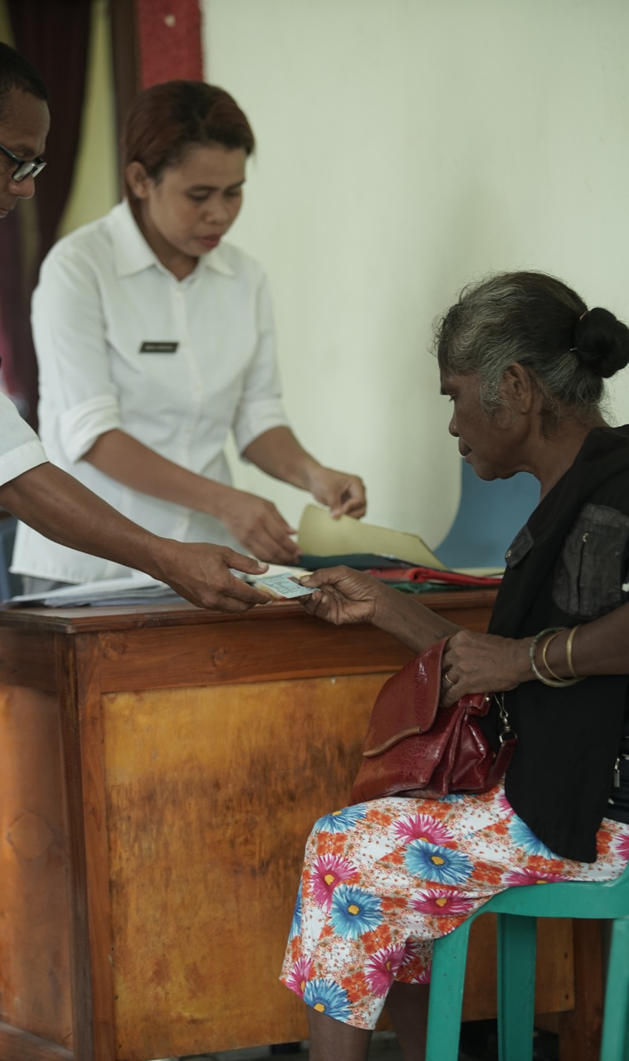

[See More](https://skala.or.id/en/publications/optimizing-the-updating-of-the-national-socio-economic-single-data-dtsen-for-inclusive-basic-services-lessons-from-regsosek-implementation-in-the-regions/)

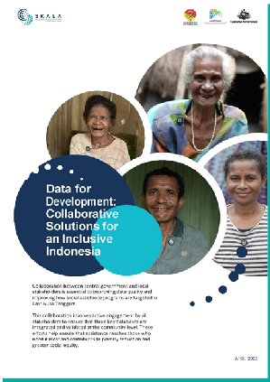

# STORIES FROM THE FIELD

Booklet

Data for Development:

Collaborative Solutions for an Inclusive

Indonesia

Collaboration between the central and local governments is the key to improving data quality and the accuracy of social assistance program targeting in East Nusa Tenggara (NTT) Province. This synergy involves various stakeholders to ensure the integration and validation of three main poverty-related data (Regsosek, DTKS, and P3KE) right up to the community level. As a result of the integration, distribution of

social assistance was better targeted to those who really needed it, thus supporting poverty reduction efforts and strengthening social justice in the community.

Inclusive development in Indonesia requires accurate, integrated and reliable data. The collaborative practice implemented in NTT is a clear example of how the integration of socio-economic data can accelerate the achievement of inclusive basic services. Through comprehensive data validation and utilization, the government can ensure that social assistance is received by people in need.

The success of NTT as a cross-sector collaboration pilot project in poverty and stunting reduction is an inspiration for other regions. By building a solid, collaborative, and sustainable data ecosystem, Indonesia can move towards a more just and prosperous society.

[See More](https://skala.or.id/en/stories/data-for-development-collaborative-solutions-for-an-inclusive-indonesia/)

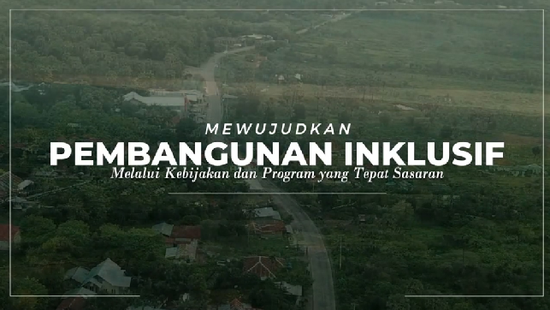

Video

Implementing Inclusive Development through Targeted Policies and Programs

This video highlights the importance of collaboration between central and local governments in improving data quality for inclusive development in NTT.

[See More](https://www.youtube.com/watch?v=0Kk1OazJ2Fc)

# SUPPORT FOR GOVERNMENT PRIORITY

One Regional Data

Satu Data Aceh:

Towards Data-Driven Government 

Satu Data Aceh is a strategic initiative of the Government of Aceh to support Satu Data Indonesia in accordance with Presidential Regulation Number 39 of 2019. It is also a flagship program of the Aceh Governor and Deputy Governor’s 2025-2029 Quick Wins.

This program aims to collate data that is accurate, up-to-date, integrated, and accountable, as well as easily accessible to the public and shared between agencies to support data-based policy-making processes.

WATCH READ

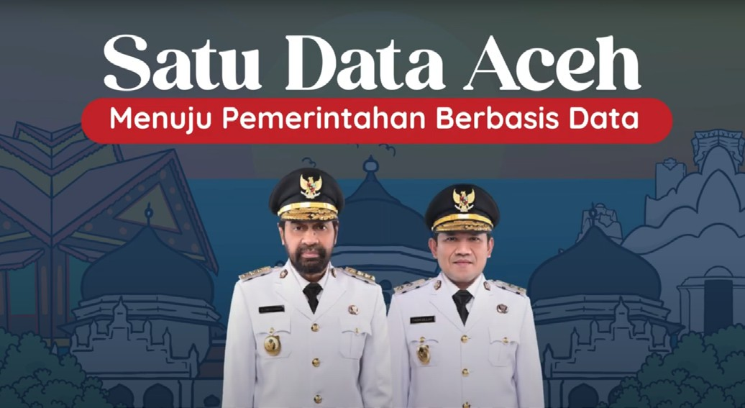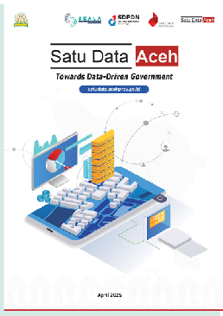

[See More](https://www.youtube.com/watch?v=9XoV_CO9Ocw)  [See More](https://skala.or.id/en/publications/satu-data-aceh-towards-data-driven-government/)

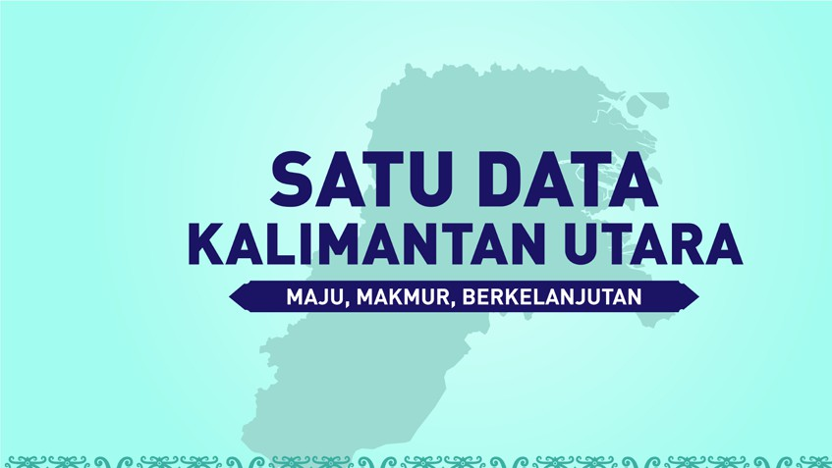

Satu Data North Kalimantan:

Advanced, Prosperous, Sustainable

Video

Watch this video about how Kalimantan Utara is building an inclusive, data-driven governance system through the Regional Satu Data initiative. Backed by strong provincial regulations and aligned with national policies, the Sidara Cantik 2.0 platform integrates sectoral data to support better planning and services.

[See More](https://www.youtube.com/watch?v=yP0tpLI7oiA)

# WHAT’S UP

PUBLICATION

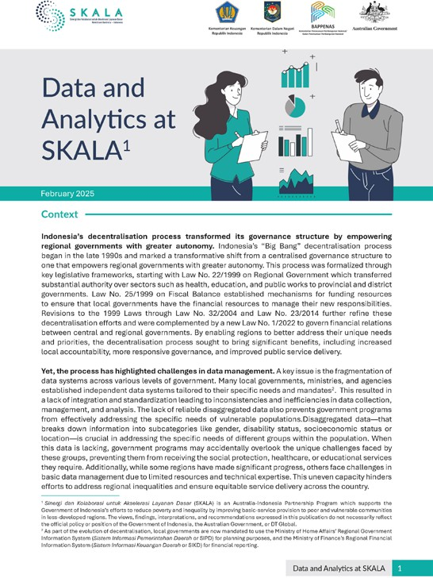

## Data and Analytics at SKALA

SKALA seeks to strengthen the government’s capacity to manage and utilize data to improve governance in Indonesia’s lagging regions, and to provide inclusive and equitable basic services in the provinces where the program is implemented. The program emphasizes the importance of reliable data to support effective governance, and works with the government to address data governance challenges through a comprehensive approach to strengthen the Data and Analytics framework.

[See More](https://skala.or.id/en/publications/data-and-analytics-at-skala/)

PUBLICATION

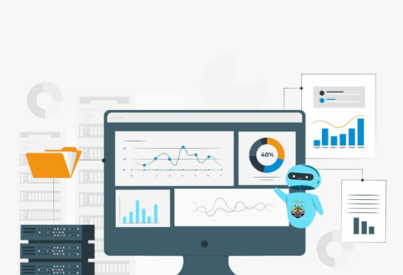

|  |  |
| --- | --- |
| **SATU DATA KALIMANTAN UTARA**  **MENUJU KALIMANTAN UTARA YANG TERINTEGRASI** | |
| **TUJUAN SATU DATA KALIMANTAN UTARA**  **Satu Data Kalimantan Utara** merupakan kebijakan penyediaan data Akurat Terpilah dan Berkualitas dapat dibagipakaikan serta mudah diakses untuk mendukung perencanaan, pelaksanaan, evaluasi dan pengendalian pembangunan Kalimantan Utara Yang Inklusif. | **SATU DATA KALIMANTAN UTARA**  Terwujudnya Satu Data Daerah di Kalimantan Utara  Membuat Keputusan yang Lebih Tepat Berbasis Data  Perencanaan dan Implementasi Program Pembangunan Lebih Inklusif dan Efisien  Meningkatkan Transparansi dan Akuntabilitas Pemerintahan  Meningkatkan Kolaborasi yang Lebih Baik Antar Berbagai Instansi Pemerintah di Kalimantan Utara |
| **DASAR HUKUM**  Peraturan Presiden Nomor 39 tahun 2019 tentang Satu Data Indonesia  Peraturan Menteri Dalam Negeri Nomor 5 Tahun 2024 tentang Satu Data Pemerintahan Dalam Negeri  Peraturan Gubernur Kalimantan Utara Nomor 30 Tahun 2022 tentang Satu Data Indonesia Tingkat Daerah  SK Gubernur Nomor 188.44/K.115/2023 Tentang Forum Satu Data Indonesia Tingkat Daerah Provinsi Kalimantan Utara |

## Satu Data Kalimantan Utara:

Towards an Integrated North Kalimantan

Satu Data Kalimantan Utara ensures accurate, disaggregated and quality data to support the planning, implementation, and evaluation of inclusive North Kalimantan development.

 [See More](https://skala.or.id/en/publications/infographics/one-data-north-kalimantan-towards-an-integrated-north-kalimantan/)

ARTICLE

## West Nusa Tenggara Driving Data Innovation for Climate Resilient Basic Services

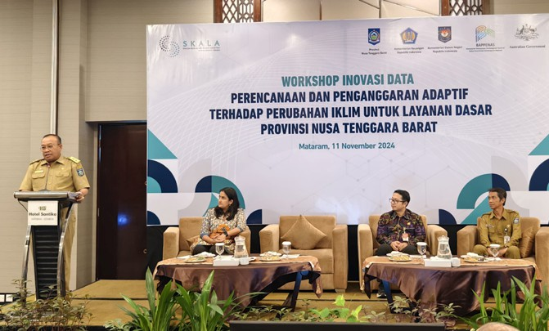A United Nations report (2024) notes that sea levels have been rising faster since the 20th century than in previous centuries. In Indonesia, the rise is about 0.8 to 1.2 cm per year according to the Meteorology, Climatology and Geophysics Agency. This figure is not just a statistic, but a reality for coastal areas such as West Nusa Tenggara (NTB) with 5.56 million inhabitants of whom 42% live in coastal areas.

[See More](https://skala.or.id/en/activity-information/west-nusa-tenggara-driving-data-innovation-for-climate-resilient-basic-services/)

Please share this newsletter [www.skala.or.id](http://www.skala.or.id/) [communications@skala.or.id](mailto:communications@skala.or.id) [Whatsapp Channel SKALA](https://whatsapp.com/channel/0029Vb5cXcuLSmbVnE2Vvc3k)



SKALA Office

IFC Tower 2, Level 17

Jl. Jendral Sudirman Kav. 22-23 Jakarta 12920