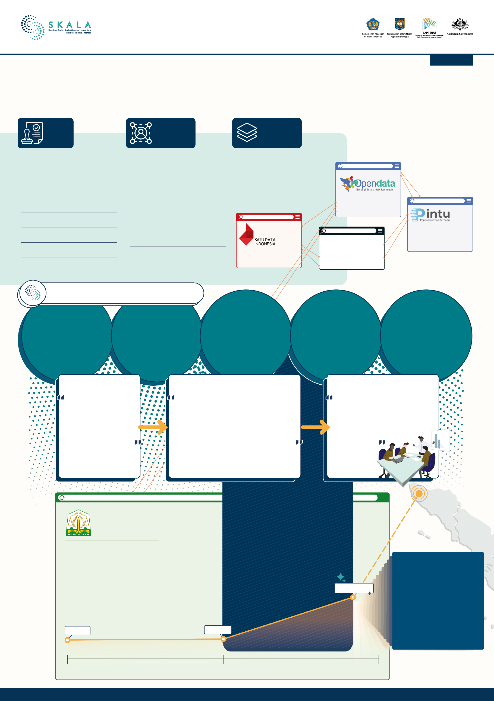Lessons from

March 2025

**Improving Data Governance in Aceh**

**Data Platform**

**Regulations**

**Governance & Human**

**Resources**

#### To strengthen data authority and governance in Aceh, local regulations need to be developed based on national regulations under the of Satu Data Aceh framework

Aceh Governor Regulation No. 20 of 2019

on the Aceh Integrated Information System

Aceh Qanun No. 7 of 2020

on the Aceh Integrated Information System

Aceh Governor Regulation No. 33 of 2021

#### Key personnel were assigned to lead the implementation of Satu Data, supported by training on both technical and content-related aspects.

Governor of Aceh Decree No. 050/1107/2021

on the Establishment of the Satu Data Forum

Governor of Aceh Decree No. 555/954/2023

on the Formation of the Statistical Sectoral Data Admin Team of the Aceh Government

#### The Aceh government uses several digital platforms to manage its village information, population data, sectoral and spatial data, as well as data visualization. These platforms are connected via APIs (Application Programming Interface).

https://data.go.id/home

https://data.acehprov.go.id/id/

Open Data and Geospatial Portal, Aceh Government's open data platform

On Gampong Information System

Aceh Governor Regulation No. 24 of 2022 on the Implementation of Satu Data

Aceh Governor Regulation No. 61 of 2022 on Electronic-Based Government Systems

Data Analysts of the UPTD Statistics, DISKOMINSA

Application development team and trainers (SIAT Dev Team - DISKOMINSA)

1. Data Planning
2. Data Collection
3. Data Checking
4. Data Dissemination

Data Warga

DataWarga, a prototype for managing BNBA data on Aceh residents as well as a data warehouse

Papan Informasi Terpadu (PINTU), a dynamic platform for visualizing data from various sectors in Aceh Government

## FORMS OF COLLABORATIVE

## DATA GOVERNANCE

**Data Consultation**

**Clinics**

The Data Clinic facilitates regular technical guidance on topics like data standards and meta data. It also supports data cleaning, system development, and procedures.

Clinics are held every 2-3 months by the UPTD Statistics unit of the Communications Department, with support from BPS and UPTD

analysts.

**Workshop Series**

Workshops are held for data mapping and data matching organized by the UPTD Statistik Diskominsa

Relevant agencies, such as the Education Office, participate based on the theme. Five workshops were held in 2023-2024.

**Partnerships**

Facilitation of partnerships between local governments (regencies/cities) and universities for the implementation of Thematic KKN on Gampong Information Systems and Data and the implementation of internships through the *Merdeka Belajar Kampus Merdeka* program.

**MSS Data Variable Mapping**

Focus Group Discussions between the MSS implementation team and all MSS-enforcing work units to identify MSS data variables and to provide MSS data groups on the Aceh opendata portal.

i

**Capacity Building & Commitment Building**

Capacity building is also provided to strengthen data governance and build commitment among policy makers in each work unit.

Strategies & Approaches:

# SYNERGY

Building chemistry with DISKOMINSA

### Encouraging DISKOMINSA and BAPPEDA to be more proactive

Strategies & Approaches:

# CONSOLIDATION

### Data Consultation Clinics offer small, focused sessions. Instead of large meetings, 2-3 people from SKPA are invited for in-depth, hands-on learning.

Strategies & Approaches:

# COLLABORATION

### Regular meetups, aligning perspectives, and encouraging non-government stakeholders such as universities and students to actively participate in strengthening SIGAP and Satu Data Aceh through the MBKM program

KOMINSA: Communication, Informatics, and Standardization Office BAPPEDA: Regional Development Management Agency

SKPA: Aceh Working Unit

OPD: Regional Device Organization

RKP: Government Work Plan

RPJMN: National Medium-Term Development Plan

MSS: Minimum Service Standard

SIGAP: Gampong Information System

MBKM: Freedom to Learn - Independent Campus Program

https://gampongaceh.sigapaceh.id/

**There has been a major increase in population data uploaded into SIGAP.**

Gampong Information System (Sistem Informasi Gampong/SIGAP)

SIGAP is an application that provides information about gampong/villages in Aceh, including population data, poverty, planning, budgeting, and training.

**731,155**

**701,611**

**5,482,527**

## 2,285,536

Aceh Population

Source (BPS-Jun 2024)

## Why SIGAP data matters:

### It supports village-level planning and budgeting.

* It helps align development efforts at district, city, and provincial levels

**2023 2024**

**October**