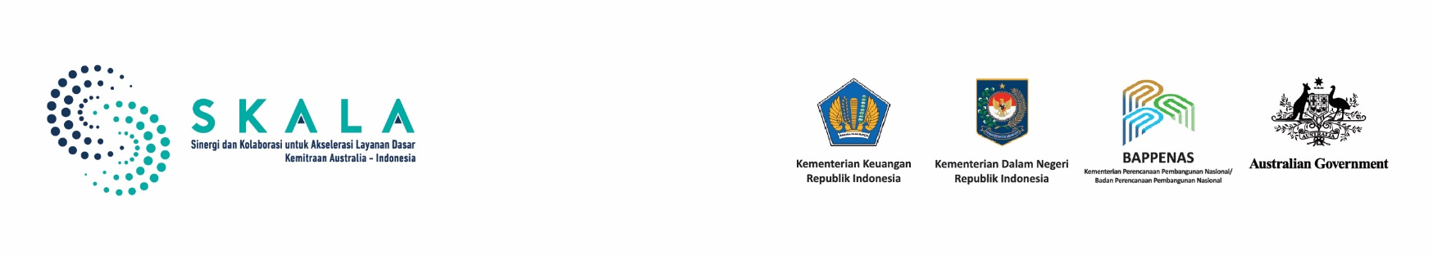

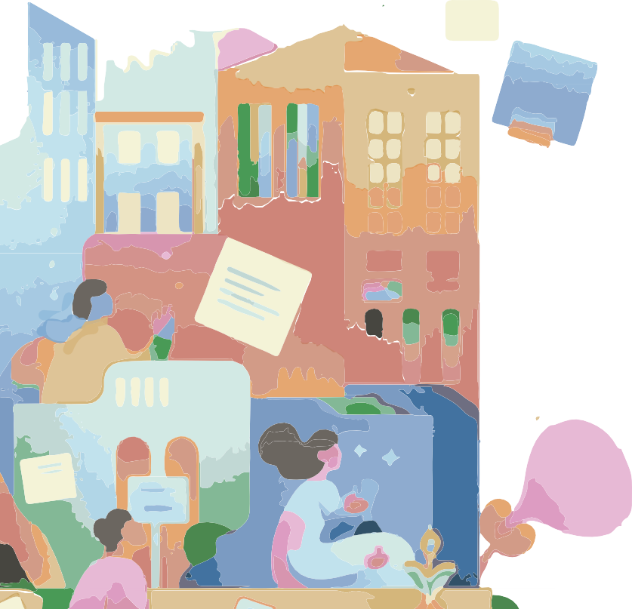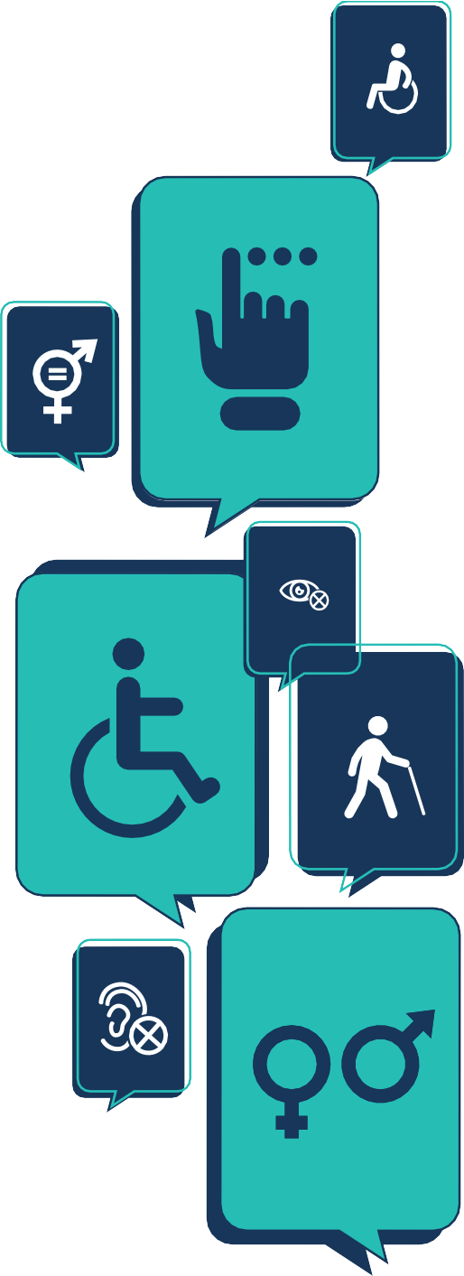

APRIL 2025

Frequently Asked Questions on

GEDSI and Inclusive

Community Participation

## What is Gender Equality, Disability, and Social Inclusion (GEDSI)?

This approach highlights the interconnection between three key concepts—gender equality, disability, and social inclusion—each with distinct goals and outcomes. It identifying and addressing barriers to the achievement of development outcomes. Tackling these obstacles is essential for driving comprehensive and transformative change.

## The definitions and explanations of these three major concepts are as follows:

### Gender Equality

is the view that all individuals,

both men and women, have equal opportunities to enjoy political, economic, social, and cultural rights. This includes

ensuring that no individual is denied access to these rights or has their rights taken away due to their gender.

Indonesia has committed to advancing gender equality across all sectors. This commitment is reflected in national laws and international agreements, including the UN Convention on the Elimination of All Forms of Discrimination Against Women (CEDAW), ratified through Law No. 7 of 1984, and the Sustainable Development Goals (SDGs), particularly Goal 5 on gender equality, adopted through Presidential Regulation No. 59 of 2017.

### Persons with Disabilities

are individuals who have long-term physical, intellectual, mental, and/or sensory impairments. These conditions hinder and restrict their interaction with

the environment and their ability to participate fully and effectively alongside other citizens on an equal basis.

Indonesia has taken steps to promote disability inclusion through Law No. 8 of 2016 on Persons with Disabilities, which is aligned with the UN Convention on the Rights of Persons with Disabilities, ratified by Indonesia in 2011 (Law No. 19 of 2011). To support the implementation of this Law, Government Regulation No. 70 of 2019, outlines strategic measures for disability-inclusive development.

### Social Inclusion

is the process of enhancing the capabilities, opportunities, and status of individuals and groups who are marginalised due to location, limited access, social status, or other factors, so that they can fully participate in society.

The concept of social inclusion is based on the understanding that individuals or groups may be excluded, either intentionally or unintentionally, directly or indirectly. Socially marginalised groups have often been excluded from the processes of development planning, budgeting, implementation, monitoring, evaluation, reporting, and oversight. Communities that are frequently excluded, often referred to as marginalised or vulnerable groups, include women, children, the elderly, persons with disabilities, indigenous communities, and other vulnerable groups.

Law No 59 of 2024 establishes the Indonesia’s National Long-Term Development Plan (RPJPN) 2025– 2045, to set the vision for “Golden Indonesia 2045.”

To realize this vision, the Law outlines 17 Development Directions, including a focus on building an inclusive society—highlighted under Direction 14: Quality Families, Gender Equality, and Social Inclusion.

## Why is it important to pay attention to GEDSI in the implementation of development programs?

**2**

Paying attention to Gender Equality, Disability, and Social Inclusion (GEDSI) is essential because people face different challenges based on factors like gender, disability, ethnicity, religion and belief, identity, and where they live.

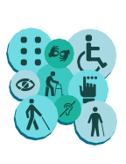

**1**

These differences can create barriers to participation, limit access to basic services, and reduce opportunities. By applying GEDSI principles, development programs can ensure that everyone— especially those often left behind—can take part, benefit equally, and have access to opportunities for a better life.

## What is meant by intersectionality and the intersectional GEDSI approach?

Intersectionality is an approach popularised by Kimberlé Crenshaw¹, a U.S. scholar of critical race theory and an advocate for Black civil rights. It is a way of understanding how different parts of a person’s identity—such as gender, disability, ethnicity, or social status —can combine to create overlapping experiences of discrimination or exclusion.

The Intersectional GEDSI Approach examines how these different factors interact and influence each other. It helps development programs identify and respond to the specific barriers people face, with the goal of promoting equality, inclusion, and respect for human rights.

[**¹https://www.law.columbia.edu/faculty/kimberle-w-crenshaw**](https://www.law.columbia.edu/faculty/kimberle-w-crenshaw)

## What is inclusive community participation?

Inclusive community participation means involving all members of society, especially vulnerable and marginalised groups, in development planning and decision-making. It applies GEDSI and intersectional approaches to ensure that no one is left behind, both at the national and local levels.

Civil society plays a key role in this process. Organisations and networks that represent or advocate for specific groups can help to:

**3**

GEDSI

perspective

in substance

The substance, process, and stages of inclusive planning forums should be designed to ensure a high-quality process and outcome. The fundamental principles of GEDSI must be applied in this process, such as non-discrimination, do no harm, respect for diversity, and the principle of “nothing about us without us,” which emphasises the importance of involving vulnerable groups, for example, persons with disabilities, in planning and policymaking that affects their lives. This principle supports the full inclusion of vulnerable groups to ensure their participation and benefit from development initiatives.

This involves establishing rules to regulate and strengthen the legal framework for implementing inclusive planning. These regulations should include a clear institutional framework and mandate cross-organizational cooperation between central and regional government agencies as a form of collaborative governance. In addition, operational guidelines should be in place to regulate all involved parties and ensure sustainable funding commitment so that the process can be implemented effectively and on time.

Institutionali-

sation process

**2**

The government’s regular planning process (known as *Musrenbang*) can be strengthened with an inclusive process to identify, map, and discuss the needs of vulnerable groups.

Inclusive

planning forums

**1**

To ensure inclusive community participation, at least the following aspects must be considered:



Determine how these basic services can reach and target them effectively.

Identify what basic services they need

Identify who and where these vulnerable groups are

# Development of Gender Equality and an Inclusive Society

The National Medium-Term Development Plan (RPJMN) 2025–2029 was enacted under Presidential Regulation (Perpres) No. 12 of 2025.

The Plan provides a logical framework to achieve gender equality, improve the Gender Development Index (GDI) and reduce the Gender Inequality Index (GII). It also sets the direction and defines efforts to promote gender equality and strengthen the roles of women, youth, and persons with disabilities.

Through gender mainstreaming (GM) and social inclusion strategies, the Government of Indonesia seeks to ensure that women, men, persons with disabilities, the elderly, indigenous communities, and other vulnerable groups have equal opportunities to engage, participate meaningfully in the development process, and benefit from its outcomes.

# Gender Mainstreaming and Social Inclusion

Women

Children, Youth, Elderly, Persons with Disabilities, Indigenous Communities, and Other Vulnerable Groups

Men

**Gender Equality and an Inclusive Society** (Holistic Individuals, Prosperous, Adaptive, Virtuous, Culturally Advanced, Excellent, and Competitive)

Different Experiences, Challenges, Issues, Needs, and Aspirations

Different Access, Participation, Control, and Development Benefits

3

Gender Mainstreaming and Social Inclusion

**Gender Analysis**

**and Inclusivity**

**Reporting**

**Supervision**

**Evaluation**

**Planning**

**Gender-Responsive and Inclusive Policies/Programs/ Activities Across All Sectors of Development**

**Budgeting Implementation**

**Monitoring**

Development Achievement Disparities

Comprehensive Integration of Gender and Social Inclusion Perspectives in All Development Processes

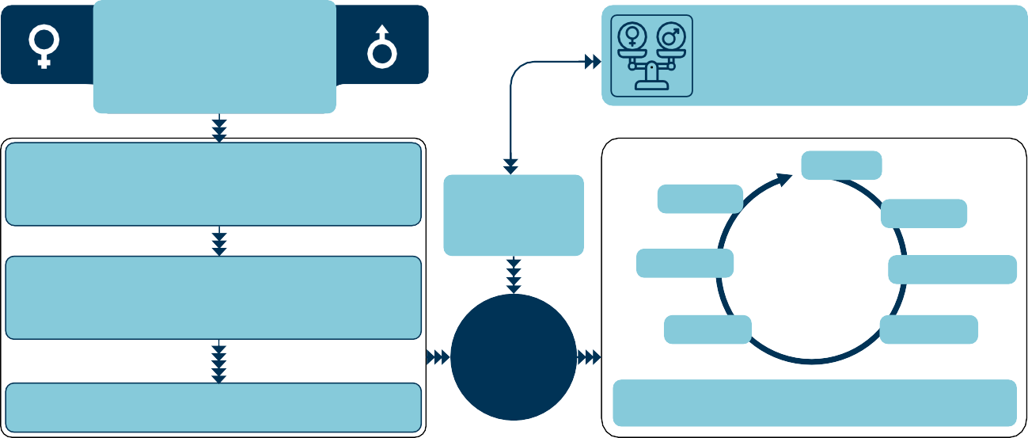

**Source: RPJMN 2025-2029, p. 81, National Development Planning Agency/Bappenas 2025**

**IFC Tower 2, Level 17**

**Jl. Jendral Sudirman Kav. 22-23 Jakarta 12920**

**skala.or.id** [**communications@skala.or.id**](mailto:communications@skala.or.id)