

**POLICY BRIEF**

Optimizing the Role of Functional Policy Analysts in the Regions to Accelerate Inclusive Basic Service Delivery

Vice Admira Fimaherera, Iskhak Fatonie dan Faisar Jihadi

April 2025

# Executive Summary

The Policy Analyst Functional Position (*Jabatan Fungsional Analis Kebijakan* or JFAK) emerged from a two- decade-long bureaucratic reform process that has brought significant changes to governance, personnel systems, and basic services in Indonesia. The role of JFAK influences effective policy implementation in support of public welfare, particularly in providing high-quality and equitable basic services such as education, health, and social services. One of JFAK’s responsibilities is ensuring alignment between regional and national policies to prevent overlapping regulations and implementation uncertainties. This policy brief identifies the challenges of JFAK at the regional level, including the limited understanding of regional leaders about the role of JFAK, resulting in underutilization, limited competence and capacity of JFAK in the regions, as well as unclear regulations governing JFAK development and management. This policy brief recommends several measures: establishing clear JFAK supervisory units at the regional level, providing guidelines for optimizing JFAK, and enhancing JFAK networks in the regions.

Keywords: *policy quality, supervision, JFAK, basic services*

# Background

One of the challenges in achieving national strategic indicators, including the Minimum Service Standards (MSS), is the variation in the quality of policies formulated by Ministries/Agencies (K/L) compared to those produced by regional governments. Aggregate data from the 2023 Policy Quality Index developed by the National Institute of Public Administration (*Lembaga Administrasi Negara* or LAN) shows that while the quality of policy



products formulated by K/L is relatively good, 5% of these policies are still categorized as low quality. At the regional level, however, 51% of policy products are still of low quality (Graph 1).

This situation underscores the need to optimize the role of the Functional Policy Analyst (JFAK).

Graph 1. Policy Quality Index (IKK) 2023 National

Inadequate 39%

Excellent 1%

Very Good 15%

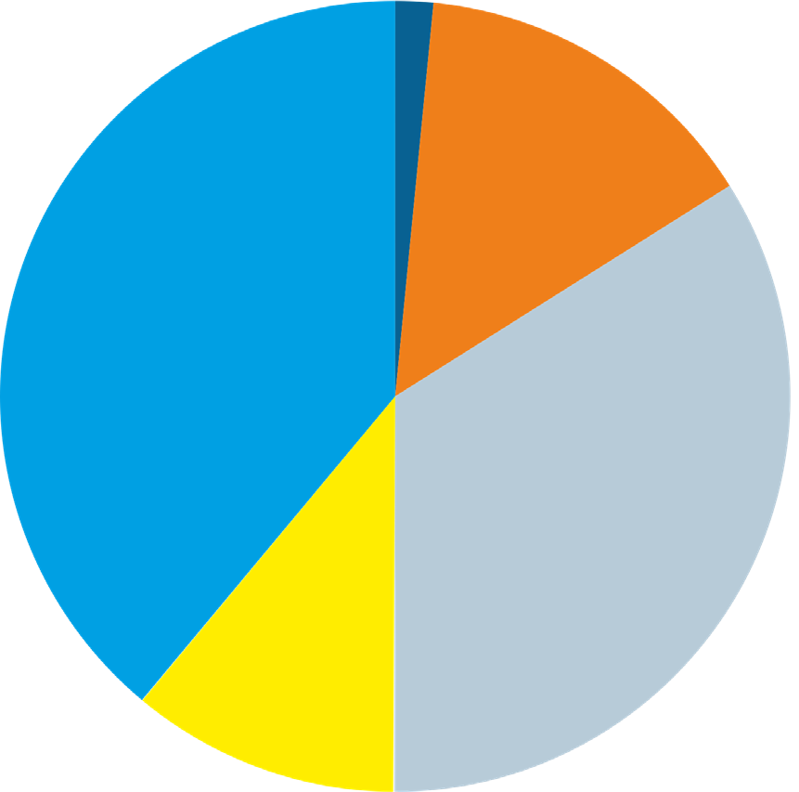

Good

34%

Adequate 11%

Central (Ministry/Institution)

Inadequate

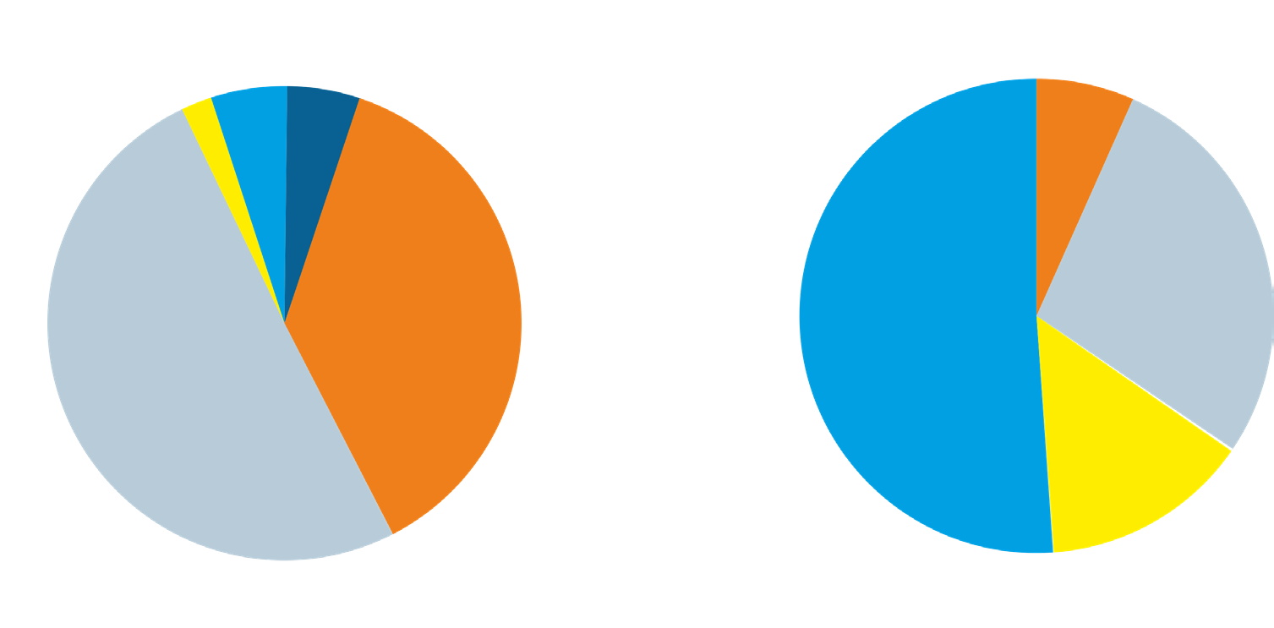

5% Excellent

Regional (Province, District/City)

Excellent

0% Very Good

Adequate

7%

2% 5%

Good 51%

Very Good 37%

Inadequate 51%

Good 28%

Adequate 14%

* Recapitulation data as of - 27 November 2023 based on updates from the National Policy Quality Index (IKK) Team.
* Validation data from all participating institutions.

The role of JFAK can positively impact policy implementation to support public welfare, particularly in providing high-quality and equitable basic services such as education, health, and infrastructure. One of its responsibilities is ensuring that regional policies align with national policies to prevent overlapping regulations and friction in implementation. During the 2002-2011 period, the central government revoked 4,000 of 13,000 regional regulations because they contradicted higher-level legislation (Kumorotomo, et al., 2014). The inefficiency caused by this process is significant,

considering that developing each regional regulation requires a minimum budget of IDR 300 million to IDR 2 billion per regulation (idem). Such inconsistencies can be prevented through the active role of JFAK in ensuring policy harmonization.

Currently, there are more than 9,861 JFAK in Indonesia, including 1,624 at the provincial level, 4,096 in districts, and 1,654 in municipal governments that can be mobilized. However, this potential has not been fully optimized by regional governments due to existing challenges.

# Problem Description

1. Limited understanding by regional unit leaders of the roles, duties, and functions of JFAK, resulting in a ‘functional position with structural responsibilities.’ JFAK in the regions are still treated by their superiors as administrative officials or ‘structural staff.’
2. Limited utilization of JFAK by regional unit leaders to improve the public policy formulation process and promote innovation to accelerate basic services. Regional government leaders do not utilize JFAK’s role due to the absence of outreach from central or regional supervisory institutions. Agencies such as Regional Planning and Development Agencies (Bappeda Litbang) and other units in the region do not involve JFAK in formulating policy recommendation studies for planning and budgeting documents.
3. Limited competence and capacity of JFAK in the regions. This limitation arises due to minimal budgets and difficulties in accessing training,

including Learning Management Systems managed by LAN. This situation is particularly prevalent in districts/cities and archipelagic areas where not all regions have internet access (limited infrastructure).

1. Limited regulations governing JFAK development and management in the regions. Clarity is needed in regulations and policies regarding JFAK supervision in the regions, especially the importance of establishing supervisory units. Such units can encourage collaboration across work units, inter- organizational cooperation, and cross-regional coordination based on strategic issues and regional priorities. Clear regulations and policies for JFAK supervision in the regions have a positive impact on determining career paths, allowances, competence enhancement, utilization, etc. This contributes to accelerating the achievement of regional governments’ priority programs and national strategic indicators, including inclusive basic service provision.

# Relevant Policies

* Law No. 23 of 2014 on Regional Government
* Government Regulation No. 18 of 2016 on Regional Apparatus
* Minister of PANRB Regulation No. 45 of 2013 on Functional Position of Policy Analysts and Credit Scores
* Minister of PANRB Regulation No. 1 of 2023 on Functional Positions

Policy Recommendations

1. The Ministry of Home Affairs (MoHA), LAN, and supervisory units in the regions can conduct regular and extensive outreach at the provincial, district, and city levels. MoHA’s Domestic Policy Strategy Agency, and the Directorate of Capacity Strengthening for Functional Position in the Field of Capacity Development and Civil Servant (ASN) Learning, LAN, can collaborate to promote JFAK in the regions (regulations, etc.).
2. MoHA and LAN can develop guidelines to optimize the role of JFAK in the regions. To improve understanding of various aspects of JFAK among regional unit leaders, MoHA and LAN can prepare guidelines on measures that work units can take to optimize the role of JFAK within their units. The guidelines would strengthen JFAK’s role in the policy cycle, particularly in accelerating basic services.

Policy Brief | Optimizing the Role of Functional Policy Analysts in the Regions to Accelerate Inclusive Basic Service Delivery 4

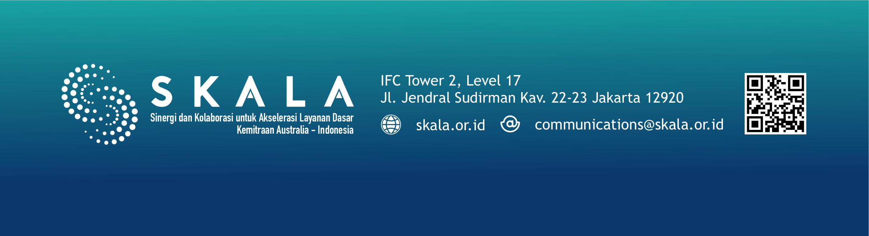

1. Revision of the MoHA Regulation No. 17 of 2016 on Guidelines for Research and Development Implementation at MoHA and Regional Governments. BSKDN, MoHA can initiate a revision of this regulation by including provisions governing JFAK supervisory units in the regions. These regulations would cover career paths, rewards, and capacity-building for JFAK at the Regional Secretariat (Setda) or Regional Human Resource Development Agency (BPSDM) and the quality of strategic policy recommendations in Bappeda Litbang or similar units (BRIDA).
2. Regional Governments can organize JFAK to work according to regional priority thematic clusters to enable them to work individually and collectively across work units, disciplines, organizations, and regions. Clustering can be aligned with regional government priority programs, such as Minimum Service Standards and inclusive basic services, climate change, GEDSI, etc. JFAK could form teams with interdisciplinary and inter-unit work competencies related to basic services, so the supervisory unit’s role goes beyond administrative matters only.
3. MoHA, LAN, and regional supervisory units can enhance JFAK competence, collaboration, and networking nationwide. JFAK requires open, massive, and online learning acces. Central agencies can also involve regional JFAK in work related to JFAK roles, for instance, through collaboration between central and regional levels. Supervisory units can facilitate certified training in cooperation with universities, professional associations, the Professional Certification Institute, etc., for training on policy recommendation writing and other policy analysis training.

***Disclaimer:*** The views, findings, interpretations, and recommendations presented in this publication reflect the opinions of the authors and do not necessarily represent the official policy or position of the Government of Indonesia, the Government of Australia, or DT Global. The SKALA Program is supported by the Australian Department of Foreign Affairs and Trade (DFAT) and is managed by DT Global.