

# Context

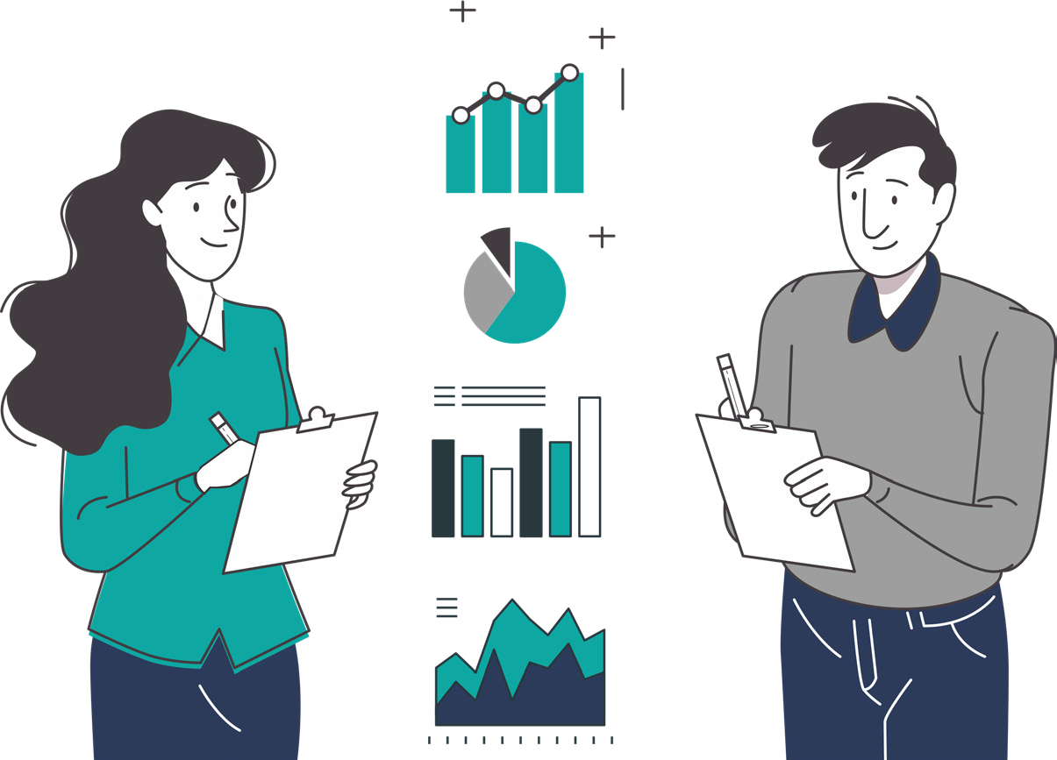

February 2025

Data and Analytics at SKALA1

**Indonesia’s decentralisation process transformed its governance structure by empowering regional governments with greater autonomy.** Indonesia’s “Big Bang” decentralisation process began in the late 1990s and marked a transformative shift from a centralised governance structure to one that empowers regional governments with greater autonomy. This process was formalized through key legislative frameworks, starting with Law No. 22/1999 on Regional Government which transferred substantial authority over sectors such as health, education, and public works to provincial and district governments. Law No. 25/1999 on Fiscal Balance established mechanisms for funding resources to ensure that local governments have the financial resources to manage their new responsibilities. Revisions to the 1999 Laws through Law No. 32/2004 and Law No. 23/2014 further refine these decentralisation efforts and were complemented by a new Law No. 1/2022 to govern financial relations between central and regional governments. By enabling regions to better address their unique needs and priorities, the decentralisation process sought to bring significant benefits, including increased local accountability, more responsive governance, and improved public service delivery.

**Yet, the process has highlighted challenges in data management.** A key issue is the fragmentation of data systems across various levels of government. Many local governments, ministries, and agencies established independent data systems tailored to their specific needs and mandates2. This resulted in a lack of integration and standardization leading to inconsistencies and inefficiencies in data collection, management, and analysis. The lack of reliable disaggregated data also prevents government programs from effectively addressing the specific needs of vulnerable populations.Disaggregated data—that breaks down information into subcategories like gender, disability status, socioeconomic status or location—is crucial in addressing the specific needs of different groups within the population. When this data is lacking, government programs may accidentally overlook the unique challenges faced by these groups, preventing them from receiving the social protection, healthcare, or educational services they require. Additionally, while some regions have made significant progress, others face challenges in basic data management due to limited resources and technical expertise. This uneven capacity hinders efforts to address regional inequalities and ensure equitable service delivery across the country.

1 *Sinergi dan Kolaborasi untuk Akselerasi Layanan Dasar* (SKALA) is an Australia-Indonesia Partnership Program which supports the Government of Indonesia’s efforts to reduce poverty and inequality by improving basic-service provision to poor and vulnerable communities in less-developed regions. The views, findings, interpretations, and recommendations expressed in this publication do not necessarily reflect the official policy or position of the Government of Indonesia, the Australian Government, or DT Global.

2 As part of the evolution of decentralisation, local governments are now mandated to use the Ministry of Home Affairs’ Regional Government Information System (*Sistem Informasi Pemerintahan Daerah* or SIPD) for planning purposes, and the Ministry of Finance’s Regional Financial Information System (*Sistem Informasi Keuangan Daerah* or SIKD) for financial reporting.

Data and Analytics at SKALA 1

**Indonesia is making concerted efforts to standardise and integrate its data systems to improve basic service delivery.** Over the last two decades, Indonesia’sgovernance data collection and utilization have evolved significantly. Over time, the government has promoted data integration and interoperability across ministries and levels of government and strengthened subnational data systems. Indonesia’s One Data policy aims to harmonize data management across government levels. Additionally, Presidential Regulation No. 95/2018 outlines the development of an integrated national portal to consolidate over 24,000 government applications to improve efficiency and to ensure nationwide access to digital services. However, these initiatives face challenges, particularly in accommodating the diverse contexts of over 500 local governments across Indonesia.

# SKALA’s Support to Data and Analytics for Inclusive Basic Services

**SKALA seeks to strengthen the government’s ability to leverage data for better governance in underserved regions of Indonesia,** and deliver inclusive and equitable basic services in its partner provinces.3 It recognises the importance of reliable data for development, and in partnership with the government, seeks to address systemic data challenges through a comprehensive approach to strengthen the Data and Analytics framework. This is linked with support to improve the subnational data cycle, which requires improvements to policies and regulations.

A significant challenge to improve data governance (e.g. regulations, standards/quality, protocols, compliance and security), is the institutional barriers hindering effective data integration. Where ministries and subnational governments have developed data systems independently, this creates barriers to cooperation and data sharing. These institutional silos make it difficult to harmonize efforts across different sectors of government. To address this, SKALA works closely with the National Development Planning Agency (Bappenas), the Ministry of Home Affairs (MoHA), the Ministry of Finance (MoF), and BPS (the Central Statistics Agency) to align data management policies and promote interoperability.

In addition to national coordination, SKALA focuses on ensuring that data management improvements are cascaded to regional governments, responsible for delivering basic services. SKALA helps develop frameworks and tools that local governments can use to integrate their data systems with national platforms so that data is collected, managed, and analysed in a standardized way across all levels of government.

**SKALA’s Data and Analytics strategy is implemented through four Thematic Action Plans (TAPs).** In addressing systemic issues to strengthen data governance, SKALA has developed Thematic Action Plans (TAP). Each TAP provides a pathway of outputs which need to be achieved in order to progress. These interlink between tasks which must be undertaken at national and subnational levels. The four TAPs under the Data and Analysis theme are:

### Regional One Data

Strengthen the functioning data cycle in partner provinces, in line with the One Data Indonesia policy.

### Data Management Systems and Integration

Implement and integrate data management systems at central and subnational levels and ensure their use in government planning and budgeting.

3 Aceh, Gorontalo, Kalimantan Utara, Maluku, Nusa Tenggara Barat, Nusa Tenggara Timur, and Papua.

2 Data and Analytics at SKALA

### Village Information Systems

Data and Analytics at SKALA 3

Ensure that village-level systems integrate variables from the national datasets to improve accuracy and analysis quality.

### Data Analysis and Utilization

Support subnational governments to regularly analyse and use data to inform planning of development activities.

## Regional One Data:

### To help unify data governance across all levels of government, SKALA supports the implementation of Indonesia’s One Data policy.

The **One Data** initiative is especially important at the subnational level, where unclear roles and responsibilities can constrain cohesive data management. To overcome this challenge, SKALA collaborates with its national and subnational partners to (i) help manage and align subnational One Data systems with national systems, (ii) standardise data cycles, (iii) develop policies for and implement regional One Data Forums, and (iv) build capacity in data management. Since its inception, SKALA has also contributed to the development and issuance of MoHA Regulation No. 5/2024 which provides a formal mechanism for accountability, data sharing, and alignment across central and subnational government agencies.

## Village Information Systems:

### SKALA strengthens these systems to ensure accurate representation of vulnerable groups.

SKALA supports the central government to coordinate and oversee integration of key variables into village systems, and partners with subnational governments to establish frameworks, build capacity, and plan for the expansion of these systems. The program also facilitates collaboration between local governments, local universities and civil society networks to strengthen and expand village systems. Since November 2022, SKALA has supported Nusa Tenggara Barat (NTB), Aceh, and the Papua region to expand the coverage of their village information systems and align their data collection protocols with national standards and systems.

## Data Management Systems and Integration:

### To promote efficiency, SKALA supports the integration of key government data systems.

SKALA collaborates with its central government partners to identify opportunities to integrate MoHA’s SIPD, Bappenas’ SEPAKAT4 and MoF’s SIKD, establish interoperability business processes, and conduct system trials. It also works to enhance the capacity of the SIPD to support subnational planning and budgeting, including through the integration of local government data systems. The goal is a stronger data environment that allows better information flows between ministries and regions. In NTB and Aceh, these integrations have already led to better planning, data compliance, and enhanced service delivery.

## Data Analysis and Utilization:

### SKALA prioritizes effective use of data by strengthening local governments’ ability to analyse and

**apply data for planning.**

SKALA has trained more than 100 national master trainers to help local government officials use analysis tools like SEPAKAT. This training will enable them to work with macro and micro data, including detailed socioeconomic data from national datasets, for better planning and aligning of budgets with local needs. Since inception, SKALA has trained over 500 local staff, notably improving data quality compliance in provinces such as Maluku and Gorontalo.

4 *Sistem Perencanaan Pembangunan Berbasis Data Regsosek Terpadu* or Integrated Regsosek Data Based Development Planning System.

Through these TAPs, SKALA seeks to address institutional and governance barriers to effective data management. This includesdeveloping coordinated, multi-level regulatory frameworks so that ministries and regional governments can work in sync. The program also promotes the creation of institutionalized forums and mechanisms, such as One Data Forums, which oversee the implementation of data policies across various levels of government. Support is delivered via a combination of modalities: (i) systems development, data analysis, research and use, (ii) capacity or skills building, (iii) policy and guidelines development, (iv) support for planning and implementation, and (v) enabling inter-agencies/inter- ministries collaboration and advocacy.

# Looking Ahead

### Regional One Data:

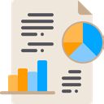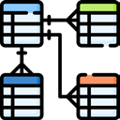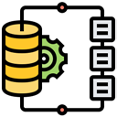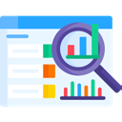

SKALA technical assistance and input has contributed to the recent issuance of a MoHA regulation on Regional One Data. SKALA is now supporting the ministry and subnational government partners to clarify organisational structures, roles, responsibilities, and processes for the effective implementation of the new regulation. This support includes building subnational government capacity in data management.

### Village Information Systems:

SKALA is working to provide analysis and facilitate dialogue between central and local governments on the need for a national policy to streamline village data inputs into national and subnational systems.

### Data Management and Systems Integration:

Following the agreement on business processes for system interconnectivity, SKALA is assisting MoHA, MoF and Bappenas to integrate their data systems. This includes providing the data and analysis required by all parties involved. SKALA is also supporting local government partners to enhance their data systems—such as data portals— through data cleaning, analysis, and by ensuring interconnectivity with central systems.

### Data Analysis and Utilisation:

SKALA is supporting subnational government partners to expand their disaggregated data to improve analysis on the needs of vulnerable communities. The program is also preparing support for subnational level use and updating of the newly issued National One Data Socio-economic dataset (DTSEN). SKALA is also assisting its partners to improve their analytical systems and capacities/skills. This support focuses on assessing the extent to which minimum service standards are met and are inclusive.



Data and Analytics at SKALA

4

**SKALA.or.id**

**CONTACT US**

**IFC Tower 2, Level 17**

**Jl. Jendral Sudirman Kav. 22-23**

**Jakarta 12G20**

[**communications@skala.or.id**](mailto:communications@skala.or.id)

Sinergi dan Kolaborasi untuk Akselerasi Layanan Dasar (SKALA) is an Australia-Indonesia Partnership Program aimed at supporting the Government of Indonesia’s efforts to reduce poverty and inequality by improving basic-service provisions to poor and vulnerable communities in less-developed regions.