**Australian Government logo.**  

# SKALA Logo: Synergy and Collaboration for Accelerating Basic Services Australia-Indonesia PartnershipWhat is



**?**

**KEMENTERIAN KEUANGAN REPUBLIK INDONESIA**

**KEMENTERIAN DALAM NEGERI REPUBLIK INDONESIA**



 



**BAPPENAS**

**Kementerian Perencanaan Pembangunan Nasional/ Badan Perencanaan Pembangunan Nasional**







 

An Australia Indonesia Partnership Program to strengthen Indonesia's capacity to deliver inclusive and equitable basic services in less developed regions.

**December 2024**

Seeks to contribute to stronger public financial management so that resource allocation is more equitable, fiscally sustainable and supported by better data quality and systems that drive informed decision‑making.

Supports Government of Indonesia policies and promotes collaboration across sectors to improve basic service delivery.

Emphasizes gender equality and the inclusion of vulnerable groups in decision‑ making processes.

Leverages outcomes and lessons from the Australia‑Indonesia Partnership's support for Indonesia's decentralisation.

# Where We Work

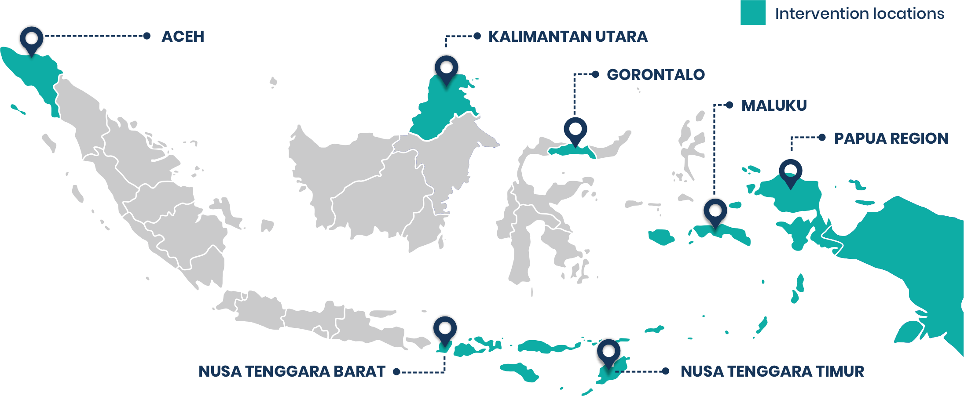

# Our Goal

To help reduce poverty and inequality within Indonesia by improving basic service provision to poor and vulnerable communities in less‑developed regions.



# Our Clients and Partners

The National Development Planning Ministry (Bappenas), the Ministry of Home Affairs, the Ministry of Finance, ten provinces, civil society networks and universities.

# Our Timeline

* 8‑year program in 2 phases (2022‑2026 & 2027‑2030)
* Commenced November 2022. Up to AUD 160 million commitment
* Subsidiary Agreement Signed (30 March 2023)

4 years



November 2022

January 2027

September

2030

Phase 1: January 2023 ‑ December 2026

Phase 2: January 2027 ‑ September 2030

# Our Approach

SKALA focuses on strengthening governance systems‑ planning, budgeting, and administration‑that underpin effective service delivery. By addressing systemic challenges and enhancing government processes, SKALA seeks to creates a sustainable enabling environment for inclusive service delivery, so that public resources reach those who need them most. We approach this through three pathways: Practice, Learning and Influence.

3 years 9 months

# Our Focus Areas



Practice

Replicating and scaling smart practices

Learning

Effective learning and adaptive management

Influence

Advocacy and enhanced influence of our stakeholders

**1**

**2**

**3**

**4**

Data and Analytics

Availability and use of data on vulnerable communities and their basic service needs, and strengthening interoperability of government information systems for improved analysis and planning.

Gender Equality, Disability, and Social Inclusion (GEDSI)

Participation, representation and influence of women, people with disabilities and other vulnerable groups in government decision making.

Minimum Service Standards

Capacity of local governments to plan and deliver high‑quality, inclusive services.

Public Financial Management

Availability and use of adequate resources by local governments to deliver inclusive services.

**Our Outcomes**

EOPO1 1:

Stronger Enabling Environment for Sub‑National Service Delivery

IO1: Central agencies improve the subnational policy and regulatory environment on Public Financial Management (PFM) and the implementation of Minimum Service Standards (MSS).

IO2: Central agencies improve the integration and governance of key data for subnational use in planning, budgeting, monitoring and evaluating the delivery of basic services.



IO3: Central agencies increasingly apply GEDSI analysis and evidence in preparing their policies, plans and budgets to ensure the needs of women, people with disabilities and vulnerable groups are addressed.

## EOPO 2:

Better Subnational Service Delivery

IO4: Selected provincial and district governments better use PFM for the provision of basic services that meet the MSS.

IO5: Selected provincial and district governments increasingly utilize evidence on women, people with disabilities and vulnerable communities' service delivery needs in their planning and budget decisions.

IO6: Senior leaders in selected provincial and district governments better recognize, measure and plan for the specific service delivery needs of all citizens.

## EOPO 3:

Greater Participation, Representation and Influence of Women, People with Disabilities and Vulnerable Groups

IO7: Strengthened government engagement with women, people with disabilities and vulnerable groups in sub‑national planning and decision‑making processes.

IO8: Increased participation and influence of women, people with disabilities and vulnerable groups and/or their representatives in sub‑ national planning and decision‑making processes.

IO9: Village level information systems provide information on the needs of vulnerable groups to inform more inclusive service delivery.

# Our Governance

The program is governed by a Steering Committee co‑chaired by Bappenas (Government of Indonesia) and DFAT (Government of Australia). Technical working groups bring together 25 directorates across three ministries (Bappenas, Ministry of Home Affairs and Ministry of Finance) to ensure cohesive implementation and alignment with government systems. Ten partner provinces are represented through Program Province Committees which ensure that provincial perspectives are integrated into program activities.



1 *EOPO = End of Program Outcome; IO = Intermediate Outcome*

# National Government Counterparts

**Technical Directorate**

**Ministry**

**Deputy/Directorate General**

Deputy of Population and Manpower

**Ministry of National Development Planning/**

**(BAPPENAS**

Deputy of Regional Development

Deputy of Human, Community and Cultural Development

Directorate General of Fiscal Balance

**Ministry of Finance**

**(MoF)**

Secretariat General

**Ministry of Home Affairs (MoHA)**

Inspectorate General

Directorate General of Regional Development

Directorate General of Regional Autonomy

Directorate of Transfer Facilitation and Regional Loan Funding

The Domestic Policy Strategy Agency (BSKDN)

Directorate for Poverty Alleviation and Community Empowerment

Directorate of Population and Social Security Directorate of Manpower

Directorate for Region Development Directorate for Regional I

Directorate for Regional II Directorate for Regional III

Directorate for Family, Women, Children, Youth and Sports

Secretariat of the Directorate General Directorate of General Transfer Funds Directorate of Special Transfer Funds

Directorate of Village Funds, Incentives, Special Autonomy,

and Privileges

Directorate of Local Taxes and Regional Levies Directorate of Regional Financing and Economics

Directorate of Information Systems and Transfer Implementation

Center for Facilitation of Cooperation Data and Information Center Inspectorate II

Secretariat of the Directorate General

Directorate of Regional Development Planning, Evaluation, and Information

Directorate of Regional Planning, Special Autonomy, and DPOD

Secretariat of the Directorate General Directorate of Regional Budget Planning Directorate of Regional Revenue

Secretariat of the Domestic Policy Strategy Agency



**Sinergi dan Kolaborasi untuk Akselerasi Layanan Dasar**

**Kemitraan Australia ‑ Indonesia**

IFC Tower 2, Level 17

Jl. Jendral Sudirman Kav. 22‑23 Jakarta 12920

skala.or.id [communications@skala.or.id](mailto:communications@skala.or.id)