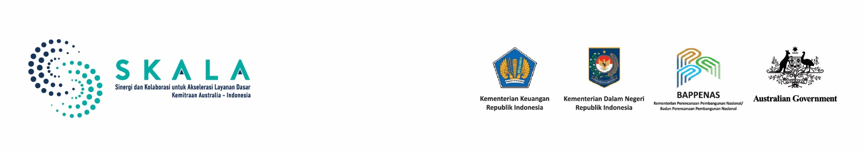

**At a Glance:**

SKALA in

West Nusa Tenggara

October 2024

## Introduction

West Nusa Tenggara (*Nusa Tenggara Barat* or NTB), in eastern Indonesia, was established in 1958 under Law No. 64/1958. The province’s administrative structure includes eight districts and two municipalities, with Mataram serving as the provincial capital. Comprising two main islands, Lombok and Sumbawa, and surrounded by 403 smaller islands, NTB is known for its rich culture and natural beauty, which contributes to a growing tourism sector. However, the province faces a unique set of challenges including frequent natural disasters due to its location in the Pacific Ring of Fire, and socioeconomic issues like high poverty rates, a low Human Development Index (HDI), and significant maternal and infant mortality rates. The province also deals with high rates of stunting, significantly above the national average.

The government of NTB is actively addressing its social and economic challenges by improving fiscal capacity, boosting local revenues, and enhancing public services.

Recent tax reforms aim to increase locally generated revenue and reduce reliance on central government transfers. To tackle inequality, NTB has implemented programs to empower women, reduce early marriage rates, and improve infrastructure for persons with disabilities. In the health sector, the NTB government is expanding access to healthcare and nutrition programs to combat stunting and improve maternal and child health, especially in rural areas. The province is also leveraging its natural resources, particularly tourism and mining, to drive economic growth while ensuring that the benefits are distributed more equitably across the population.

SKALA¹ works with the NTB Provincial Government to strengthen the participation of vulnerable groups in development planning, as well as to improve the use of reliable data and analysis, increase regional financial capacity, and strengthen the quality of public spending. SKALA’s NTB office became operational in May 2023.

*Figure 1. Key Administrative Data (Source: BPS-Statistics unless otherwise stated)*

Population:

**5,560,000 people**

(2023)

Area:

**47,586 km²**

**(41.33% land and**

**58.67% of water)**

Administrative center and capital city:

**Mataram**





1

Regional Fiscal Capacity:

**Rp6.1 trillion, with 50% from regional fiscal transfers**

(West Nusa Tenggara Governor Regulation No.1/2024)

1. *Sinergi dan Kolaborasi untuk Akselerasi Layanan Dasar* (SKALA) is an Australia-Indonesia Partnership Program aimed at supporting the Government of Indonesia’s efforts to reduce poverty and inequality by improving basic-service provision to poor and vulnerable communities in less-developed regions.

*Figure 2. Key Socioeconomic Data*

*(Source: BPS-Statistics unless otherwise stated)*

## Economic and Social Development

**Gross Regional Domestic Product (GRDP):**

# Rp103.90 trillion

(2023)

**Unemployment Rate:**

# 2.80%

(2024)

**Poverty rate:**

# 13.85%

(2024)

# 2.17%

**of population with disabilities**

(Regsosek, 2022)

**Gini coefficient:**

# 0.375

(2023)

**Human Development Index:**

# 72.37

(2023)

**Enrolment Rates (Net): Elementary : 98.76% Junior High : 84.03% Senior High : 68.04%** (2023)

**Maternal mortality rate:**

**90.49 per 100,000 live births**

(2023)

**Infant mortality rate:**

**7.91 per 1,000 live births**

(2023)

**Stunting:**

# 24.6%

(2023)

2

NTB is a province of vibrant opportunities, with rich natural beauty and a growing economy anchored in agriculture, fisheries, tourism, and small-scale industries. The province’s diverse landscapes and resources provide a strong foundation for economic development and sustainability. However, local industries face challenges such as global market shifts and climate and disaster-related disruptions. NTB also has one of the highest child marriage rates in Indonesia, with many girls dropping out of school to marry early. Also, roads, bridges, and public transportation systems are underdeveloped, particularly in rural and remote areas so many communities remain isolated with limited access to markets, healthcare, and education services. The NTB government’s efforts to bridge gaps in infrastructure, education, and healthcare are paving the way for more inclusive growth so that even the most vulnerable communities can benefit from improved access to services. The province’s strong cultural heritage, combined with strategic investments in development positions NTB for continued progress in reducing poverty and enhancing economic opportunities for all its residents.

## SKALA’s Support to Improve Inclusive Basic Services in NTB

The provision of public services is a key responsibility of local governments, and SKALA actively supports these efforts. In NTB, the provincial government plays a crucial role in facilitating the successful implementation of SKALA-supported initiatives. The establishment of a Provincial Program Committee, formalized by the Governor’s Decree, aims to enhance coordination across regional agencies in managing the implementation of the SKALA Program. SKALA aligns its Annual Work Plan with local government priorities so that its support is integrated with regional planning documents and initiatives. This approach strengthens the achievement of government priorities and promotes collaborative governance based on shared understanding, partnership, and synergy, ultimately enhancing the effectiveness of regional governance.

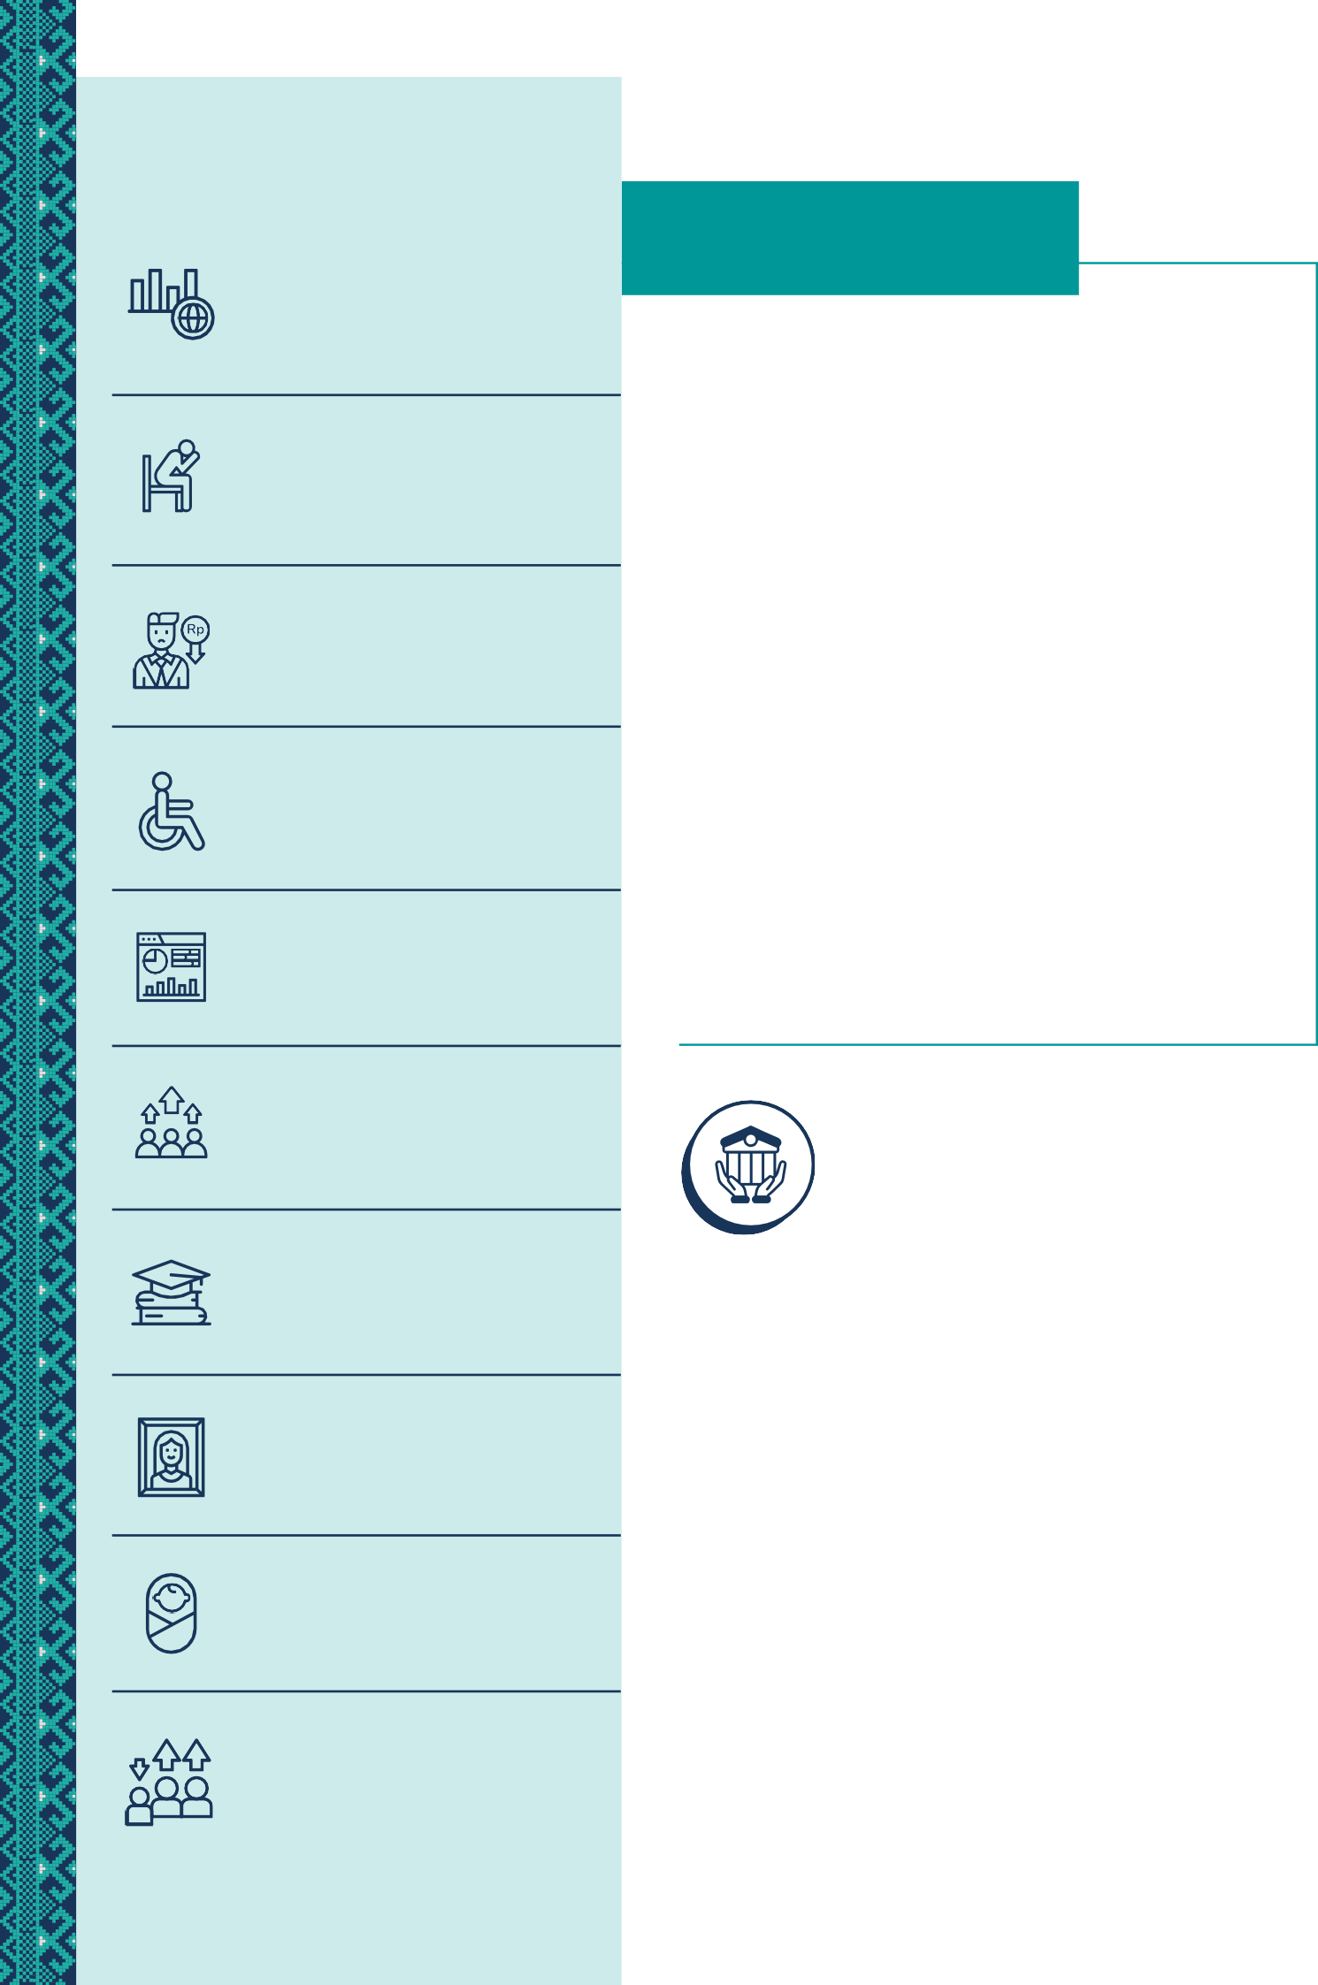

## Promoting Gender Equality, Disability, and Social Inclusion (GEDSI)

The NTB government has enacted several regulations and policies to promote GEDSI, such as the Governor Regulation on Gender Mainstreaming, a bylaw on disability rights, and measures to prevent child marriage. A Regional Disability Commission has also been established. Civil society organizations actively collaborate with government on GEDSI issues and service delivery, creating opportunities for robust partnerships. With support from SKALA, the government has revitalized the PUSPA Forum² which advocates for women and children’s rights in government planning processes and is working to secure sustained funding for GEDSI initiatives. The Raosan Sante forum, a monthly knowledge-sharing platform facilitates discussions on disability services and preventing gender-based violence and has resulted in basic sign language training held by the Department of Transportation and disability-friendly infrastructure improvements at Department of Social Affairs. Additionally, the Regional Action Plan for Persons with Disabilities (RAD-PD) is being developed, with data from the socioeconomic registry (Regsosek) to ensure that the needs of persons with disabilities are addressed in alignment with national frameworks. With support from SKALA, the province is also developing its Gender Mainstreaming Action Plan, an Action Plan for the Elderly, and regulations to support the implementation of an inclusive local development planning conference.

## Using Data and Analytics for Better Planning and Service Delivery

The NTB government is improving the delivery of basic services through enhanced use of data and analytics with a focus on evidence-based decision-making. To overcome fragmented data management across departments, and in alignment with the Satu Data policy, NTB, with support from SKALA, is unifying its data systems into a platform called the NTB Satu Data to consolidate socioeconomic and demographic data.

The NTB government has also established the Satu Data Action Plan to prioritize the collection and use of gender-disaggregated and disability-specific data. The datasets will be used to inform planning documents such as the regional Medium-Term Development Plan (RPJMD) and the Strategic Plan (Renstra). The NTB Satu Data Forum identifies gaps in data about vulnerable groups, including women, persons with disabilities, and poor households. NTB is also expanding the coverage of its Village Information System as a data source on and for basic services. Training programs have equipped over 24 provincial departments to use tools like Regsosek and the Integrated Regsosek Data-Based Development Planning System (SEPAKAT) for better planning and budgeting. Collaboration to build the capacity of data producers and mechanisms for data updates is contributing to data on Minimum Service Standards (MSS) that better represents the needs of the vulnerable.

## Enhancing Fiscal Capacity

The NTB government is working to strengthen its fiscal capacity and reduce reliance on central government transfers. To do so, NTB is improving local tax policies and fiscal management systems, with the goal of increasing locally generated revenue beyond the current 30-50%. With SKALA’s support, NTB ratified Governor Regulation No. 23/2024³ which governs local taxes and includes provisions for tax relief for modified motor vehicles for persons with disabilities. SKALA also supports the drafting of guidelines to ensure these revenues are efficiently directed toward inclusive public services. NTB has developed a Memorandum of Understanding (MoU) on revenue-sharing between the province and districts to ensure equitable distribution of funds, particularly in remote and vulnerable areas. SKALA also works with NTB to build human resource capacity so that the new regulations on regional taxes and levies (*Pajak Daerah dan Retribusi Daerah or PDRD*) are implemented. As part of its strategy, SKALA recommends including a human resource development component in the Cooperation Agreement signed by the province and each district/city in NTB.

1. *Forum Partisipasi Publik untuk Kesejahteraan Perempuan dan Anak* or

Public Participation Forum for the Welfare of Women and Children.

1. On the Procedures for Collecting Motor Vehicle Taxes, Motor Vehicle Title Transfer Fees, Motor Vehicle Tax Operations, and Motor Vehicle Title Transfer Fee Operations.



3



## Improving Quality of Spending:

**Planning for Minimum Service Standards**

Through its combined efforts to increase participation of the vulnerable in decision-making, better use data to plan and budget for services, and by boosting regional fiscal capacity, the NTB government is working to meet Minimum Service Standards (MSS) in the delivery of essential services such as health, education, and social protection. SKALA has assisted the government to strengthen MSS data collection and budget tagging. A notable outcome is the Housing Development Program for which the budget increased from IDR 123 million in 2023 to IDR 1.5 billion in 2024. SKALA is also strengthening MSS Implementation Teams at the provincial and district levels, equipping them with the tools needed to monitor and evaluate MSS action plans.

## SKALA’s 2024-2025 Work Plan:

This includes supporting NTB to integrate MSS goals into the Regional Long-Term and Medium-Term Development Plan (RPJPD and RPJMD). SKALA has also worked with NTB to ensure that essential items for planning and budgeting inclusive basic services are included in the Governor’s Decree No. 027-326/2024, which sets the 2025 Standard Unit Prices (the official list of costs for goods and services used in budgeting). This list now includes costs for inclusive services such as sign language interpreters, tactile flooring to help people with visual impairments navigate, accessible toilets, emergency panic buttons, disability-friendly buses, accessible doors in public spaces, and other items that were not previously included in the list.

**THEME FOCUS AREAS**

**Gender Equality, Disability and Social Inclusion (GEDSI)**



4

**Strengthen Data and Analytics (D&A)**

**Improve Regional Fiscal Capacity**

**Enhance Quality of Spending (MSS)**

**Program Governance (PPC)**

* Support NTB government to work together to create plans and budgets that include the needs of everyone, especially vulnerable groups.
* Facilitate community groups to come together to speak up for the needs of vulnerable

people to make sure they are part of the planning and budgeting process.

* Ensure community groups have access to important data about gender equality, disability, and basic services to help them understand the situation better and advocate for improvements.
* Strengthen the NTB Satu Data by supporting the development of the Governor’s Regulation on the Regional Satu Data Action Plan. Build the capacity of the NTB Satu Data Forum to lead and coordinate data integration across the region.
* Enhance the NTB Satu Data portal, integrating it with SEPAKAT and other local systems, and improving accessibility features for persons with disabilities.
* Support the Village Information System by providing technical assistance to finalize and disseminate the revised Roadmap to districts and cities.
* Strengthen the use of Regsosek data for planning and decision-making by ensuring Master Trainers are available to assist with microdata analysis and support regional and village-level data use.
* Support development of regulations and policies on regional taxes and levies (PDRD).
* Support development of a business plan to increase locally generated revenue (PAD) and its implementation.
* Facilitate updated data and integration of action plans into annual planning documents

using the SIPD-RI system.

* Support calculation of unit costs for MSS activities and identification of financial

resources needed to ensure service delivery for vulnerable groups.

Support for SKALA program governance in NTB Province