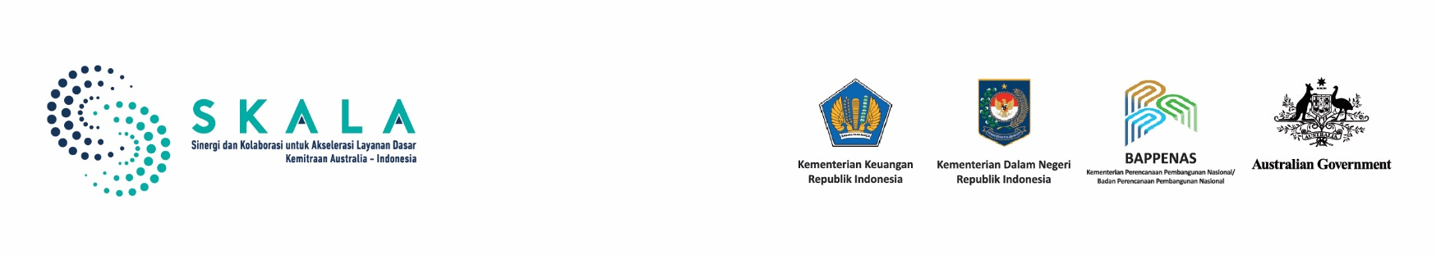

**At a Glance:**

SKALA in Gorontalo

October 2024

## Introduction

Gorontalo Province is located on the northern arm of Sulawesi Island in eastern Indonesia. It became the 32nd province of Indonesia in December 2000, based on Law No. 38/2000. The province’s administrative structure comprises five regencies and one city, with 77 subdistricts, 72 urban villages, and 657 rural villages. The capital city, also named Gorontalo, serves as a hub for both administrative and economic activities. Gorontalo is bordered by the Celebes Sea to the north and the Gulf of Tomini to the south. Its terrain ranges from coastal flatlands to towering mountains. The region is renowned for its biodiversity as it is part of the Wallacea biogeographical zone and is home to some of the world’s most unique flora and fauna. For instance, Gorontalo offers a rare opportunity for

visitors to interact with Whale Sharks in Botubarani. Agriculture forms the backbone of its economy, with an emphasis on crops like corn, rice, and coconut. However, poverty in Gorontalo remains a significant issue at a rate of 14.57% in 2024, which is higher than Indonesia’s national average.

SKALA¹ works with the Gorontalo Provincial Government to strengthen the participation of vulnerable groups in development planning, as well as to improve the use of reliable data and analysis, increase regional financial capacity, and strengthen the quality of public spending. SKALA’s Gorontalo office became operational in October 2023.



1

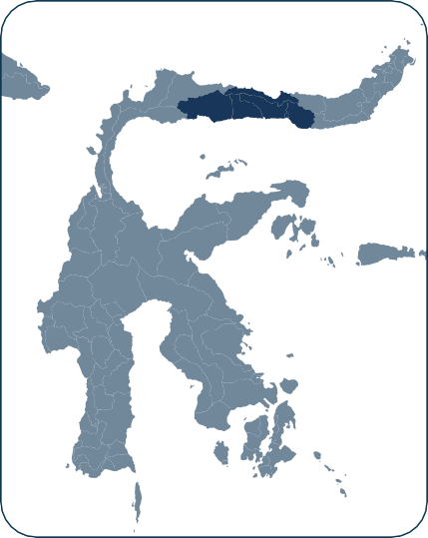

*Figure 1. Key Administrative Data (BPS unless otherwise stated)*

Population:

**1,213 million people**

(2024)

Area:

**11,257 km²**

(Ministry of Home

Affairs, 2019)

Administrative center and capital city:

**Gorontalo**

Regional Fiscal Capacity:

**IDR 13.83 trillion (2024), with 40-50% from regional transfer funds**

(Gorontalo Provincial Finance Agency and Antara News Media)

1. *Sinergi dan Kolaborasi untuk Akselerasi Layanan Dasar* (SKALA) is an Australia-Indonesia Partnership Program aimed at supporting the Government of Indonesia’s efforts to reduce poverty and inequality by improving basic-service provision to poor and vulnerable communities in less-developed regions.

*Figure 2. Key Socioeconomic Data (Source: BPS unless otherwise stated)*



## Economic and Social Development

## Economic and Social Development

**Gross Regional Domestic Product (GRDP):**

# IDR 51.74 billion

(2023)

**Unemployment Rate:**

# 3.06%

(2023)

**Poverty rate:**

# 14.57%

(2024)

# 2.23%

**of the population are disabled**

(Regsosek, 2022)

**Gini coefficient:**

# 0.414

(2024)

**Human Development Index:**

# 72.98

(2024)

**Education Enrolment Rates (Net):**

**Elementary : 98.69%**

**Junior High : 73.55%**

**Senior High : 60.18%**

(2023)

**Maternal Mortality Rate:**

**197.7 per 100,000**

**live births**

(Gorontalo Health Profile 2022)

**Infant mortality rate:**

**11.4 per 1,000 live births**

(Gorontalo Health Profile 2022)

**Stunting:**

# 24.6%

(Gorontalo Provincial Health

Office Report, 2023)

2

Gorontalo has made steady progress in its social and economic development, particularly in the sectors of agriculture, forestry, and fisheries, which remain key contributors to the local economy, accounting for 38% of the province's GDP. The region's economic growth has been supported by strategic policies aimed at recovery and growth following the challenges of the COVID-19 pandemic. While still focusing on its agricultural strengths, Gorontalo is seizing opportunities to diversify its economy, with ongoing efforts to enhance other sectors like manufacturing and construction. Basic services in the province, particularly in health and education, are being strengthened to address socio- economic disparities. The government has sought to improve school participation rates and healthcare access, with increasing life expectancy and better school attendance rates. However, rural areas still face challenges in accessing adequate facilities, especially for healthcare and education. Government efforts are aimed at building an inclusive and resilient economy that benefits all segments of the population to foster long-term prosperity for the province.

## SKALA’s Support to Improve Inclusive Basic Services in Gorontalo

The provision of public services is a key responsibility of local governments, and SKALA actively supports these efforts. In Gorontalo, the provincial government plays a crucial role in facilitating the successful implementation of SKALA-supported initiatives. The establishment of a Provincial Program Committee, formalized by the Governor's Decree, aims to enhance coordination across regional agencies. SKALA aligns its Annual Work Plan with local government priorities so that its support is integrated with regional planning documents and initiatives. This approach strengthens the achievement of government priorities and promotes collaborative governance based on shared understanding, partnership, and synergy, ultimately enhancing the effectiveness of regional governance.

## Promoting Gender Equality, Disability, and Social Inclusion (GEDSI)



The Gorontalo government is prioritizing inclusive and quality regional planning by integrating GEDSI into the 2025-2045 Regional Long-Term Development Plan, which will be further refined through 5-year and annual plans. To support this initiative, with support from SKALA, Gorontalo has established Women's and Disability Network Nodes to engage vulnerable groups in the planning process and is conducting public consultations for the 2025 Regional Government Work Plan (*Rencana Kerja Pemerintah Daerah* or RKPD) to integrate GEDSI perspectives. The Network includes organisations such as the Leader Institute, Yayasan Putra Mandiri Wire G Salampuan, and Yayasan Ummu Sahidah. Initial efforts also include the formation of a Gender Mainstreaming (*Pengarusutamaan Gender* or PUG) Working Group, established by Governor's Decree No. 310/2024 and the formation of PUG Technical Teams under Governor’s Decree No. 265/2024 to draft regulations that will strengthen gender mainstreaming, women’s empowerment, and child protection. SKALA is also facilitating the preparation and implementation of the Regional Action Plan on Disability (RAD PD) and Gender Mainstreaming Action Plan (RAD PUG)

## Using Data and Analytics for Better Planning and Service Delivery

Gorontalo is also leading efforts to improve governance and service delivery through better data and analytics. A key initiative in this effort is the Gorontalo Satu Data (GSD), a comprehensive data management platform that will address the challenges of fragmented and inconsistent data across various government levels and institutions. GSD consolidates data from multiple sources into a single platform, and will provide real-time, accurate, and accessible information to support evidence- based policymaking. Data from the socioeconomic registry (Regsosek) is also being analysed, integrated

3

into GSD, and is being updated regularly. Bappenas has selected Gorontalo as a pilot region for updating Regsosek data, with SKALA providing support through training to improve data use in regional planning. The Governor has also appointed SEPAKAT Account Managers to ensure the effective utilization of this data.

Additionally, village information systems are being integrated into GSD, to enhance data collection and usage at the local level. With support from SKALA and in collaboration with the National Administration Institute and the Ministry of Home Affairs, functional Policy Analysts in Gorontalo have also received training on how to advocate for inclusive, evidence- based policies.

## Enhancing Fiscal Capacity

The Gorontalo Provincial Government is actively working to enhance its fiscal capacity and reduce reliance on central government transfers. To do so, the government is working to increase local revenue through better tax collection, more efficient financial management, and promoting growth sectors like tourism and agriculture. The provincial government is also improving the management of intergovernmental transfers to ensure funds are effectively allocated and utilised. A key part of this effort is the implementation of Regional Regulation No. 1 of 2024 on Regional Taxes and Levies, which includes preparing Regional Head Regulations for regencies and cities. Additionally, with support from SKALA, the government is conducting a technical study on regional revenue and financing potential. To tackle challenges in tax collection, the government is re-registering taxpayers and collaborating with local governments to improve tax management, especially for vehicular taxes, in line with the mandate of Law No. 1 of 2022 on Fiscal Relations between Central and Regional Governments. These initiatives aim to boost Gorontalo’s fiscal autonomy and ensure long-term financial stability.



## Improving Quality of Spending:

**Planning for Minimum Service Standards**

Gorontalo is actively working to improve the quality of its public spending by focusing on achieving Minimum Service Standards (MSS), which set the minimum level of public services local governments must provide. With SKALA’s support, the province is strengthening its planning, budgeting, and service delivery processes to ensure that essential services such as healthcare, education, and clean water are accessible to all residents. Special attention is being given to addressing the needs of vulnerable groups, including the elderly and people with disabilities, as part of a broader effort to ensure equity in service delivery.

## SKALA’s 2024-2025 Work Plan:

To support the Gorontalo province achieve these goals, SKALA has provided targeted training to the Provincial MSS Implementation Team to enhance their understanding of MSS processes and improve their ability to assess service quality. The team, led by senior officials and supported by technical staff, has also established a dedicated task force to accelerate the implementation of MSS across the province. These efforts are designed not only to meet compliance requirements but also to ensure that Gorontalo’s residents benefit from high-quality, equitable services that contribute to the province’s long-term development.



4

|  |  |
| --- | --- |
| **THEME** | **FOCUS AREAS** |
| **Gender Equality, Disability and Social Inclusion (GEDSI)** | * Strengthen participation, representation and influence of vulnerable groups in planning and decision-making processes. |
| **Strengthen Data and Analytics (D&A)** | * Strengthen regional one data policies and institutions. * Enhance village-level information systems. * Support integration between data management systems. * Strengthen data analysis, updating, and utilization. |
| **Improve Regional Fiscal Capacity** | * Stengthen regional income and revenue. * Improve management of central government fiscal transfers to Gorontalo. |
| **Enhance Quality of Spending (MSS)** | * Strengthen the management of MSS Implementation. * Enhance regional planning and budgeting for the implementation and fulfilment of inclusive basic services. |
| **Program Governance (PPC)** | Support for SKALA program governance in Gorontalo Province. |