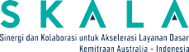 



At a Glance:

SKALA Program

in North Kalimantan 2024-2025



## Introduction

Established on October 25, 2012, based on Law No. 20/2012, North Kalimantan (Kaltara) is one of Indonesia’s newest provinces. It is classified as an outermost, frontier, and less developed region. The province borders Malaysia and is strategically located on Asia-Pacific sea lanes. Kaltara’s strategic location offers significant potential for development.

The province of Kaltara is administratively divided into four regencies (Bulungan, Nunukan, Tana Tidung, and Malinau) and one city (Tarakan), with its tentative capital located in Tanjung Selor.

Given its large geographic area and population dispersed across remote regions, the provincial government remains committed to infrastructure development. This focus aims to enhance connectivity and improve the efficiency of public service delivery, particularly basic services and governance.

SKALA1 works with the provincial government to strengthen participation of vulnerable groups in development planning, data provision and use, regional fiscal capacity, and quality of public spending. SKALA’s Kaltara office became operational in October 2023.

*Figure 1. Key Administrative Data*

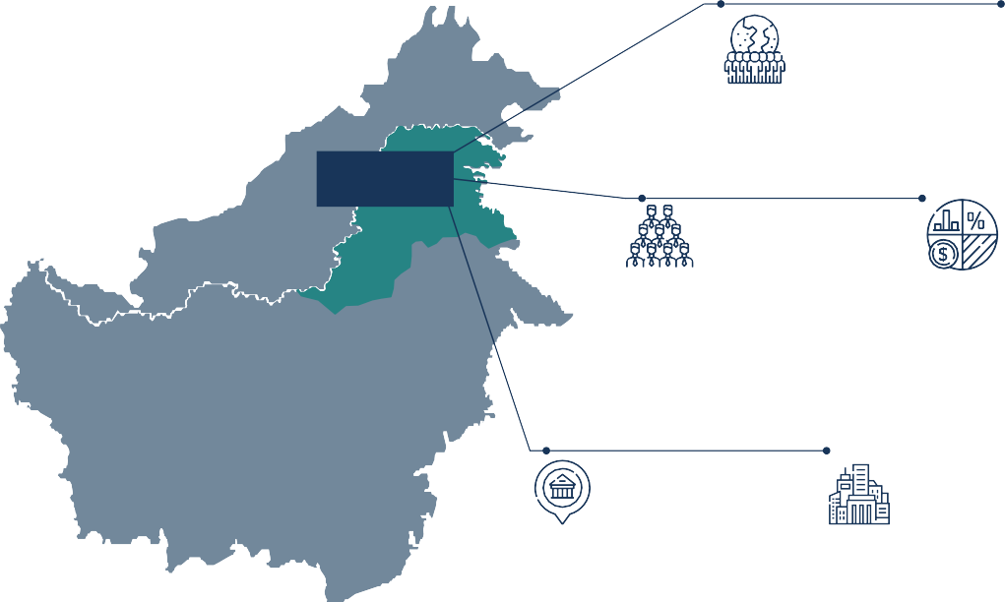

|  |
| --- |
| North Kalimantan |

Population:

### 739.778

(BPS-Statistics Indonesia, 2024)

Area:

### 75.467,7 km²

(BPS-Statistics Indonesia, 2023)

Number of Civil Servants:

### 20.490

(BPS-Statistics Indonesia, 2023)

Fiscal Capacity:

### Rp3,12 trillion, with 69% coming from Regional Fiscal Transfers.

(DJPK Kemenkeu, 2024)

Administrative Center of Government:

### Tanjung Selor

Largest City:

### Tarakan





1

1. *Sinergi dan Kolaborasi untuk Akselerasi Layanan Dasar* (SKALA) is an Australia-Indonesia Partnership Program aimed at supporting the Government of Indonesia’s efforts to reduce poverty and inequality by improving basic-service provision to poor and vulnerable communities in less-developed regions.

*Figure 2.*



***Key Socioeconomic Data***

**Gross Regional Domestic Product (GRDP):**

# Rp201,75 million

(BPS-Statistics Indonesia, 2023)

**Unemployment Rate:**

# 4,01%

(BPS-Statistics Indonesia, 2024)

**Poverty Rate:**

# 6,32%

(BPS-Statistics Indonesia, 2024)

**Population with Disabilities:**

# Mild : 36.558

**Severe : 9.889**

(Regsosek-SEPAKAT, 2022)

**Gini Ratio:**

# 0,277

(BPS-Statistics Indonesia, 2024)

**Human Development Index (2023):**

# 72,88

(BPS-Statistics Indonesia, 2023)

#### Education Net Enrollment Rate (NER):

**Primary School : 94,73 Lower Secondary School : 80,53 Upper Secondary School : 66,70**

(BPS-Statistics Indonesia, 2023)

|  |
| --- |
| **Economic and Social Development** |

Kaltara’s economy benefits greatly from its abundant natural resources, particularly the mining sector, which plays a major role in the provincial GDP. There is a significant opportunity to diversify employment opportunities, especially for low and middle- skilled workers, by expanding beyond resource- based activities. Efforts to improve infrastructure and access to finance are underway, to unlock the province’s full economic potential. There is a strong government commitment to advancing social development, particularly in education and health, to ensure that all residents benefit from improved service delivery and meet the province’s minimum service standards (MSS)²

## Inclusive Basic Services in Kaltara

The provincial government is responsible for the establishment and operationalization of the SKALA program governance in Kaltara. The creation of the SKALA Provincial Program Committee (PPC), through Governor’s Decree No. 188.44/K.537/2023, which established the SKALA program secretariat, enables coordination among regional government departments (*Organisasi Perangkat Daerah* or OPD). SKALA also aligns its Annual Work Plan with regional planning documents and initiatives to foster shared understanding and collaboration among the government partners it supports. This synergy enhances the effectiveness of regional governance.

#### Number of Health Facilities:

**16 Hospitals**

**58 Public Health Centers**

**52 Clinics**

**766 Maternal and Child Health Centers**

(BPS-Statistics Indonesia, 2023)

1. North Kalimantan Province in figures, Central Statistics Agency

(BPS) 2023 and SEPAKAT- Regsosek Bappenas RI.

2

## Promoting Gender Equality, Disability, and Social Inclusion (GEDSI)

In a first for the region, the Kaltara government initiated the inclusion of GEDSI issues in planning and delivering basic services by facilitating consultations with civil society organizations (CSOs). The collaboration helped form the Forum for Communication for Disabilities, Vulnerable Groups, Women, and Children which comprises 12 CSOs3 and five OPDs. This network initiated and represented the GEDSI group at Kaltara’s first Inclusive Development Planning Conference (*Musyawarah Perencanaan Pembangunan or Musrenbang* – ‘Mentari Kaltara’) and provided inputs to the draft Regional Regulations on Gender Mainstreaming and for People with Disabilities. This effort marks a significant step towards inclusive governance in Kaltara, ensuring that the needs and voices of marginalized groups are integrated into regional planning and policy development.

## Using Data and Analytics for Better Planning and Service Delivery

With support from SKALA, the government initiated the redesign of the Kaltara Satu Data platform SIDARA CANTIK4. A priority data and metadata list was developed, and the Satu Data action plan was approved for implementation through financial support in the 2024 budget. Additionally, Master Trainers were trained to use the socioeconomic registry (Regsosek) through the Integrated Regsosek Data Based Development Planning System (SEPAKAT), enabling 13 OPDs to gain access rights to Regsosek. The Kaltara government used this data for planning across 20 OPDs, incorporating it into key documents such as regional medium- and long-term development plans, workplans, and action plans. The government also developed a list of issues and a draft Gubernatorial regulation on the village information system.

## Enhancing Fiscal Capacity

The Kaltara provincial government has made efforts to synchronize central and regional policies, including the nomenclature of programs focused on poverty and basic services, within the 2021- 2026 Strategic Plan Amendments for 35 OPDs, with support from SKALA. In 2024, Kaltara ratified Regional Regulation No. 1/2024 and Gubernatorial Regulation No. 25/2024 on regional taxes and levies (*Pajak Daerah dan Retribusi Daerah* or PDRD). These were informed by a local revenue mapping which was done in collaboration with SKALA and local institutions5. The government also identified key issues for the draft PDRD implementation guidelines based on this mapping. A study on locally-generated revenue (*Pendapatan Asli Daerah* or PAD) was also completed with feedback from 12 OPDs and two local universities6. The provincial government approved and submitted the 2024 General Allocation Fund (DAU) budget report, identifying activities and sub-activities aligned with MSS using Regsosek data. This approach led to a 52% increase in education spending. Additionally, SKALA supported enhanced government understanding and capacity in managing DAU Specific Grants through targeted tagging and problem identification to fulfil MSS in education, health, and public works and promoted the use of Regsosek data for targeted programs. This progress demonstrates the leadership of the Kaltara government in aligning policies and enhancing revenue management to improve service delivery.

1. Forum Anak Daerah, Puspa Benuanta, Yayasan Insan cita assyaili, PW Salimah Kaltara, Yayasan Faqih Hasan Centre, Himpunan Wanita Disabilitas Indonesia Fatayat NU (HWDI), Hangout Community, Yayasan Mulya Bulungan (YMB), Perkumpulan Penyandang Disabilitas Indonesia (PPDI), PW. Muslimat NU, Gerkatin Kaltara, Pusat Pemilihan Umum Akses Penyandang Disabilitas (PPUA Penca).
2. *Sistem Informasi Data Statistik Sektoral Cepat, Akuntabel, Informatif,*

*dan Konkrit.*

1. UPTD Bappenda, Bappeda, Universitas Borneo Tarakan, dan Politeknik

Nunukan.

1. University of Borneo Tarakan and University of North Kalimantan.

3



Improving Quality of Spending: **Planning for Minimum Service Standards**

The Kaltara government has made significant strides to improve the quality of its spending by strategically planning to meet MSS. By using Regsosek data and analysis, the government has effectively integrated multi-sector data to better understand and plan for its residents’ basic service needs. Progress is also reflected in the increased operational budgets for the MSS secretariat and the redesign of the SIDARA CANTIK. Technical support for provincial

and district-level officials on targeting inputs, monitoring, and evaluation across six MSS sectors has equipped them to better plan for and supervise inclusive service delivery. Additionally, the Kaltara government’s efforts to advocate for inclusive governance and draft local regulations on taxes and levies have contributed to a more sustainable and focused approach to public spending in Kaltara.



4

**SKALA’s 2024-2025 Work Plan:**

|  |  |
| --- | --- |
| **THEME** | **WORKPLAN 2024-2025 FOCUS AREA** |
| Gender Equality, Disability and Social Inclusion (GEDSI) | Participation, representation and influence of vulnerable groups in  planning and decision-making processes |
| Enhance Data and Analysis (D&A) | * Regional Satu Data policies and institutions * Village-level information systems * Systems and integration between data management systems * Data analysis, updating, and utilization |
| Strengthen Regional Fiscal Capacity (Public Financial Management) | * Regional income * Management of fiscal transfers to regions |
| Improve Quality of Spending (Minimum Service Standards) | * Management of MSS implementation * Regional planning and budgeting to ensure inclusive basic services |
| Governance (PPC) | Support for SKALA Program Governance in Kaltara |