



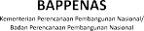


Disability Inclusion in the Workplace: Early Lessons from SKALA’s Journey1
September 2024

Inclusion in the workplace begins with a mindset that prioritizes diversity in all its forms. Disability inclusion is about adopting an intentional perspective that values accessibility and equity in every aspect of work. This mindset creates space for explicit policies that thoughtfully address physical accessibility and ensure inclusive recruitment and robust employee support
systems. SKALA’s experiences offer early lessons in building a more inclusive work environment, particularly in corporate practices, including its successes and areas for further improvement. This note details lessons gained so far, with examples of initiatives and enhancements based on the perspectives of SKALA employees who have disabilities.

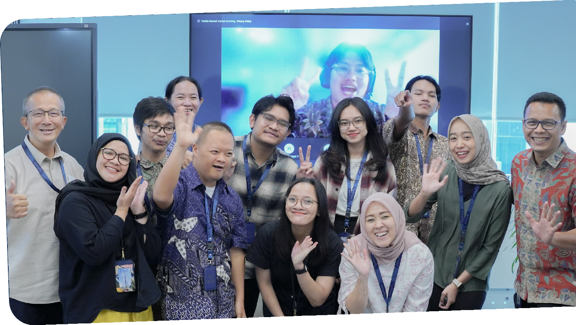

- This note has been reviewed by SKALA’s staff, including those with disabilities.

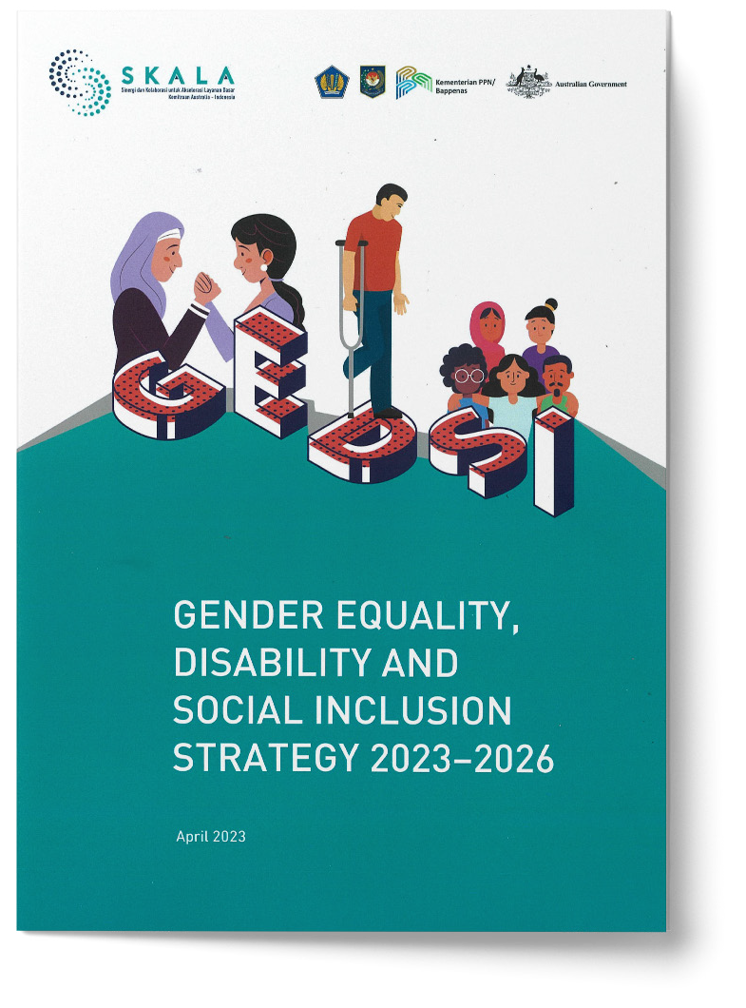
Enforce accessibility in recruitment and employment.

Inclusive recruitment and reasonable adjustments can foster a diverse workforce that includes people with disabilities (PwD). Presently, 3% of SKALA staff (four individuals) are people with disabilities, of whom two identify as women, and two as men. As part of affirmative action towards disability inclusion, SKALA enacts a recruitment policy that requires a minimum of 5% of staff positions to be filled by people with disabilities. To implement this policy, SKALA uses two types of recruitment.

The first is open recruitment wherein SKALA promotes vacancies through advertisements and encourages candidates with disabilities to apply. If a person with disability does so, SKALA accommodates their specific needs during the selection process. These accommodations may include sign language interpreters for deaf or hard-of-hearing applicants, extra reading time for those with learning difficulties, or screen-reading
software for individuals with visual disabilities.

The second type is specific recruitment to hire people with disabilities. To do this, the hiring team makes a deliberate effort to ensure that Terms of Reference do not contain unconscious bias against PwDs that may exclude them from the recruitment process, raises awareness of existing colleagues on how to include new staff who have disabilities, as well as prepares accommodations to ensure new staff have what they need to participate productively. The availability of adjustments is also communicated in the applicant information pack, which includes contact details for an officer who can assist with further requests that applicants with disabilities may have.

SKALA also actively reaches out to networks and organisations working with PwDs as part of promoting employment opportunities. This proactive approach ensures that the program is visible to a wide audience, helping to attract a diverse pool of applicants.

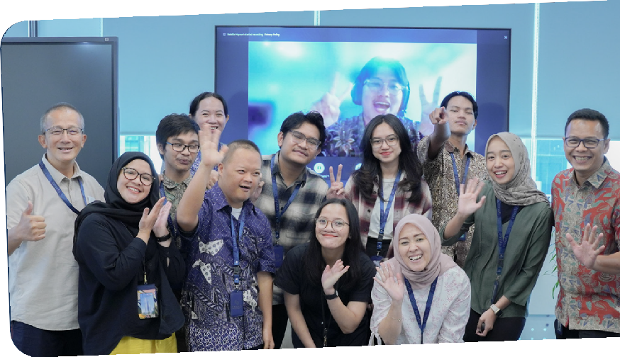
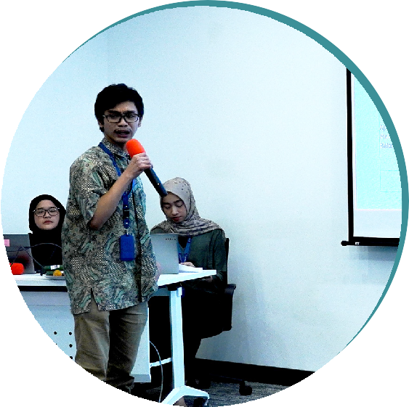
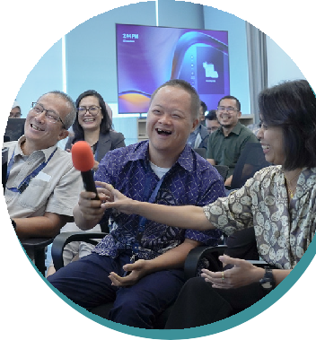
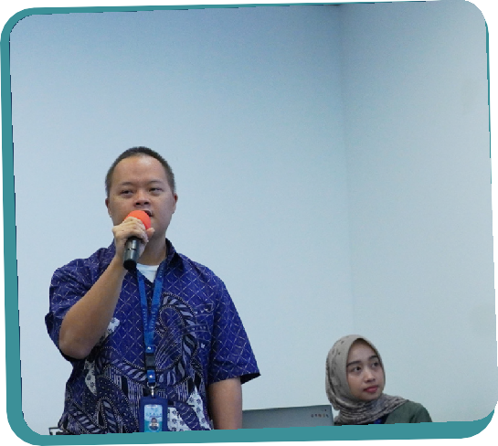
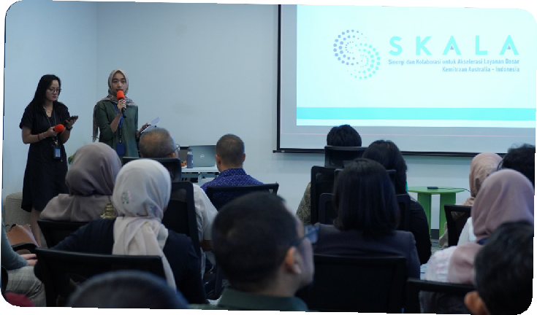
Create pathways to future employment for young people with disabilities.

SKALA’s commitment to disability inclusion extends to its internship program, which is designed to be inclusive of both young people with and without disabilities. The internship program provides professional experience to young people and serves as a pathway to future employment. SKALA allocates eight to ten positions annually for interns, including those with disabilities. The program reaches out to tertiary institutions, graduate forums, and disability organizations to attract qualified candidates.

As with staff, SKALA makes every effort to understand and tailor adjustments to its interns’ specific needs, such as specialized software to enhance screen readability for those with vision impairments or reconfiguring workspaces to improve accessibility for employees using wheelchairs. This also
includes providing dedicated volunteers to support their work and establishing a clear workplan for the interns to pursue as part of their professional development.

Interns’ presentation on learning at SKALA at the Sharing Session on July 15, 2024
Photo by: SKALA 2024

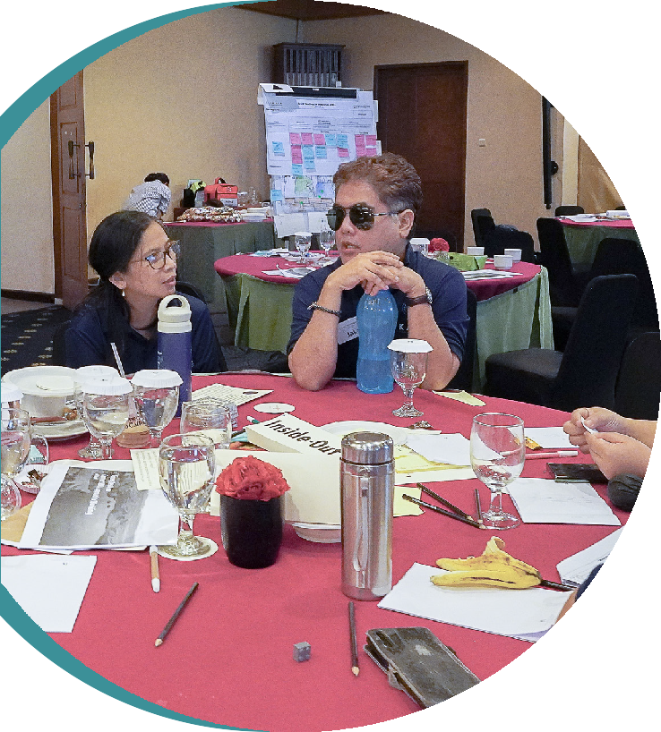
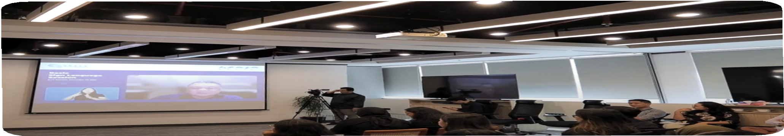
Build an organizational culture so all employees feel valued and supported.

As noted earlier, creating an inclusive workplace requires a mindset that embraces and values diversity. It often requires a change in corporate culture that begins with greater awareness. To this end, SKALA provides training programs to employees about the challenges faced by colleagues with disabilities and on how to support them effectively. This training includes practical guidance on how to communicate effectively with a colleague who is deaf and how to assist people with physical disabilities. Such training raises awareness and builds confidence among employees so they are equipped to support their colleagues in a respectful and meaningful way.

For colleagues with intellectual disabilities, another SKALA staff fills the role of ‘office companion’. The office companion assists with navigating tasks, understanding workplace procedures, facilitating communication, and providing guidance to help colleagues with an intellectual disability fully participate in the work environment. Additionally, SKALA’s travel policy supports employees with disabilities, based on their unique needs. Social activities at SKALA include competitions to communicate in sign language to sustain focus on inclusion.
SKALA also ensures that all its publications adhere to accessibility guidelines to be screen-reader friendly and accessible to people with visual disabilities.

Discussions at the Ways of Working workshop and Basic Sign Language training.

Photo by: SKALA 2024

Implement accessibility standards for inclusive infrastructure.

Creating accessible physical spaces is a key step in disability inclusion. SKALA recognized this early on and adopted the Victoria Government Access to Buildings and Australian Disability Standards 2010 as benchmarks for assessing how accessible its office premises are.

SKALA’s Jakarta office was chosen in part due to its compliance with these accessibility standards, which include building access for wheelchairs and restrooms for people with disabilities. It has sliding doors that can be opened with the push of a button or a keycard tap and has tactile flooring to help people with visual disabilities navigate the office. The office also has a multifunction room, which supports inclusivity by offering a space for various needs, including breastfeeding and for people with disabilities to rest as needed. This is needed to avoid triggering decubitus² for people who use wheelchairs
and to reduce tension for people with mental health challenges. And
such facilities benefit everyone.

In provincial offices, additional fit-out work was done to include ramps for wheelchairs and adjusted door widths to accommodate larger mobility devices. Where SKALA offices are co-located in government buildings, the team continues to work with building management authorities on incremental changes that can improve accessibility for people with disabilities.

Tactile flooring for people with visual impairments at SKALA’s Jakarta office and a ramp for wheelchair users at SKALA’s Gorontalo office.

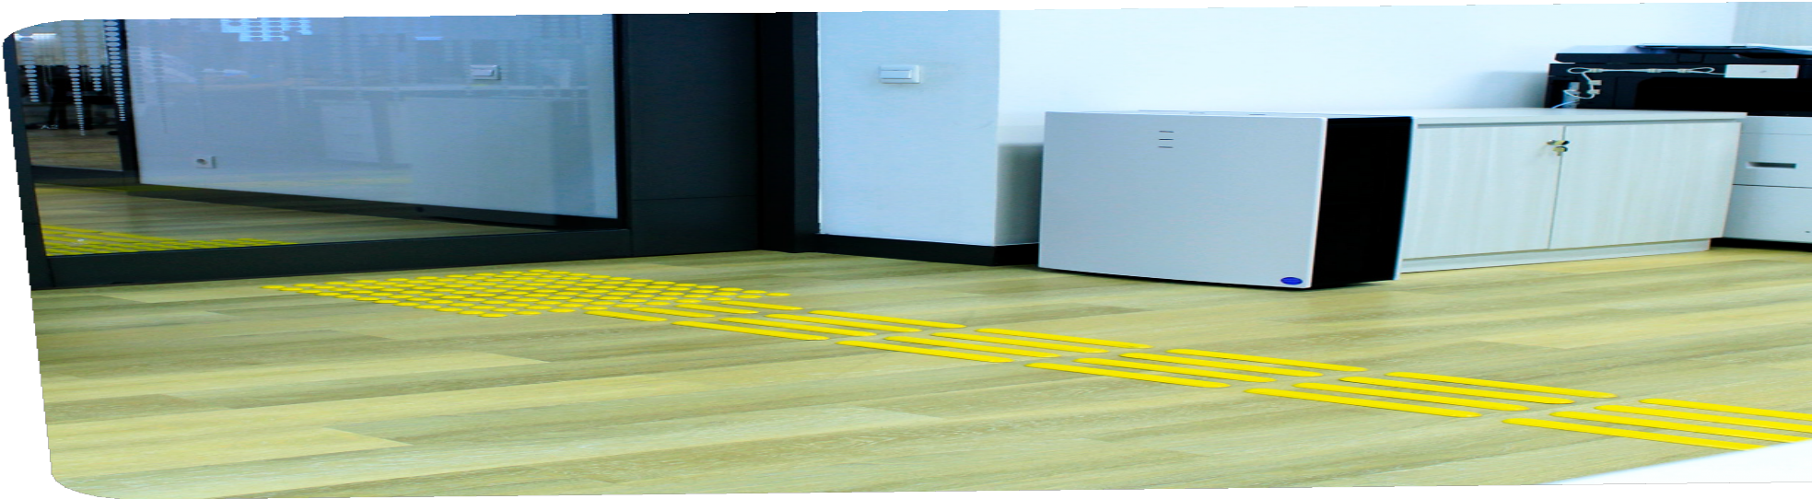
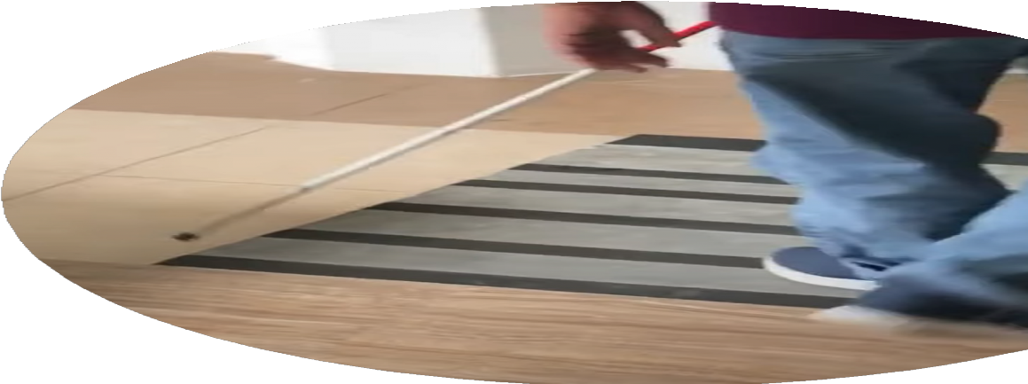
- Injury to skin and underlying tissue resulting from prolonged pressure on the skin.

Photo by: SKALA 2024

Host accessible events at inclusive venues.

Ensuring that events and venues are accessible to persons with disabilities is another important aspect of SKALA’s inclusion strategy. This consideration extends to both internal events and those involving external participants. At its events, SKALA provides sign language interpretation for those who are deaf. For participants with disabilities who need to be accompanied by a supportive companion, SKALA makes provisions to cover travel related expenses for that companion. For participants with disabilities who find it difficult to access public transport to attend a SKALA-supported event, SKALA makes provisions to rent a private car as an alternative. While the standard practice is to make allowance payments via bank transfer, there are provisions that allow cash payments to participants with disabilities who do not have access to a bank account. To ensure balance between needs and operational realities, SKALA makes these decisions on a case-by-case basis.


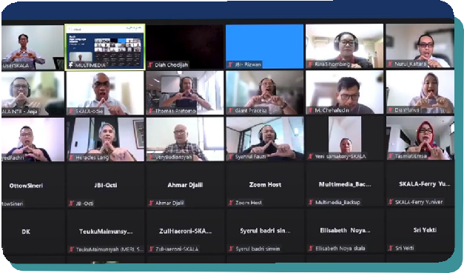
Remote locations also often do not have venues that are disability friendly. To the extent possible, when selecting venues for events, SKALA prioritizes locations that are wheelchair accessible, have elevators, and provide ample parking space. Accommodation for traveling employees or event participants must also be friendly to people with disabilities. Additionally, SKALA’s staff are trained to be vigilant about the specific needs of participants with disabilities, providing on-the-spot support as required. During a recent training event, a staff member noticed that a participant using a wheelchair was struggling with the height of the dining tables. The staff member
quickly arranged for a lower table to be brought in, ensuring the participant could comfortably join the group. This kind of proactive support is
key to creating an inclusive environment where everyone feels welcome.

Hybrid session on Basic Sign Language training at SKALA.
Photo by: SKALA 2024

Moving Forward

While SKALA has made important strides in disability inclusion, there is more that can be done. The following is a series of actions SKALA is considering as it continues to improve disability inclusion at its offices.

- Implement additional training for hiring teams so they know how to develop inclusive Terms of Reference and understand the specific accommodations required for different disabilities.

- Collaborate with the DT Institute, which supports research to advance opportunities for individuals, including those with disabilities.

- Make training programs on disability inclusion regular and systematic, focusing on specific challenges and the needs of employees with different types of disabilities.

- Institutionalize the role of ‘office companion’ for colleagues with disabilities, including support, training and recognition for ‘office companions’.

- Where possible, upgrade office spaces and event venues to meet or exceed accessibility standards. Implement formal accessibility audits before and after improvements to ensure that infrastructure adaptations at SKALA offices meet the needs of all employees and identify gaps.
- Enhance accessibility in provincial office locations by working closely with local authorities and building management and include multifunction rooms in provincial offices where possible.

- Revisit the design of tactile guiding blocks to ensure they are easily detected by individuals using canes or walking aids, they include continuous not disconnected straight lines, and do not impede wheelchair users (rubber or textured carpet instead of stone or metal).

- Replace sharp or difficult-to-use door handles with more ergonomic designs that accommodate a wider range of disabilities, including options that do not require the use of fingers or that are easier to push or pull.

- Seek regular feedback from employees with disabilities to understand their needs better and continuously improve the workplace environment.



