

**SINERGI DAN KOLABORASI UNTUK AKSELERASI LAYANAN DASAR (SKALA)**

INVESTMENT DESIGN DOCUMENT

August, 2022

August, 2022

Contents

1. Strategic Intent and Rationale 6

1.1 Strategic Setting and Rationale for Australian Engagement 6

1.2 Innovation, Gender, and Private Sector Engagement 7

2. Proposed Outcomes and Investment Options 8

2.1 Overall PROGRAM LOGIC 8

2.2 Goal and Objective 10

2.3 End of Program Outcomes 11

2.4 Intermediate Outcomes 13

2.5 Delivery approach 19

3. Implementation Arrangements 21

3.1 Overall management and governance structure 21

3.2 Program governance 22

3.3 Program management 24

3.4 Phased delivery cycle 25

3.5 Policy Dialogue 25

3.6 Profile and Public Diplomacy 26

3.7 Sustainability 26

4. Monitoring and Evaluation 27

4.1 MERL Approach 27

4.2 MERL Tools 28

4.3 Performance reviews 29

4.4 Research 29

4.5 Learning Processes 29

4.6 Reporting 30

4.7 MERL Resourcing 31

5. Gender, Disability and Social Inclusion and Other Cross Cutting Issues 31

5.1 Gender, disability, and social inclusion 31

5.2 Other cross-cutting issues 35

6. Budget and Resources 36

6.1 Budget 36

6.2 Resources 36

6.3 Value for Money 36

7. Procurement and Partnering 36

8. Risk Management and Safeguards 36

8.1 Key Risks 37

8.2 Risk controls 37

9. Annexes and Tables 39

9.1 ANNEX 1: Geographic Targeting: provincial selection methodology & district-level data 39

9.1.1 Province Selection Methodology 39

9.2 ANNEX 3: List of key Stakeholders Consulted during the design phase 44

Acronyms

ABIP Australia - World Bank Indonesia Partnership

AIPTIS Australia–Indonesia Partnership Towards an Inclusive Society (INKLUSI)

BAPPEDA Subnational planning authority at both the district and province levels

BAPPENAS Ministry of National Development and Planning

BLT DD Bantuan Langsung Tunai Dana Desa (Village-level cash transfer)

BPKA Badan Pengelola Keuangan dan Aset   
(the district financial management office)

BPS Badan Pusat Statistik (Central Statistical Bureau)

CATAHU Catatan Tahunan Kekerasan terhadap perempuan (Annual report of violence against women)

CSO Civil Society Organization

DAK Dana Alokasi Khusus (special allocation fund)

DAU Dana Alokasi Umum (general allocation fund)

DFAT Department of Foreign Affairs and Trade

DID Dana Insentif Daerah (regional incentive fund)

DPR Dewan Perwakilan Rakyat   
(National Parliament)

DPRD Dewan Perwakilan Rakyat Daerah  
(Local parliament, at district (Kabupaten) and province (Propinsi) level)

EOPO End of Program Outcomes

ERAT Tata Kelola PemERintahan yang Efektif, Efisien, dan KuAT   
(Local Governance Enabling Environment)

GEDSI Gender Equality, Disability, and Social Inclusion

GHD Governance and Human Development   
(Branch of DFAT Post, Jakarta)

GOI Government of Indonesia

G2G Government to Government

HKPD Hubungan Keuangan antara Pemerintah Pusat dan Pemerintah Daerah (Financial arrangement between national and sub-national governments)

IO Intermediate Outcomes

ISAT Independent Strategic Advisory Team

KEMENDES Kementerian Desa, Pembangunan Daerah Tertinggal, dan Transmigrasi (Ministry of Villages, Lagging Region and Transmigration)

KEMENKO Kementerian Koordinator (Coordinating Ministry)

KEMENAKER Kementerian Ketenagakerjaan (Manpower/Labour Ministry)

KOMNAS PEREMPUAN Komisi Nasional Perempuan (National Commission for Woman)

KOMPAK Kolaborasi Masyarakat dan Pelayanan untuk Kesejahteraan

KPP Knowledge Partnerships Platform

KSI Knowledge Sector Initiative

MAHKOTA Menuju Masyarakat Indonesia Yang Kokoh Sejahtera (Towards a Strong and Prosperous Indonesian Society)

M&E Monitoring and Evaluation

MC Managing contractor

MERL Monitoring, Evaluation, Research and Learning

MEF M&E Framework

MOF Ministry of Finance

MOHA Ministry of Home Affairs

MoSA Ministry of Social Affairs

MoWE Ministry of Women’s’ Empowerment

MSS Minimum Standards for Service Delivery

Otsus Otonomi khusus (Special Autonomy)

PEA Political-economy analyses

PEFA Public Expenditure and Financial Accountability

PFM Public Financial Management

PMT Program Management Team

PNG Papua New Guinea

PROSPERA Program Kemitraan Indonesia Australia untuk Perekonomian (Australia Indonesia Partnership for Economic Development)

PWD People with disabilities

R&R Review and reflection

RPJMN Rencana Pembangunan Jangka Menengah Nasional   
(Medium-Term Development Plan)

SA Subsidiary Arrangement

SAKERNAS Survei Angkatan Kerja Nasional (the national labour force survey)

Sekda Sekretaris Daerah   
Regional secretary (appointed government official at province and district levels who assists the head in planning and formulate policies, coordinating offices and institutions)

WAPRES Wakil Presiden (Vice President)

SEPAKAT Sistem Perencanaan, Penganggaran, Analisis & Evaluasi Kemiskinan Terpadu (Integrated System for Planning, Budgeting, Analysis and Evalution of Poverty)

SID Sistem Informasi Desa (Village information system)

SDG Sustainable Development Goals

SKALA Sinergi dan Kolaborasi untuk Layanan Dasar   
(synergies and collaboration for service delivery acceleration)

SMT Senior Management Team

TNP2K Tim Nasional Percepatan Penanggulangan Kemiskinan (The National Team for the Acceleration of Poverty Reduction)

USAID United States Agency for International Development

1. Strategic Intent and Rationale
   1. Strategic Setting and Rationale for Australian Engagement

**SKALA strongly supports Australia’s immediate strategic priority in Indonesia—assisting the country recover from COVID-19** (as defined in DFAT’s *Partnerships for Recovery* strategy). SKALA’s support for basic service delivery to less developed regions, especially in the Papua provinces and other disadvantaged areas, will help revive Indonesia’s human development progress and restore inclusive economic growth. This focus is consistent with DFAT’s *COVID-19 Development Response Plan* for Indonesia, which commits to protecting the most vulnerable communities and promoting their resilience.

**SKALA also promotes Australia’s longer-term strategic priorities in Indonesia.** SKALA’s focus on strengthening the capacity of subnational governments to tackle underlying drivers of inequality and regional disparity will boost Indonesia’s social cohesion and stability. This focus is consistent with Australia’s regional *international development objective* to promote stability and security in the Indo-Pacific region; as well as the Government of Indonesia’s medium term development objectives (contained in the *Medium-Term Development Plan for 2020-2024, RPJMN*). Of the RPJMN’s four main targets, SKALA directly aligns with 3: a) reduced regional disparities between Eastern and Western parts of Indonesia and between Java and non-Java islands; b) improved quality and access to basic services; and c) increased provincial coordination on shared service delivery, economic and human development issues.

The investment also addresses all of DFAT’s ‘aid principles’:

* **National interest:** SKALA will contribute to strengthening the democracy, stability, and security of Australia’s largest neighbour and most important geo-strategic partner. By strengthening relationships with key central government ministries, SKALA will bolster the bilateral relationship, reinforcing Australia’s status as Indonesia’s ‘partner of choice’, including people-to-people links
* **Economic growth and poverty alleviation:** Though not directly focussed on economic growth, private sector development and private sector engagement, SKALA’s long-term goal is to reduce poverty and inequality. This goal will be achieved by improving the capacity of subnational governments to deliver basic services for vulnerable people in the least developed regions of Indonesia. Improvements in basic service delivery improve human capital, which, inter alia, is a major driver of economic growth
* **Value-add:** SKALA adds value by building on learning over the last 20 years of Australian support to Indonesia’s decentralisation process, leveraging Australia’s professional expertise and long-standing relationships in the country, and complementing significant other Australian investments relating to service delivery and other cross-cutting themes (see below)
* **Performance:** SKALA is designed to deliver improved results and effectiveness compared with its predecessor, KOMPAK, by adopting a sharper strategic focus, building on lessons learned, and adopting a fit-for-purpose MERL approach that can measure progress towards outcomes, and support learning for continuous performance improvement.

**SKALA fills an important strategic niche in Australia’s portfolio of development investments in Indonesia.** SKALA is the only DFAT investment with a dedicated and specialist focus on the core functions of subnational government. This focus complements and adds value to Australia’s other investments, particularly major investments in basic education (INOVASI[1], UNICEF), economic governance (PROSPERA)[2], poverty reduction (MAHKOTA)[3], gender equality, disability and social inclusion (INKLUSI)[4] and the knowledge sector (KSI/KPP). These investments work, by design, in varying degrees at both national and sub-national levels. However, subnational government is pivotal to the effective delivery of almost all policies that aim to have tangible benefits on ordinary citizens. SKALA can add value to these, and other, DFAT investments by providing a more solid grounding and entry point at the subnational level, supporting these investments to better understand how to develop more practical policy for implementation at the subnational level. Conversely, SKALA will benefit from engaging with other DFAT investments on how to influence central and line ministries at the national level, particularly in seeking to take SKALA-supported policy and program innovations to scale.

**To increase impact, SKALA will collaborate and share learning with relevant initiatives being by supported by other development partners.** Of particular importance is USAID’s similar, recently commenced governance intervention, ERAT. This intervention has a related focus to SKALA on ‘*increasing the quality of policy implementation and service delivery at the subnational level*’ and employs a similar delivery modality, with concentrated focus on 30 districts in 6 provinces.[5] In addition, the World Bank is delivering important complementary initiatives in Public Expenditure and Financial Accountability (PEFA) and Strengthening for Improved Village Service Delivery village.

* 1. Innovation, Gender, and Private Sector Engagement

SKALA’s approach to innovation, gender equality and private sector engagement reflect DFAT’s current thinking and policies.

****Innovation**:** Consistent with **DFAT’s approach to innovation**[6], the SKALA program logic recognises that precise solutions to many decentralisation problems are unknown (such as how to take local results to scale at the national level). The Program will need to develop new approaches, learn why they worked (or not), and adapt. Many of these approaches will relate to how best to promote synergy and collaboration among multiple stakeholders.

One of the key lessons from KOMPAK is the importance of ensuring that the development of an innovation remains the means to end (ie. the outcome) and is not mistaken for being the end. To avoid this risk requires the development of clear criteria against which to assess whether innovations are contributing to outcomes as expected. SKALA has been designed with a robust MERL system to collect the information required to make such assessments.

Moreover, the SKALA MERL system includes the use of several innovative tools for measuring the qualitative and quantitative dimensions of a wide scope of interventions (policy influencing activities, PFM, capacity building, civil society collaboration etc). These tools include public expenditure tracking, outcome harvesting, process tracing and impact evaluation (see Section 6.2).

****Gender equality, disability and social inclusion**:** SKALA’s focus on promoting women’s leadership and disability-inclusive development is a key priority of the *Indonesia Australia Comprehensive Strategic Partnership*. Moreover, SKALA’s **approach to GEDSI** is guided by all of DFAT’s relevant policies and strategies[7] and aims to improve women, people with disabilities and vulnerable groups’ access to basic services as well as increase representation, participation and influence in planning and decision-making processes (see Section 7.1).

****Private sector engagement**:** Given the focus on core governance functions, private sector engagement is not SKALA’s primary purpose. However, as a part of developing core governance capacity, SKALA will promote private sector engagement in two main ways. First, SKALA will work with the **Indonesian private sector to assist with the delivery of some of the Program services to government partners.** By engaging Indonesian consultants and sub-contractors, SKALA is expected to have a positive downstream impact on the development of Indonesia’s professional services market, an outcome which aligns with the first strategy of DFAT’s Private Sector Engagement Operational Framework.

Second, in building the government’s PFM and management capacity, SKALA in collaboration with PROSPERA and other relevant programs and partners, may also support provincial/district governments to better engage with the Indonesian private sector. One potential area of private sector engagement is in relation to setting fair and competitive taxes as part of government revenue raising. Another area is through government procurement processes, including for providing essential or basic services in remote areas or for hard-to-reach communities.[8]

More specific information on SKALA’s approach in these areas is provided in Section G.

1. Proposed Outcomes and Investment Options
   1. Overall PROGRAM LOGIC

SKALA’s overall program logic is represented in Figure 1 on page 9 The rest of this section explains this logic further by defining each outcome area, discussing how intermediate outcomes contribute to stated end-of-program outcomes, and outlining critical assumptions.

Figure 1 SKALA program logic

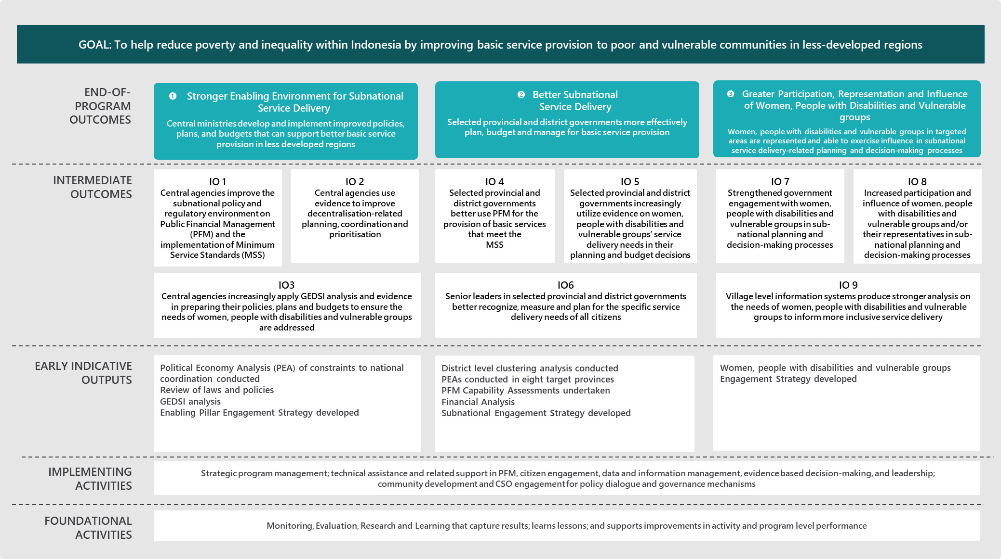

* 1. Goal and Objective

**Goal** To help reduce poverty and inequality within Indonesia by improving basic service provision to poor and vulnerable communities in less-developed regions

The goal of SKALA is to support the Government of Indonesia’s RPJMN 2020-24 objective to build a more ‘*independent, advanced, just, and prosperous Indonesian society*’ by accelerating development in less developed regions of the country. The uneven delivery of basic services, particularly to poor and vulnerable communities, is one of the key characteristics of regional disparity in Indonesia. In line with the approach taken in the Australia-Indonesia Partnership Towards an Inclusive Society (INKLUSI), SKALA defines ‘vulnerability’ broadly as ‘*individuals or groups that experience exclusion from full participation in social, economic or political life*.’[9] This definition enables the program to focus on the different types of vulnerable communities that exist in different parts of Indonesia. To progress the goal, SKALA will improve the efficiency and effectiveness of the decentralisation policies and practices that shape the provision of services to poor and vulnerable communities at the local level.

SKALA will not directly focus on strengthening the provision of services. Rather, the assumption is that other sector-based reform initiatives (including those supported by Australia and other development partners) will focus on strengthening front-line service providers, while SKALA focusses on strengthening the core governance planning and financing functions on which front-line service providers rely. This focus is based on DFAT’s experience that overall impact in previous governance programs (including KOMPAK) has been diluted by trying to address too many aspects of Indonesia’s complex decentralised service delivery system (ranging from central ministries, subnational government bodies, front-line serve delivery units and the end users in villages). However, SKALA could work with other DFAT sectoral programs to pilot approaches for strengthening the front-line service providers delivery of quality services to marginalised groups, for example in health/education.

**Objective To support the use of evidence-based policies, and improve systems to reduce poverty and inequality in Indonesia**

To achieve the program goal, SKALA will pursue one of the key objectives[10] under the Indonesia-Australia Comprehensive Strategic Partnership, Plan of Action (2020-2024), which is to support the adoption and use of evidence-based policies that can improve governance systems and reduce poverty and inequality in Indonesia. SKALA’s objective and goal will be progressed through three inter-related change pathways that provide the pillars of SKALA’s Program logic these include: improving inter-governmental planning and coordination, ensuring better sub-national governance for service delivery, and supporting the greater participation of women and vulnerable groups in sub-national planning and decision-making.

* 1. End of Program Outcomes

##### Pillar 1: Stronger Enabling Environment for Sub-National Service Delivery

**EOPO 1**Central ministries develop and implement improved policies, plans, and budgets that can support better basic service provision in less developed regions

The Government of Indonesia’s decentralised governance policies and processes create the enabling environment for the delivery of basic services at the subnational level. The responsibility for setting policies and processes over 542 subnational level government authorities (34 provinces; 415 districts and 93 municipalities) rests with a few central government ministries. SKALA will work closely (though not exclusively[11]) with the three main ministries in Indonesia’s decentralised governance structure:

* **MoHA:** responsible for subnational government administration (human resource, finance), delegation of authority and minimum service delivery standards (MSS). In relation to the MSS, the challenge is that MOHA is more focussed on subnational government’s compliance with these standards, than performance.
* **MoF:** responsible for fiscal decentralisation policy and fiscal transfer arrangements (funds disbursement, reporting), incentive/penalties. One of MoF’s main challenges is with the quality of data and analysis it relies on to target allocations toward beneficiaries, particularly vulnerable groups.
* **Bappenas:** responsible for setting national development priorities in alignment with subnational government priorities.

These ministries have complementary but closely interrelated roles in Indonesia’s decentralised governance structure. Coordination between them is a challenge, and at times has resulted in the development of inconsistent policies and regulations. Implementation at the subnational level is complex and subnational governments’ are not always incentivised to take responsibility for implementation.

SKALA will focus initially on establishing relationships with each ministry by helping them to address their own policy priorities and bottlenecks, such as supporting MoHA to take a more performance-oriented approach, and MoF improve the quality of its data and analysis. After building credibility with each Ministry, individually, SKALA will then look for opportunities to support them to coordinate and cooperate for the development and implementation of more harmonised policies and regulations. SKALA will identify specific problems which each Ministry has a stake in resolving, facilitate cross-Ministry discussions and provide technical analyses on potential policy solutions.

SKALA will continue to build on Australia’s existing close relationships with MoF and Bappenas, formed through KOMPAK and DFAT’s other programs, as well as significantly expanding the relationship with MoHA, which has not been a primary partner for DFAT in the past.

##### Pillar 2: Better sub-national governance for service delivery

**EOPO 2**Selected provincial and district governments more effectively plan, budget and manage for basic service provision

SKALA will focus on developing provincial/district governments’ PFM and government management capacity. Lack of capacity in these areas is recognised as a long-standing problem of Indonesia’s decentralised government system and has been worked on in successive phases of DFAT’s governance programming, including the KOMPAK program. While building on this past work is important, SKALA’s approach will be distinct from KOMPAK’s in that it will adopt a more concerted focus on subnational level PFM. Pillar 2 will be SKALA’s largest area of work and the cornerstone of this new initiative. This fills a gap in existing governance assistance to Indonesia provided through other development partners, which is primarily focussed on either national or village-level government but not the district and provincial levels. The critical assumption which underpins this EOPO, is that this ‘mid-level’ of subnational government is a key leverage point for improving Indonesia’s broader system of decentralised service delivery.

A further distinction from KOMPAK is the approach taken to support provincial and district governments. Whereas KOMPAK’s approach was ‘strategically opportunistic’, and responsive to needs as they emerged (e.g. supporting government budgeting for COVID-19 response and the new cash transfer program, BLT DD), SKALA will take a proactive and systematic approach focussed on embedding sustainable change. This approach will involve strategically selecting district governments to work with based on a political economy assessment of their interests and incentives for reform. The Program will take time to build relationships with senior leadership, up to and including the Bupati level[12], seeking to understand their management challenges and constraints while also building ownership.

Drawing on diagnostic analysis of the status of the government’s PFM and other subnational government management systems (undertaken in collaboration with and/or drawing on existing analysis supported by other development partners where relevant), SKALA will develop (in cooperation with senior subnational government leaders) a politically smart program of tailored capacity development support that seeks to improve capacity in key areas of PFM and management, and is linked with work to promote leadership (under IO6, see below). This will include how to improve coordination within and between district and provincial government. This will be of particular importance for Special Autonomy provinces with the passing of the revised law on Papua Otsus and potential revision of Aceh Otsus law. This analysis will provide a baseline against which progress will be assessed over the life of the program. As the performance of subnational government improves, the Program will build a base of evidence for how the national government could support similar improvement in other parts of the country.

##### Pillar 3: Greater participation, representation and influence of women and vulnerable groups

**EOPO 3:**Women, people with disabilities and vulnerable groups in targeted areas are represented and able to exercise influence in subnational service delivery-related planning and decision-making processes

Indonesia’s constitution recognises the rights of women, people with disabilities and vulnerable groups, and the national government has passed several progressive laws and policies promoting gender equality, and the inclusion of people with disabilities and vulnerable groups.[13] However, practical implementation of these laws and policies, particularly at the subnational level, has been limited. Many women, people with disabilities, and vulnerable groups are still unable to access services and/or services do not meet their needs. This problem reflects socio- cultural norms and traditions relating to the role of women, people with disabilities and vulnerable groups in society.

SKALA can have a tangible impact on service delivery to women, people with disabilities and vulnerable groups through complementary interventions that seek to strengthen provincial/district governments’ implementation of formal laws and policies, while challenging the informal socio-cultural norms that constrain their implementation. SKALA’s approach will build on KOMPAK’s ‘twin-track’ approach. One track will be to work with the grain of Indonesia’s existing laws and policies for mainstreaming GEDSI issues into government processes and plans. The other track will provide support and create opportunities for increasing the participation, representation and influence of women, people with disabilities and vulnerable groups in government planning and policy processes. The critical factor for success is to design interventions where these twin-tracks are complementary and mutually reinforcing.

* 1. Intermediate Outcomes

##### Pillar 1: Stronger Enabling Environment for Sub-National Service Delivery

**IO 1:**Central agencies improve the subnational policy and regulatory environment on Public Financial Management (PFM) and the implementation of Minimum Service Standards (MSS).

To improve subnational level service delivery, the overarching policy and regulatory environment needs to be improved, particularly as it relates to PFM and the implementation of the MSS. This IO rests on the assumption that the development of numerous, often unclear, regulations and policies, particularly related to PFM, causes confusion at the subnational government level. This confusion often leads to financial underspends due to fear of adhering to the wrong regulation or policies. As a result, scarce financial resources which could be allocated to basic service provision may not be disbursed (See Section 2.2, Problem Analysis). Too often the assumption from central ministries is that the issuance of a new regulation or ordinance is sufficient, without fully assessing its impact and the implementation challenges at the subnational level. Similarly, there is a need to further develop a joint understanding regarding MSS where success is not in achieving MSS but in exceeding these standards in response to local service delivery conditions and contexts. This IO will focus on improving both the clarity and expectations around both PFM, and the implementation of the MSS. The primary counterpart agencies SKALA will work with to further achievement in these areas is MOHA and MOF.

**IO 2:**Central agencies use evidence to improve decentralisation-related planning, coordination, and prioritisation

Many challenges faced by subnational governments stem from inconsistencies and/or overlapping regulations and instructions from central government agencies (MoHA, MoF, Bappenas and line ministries). Work in this IO will move beyond anecdotal examples to present evidence on the detrimental effect and costs to Indonesia caused by poor coordination, including fragmentation of information flows amongst central agencies.

SKALA has an opportunity to work with central ministries to support the implementation of several new national policies that require coordination across government including:

* New law on fiscal balance covering new formulas in performance-based fiscal transfers of general funds (DAU, Revenue Sharing arrangements and village funds) (issued in 2022)
* Revised law on Papua region special autonomy (issued in 2021)
* New/revised law on Aceh special autonomy (anticipated to be revised in 2024-25)
* Alignment of priorities in the current RPJMN and the next RPJMN 2025-2030.

In addition to improving coordination amongst central agencies, there is also a need to improve subnational level planning.

**IO 3:**Central agencies increasingly apply GEDSI analysis and evidence in preparing their policies, plans and budgets to ensure the needs of women, people with disabilities and vulnerable groups are addressed

To improve subnational service delivery for all citizens, central agencies’ policy development, planning and budgeting must meet the needs of all citizens. To achieve this, central agencies need better understanding and analysis of the specific needs of citizens that are currently under-served, especially women and vulnerable communities.

Indonesia’s formal laws and regulations recognise the importance of addressing the specific needs of under-served citizens. On issues of gender equality, for example, all ministries are required to complete a gender analysis when developing their annual workplans and budgets. The problem is that the ministries set up to drive inclusion are under-resourced and structurally weak:

* Ministry of Women’s Empowerment and Child Protection (MoWECP) is responsible for driving gender equality but is not a ‘coordinating ministry’ and has no formal authority over other government agencies (including the powerful ministries of MoHA, MoF and Bappenas)
* Ministry of Social Affairs (MoSA) is responsible for driving poverty reduction and the inclusion of vulnerable groups (including people with disabilities) but is also not a coordinating ministry, and has also been mired in controversy in recent years.

In a recent World Bank report, only 26 per cent of ministries (23 out of 87 ministries) were found to have developed gender analyses as a part of budget preparations; and when done, such analysis did not specifically address gender equality.[14]

However, there are opportunities for progressing gender equality and broader social inclusion issues that SKALA can build on. MoHA’s role advising the President and the national parliament accords the ministry credibility and influence with the rest of government, and MoSA’s work on disability inclusion is generally not politically contentious, although stigma towards people with disabilities in Indonesian society remains a challenge.

One opportunity is presented by the Joint Circular on gender-responsive budgeting issued by MoWECP, Bappenas, MOHA, and MoF in 2012 (under the National Strategy on Accelerating Gender Mainstreaming). SKALA could work with, and build on, Prospera’s current work supporting MoF’s implementation of this circular at the national level. Another opportunity is presented by Bappenas’ recent development of a national strategy on disability inclusion as part of the implementation of the *People with Disability Law 2016.*

Work under this IO will be undertaken in close collaboration with other Australian investments, particularly INKLUSI – which will be working with the same central agency partners on similar issues – and ABIP, under which Australia is funding a significant body of work gender equality and women’s empowerment. In relation to disability inclusion, SKALA will work closely with INKLUSI, and in doing so will also build on the KOMPAK work, including continuing KOMPAK’s collaboration with AIPJ2, MAHKOTA and PROSPERA.

##### Pillar 2: Better sub-national governance for service delivery

**IO 4:**Selected provincial and district governments better use PFM for the provision of basic services that meet the MSS

Under current national financing provisions, district governments have extremely limited fiscal space for funding service delivery (salary costs consume most of the funding). However, districts are also not maximising the financing that is available, and weak planning, budgeting and performance monitoring constrains basic service delivery performance.[15] SKALA will build on KOMPAK’s PFM work to proactively and systematically support subnational governments to address key problems in the planning, budgeting, and management of service delivery. SKALA will also go beyond KOMPAK’s work and collaborate with PROSPERA, and other relevant programs and partners, such as the World Bank, to explore potential support for provincial/district governments to improve their revenue generation.

SKALA will develop activities specific to each district based on the diagnostic analysis mentioned under EOPO2. However, these activities are likely to include support for provincial and districts government to:

* coordinate with key government units under the leadership of Sekretaris Daerah (Sekda) to identify priorities for plans and budgets, including Bappeda, BPKA (the district financial management office) and technical units (dinas sosial for poverty reduction, dinas education, dinas health, dinas for GESI, and dinas for village governance)
* integrate MSS standards into their annual plans and budgets to address service delivery priorities, with clear outcomes for measuring performance, building on KOMPAK’s successful pilots promoting the integration of MSS into planning[16]
* access and use central government funding (DAK fisik and non-fisik, and DID) to support service delivery, including partnerships between local governments and non-government actors, where appropriate, also building on KOMPAK’s successful work at the central level (MoF) and the subnational level and the work of KSI in supporting reforms to Indonesia’s government procurement regulations
* apply cross-sectoral program-based budgeting in alignment with national policies (set by Bappenas and MoF). This budgeting could be based on MSS budget ‘tagging’, whereby budget allocations in targeted service delivery areas are aligned across district technical offices; and lead to improved coordination among these offices and more effective reporting on the specific program (i.e. for climate change, stunting, etc)
* better monitoring budget implementation for specific outcomes across programs, including the Otsus fund in Special Autonomy provinces.

This IO assumes that the political dividends for district and provincial governments to improve their PFM for better service delivery are sufficient incentive for them to reform and improve their systems and capacity; that this incentive will continue should there be changes in subnational government at the Pilkada elections; that there are sufficient interests and incentives among both government and non-government actors to explore opportunities to enter into partnerships for improved basic service delivery; and the SKALA team will be able to develop trusting relationships where subnational governments recognise the value SKALA can bring.

**IO 5:**Selected provincial and district governments increasingly utilise evidence on women, people with disabilities and vulnerable communities’ service delivery needs in their planning and budget decisions

The better use of evidence at the subnational level is essential if service delivery is to meet the needs of all citizens, including women and vulnerable groups. In the last several years GoI has made several major policy commitments to developing the government’s knowledge base across all areas of Indonesian society and it has invested in the development of several ambitious, multi-dimensional databases. DFAT has assisted Indonesia develop databases in selected sectors, including under KOMPAK, and it has supported the development of Indonesia’s overall knowledge ecosystem.

The primary focus of this IO is to support provincial and district governments to make better use of the available data and evidence in their decision-making and planning. Three challenges include:

* constricted flow of information—each ministry has their own source of data and the sharing of information is limited
* limited capacity to analyse the available data to inform planning
* gaps and quality issues in the data, particularly in relation to women and vulnerable groups.

IO5 will primarily focus on the first and second of the above challenges and roll out KOMPAK’s successful pilots to SKALA’s target provincial and district governments. SKALA will support them to utilise SEPAKAT, social economy registry data, budget constraint analysis, and proven tools on multidimensional poverty analysis (engaging with the *Tim Koordinasi Penanggulangan Kemiskinan*/Poverty Reduction Coordination Team). They will also identify any limitations in the data that constrain service delivery planning for women and vulnerable groups (these will be addressed under IO9). There may be opportunities to collaborate with other Australian development programs supporting the generation of relevant evidence, data and analysis, including under INKLUSI, AIPJ2, MAHKOTA, ABIP and, over time, the forthcoming Australia Indonesia Knowledge Partnerships Platform.

This IO assumes that provincial and district governments will have adequate incentive to make more evidence-based decisions in relation to vulnerable groups, based on ‘top-down’ pressure from the central ministries and national government policy combined with ‘bottom-up’ pressure from the increased participation and representation of vulnerable groups in decision-making forums (which is the focus of pillar 3).

**IO6:** Senior leaders in selected provincial and district governments better recognise, measure and plan for the specific service delivery needs of all citizens

IO6 recognises that subnational governance reforms leading to more inclusive service delivery (as outlined under IO4 and 5) will only be successful if they are owned and driven by senior provincial and district government leaders, such as Heads of Districts, the DPRD, Sekda, Bappeda and targeted technical offices.

SKALA will foster close relationships with these leaders and build their support and ownership over the reforms. SKALA will also develop specific activities to foster leadership abilities, including to[17]:

* facilitate collaboration and shared responsibility between competing entities
* think strategically about, and develop plans to overcome, the institutional and societal barriers to implementation of reforms to promote more inclusive service delivery
* maintain commitment and conviction to reforms
* build constructive relationships with higher levels of government, relevant non-government actors and vulnerable community groups
* openness to learn from others with expertise.

In pursuing this IO, SKALA will proactively look for opportunities to collaborate with other Australian development programs and partners, particularly to foster stronger relationships and networks among relevant actors at national, subnational and community level, particularly under INKLUSI, AIPJ2, ABIP and, potentially, among Australia Awards Indonesia alumni.

##### Pillar 3: Greater participation and representation of women, people with disabilities and vulnerable groups

Pillars 1 and 2 are focussed on strengthening the enabling environment for better service provision and the implementation of core decentralisation policies and plans, at national and subnational levels, for improving the delivery of basic services to all Indonesian citizens inclusive of women, people with disabilities and vulnerable groups. Pillar 3 is focussed on the processes for empowering citizens to participate in policy development and planning to ensure their needs and interests are properly represented and addressed. Meaningful citizen participation in these processes creates mutual responsibility and accountability between government and citizens and builds the incentive for improving services.

Indonesia has several good laws and policies in place to facilitate general citizen participation, with specific laws for the participation of women. [18] The challenge is that these laws are often not implemented in a meaningful way and women, people with disabilities, and vulnerable groups are regularly excluded from services. Formal laws and regulations supporting the participation of people with disabilities are less well-developed, particularly at the subnational level.

Pillar 3 will complement the work of DFAT’s INKLUSI program. Both interventions aim to foster constructive engagement between government and citizen groups, particularly marginalised groups, to achieve more inclusive development outcomes. However, the starting points are different, reflecting each interventions specific program logic and respective areas of expertise. INKLUSI starts from the vantage point of civil society, and brings deep expertise in citizen empowerment and action, particularly of marginalised groups. SKALA will bring technical expertise in core government planning and budgeting process, and, in terms of behaviour change, is primarily focussed on influencing government officials to implement meaningful citizen engagement processes. While more inclusive subnational government planning processes are one of many anticipated themes to be addressed under INKLUSI, this will be SKALA’s primary focus. Working to each intervention’s comparative strengths, SKALA and INKLUSI will work closely together to support more effective citizen engagement in subnational processes.

**IO 7:**Strengthened government engagement with women, people with disabilities and vulnerable groups in sub-national planning and decision-making processes

Each of SKALA’s three main central ministry counterparts (MoHA, MoF, and Bappenas) have set laws and regulations mandating citizen participation in planning and budgeting processes. SKALA will support provincial and district governments to operationalise these laws, by scaling up the successful pilots implemented by KOMPAK, mainly at the village-level, such as the ‘inclusive musrembang’ (village development forums), drawing also on relevant initiatives and documented learning from Australia’s previous gender equality and women’s empowerment program, MAMPU, and previous social inclusion program, PEDULI. SKALA will look for opportunities to support subnational governments to apply gender responsive planning and budgeting, which is prioritised in Indonesia’s current medium-term development plan (RPJMN 2020-2024) as well as specifically mandated by central ministry regulations.[19]

Provincial and district government’s limited use of participatory processes reflects their: a) limited experience and capacity in these processes; as well as b) lack of pressure on them to implement these processes from central government, elected subnational parliaments or from non-state actors and communities themselves. Entrenched, discriminatory gender and social norms are part of the reason these processes are not prioritised. To improve their implementation requires changing these attitudes, which is a long-term process. In the short-to-medium term, SKALA can seek to change government incentives by helping relevant actors to understand how participatory processes can benefit them, by enabling them to improve their service delivery performance.

**IO 8:**Increased participation and influence of women, people with disabilities and vulnerable groups and/or their representatives in subnational planning and decision-making processes

Participation in planning and decision-making processes, such as the inclusive musrenbang forums is meaningful when citizens can be ‘actively involved’ and exert influence. For women, people with disabilities and vulnerable groups, meaningful participation is when they exercise their agency, and voice their needs to decision-makers. To be able to participate fully, women, people with disabilities and vulnerable people need to have knowledge about these processes, how to engage in them, and the interest and capacity to participate. It may not be realistic for these groups to participate, as they lack education or confidence, and social power asymmetries militate against their engagement. In such cases, CSOs may operate as effective intermediaries, however, there is also a risk – given challenges relating to CSO capabilities and other political-economy dynamics - that such organisations may not represent the voices of those for whom they advocate.

To complement the work with government authorities under IO7, SKALA will work with INKLUSI to empower inclusive citizen groups to engage in these processes. The theory is that IO8 can maximise the potential success of these processes by leveraging the trust developed with government authorities and the trust INKLUSI has developed with civil society actors, including women-led organisations and organisations for people with disabilities. The focus of IO8 is on facilitating participatory processes to happen rather than capacity building of citizen groups to engage in them, which is the role of INKLUSI (and other relevant development partners and programs). However, SKALA could support INKLUSI by providing specific information on how government planning and budgeting processes work.

**IO9:**Village level information systems produce stronger analysis on the needs of women, people with disabilities and vulnerable groups to inform more inclusive service delivery

KOMPAK enjoyed significant success supporting the implementation of MoHA’s recent policy for all villages to set-up and maintain a functioning information system (*Sistem Informasi Desa*/SID and SEPAKAT DESA) to provide accurate data, including on women, people with disabilities and vulnerable groups, for planning and budgeting of target services. However, challenges remain. The quality of data is uneven (particularly for people with disabilities), partly because of the use of different data collection methodologies. Data interpretation and analysis is partial and inconsistent. Limited connectivity between SID and Indonesia’s multiple other information systems creates confusion and the risk of duplication.

The purpose of IO9 is to strengthen the rigour of data collection and analysis by supporting provincial and district government to develop clear systems and processes for how villages should maintain their information systems. SKALA’s work in IO6 to support provincial and district government’s better use this information will create a demand and incentive for IO9. Work under this IO will also strengthen data and evidence around the needs of women, people with disabilities and vulnerable groups and strengthen subnational policy development, planning and budgeting at the national level (see IO3).

* 1. Delivery approach

##### Overall Approach

SKALA will be delivered through a ‘flexible program approach.This approach will be based on the recent convergence of thinking in international development on how best to achieve sustainable outcomes by better engaging with the realities on the ground, understanding the perspectives of those at ‘the margins’, identifying problems, and focussing on tangible outcomes. Some of the main strands in this current thinking are identified in the box below (although this IDD has tried to avoid the jargon often associated with these approaches).

****Box 1: Relevant international development approaches**:**

* **‘Governance from below’ (UK Institute of Development Studies, November 2021) [20]**
* **‘Highly responsive, politically informed, iterative, searching models of assistance (The Asia Foundation, 2012-2019) [21]**
* **‘Developmental leadership’ (DFAT, 2008-17) [22]**
* **‘Governance for development’ (World Bank, 2017)[23]**
* **‘Doing development differently’ (Overseas Development Institute, 2015) [24]**
* **‘Politically smart, locally-led development’ (Policy Practice, 2014) [25]**
* **‘Thinking and working politically’ (UKAid, 2013) [26]**
* **‘Problem-driven iterative adaptation’ (PDIA, Harvard, 2012). [27]**

SKALA will be primarily delivered through a diverse team of technical and development professionals, based at national and subnational levels, that together can provide technical assistance to government and other implementing partners as well as facilitate collaboration across multiple stakeholders to solve shared problems. This core delivery modality will be complemented by relatively small, targeted and flexible funding mechanisms.

To manage delivery, the SKALA Investment Concept Note confirmed engagement of an MC as the preferred option. DFAT will conduct an open procurement process to select the MC. The MC implementation team is expected to mainly consist of Indonesian professionals, as they will be best placed to understand and manage the sensitivities related to Indonesia’s decentralised governance system, although international professionals with in-depth local knowledge may also be effective.

##### Phased Delivery

The Program will be implemented in two phases of four years each. Transition from the first phase to the second will be subject to adequate progress against end-of-program outcomes, as assessed by independent review. Given the ongoing challenges of COVID-19 and the ambitions and complexity of this eight-year investment, SKALA includes an extended inception period of nine months duration.

##### Inception Phase Deliverables

The Program will be set up in the Inception Stage through completion of the following key deliverables:

1. ****Context analysis and District targeting strategy**** SKALA is expected to work in eight provinces and up to 32 districts (an average of four districts per province). The Program will continue working in the three **Special** Autonomy Provinces supported by KOMPAK—Aceh, Papua, and Papua Barat. It is proposed that SKALA will also work in the following five provinces —Nusa Tenggara Timur, Sulawesi Barat, Kalimantan Barat, Maluku Utara, and Nusa Tenggara Barat—only one of which is a current KOMPAK province (Nusa Tenggara Barat). Together these eight provinces are Indonesia’s most disadvantaged, as assessed against the Human Development Index (HDI) and poverty rates (see assessment methodology in Annex 1). Most of these provinces do not have other major decentralised governance development programs currently operating, with the exception of Nusa Tenggara Timur and Kalimantan Barat, which are provinces under the USAID program, ERAT and Papua and Papua Barat, which are provinces under USAID program, KOLABORASI.

SKALA will have the flexibility to both expand work to additional provinces and stop working in targeted provinces, as required to maximise achievement of end of program outcomes. In the Inception period, the MC will develop criteria for assessment of progress in each province, with clear triggers for continuing and stopping program engagement in particular locations.

To determine district locations, the MC will conduct an initial (desk-based) technical assessment of all the districts in these eight provinces. The assessment will examine each district’s:

* performance in providing services and promoting development outcomes, and
* The nature of any development assistance currently being provided by DFAT or another development partner in that district location.

From this assessment, districts will be short-listed for a more in-depth context analysis. The context analysis will consider the potential for achieving change in each district by examining the political economy drivers shaping:

* Vertical relationships between the central, provincial, and district government; horizontal relationships (e.g. between district governments and service providers); and relationships with Australian and other development partner programs
* Status of subnational public financial management and the planning, budgeting and management of service delivery
* GEDSI and citizen engagement in government decision-making process, particularly of women and vulnerable groups.

Based on both the technical and political context assessments, the final district locations will be confirmed in consultation with key Government of Indonesia partners.

1. ****Pillar Engagement strategies:** Once locations are decided, the MC will develop strategies for engaging with and achieving results under each of the Program’s three pillars. Under these strategies detailed activities will be designed based on the context analysis that responds to partner priorities (as they align with SKALA’s outcomes) and maximise synergies between SKALA and other DFAT programs/partners focusing on similar issues (the strategies will include an annex which maps the intersections between SKALA and other DFAT programs/partners on shared issues). The strategies will be on**:****

* Pillar 1: Enabling environment engagement strategy: one strategy to cover work with all central ministries at the national level, including GEDSI issues
* Pillar 2: Subnational engagement strategies: eight strategies to cover work with partner in each of SKALA’s eight subnational locations (province and district)
* Pillar 3: GEDSI and Citizen engagement strategies: eight strategies to cover work with partners in each of SKALA’s subnational locations (province and district). These strategies will set the GEDSI related actions for the subnational locations in line with the SKALA’s twin-track approach, as well the plan for citizen engagement work.

**During the Inception Stage, the MC will develop activity design and selection criteria.** These criteria will ensure the relevance and quality of activities developed across the Program. Indicative criteria are presented below:

Table 1 Activity Decision Making Criteria

| Criteria | Details |
| --- | --- |
| 1. Problem analysis | Analysis of technical and political aspects of the specific governance problem/ bottleneck to be addressed. Alignment with Indonesian partner’s organisational and leadership priorities. Potential to build on reforms supported by KOMPAK and build links with multiple stakeholders |
| 1. Program coherence | Alignment with specific IOs in the SKALA program logic and complementarity/synergies with other planned SKALA activities and/or DFAT/other development partner activities |
| 1. Results and risks | Anticipated results and potential pathway for increasing impact at scale, weighed against the risks (e.g. risk of not achieving results, reputational risks, execution risks etc) |
| 1. GEDSI | Potential to progress SKALA’s GEDSI ambitions and proposed approach (mainstreaming and/or targeted) |

1. ****SKALA Implementation Strategy and** Multi-year **Work-plan—July 2023 to June 2026** (three years):** The Implementation Strategy will provide the overarching approach for how the MC will deliver SKALA’s EOPOs and ensure collaboration across pillars to achieve them. The document will provide a high-level summary of the context analysis and the objectives of all pillar engagement strategies. The document will also provide details on the MC’s program management arrangements, human resource management, safety and security, risk and financial management, safeguarding processes etc, and /or provide references to other documents with this information. The work plan will aggregate the activities from across the strategies, with a multi-year budget and performance targets expected to be achieved each year (these targets can be reviewed and revised in each annual plan).
2. Implementation Arrangements
   1. Overall management and governance structure

The primary objectives of SKALA’s governance and management structure are twofold:

* Provide clears line of responsibility and accountability for program design-making, implementation, and risk management.
* Promote constructive program engagement with key Indonesian partners to enable Indonesian leadership over SKALA’s activities and build multi-stakeholder communication and collaboration to effectively implement activities.

SKALA’s program governance structure is represented in Figure 2 explained below.

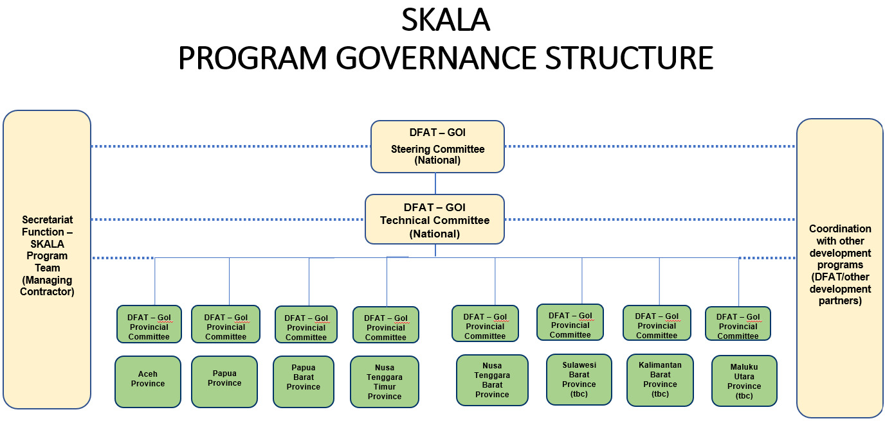Figure 2 SKALA governance structure

* 1. Program governance

The Program has governance bodies at the overall program and central/national level as well as at each subnational location.

##### Overall Program and National level

There are two governance bodies at the overall Program and national level, a Steering and a Technical Committee:

1. **Steering Committee (SC):** The Program’s highest-level governance body with ultimate responsibility for setting and overseeing the Program’s overarching strategic direction, performance, and risk management. The SC will approve key documents endorsed by the Technical Committee, including strategic documents, annual plans, and progress and financial reports. The SC also provides a forum for discussion and endorsement of SKALA’s support to government policy development.

It is proposed that the Steering Committee will be co-chaired by Deputy Head of Mission (DHOM), Australian Embassy for Indonesia and the MoHA Secretary General or Director General (with possible alternate and/or rotating co-chairs from Bappenas and/or MoF to be confirmed by GoI in the Inception Period). The Committee members will be the MoHA Director-Generals for Regional Autonomy, Fiscal Autonomy, and Regional Development; the MoF Director-General for Fiscal Balance; and a senior Bappenas representative to be confirmed by GoI in the Inception Period. From among these members, the GoI will nominate female representatives and/or gender equality, disability, and social inclusion (GEDSI) champions.

DFAT’s Minister Counsellor Governance and Human Development (GHD), Counsellor Human Development, Unit Manager Decentralised Governance, and the SKALA Team Leader will attend SC meetings to report progress and answer questions, and the SKALA Program Management Team (Managing Contractor) will provide Secretariat functions. Other stakeholders may be invited to attend SC meetings as observers (such as representatives from other DFAT programs, CSOs, research organisations and other sub-national level partners). The SC will meet 6-monthly. The constitution of the SC will be discussed and confirmed in the first meeting.

1. **Technical Committee (TC).** This committee is responsible for overall Program delivery and national level program activities, as well as driving operational coordination between national and subnational government partners and other development programs. The committee will technically review and endorse the following documents prepared by the national Program Management Team before they are submitted to the Steering Committee for final approval:
   * Key Program strategic documents (SKALA’s implementation strategy and three-year subnational work plans)
   * Program annual work plans and reports
   * Program BAST (Hand-over Notes required by the Indonesian Government on a semester basis).

In support of overall Program delivery, the TC will promote coordination between SKALA’s national and subnational activities as well as help to realise synergies with other programs/partners. In particular, the TC will play an important role in supporting visibility and collaboration across development programs in two areas: public financial management (PFM)and gender equality, disability, and social inclusion (GEDSI). The PFM focus will follow the successful approach developed between KOMPAK and PROSPERA in working together to support HKPD reforms.[28] The GEDSI focus will include close engagement with INKLUSI particularly on pillar 3. Other development programs/partners will be invited to attend TC meetings as appropriate (including CSOs, research organisations and other sub-national level partners).

The composition of the TC will mirror the SC in terms of ministries and representation of women and people with disabilities, but also includes officials at more operational levels along with representatives from partner subnational governments. The Technical Committee will be co-chaired by the DFAT Counsellor, Human Development, and the MoHA Director for International Cooperation (with possible alternate and/or rotating co-chairs from Bappenas and/or MoF to be confirmed by GoI in the Inception Period). The members will consist of GoI officials from SKALA’s national and provincial government partners. These officials will have management and operations roles within their organisations and will be directly engaged in SKALA’s implementation. The national government officials will consist of the directors from MoHA’s Regional Autonomy, Fiscal Autonomy, and Regional Development Directorates; MoF’s Fiscal Balance Directorate; and the relevant Bappenas directorates or as assigned by Bappenas. The provincial government officials will be determined in the Inception Period in consultation with GoI. From among these members, the GoI will nominate female representatives and/or GEDSI champions. The SKALA Team Leader will attend committee meetings to report on progress and answer questions, and the SKALA PMT will provide Secretariat functions.

The TC will meet six-monthly. The constitution of the TC will be discussed and confirmed in the first meeting.

##### Subnational level

**Provincial Committees in each of SKALA’s eight provinces are responsible for planning, coordination, and monitoring of program delivery in that location (at province and district level).** The Provincial Committees will review and endorse subnational strategy documents work-plans and reports, as prepared by the Provincial PMT with government counterparts. They will be the primary mechanism for facilitating horizontal collaboration (between districts) and vertical collaboration (between district, provincial and national governments).

The Provincial Committee will be co-chaired by a representative of DFAT’s Decentralised Governance Unit and the Provincial Secretary or Head of Provincial Planning Agency. The members will be representatives of relevant Provincial government agencies and district governments. The lead of the Provincial PMT will attend to report progress and participate in discussion. The Provincial PMT will also provide Secretariat functions for meetings. The Provincial Committee will meet quarterly, and the constitution of the committee will be discussed and confirmed in the first meeting.

* 1. Program management

The key SKALA management bodies at each level are:

##### Program and national level

****DFAT’s Decentralised Governance Unit, GHD, Australian Embassy in Jakarta.**** The DFAT **Decentralised Governance Unit in GHD is responsible for day-to-day review of the (national level) PMT’s management of program delivery and risks, in line with the strategic direction and** priorities set by the Steering and Technical Committees and the MC’s contract for delivery. This includes reviewing and approving operational and risk processes, and key program documents (multi-year implementation strategy, annual work plans and reports). DFAT will also regularly engage with government partners through formal governance bodies (see section E.2) and other the program processes set up to facilitate learning and collaboration (see section F). DFAT will meet the Central SKALA PMT at least monthly, more frequently during the Inception Phase. The DFAT Decentralised Governance Unit will perform this role from with its current human resources.

****Contractor Representative, Managing Contractor.**** DFAT will engage a MC to manage SKALA’s implementation and related risks, including through PMT roles at central and subnational levels. The Contractor Representative is ultimately responsible and accountable to DFAT for the delivery of SKALA in accordance with the contract and compliance with DFAT’s mandatory policies (e.g. Preventing Sexual Exploitation, Abuse and Harassment; child protection; fraud control etc). The Contractor Representative will performance manage the SKALA Team Leader and overall PMT.

****Central Program Management Team.**** The MC will appoint professionals to form the Central PMT and will set up a program office close to the Australian Embassy in Jakarta. The Central PMT will include professionals identified by DFAT to be novated across from the KOMPAK program into SKALA, and newly recruited professionals, who will be endorsed by DFAT.

The Central PMT will be a diverse in-house team of management and technical professionals with experience in Indonesia’s decentralised government system including positions in: team leadership, MERL, operations and financial management, GEDSI, public financial management, policy development, data analysis, development planning and budgeting, and citizen participation. The Central PMT will also have the capacity to recruit short-term specialist technical advisors from national[29] and international consulting markets. However, SKALA will not provide long-term technical assistance positions that are embedded within government partner agencies, which risk being perceived as replacing government officials’ functions.

The Central PMT is responsible for the implementation of national-level activities and the overall program in line with the strategic direction and priorities set by the SC and TC. Reporting to DFAT, the key responsibilities of the Central PMT are to develop and implement the:

* multi-year program strategy and work plan (and all inception phase deliverables in section E.4)
* annual program work plans and six-monthly reports
* cross-cutting processes in: MERL and related learning and collaboration processes (see section F); GEDSI (see section G); thinking and working politically approaches; and communications
* financial management, grants and procurement processes
* safeguarding, risk management and fraud control procedures in compliance with DFAT policies, including process for reporting fraud risks to DFAT and communicating to other stakeholders (see Section J).
* human resource management processes
* secretariat function for SC and TC.

The Central PMT will also performance manage the Provincial PMTs and promote learning and collaboration across all program levels to ensure the overall program is ‘greater than the sum of its parts.’

There is no mandatory team structure for the Central and Provincial PMTs. Rather, as part of the MC procurement process, DFAT will invite potential MCs to propose the most efficient and effective team structure with the necessary skills and experience for delivering on SKALA’s end of program outcomes.

##### Subnational level

****Provincial Program Management Teams (P-PMTs).**** The function of the P-PMTs is to design and deliver activities to meet province and district partner priorities in line with SKALA’s objectives. The P-PMT’s will work closely with the Central PMT to broker coordination and collaboration between stakeholders at each of these levels. They will also facilitate learning and collaboration activities across districts within the province to increase scale of impact at the subnational level. They will develop close working relationships with Indonesian partners, and provide secretariat functions to Provincial SCs.

The MC will recruit a core team of professionals for each province to conduct the initial scoping and activity design. This will include some candidates identified by DFAT from the current KOMPAK program that are to be novated across to SKALA. DFAT will approve all candidates. Through the activity design process, the composition of the full P-PMT will be confirmed. However, key positions will be required in: Team leadership, MERL, GEDSI, PFM, citizen participation, data analysis/policy development, and financial and operational management.

* 1. Phased delivery cycle

SKALA is to be implemented over eight years, divided into two phases of four years each. The Program is designed to achieve EOPOs at the end of the eight-year period. Continuation of the Program from Phase I to Phase II will be contingent on adequate progress toward EOPOs as determined by an independent Mid-Term Review to be commissioned by DFAT in financial year 2024/25.

Subject to procurement of the MC, SKALA is scheduled to start in October 2022 and finish in June 2030. Indicative dates are:

* Phase I: October 2022 to June 2026
* Phase II: July 2026 to June 2030.
  1. Policy Dialogue

Policy dialogue is central to the SKALA Program. Most of the Program’s policy dialogue will be with the three central ministries (MoHA, MoF and Bappenas) for the purposes of strengthen the enabling environment for subnational service delivery (Pillar 1). SKALA will seek to influence the policies of each of these three ministries, and most critically, facilitate dialogue between these ministries to promote increased policy coherence and effectiveness.

At the subnational level, most of SKALAs policy dialogue work will be focussed on promoting increased coordination between the different levels of government and increased engagement of women and vulnerable groups, and their representatives, in Indonesia’s policy processes.

Engagement with the three central ministries will be required to progress persistent policy challenges such as:

* Budget allocations to districts not based on analysis and evidence of need or district government performance, leading to horizontal imbalances in funding
* Plans and policies not based on the available data and evidence of the needs of women and vulnerable groups and, hence, not meeting those needs
* Multiple, unclear PFM policies and regulations causing confusion at the subnational government level resulting in limited implementation.
  1. Profile and Public Diplomacy

SKALA will build on Australia’s strong reputation for supporting Indonesia decentralised government reforms, and promote DFAT’s public profile and diplomacy priorities. Through SKALA’s production of strategic communication materials, the Australian Government will be able to demonstrate and effectively communicate how the investment contributes to both Indonesia’s immediate recovery for COVID-19 and longer-term development as a prosperous, inclusive and stable country within the Indo-Pacific region. A variety of media and methods will be used including social and traditional media, articles and think pieces, and engaging with key influencers and groups.

The Managing Contractor will be responsible for the development and implementation of a comprehensive communications strategy, which includes the production of materials for DFAT public diplomacy priorities. The strategy will outline public diplomacy and communication objectives and provide a detailed plan for how these objectives will be achieved. The Managing Contractor will be required to work in close collaboration with DFAT to develop the strategy and support its delivery.

Branding and its utilisation will be targeted and selective, mindful of the fact that SKALA is focused on supporting GoI ownership and leadership, inclusive partnerships, and making a contribution to development outcomes. In publicly promoting SKALA, it will be important that improvements in public administration, PFM, inclusive policy making, service delivery, etc are focused on tangible impacts for program beneficiaries, and credited to the GoI and the partnership.

* 1. Sustainability

SKALA will embed internationally agreed development effectiveness principles into the way it will operate, including a focus on supporting GoI ownership and leadership, inclusive partnerships, a results-focus and institutional capacity building. SKALA will implement initiatives through government systems, while strengthening those systems. Strengthening subnational government PFM and other systems in a key focus of the program and will be done in a way that takes into consideration the institutional capability and absorptive capacity of counterpart agencies.

SKALA is designed to influence policy and budget reforms to ensure financial resources are more effectively and efficiently allocated by the GoI and used by subnational governments. Doing this will increase fiscal sustainability, which is important considering the pressures on government budgets due to the COVID-19 pandemic. SKALA’s emphasis on supporting GEDSI objectives also supports the sustainability of results, given that inequality and exclusion undermine social and political stability, and marginalises a large proportion of society from maximising their productive contribution to social and economic development.

In order to ensure sustainability issues are considered from the outset, the MC will be required to develop a Sustainability Plan during the inception phase, this will explain how its Engagement Strategies and various other plans and strategies work together to maximise the sustainability of SKALA’s results. This Plan will be informed by the various risks identified in this design and there will be a strong link between the Sustainability Plan and SKALA’s M&E Plan. To assess progress toward sustainability, the Program could consider conducting a study at the beginning of the second phase which assesses and compares changes in SKALA supported locations and changes in non-SKALA supported locations.

SKALA will also seek to foster localisation, as this assists in addressing a range of sustainability issues and is prudent considering the ongoing threat from COVID-19. This will include the use of local (i.e. Indonesian) technical advisers in senior key technical positions; the building of local staff capacity in key technical areas; and through the use of local consulting firms and suppliers. The intention should be to use local people to deliver local technical advice and services where possible – something that will be particularly important in a decentralised program such as SKALA. The MC will be expected to develop a Localisation Strategy during the Inception Phase that outlines its approach in this area.

1. Monitoring and Evaluation
   1. MERL Approach

The dual purpose of SKALA’s Monitoring Evaluation Research and Learning (MERL) approach is to facilitate organisational learning through the development and sharing of evidence and analysis to inform decision-making and program direction, while also serving the accountability needs of both governments, including by generating information relevant for DFAT’s Investment Monitoring Reporting. Information generated by the MERL system and through applied Political Economy Analysis, will be used to explain and contextualise progress towards the EOPOs, and assess the efficacy of the delivery approach and the various engagement strategies. The MERL system will generate data and information that can be used to clearly explain how well SKALA is progressing and whether such progress can be considered reasonable within the prevailing context. While the MC is only accountable for progress toward agreed EOPOs, the MERL system will also collect information on how SKALA is *contributing* toward service delivery-related changes at the goal level, as this is critical for assessing the veracity of the program logic.

The MERL Plan will explain SKALA’s systems and will be developed by the end of the inception period. This Plan will explain how the MERL system will function, including outlining MERL processes and activities at various levels in accordance with DFAT’s M&E Standards.

The MERL Plan will include:

* Guiding Principles and Key Approaches (including a focus on working with and through GoI systems at various levels and building local M&E capacity)
* Re-Validation/Updating of the SKALA Program Logic (validated/updated through a participatory process which will include DFAT activity managers and key SKALA staff in the first three months of implementation)
* Program-Level Monitoring Processes (including developing clear definitions and qualitative criteria for relevant indicators, such as for the significance of the change; processes for collecting baseline data; and Key Monitoring Questions and related processes of enquiry for strategic context monitoring – this will include applied PEA)
* Program-Level Evaluation Process (including Key Evaluation Questions and related processes of enquiry, which should include coherence and complementarity issues)
* Activity-Level Monitoring and Evaluation processes
* Data Management and Information System functions
* Research Strategy
* Learning Strategy
* Provincial and District government-level M&E Capacity Building Strategy
* MERL Roles and Responsibilities
* MERL Implementation Schedule
* Reporting schedule
* an updated M&E Framework (MEF).

The MERL system will also monitor, measure and report on results from the integration of GEDSI development, in particular it will:

* Develop indicators for the various GEDSI outputs and include these in the MEF
* Consistently collect and apply disaggregated data (sex, age group, location and disability) reporting as standard practice
* Promote inclusive participation in MERL-related activities, and monitor and report on such participation
* Ensure gender analysis and a gender perspective is incorporated into all MERL capacity building activities with GoI partners and CSOs
* Ensure the findings from Gender Analysis inform the refinement of the MERL strategy
* Establish and facilitate learning processes that promote the effective participation of women, young people and people with disabilities
* Conduct research in GEDSI areas where required.
  1. MERL Tools

The MERL Plan will outline the particular M&E tools that will be used to monitor and evaluate capacity development, policy and systems-level changes, and GEDSI outcomes. A description of potential tools and how they may be used will be outlined in an appendix to the M&E Plan - SKALA’s M&E Toolkit. Due to the wide scope of this intervention which includes, inter alia, policy influencing activities, PFM, capacity building, civil society collaboration etc there will be a need to use a wide variety of M&E tools, these made include, but are not limited to:

* Surveys
* Rapid Appraisal
* Participatory methods
* Public expenditure tracking
* Significant Instance of Policy and Systems Improvement
* Most Significant Change
* Outcome Harvesting
* Process Tracing
* Impact evaluation
* Contribution analysis.

The M&E Toolkit will explain which tools may be used to monitor and evaluate certain aspects of the program (e.g. MSC for capacity development, SIPSI/outcome harvesting for policy change etc). The toolkit will be a reference document for the SKALA M&E team and will be the basis for M&E training and capacity building within the SKALA team and with counterparts. Special attention will be paid to the design, monitoring and evaluation of pilots as these will be a key influencing activity. An overarching approach to piloting will be outlined in the M&E Toolkit, this will explain the circumstances within which pilots will be used with suggested methodologies, tools and design considerations. As pilots involve a comparatively high level of M&E resourcing it is important that they are used in a targeted way in areas where their potential for influencing policy change at scale are high.

* 1. Performance reviews

DFAT will commission an independent mid-term review which will be used to assess progress towards the EOPOs and suggest course corrections. The results of this evaluation will feed in to DFAT’s decision making regarding Phase 2 of SKALA.

* 1. Research

SKALA’s research agenda will be developed in cooperation with DFAT, SC and the TC. The demand for such research may emerge from DFAT, GoI, or from advisers who have identified knowledge gaps that they believe are integral to understanding of various technical, organisational and political-economic issues.

The MC will develop a research strategy as part of the MERL Plan that will guide the research process and assist with prioritising research. This will include:

* purpose and objective of SKALA research
* indicative research topics
* research commissioning process
* research management process
* research quality assurance process
* research communication.

Where possible SKALA will work with GoI stakeholders and research institutions to build in research capacity development elements into research projects. Over time, SKALA will also look for opportunities to collaborate with research institutions participating in the forthcoming Australia-Indonesia Knowledge Partnerships Platform.

* 1. Learning Processes

SKALA will prioritise organisational learning and a focus on critical reflection in order to generate lessons that can lead to more effective implementation. It will also ensure such lessons are captured and communicated clearly to DFAT (and other key partners) through its reporting. To assist with this SKALA will use formal and informal applied political economy analysis (PEA), including GEDSI analysis, to understand national provincial and district level institutional and organisational contexts. A strategy for applied PEA, including GEDSI considerations, timing, resources, and outputs, will be developed during the inception stage. All PEAs will include a gender equality, disability inclusion, and social inclusion analysis as an integral part of the process.

Given SKALA’s broad mandate, the diversity of its activities and the uncertain context, it is envisaged that PEA updates will be most useful at the component/work stream level to inform reflection, learning, planning and decision-making. In between formal updates, SKALA will keep abreast of day-to-day contextual developments under each workstream, including institutional dynamics in GoI partners, relying in particular on the knowledge of local core team members, advisers and partners. PEA updates and potential course corrections to respond to changes in political context will be discussed during regular team meetings. SKALA may also convene political economy workshops with a wider range of participants, including from other DFAT programs, focused on cross-sectoral governance challenges (e.g. decentralisation, service delivery).

SKALA will place high value and importance on review and reflection (R&R) processes as a means to regularly assess the political economy, evaluate the relevance and effectiveness of activities, test assumptions, and modify engagement strategies. Structured internal R&R sessions are expected to take place on a six-monthly and annual basis, to align with progress reporting. The R&R process will pay particular attention to DFAT’s M&E Standards with regards to special target groups for gender equality, people living with disabilities, and social inclusion.[30] The R&R sessions will enable the SKALA team, advisers and partners to reflect on the quality and impact of relationships, collaboration and/or coordination with other DFAT and other development partner programs, and changes in the development partner landscape, such as new development programs coming online and broader dynamics shaping the Australia-Indonesia bilateral relationship.

In addition to the internal, program-focused R&R processes there is also a need to establish a broader stakeholder-based R&R process that includes the program, DFAT and GoI stakeholders. The purpose of this process is to elevate R&R to a more strategic, overarching level, facilitating reflection on the roles of the different stakeholders in the program. The timing of these processes is important and should take place after the program level R&R sessions but before Steering Committee meetings. This will ensure the lessons from stakeholder level R&R can feed into Steering Committee decisions. In order to foster independence and critical reflection, an independent strategy advisory team (ISAT) with expertise in M&E, PFM and the political economy of decentralisation in Indonesia should design and facilitate these sessions in cooperation with the SKALA MEL Team. The implementer will work with DFAT and GoI counterparts during the inception stage to design an appropriate process and procure the services of an ISAT.

* 1. Reporting

It is anticipated that SKALA will provide the following formal reports to DFAT:

* Six-monthly reports that cover progress of activities and notable achievements, risk and implementation (due in August)
* Annual reports that cover progress against EOPOs and IOs as well as the implementation issues cover in the six-monthly report (due in February/March)
* Phase 1 completion report that cover progress against EOPOs and IOs over the whole four years of Phase 1 and summarises key lessons learned.

SKALA’s annual reporting will be concise, strategic and explanatory in nature and not simply descriptive. These reports will clearly explain how SKALA is progressing against the high-level outcomes, the constraints and development risks faced the program, and the changes made to implementation to address these constraints and risks. Annual progress reports are an important record of ongoing performance and are central to the evaluation process and thus they must be able to explain observed changes in implementation over the life of the investment.

In accordance with DFAT’s M&E Standards[31] SKALA’s six-monthly progress report will include:

* An up-to-date description of the strategic and implementation context (to enable DFAT to understand shifts in important political-economic and related factors)
* A discussion of the ongoing relevance of SKALA to Indonesia; along with a discussion of how SKALA assists Australia further its strategic objectives in Indonesia
* A discussion of the adequacy of progress against the high-level outcomes (incorporating reflections on how changes in context have affected progress)
* A review of performance against the Annual Work Plan (with a discussion of productivity/efficiency issues)
* Reflections on the performance of SKALA’s implementation approaches with a summary of lessons and how these will inform the subsequent annual plan and implementation period.

Reports will also include reflections on the efficacy of governance mechanisms, risk management issues and other operational issues.

* 1. MERL Resourcing

In keeping with DFAT guidance, the budget for MERL in SKALA will be between 4-7 per cent over the life of the investment. There is a strong business case for front-loading MERL investments up to 7 per cent of the program budget in the initial years to assist with developing baselines, conducting applied PEAs, designing the MERL Plan and building M&E capacity. This design proposes that the MERL team include:

* a full-time international adviser (or local adviser with equivalent expertise) with significant knowledge of decentralisation and PFM-related issues and experience in developing M&E systems for large, complex programs
* up to 12 locally recruited MERL professionals to be based in each of SKALA’s central and provincial offices with skills and experience in: M&E capacity building with GoI and CSOs; quantitative and qualitative data collection and analysis; GoI district, province and national level PFM data systems; GEDSI data collection, disaggregation and analysis; and designing and facilitating learning processes.

1. Gender, Disability and Social Inclusion and Other Cross Cutting Issues
   1. Gender, disability, and social inclusion

##### Gender Equality

Indonesian women, especially women in rural/remote areas in Eastern Indonesia, have a lower quality of life compared to their male peers. This is evident in almost all facets of life and demonstrated in key development indicators (see box):

Box 1: Key development indicators of gender inequality

* **Education:** Women in Papua, West Nusa Tenggara and East Java have the lowest average years of schooling, as well as the highest illiteracy rates for girls and women over 10 years old.[32]
* **Health:** The national maternal mortality rate is 305 per 100,000 while provinces in Eastern Indonesia including Papua, Nusa Tenggara, and Maluku have much higher rates at 489/100,000.[33] Additionally, whilst minimum service standard regulations recognise the rights of women to reproductive services, only married women can access contraception and in the case of an emergency, must seek her husband’s permission to terminate a pregnancy. Indonesia has the second highest stunting rate in ASEAN with stunting[34] in rural areas higher for girls at 6.3 per cent compared to 4.6 per cent for boys.[35]
* **Employment:** Women have a significantly lower labour participation rate of 53.1 per cent compared to men at 82.4 per cent[36], with most women working in the informal sector where working conditions are more vulnerable. For women who have employment, their monthly salary of AUD235 is notably less than the national average of AUD276.[37]
* **Gender-based violence:** One in three women aged 15 to 65 years have experienced physical violence during their lives, in which 79 per cent of cases reported in 2020 were domestic violence.[38] Despite the high number of violence, access to services for the victims remains limited.
* **Decision-making:** Women continue to be underrepresented in decision-making structures and processes. Women’s representation in national parliament is only 20.9 per cent, approximately 18 per cent of echelon 1s[39], only 3 per cent of governors, and 5 per cent of village heads.[40]

Indonesia is advanced at recognising gender equality in legislation and policies, including the ratification of the Convention on the Elimination of All Forms of Discrimination against Women (CEDAW) (8/1984), gender mainstreaming, anti-trafficking, reproductive rights, elimination of domestic violence, gender quotas, as well as the participation of women in planning and policy. The implementation of these policies, however, is highly dependent on government officials understanding on gender equality, entrenched gender norms, conflicting policies and regulations, a lack of budget and political will, unavailable data, an ill-informed public regarding regulations, and limited (and in some cases, non-existent) services. For example: implementation of health law 36/2009, particularly with regards to reproductive health, is influenced by religious beliefs and only provides information and access to contraception for married couples, which contradicts law no 7/1984 on CEDAW. The restricted access to reproductive health information and services contributes to unsafe abortion practices and teenage pregnancies.

Another example is law 23/2004 on the elimination of domestic violence and regulation no 4/2006, which provides health services for domestic violence survivors. Despite these regulations, there are very few hospitals and clinics that can provide services to survivors due to a lack of government funding. Additionally, the government’s sub-national women’s crisis centres (P2TP2A) are poorly funded and under-resourced, which often leaves CSOs to provide services. Data on violence against women is complex and costly to collect resulting in governments not having sufficient evidence to inform budgeting for services.

##### Disability Inclusiveness

People with disabilities (PWD) have much lower quality of life and are more prone to be living in poverty compared to non-disabled people. PWD have a shorter life expectancy, the result of a combination of variables, including complications relating to their disability, a lack of access to appropriate health care and exploitation and coercion in their lives. Women with disabilities are more prone to be assaulted, this is especially the case for women with an intellectual disability and deafness. PWD also face major challenges to access education, including appropriate facilities to accommodate their disabilities, with only 56 per cent of children with a disability completing primary school, and 26 per cent completing their secondary education.[41] Poorer education outcomes have resulted in low employment rates for PWD at 42.9 per cent. For those PWD that have access to work, their average salary is almost one third of non-disabled persons. Negative stigma linked to disability, a lack of accessible facilities and discriminatory policies have hampered PwD’s access to services and decision making.

The new disability law 8/2016 has adopted a rights-based and multi-sector approach to supporting people with disabilities. Since passing of the law, the government has issued six implementing regulations across six ministries[42], and is preparing for a regulation on concessions and subsidies. At the sub-national level, 12 provinces have regulations on disability inclusion. There are a range of issues that have hindered implementation of these local regulations, including a lack of technical guidelines to support sub-national implementation, as well as an absence of integrated and comparable data[43] that includes people with disabilities. Additionally, persistent negative stigma and practices regarding people with disabilities have led to families hiding members with disabilities. Within the community, people with disabilities are seen as a burden and embarrassment to their families, are incapable of being independent, and have little capability to assert their reproductive rights.

##### Implementation

KOMPAK has implemented a twin-track approach where GEDSI is mainstreamed at all stages of the program cycle and targeted interventions are implemented in areas where GEDSI outcomes are slow or will have the most impact for women, people with disabilities and vulnerable groups. Based on learnings from GEDSI implementation in phase 1, KOMPAK strengthened its GEDSI approaches and programming in phase 2, mainstreaming enhancements such as improvements in MERL practices and tools, increased resources for GEDSI, and collaboration with other DFAT programs. With regards to targeted interventions, KOMPAK focused on building local women’s leadership and affirmative action for women and vulnerable groups in village planning and development processes. These improvements have resulted in significant contributions towards GEDSI outcomes in the program.

Based on KOMPAK’s GEDSI learnings, SKALA will continue to apply a twin track approach, but with increased ambition by specifically embedding GEDSI across all of SKALA’s three pillars. SKALA will also have specific GEDSI EOPOs under pillar 3, and IOs that are focused on strengthening the implementation of gender mainstreaming in government processes and plans, as well as increasing access of women and vulnerable groups to service delivery-related planning and decision-making processes at the sub-national level.

The Program will work across three interrelated areas:

* **Government policy and practices:** supporting government planning and budgeting, including the collection, analysis and use of quality data and evidence to inform policies and budgeting. Gender-based budgeting approaches will be a feature of the program
* **Supporting inclusive decision-making process:** supporting sub-national governments to implement disability-inclusive policies, to strengthen access of women and vulnerable groups to decision-making, increasing government knowledge on disability issues and access to services, as well as facilitating engagement with Disabled Persons organisations
* **Reducing harmful gender and social norms:** supporting policies that advance the participation and representation of women and vulnerable groups in decision-making, building partnerships with other DFAT programs, particularly INKLUSI, to leverage SKALA initiatives to tackle gender and social norms through policy changes and working with champions.

SKALA will continue building partnerships with other DFAT programs/partners to leverage synergies and policy alignment. This will include working with INKLUSI, under pillar 3, on policy influence with CSOs, MAHKOTA to improve access to social protection, and PROSPERA on gender budget policy and practices. There are also meaningful opportunities for collaboration with other development partners and program such as USAID ERAT on implementation synergies of the of ERAT program, particularly on GEDSI policies, and the World Bank Public Expenditure and Financial Accountability (PEFA) and Strengthening for Improved Village Service Delivery.

Leadership, clear mechanisms, and sufficient resources are the keys to achieving GEDSI outcomes. Following the model implemented by PROSPERA, SKALA will establish an internal GEDSI committee to develop and oversee delivery of the GEDSI Strategy. This committee will be led by the Team leader and include membership of the senior management team, GEDSI team, provincial coordinators and other members on a rotational basis. On the steering committee, the GoI hosting agency will allocate a senior representative responsible for overseeing GEDSI in addition to including GEDSI on the agenda for governance meetings with government counterparts. DFAT will work with with GoI to ensure that women and people with disabilities are represented on national and provincial governance committees. Developing a GEDSI strategy will be a priority for the first six months of program implementation.

A Senior GEDSI Advisor will be recruited as part of the senior management team and will be responsible for leading the GEDSI team, including 2- 3 GEDSI experts who will be responsible for managing relationships and policy dialogue with national and sub-national governments on GEDSI activities, as well as supporting provincial coordinators. A Senior Disability Inclusion Adviser will ensure disability inclusion is implemented across the program including in SKALA’s human resource practices and to manage disability inclusion awareness activities. The program will consistently collect GEDSI disaggregated data for all activities and apply equal opportunities in the program including in the recruitment of staff. This should include targeted recruitment of people with disabilities and other minority/vulnerable groups

SKALA’s targeted approach to disability will include:

* Identifying specific program activities for mainstreaming disability inclusion. This will include SKALA’s support to government planning and budgeting activities where the perspectives and voices of people with disabilities has the potential to inform government funding and services for people with disabilities.
* Targeted disability inclusion activities to raise awareness amongst government stakeholders and inform government policy. This could include capacity building support to government on disability inclusive data collection and use.

Across these two types of activities, SKALA will support the Indonesian government to implement its disability-inclusive development priorities, specifically:

* Supporting the national and sub-national governments to implement People with Disabilities Law No 8/2016, including implementation of the government’s disability inclusive development action plans, supporting disability inclusive budgeting, the participation and representation of Organisations of People with Disabilities in policy dialogue, and facilitating central ministry coordination on integrated data on people with disabilities.
* Supporting sub-national governments to develop regulations on People with Disabilities, to implement disability-inclusive decision-making processes such as disability inclusive *Musrenbang* Forum, to collect and use data on disability to inform policies and practices.
* Increasing government knowledge and awareness on disability to increase access to services and develop partnership, including collaboration with the INKLUSI program and Organisations of People with Disabilities to promote disability rights.
  1. Other cross-cutting issues

##### Climate Change

A global risk analysis conducted by the World Bank[44] ranks Indonesia as twelfth out of 35 countries facing a relatively high mortality risk from climate change induced hazards. These hazards include earthquakes, tsunamis, volcanic eruptions, floods, landslides, droughts, and forest fires. An estimated 40 per cent of Indonesian citizens are at risk particularly those in eastern and western Java, the coastal regions of Sumatra, parts of western and northern Sulawesi, and south-eastern Papua islands.

Women and vulnerable populations of people in these high-risk areas (i.e. disabled people and those that are socially excluded) face heightened risk. This is one of the reasons why SKALA is focusing of improving the provision of services to such groups, as this will help them better cope with the risks associated with climate change. In order to ensure climate change and disaster risk issues are addressed appropriately, SKALA will include climate change vulnerability and susceptibility to natural disasters assessment in its District Targeting process, this will add an additional lens to the identification of target districts. In undertaking this work, SKALA will also proactively explore opportunities to coordinate and collaborate with the Australia-Indonesia Disaster Risk Management Partnership (SIAP SIAGA), particularly in over-lapping target provinces/ districts, along with other development partners, where relevant.

##### Private Sector

As an initiative that seeks to improve the enabling environment for decentralisation and various PFM and planning-related government systems and processes, SKALA will primarily be working with National, Provincial and District-level governments in Indonesia. However, an improved enabling environment for service delivery may also include efforts to foster more effective and effective partnerships between government, non-government, and private sector actors including through potential collaboration with PROSPERA and other relevant programs and partners, such as the World Bank, on revenue generation and the use of government budget and procurement systems to procure essential services support or delivery. There will also be an opportunity to work with private sector professionals and consulting firms who already provide a range of advisory services to local governments. These local private sector actors will be identified and vetted during the Inception stage. For localisation, sustainability and financial reasons it will be prudent to work with high-quality private sector advisers who have strong relationships with local government officials.

##### Innovation

SKALA will develop an innovative approach to MERL that is fit-for-purpose and draws on a range of M&E tools. SKALA’s District Targeting approach is an innovative approach to identifying and targeting potential subnational partners with pre-determined characteristics. More broadly, SKALA’s program logic is based on an approach of supporting developmental change through a process of iteration, adaptation and learning, supporting local actors to identify innovative solutions to persistent policy challenges and bottlenecks hampering effective service delivery at the local level.

1. Budget and Resources
   1. Budget

The budget allocation for SKALA across the eight years is up to $160 million, with up to $80 million for the first four4 years.

* 1. Resources

This investment will operate under the oversight and leadership of the DFAT Minister Counsellor (SES Band 1), GHD, Jakarta. On a day-to-day basis, the investment will be managed by the Decentralised Governance Unit, under the leadership of the Unit Manager (LE7) and with an oversight from Counsellor (EL2), Human Development.

* 1. Value for Money

SKALA will operate in a much more strategic, targeted, and programmatic fashion than previous Australian investments in decentralisation governance, which has important value for money outcomes for DFAT. This more targeted approach will ensure scarce financial resources are used in a focused and strategic way in provinces and districts where the chances of success are comparatively high, thus maximising efficiency and effectiveness. The use of highly capable local (i.e. Indonesian) staff for the provision of technical advice in the provinces and districts, along with the use of local consulting firms, will help ensure outputs can be delivered in an economical and timely fashion. It is envisaged that most short and long-term advisers in the program will also be Indonesians, which is appropriate from a sustainability and relationship perspective, and financially prudent. While the budget for M&E and GEDSI is in the upper limit (at 7 per cent of the budget), this will have important positive value for money outcomes as strong M&E and organisational learning means programs can ‘fail quickly and cheaply’, which supports better program adaptation which, in turn, improves efficiency and effectiveness.

1. Procurement and Partnering

SKALA will be delivered by a MC for the reasons explained in Section D5. A competitive tender will be called to award the contract in compliance with the Commonwealth Procurement Guidelines. During implementation all program-level procurement will comply with these procurement policies. All bidders for contracts above a set level (to be decided during the inception phase), will need to have GEDSI-compliant corporate policies in place, such as procedures for safeguarding and tackling gender-based-violence. The advantage of this approach is that it will motivate sub-contractors to implement GEDSI policies and it will encourage more diverse organisations to bid for work.

SKALA’s primary role is to support the high-level development cooperation partnership between the Australian Government and the GoI. In doing so, SKALA may also support DFAT’s engagement with multilateral development partners, other bilateral development partners such as USAID, and with NGOs. Partnerships may also be formed with local CSOs, universities or think tanks who can provide support in technical, M&E or community development areas. The MC will develop an operations manual that outlines the different partnership typologies and suitable local procurement mechanisms that adhere to Australian government policies.

1. Risk Management and Safeguards

SKALA is a high-risk investment, as assessed against DFAT’s Risks and Safeguard Tool. The most important strategic risks and control measures are summarised here

* 1. Key Risks

1. **Contextual**

Major risks in SKALA’s operating context are the:

* + - Ongoing **COVID-19 pandemic**, which could disrupt Program start-up and implementation, making it difficult for the Program to develop trusting stakeholder relationships which are vital to the success of the Program
    - Indonesian national (Presidential) and local (Pilkada) **elections** in 2024, which could create uncertainty about future government priorities, making it difficult for the Program to develop working relationships with partners and agree activities until after the elections
    - Increasing conflict in the Papuan provinces especially in the highlands may pose security threats for the Program team.

1. **Stakeholder**

Major risks related to stakeholders who are pivotal to the work of SKALA are the:

* + - **Transition** from KOMPAK to SKALA may impact on relationships with counterparts at both national and subnational levels, and the development outcomes achieved to date. KOMPAK's key counterparts might want their support to be continued under SKALA
    - **Progress in creating a more coherent enabling environment for subnational government by promoting collaboration and coordination between national ministries** could be slow because of the difficulty influencing the political economy, including strong incentives of central ministries to compete. As a result, central ministries could continue to develop overlapping and contradicting policies and regulations that create confusion among subnational governments, slowing reform progress at this level

1. **Resources**

Risk under this category is related to the management of the relatively high value program budget. The Program will need to ensure fraud risk is considered when planning and conducting all activities as stipulated in the Commonwealth Fraud Control Framework. The risk of fraud is reduced by the proposed SKALA delivery approach, where the MC team will be responsible for the delivery of most SKALA activities, with other third parties (such as CSOs, think-tanks) expected to be less frequently engaged for direct delivery of activities. However, given that SKALA will be operating in some of Indonesia’s remotest and least developed regions, financial mismanagement and fraud remains a key risk that must be closely monitored and managed.

1. **Social**

The Program will need to deliver on DFAT’s corporate commitments to building respectful and ethical working cultures and preventing sexual exploitation, abuse, or harassment (PSEAH) and child protection (CP). This culture needs to be developed both within implementation teams and between these teams and the partners and beneficiaries they work with. To build this culture, the MC will need to develop processes to educate a large and geographic disparate team on PSEAH and CP policies and monitor compliance with these polices. Moreover, these policies will need to identify and monitor the numerous engagements the team will have with a diverse range of stakeholders, which will include vulnerable communities in remote locations where children are also likely to be present.

* 1. Risk controls

Risks will be carefully managed by Post, involving a Unit Manager (LE7) and Counsellor (EL2) under the oversight of a Minister Counsellor (SES Band 1), to ensure that program implementation is not negatively impacted. Post will ensure that the MC is assessing and managing risks according to DFAT’s requirements. These requirements will be stipulated in the head contract and assessed on a regular basis.

The MC will update the Risks and Safeguards register on a quarterly basis and submit to DFAT. In the Inception Stage, the MC will put in place a rigorous risk management and fraud control system in accordance with DFAT’s requirements as outlined in DFAT’s Risk Management Guide for Aid Investments (which includes the Risk and Safeguards Tool) and Fraud Control Toolkit for Funding Recipients.

Key controls, as outlined in the Risk and Safeguard Assessment, include:

1. Operating context:
   * + To respond to COVID-19 issues, the MC will be required to develop a Business Continuity Plan and a Risk and Safeguard Management Plan during the inception period to ensure essential functions can be carried out, while reducing COVID-19 risk to personnel as far as possible.
     + To respond to potential disruptions caused by the forthcoming Indonesian elections, Program workplans will have flexibility to respond to changing priorities and context. This will take place within the design’s framework to avoid the program being driven in different directions and spread too broadly.
     + To respond to Papua-related security risks, the SKALA MC will regularly monitor the situation and consult with DFAT prior to any deployment to the region. Post will closely engage internally with the Embassy’s Security Operation Centre and strictly apply the policy on operating in “reconsider your need to travel area/location”.
2. Stakeholders’ relationships:
   * + DFAT Jakarta Post will proactively manage key government and other stakeholder relationships over the transition period between the KOMPAK and SKALA programs.
     + Program governance committees will be established during program inception (immediately after program mobilisation) to provide early and adequate bilateral oversight on program strategic direction and work-planning.
3. Resource management: The MC will be required to have experience in the effective management of fiduciary risk and fraud control and report to DFAT on a regular basis as outlined in the head contract. During the Inception Period, the MC will set up in the inception period fraud control procedures in accordance with the Commonwealth Fraud Control Framework and DFAT’s Fraud control toolkit and policies. These will include:
   * + Stipulating fraud control and prevention measures in all personal contracts and subcontractor/grantee agreements.
     + Measures to allow DFAT to review and ensure all delivery partners are complying with fraud control and prevention measures stipulated in their contracts.
     + Due diligence on all subcontractors/grantees to assess for risk of fraud.
     + Quarterly reporting on fraud risks and compliance with fraud policies.
4. Social: In the Inception Period, the MC will set up systems to ensure that that DFAT’s PSEAH and CP policies are adhered to. In particular, the MC will:
   * + As a part of the standard recruitment process, conduct police checks on all national and international candidates for all SKALA positions.
     + Establish and train all program staff and sub-contractors/grantees in a code of conduct, which includes PSEAH.
     + In personal contracts and sub-contractor/ grantee agreements define obligations for understanding and adherence to DFAT PSEAH and CP policies.
     + Undertake quarterly monitoring of potential risk and compliance with policies.
     + Include the auditing and reporting requirements outlined in these policies in operational procedures, including regular updates to DFAT’s Risk and Safeguard Tool and compliance reported six-monthly (and in the Inception Report). The MC will be required to have experience in the effective management of fiduciary risk and fraud control and report to DFAT on a regular basis as outlined in the head contract. This will include oversight of partner compliance with operational policies, requiring expertise at the operational level, to review partner financial reports and undertake additional due diligence and risk processes to ensure compliance with safeguards and financial policies.
5. Annexes and Tables
   1. ANNEX 1: Geographic Targeting: provincial selection methodology & district-level data

## 9.1.1 Province Selection Methodology

The Human Development Index (HDI) and poverty rates for 2021 have been used to select SKALA’s initial focus provinces. Table 1 shows the 10 Indonesian provinces with the lowest HDI scores, as well as the score for Aceh, which will be SKALA province due to its special autonomy importance, and DFAT’s history of support in that province. SKALA will focus on the seven lowest performing HDI provinces along with Aceh. Table 1 also shows that the poverty rates for these provinces which are among the highest rates in Indonesia.

The HDI is a summary measure of average achievement in key dimensions of human development: a long and healthy life, being knowledgeable and having a decent standard of living. The HDI is the geometric mean of normalized indices for each of the three dimensions as follows:

* health is measured using life expectancy at birth
* education is measured using years of schooling for adults aged 25 years and more, and expected years of schooling for children of school entering age.
* standard of living is measured using gross national income per capita.

The use of a multi-dimensional poverty index to identify an initial list of focus provinces is particularly relevant for a program such as SKALA which seeks to improve the enabling environment for the delivery of better services in lagging regions of Indonesia. The poverty rate is used to triangulate HDI data and confirm that the provinces are among the poorest in Indonesia.

**Table 1: SKALA’s initial focus provinces**

|  |  |  |  |  |
| --- | --- | --- | --- | --- |
| **No** | **Province** | **HDI Score,**  **2021** | **Poverty Rate, 2021** | **Proposed-SKALA Provinces in the IDD** |
| 1 | Papua | 60.62 | 27.38% | 1 (USAID’s KOLABORASI prov. and ex-KOMPAK prov.) |
| 2 | Papua Barat | 65.26 | 21.82% | 2 (USAID’s KOLABORASI prov and ex-KOMPAK prov.) |
| 3 | Nusa Tenggara Timur (NTT) | 65.28 | 20.44% | 3 (USAID’s ERAT prov.) |
| 4 | Sulawesi Barat | 66.36 | 11.85% | 4 |
| 5 | Kalimantan Barat | 67.90 | 6.84% | 5 (USAID’s ERAT prov) |
| 6 | Nusa Tenggara Barat (NTB) | 68.65 | 13.83% | 6 (ex-KOMPAK prov.) |
| 7 | Maluku Utara | 68.76 | 6.38% | 7 |
| 8 | Gorontalo | 69.00 | 15.41% | - |
| 9 | Maluku | 69.71 | 16.30% | - |
| 10 | Sulawesi Tengah | 69.79 | 12.18% | - |
| 11 | Aceh | 72.18 | 15.53% | 8 (ex-KOMPAK prov.) |
| **Indonesia** | | **72.29** | **9.71%** |  |

The districts for each of the 8 initial provinces will be determined in the Inception Period in close consultation with the GoI and using a methodology that needs to be developed by the Program Team. There are a total of 157 districts across the 11 provinces listed in Table 1 above. The HDI and poverty rates in each of these 157 districts are summarised in the maps below.

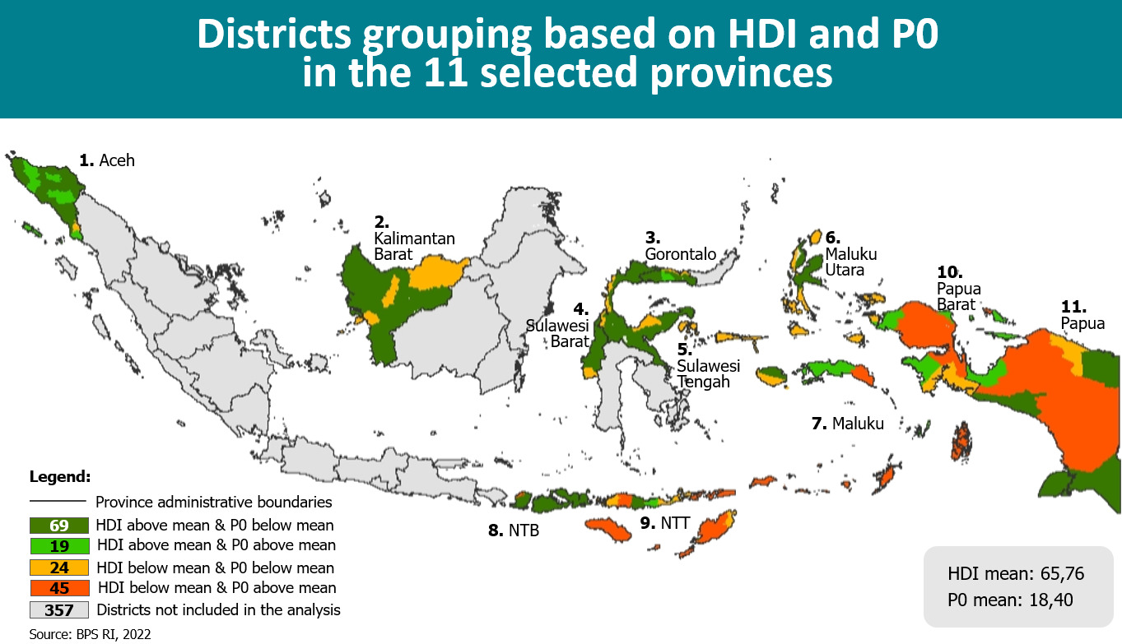**Figure 1: Grouping of potential SKALA districts based on HDI and poverty rates (PO) across 11 provinces**

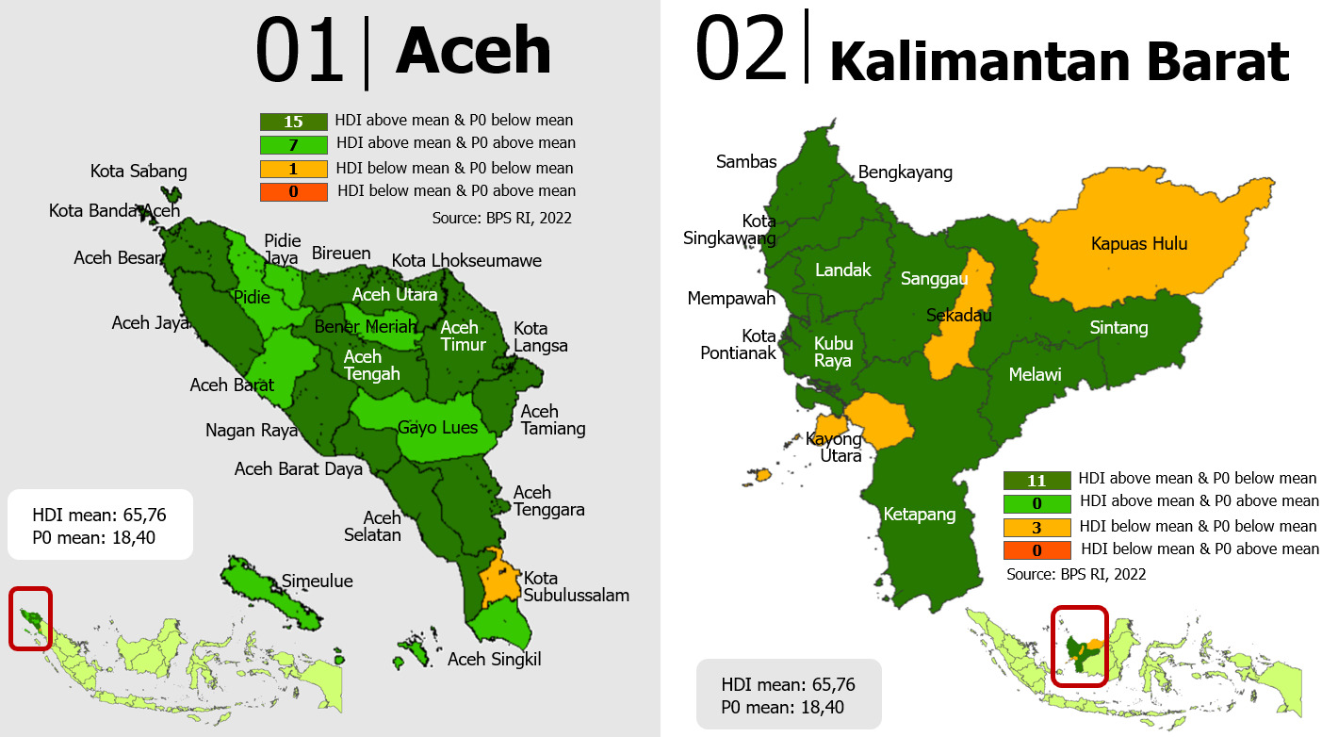**Figure 2: Grouping of potential SKALA districts in Aceh and Kalimantan Barat provinces**

**Figure 3: Grouping of potential SKALA districts in Gorontalo, Sulawesi Barat, and Sulawesi Tengah provinces**

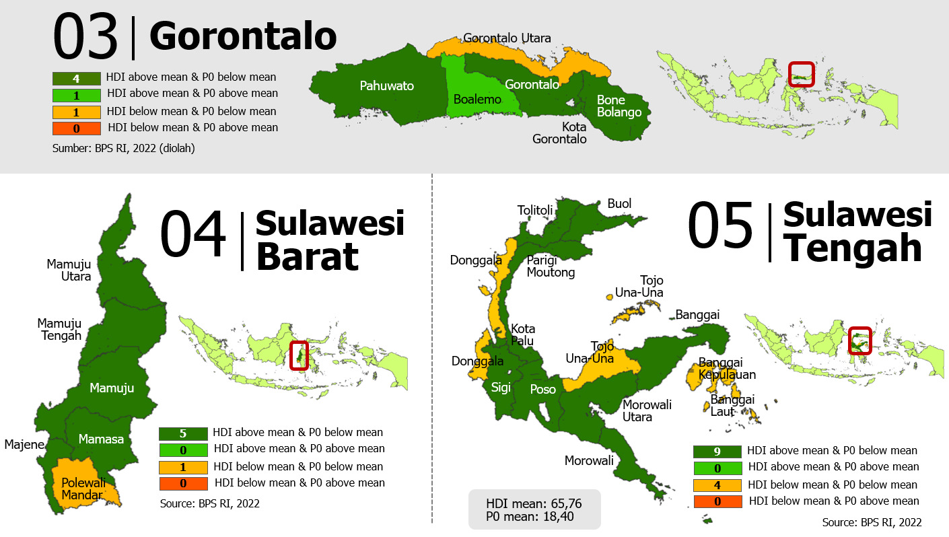

**Figure 4: Grouping of potential SKALA districts in Maluku Utara and Maluku provinces**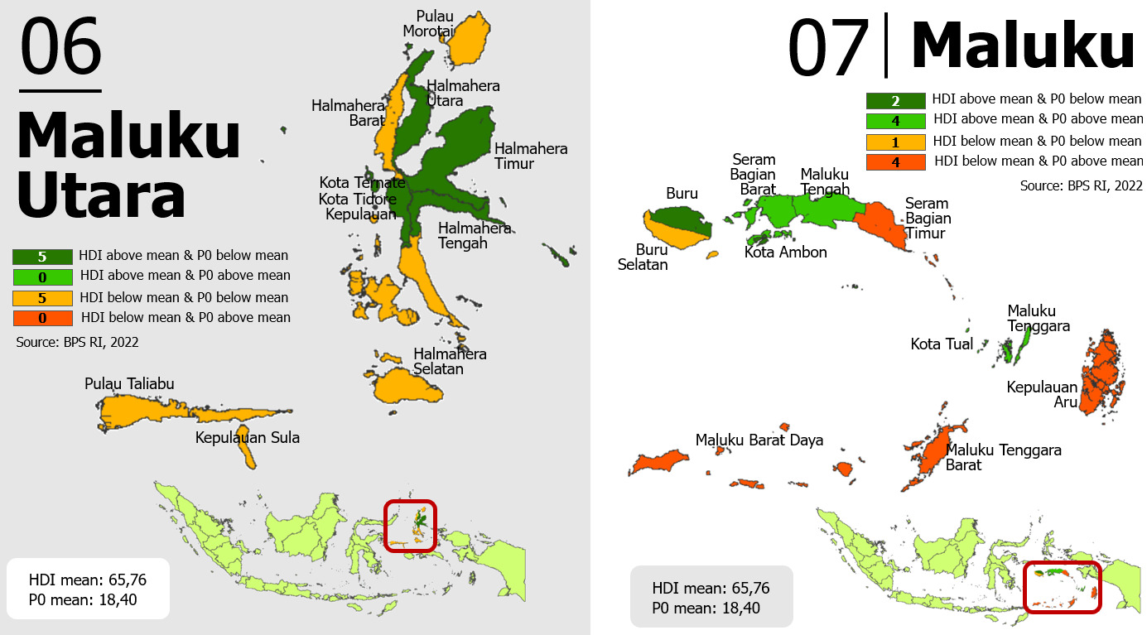

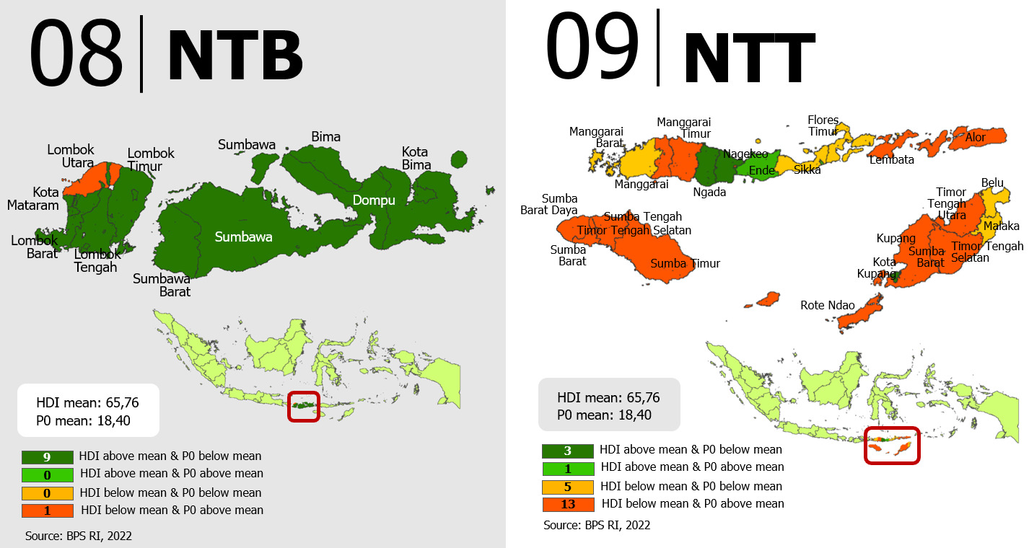**Figure 5 Grouping of potential SKALA districts in Nusa Tenggara Barat (NTB) and Nusa Tenggara Timur (NTT) provinces**

**Figure 6 Grouping of potential SKALA districts in Papua Barat and Papua provinces**

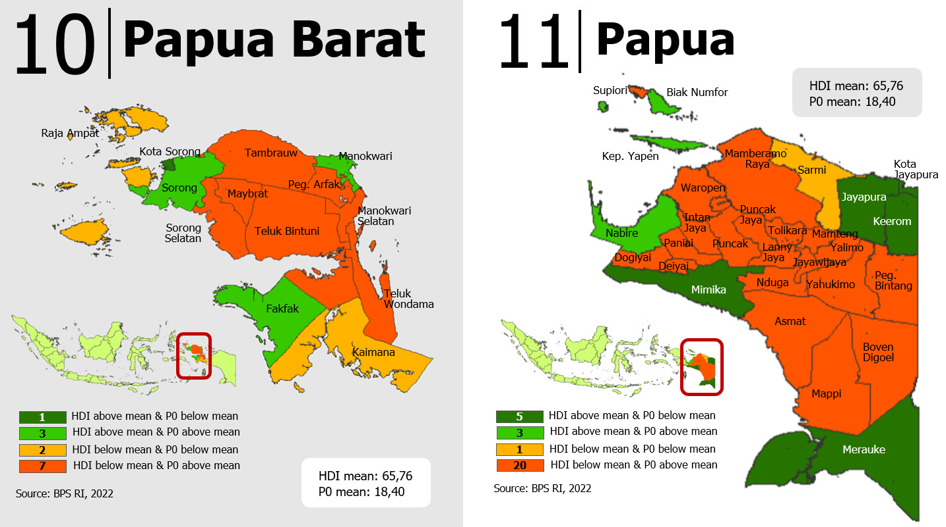

* 1. ANNEX 3: List of key Stakeholders Consulted during the design phase

**Ministry of Home Affairs**

1. Secretary General through Pusat Fasker /Centre of Cooperation Facilitation (under Secretaary General), Dr. Heriyandi Roni, M.Si
2. Direktorat Jenderal Pembangunan Daerah
3. Direktorat Jenderal Keuangan Daerah
4. Direktorat Jenderal Otonomi Daerah

**Ministry of National Development Planning (Bappenas)**

1. Ir. Rudy Soeprihadi Prawiradinata, Ph.D Deputi Pengembangan Regional
2. Drs. Pungky Sumadi, MCP, Ph.D Deputi Kependudukan dan Ketenagakerjaan
3. Drs.Oktorialdi, MA, Ph.D Staf Ahli Bidang Pemerataan dan Kewilayahan
4. Ibu Lisa ( Woro Srihastuti Sulistyaningrum) Director Of Family, Women, Children, Youth, and Sports
5. Maliki, ST, MSIE, Ph.D Director of Poverty Alleviation and Community Development

**Ministry of Finance**

1. DG Financial Balance / Ditjen Perimbangan Keuangan through Secretary of DG Financial Balance, Ir. Mariatul Aini, MBA

**The National Team for the Acceleration of Poverty Reduction (Tim Nasional Percepatan Penanggulangan Kemiskinan or TNP2K)**

1. Suprayoga Hadi Executive Secretary

**DFAT Gender Equality and Social Inclusion and INKLUSI program team**

1. Felicity Lane DFAT
2. Patricia Bachtiar DFAT
3. Lisa Humaidah DFAT
4. Fransisca Indarsiaini AIPTIS
5. Endah Agustiana AIPTIS

**Lembaga Adat Perempuan Papua (LAPEPA) West Papua**

1. Mrs Kondologit

**Balai Syura Aceh (women’s organisation)**

1. Suraiya Kamaruzaman

**Female-Headed Household Empowerment Program (PEKKA)**

1. Fitria Villa Sahara

**Disability Inclusion & Advocacy Movement (Sasana Inklusi & Gerakan Advokasi Difabel - SIGAB Indonesia)**

1. Joni Yulianto

**Association of Women with Disabilities West Nusa Tenggara (Himpunan Wanita Disabilitas Indonesia - HWDI)**

1. Chairperson, Sri Sukarni

**Center on Child Protection and Wellbeing at Universitas Indonesia (Pusat Kajian dan Advokasi Perlindungan dan Kualitas Hidup Anak - PUSKAPA UI)**

1. Santi Kusumaningrum, Director

**National Secretariat of the Indonesian Forum for Budget Transparency (Sekretariat Nasional Forum Indonesia untuk Transparansi Anggaran - SEKNAS FITRA)**

1. Misbakhul Hasan
2. Badiul

**Australia-Indonesia Partnership fop Economic Development (PROSPERA) program team**

1. David Nellor Facility Director
2. Della Temenggung Deputy Facility Director

**Australia-Indonesia Governance for Growth (KOMPAK) program team**

1. Anna Winoto Team Leader
2. Theodore Weohau Director Implementasi & Leads
3. Grace Palayukan, KVS & SID Lead
4. Dewi Sudharta, Deputy Dir Implementation
5. Lily Hoo Director MEL
6. Ancilla Irwan Lead & Team - Research MEL
7. Atiq Rahman Operational Director
8. Anastasia Eliza, Finance Manager
9. Ratna Fitriani, Lead & Team GEDSI Manager

**KOMPAK Papua**

1. Hilda Eveline
2. Tim Sub-National Papua
3. Tim Otsus Papua (KOMPAK Team & TA)
4. Tim Otsus Papua (KOMPAK Team & TA)
5. Tim Otsus Papua (KOMPAK Team & TA)

**KOMPAK Aceh**

1. Dicky Ariesandi Tim Sub-National Aceh

**KOMPAK Public Finance Management consultants**

1. Heracles Lang
2. Devi Suryani
3. Machfud Sidik
4. Prof Eddy Suratman

**Eastern Indonesia Knowledge Exchange Foundation (Yayasan Bursa Pengetahuan Kawasan Timur Indonesia - Bakti)**

1. Yusran Laitupa Executive Director
2. Ottow Sineri
3. Septer
4. Ricky
5. Odie Seumahu

**Towards a Strong and Prosperous Indonesian Society (Menuju Masyarakat Indonesia Yang Kokoh Sejahtera - MAHKOTA)**

1. John Brownlee Team Leader
2. Lina Kalfayan Deputy Team Leader

**Knowledge Sector Initiative**

1. Jana Hertz Team Leader

**Innovation for Indonesia's School Children (INOVASI)**

1. Mark Heyward Team Leader

**UNICEF**

1. Abdullah Modhesh Education Specialist

**Australia-Indonesia Partnership for Justice Phase 2**

1. Craig Ewers Team Leader
2. Peter Riddell-Carre Deputy Team Leader

**Abdul Latif Jameel Poverty Action Lab (J-PALSEA)**

1. Lina Marliani Team Leader

**DFAT Canberra - Program Enabling Division (Design Section)**

1. Kirsty Harris
2. Kirsten Hawkes

**DFAT Canberra - Gender Equality Branch**

1. Annemarie Reerink

**DFAT, Canberra - Development Procurement Section**

1. Simon Cann Evans,
2. Eduardo Cajina

**DFAT, Canberra - Indonesia Desk**

1. Zulaikha Chudori
2. Simone Corrigan



1. Innovation for Indonesia's School Children
2. Australia-Indonesia Partnership for Economic Development
3. Towards a Strong and Prosperous Indonesian Society
4. Australia Indonesia Partnership Towards an Inclusive Society
5. North Sumatra, Banten, East Java, West Kalimantan, South Sulawesi, and East Nusa Tenggara. Currently, KOMPAK is also working in East Java and South Sulawesi but ERAT is planning to work in different districts to KOMPAK.
6. https://www.dfat.gov.au/development/innovationdfat
7. Namely: DFAT’s *Gender Equality and Women’s Empowerment Strategy*, *Enhancing women’s voice in decision-making and leadership approach*, and *Development for All strategy;* as well as Jakarta Post’s Gender Strategy, ‘*Supporting women and girls’ access to key Government services*’*.*
8. Presidential Decree No. 16/2018 on Public Procurement (Pengadaan Barang/Jasa Pemerintah) provides opportunities for partnership between government and non-government agencies to delivery public services and government program (under the “swakelola tipe III” or self-management procurement type III scheme). <https://www.akatiga.org/language/en/swakelola-tipe-3/>
9. INKLUSI Investment Design Document
10. Indonesia-Australia Comprehensive Strategic Partnership, Plan of Action (2020-2024), Clause 18
11. Other relevant stakeholders include the Ministry of National Apparatus and Bureaucratic Reform (Monir), Ministry of Social Welfare, and the National Public Administration Institute (LAN).
12. Considering leadership changes resulting from the nationwide elections 2024
13. Relevant laws are Law no 7/1984 on the Ratification of the Convention of All Forms of Discrimination against Women, Presidential Instruction no 9/2000 on Gender Mainstreaming, Law no 23/2004 on Elimination on Domestic Violence, Political Laws that regulate women’s representation, Human Rights Law no 39/2009, a joint Ministerial Circular on Gender Responsive Planning and Budgeting 2012, Law on People with Disabilities no 8/2016
14. World Bank (2020) Assessment of Gender Responsive Public Financial Management <https://www.pefa.org/node/4416>
15. Indonesia Public Expenditure Review 2020 by World Bank (Spending for better results), section: Reforming the intergovernmental fiscal transfers for better services; and see Section B.
16. This includes technical assistance to -assisted districts to calculate budget requirements for meeting MSS standards
17. This is based on research by DFAT’s DLP Program on the key characteristics of developmental leaders.
18. These laws are Law no 25/2009 on public Services, Ministry of village regulation on village, less-developed regions and transmigration no 17/2019, Ministry of Home Affairs Regulation no 54/2010 on steps, process, development and evaluation of Regional Development Planning, Government regulation on Minimum Service Standard no 2/2018, Ministry of Bappenas regulation no 70/2019 on Planning, Implementation and Evaluation on Disability inclusiveness in Development
19. MOWECP, Bappenas, MOHA, and MoF issued a joint circular in 2012 to accelerate gender budget and the implementation of gender mainstreaming both local and central government. This circular regulated for the national and sub-national governments to adopt the National Strategy on Accelerating Gender Mainstreaming as a foundation to conduct consultation on gender responsive planning and budgeting; and ministries and sub-national governments to implement Gender Responsive Planning and Budgeting when they develop their workplan and budget
20. Barnes, Katrina, et al (2021) ‘Understanding governance from the margins: What does it mean in practice?’, A4EA Policy and Practice Paper, Brighton: Institute of Development Studies.
21. Sidel and Faustino, 2019, The Asia Foundation
22. DFAT, Development Leadership Program, 2008-17
23. World Bank, 2017
24. Wild, 2015
25. Booth and Unsworth, 2014. See Graham Teskey, January 2022 Thinking and working politically: What have we learned since 2013? Abt Associates
26. See Graham Teskey, January 2022 Thinking and working politically: What have we learned since 2013? Abt Associates
27. Andrews et al. 2012
28. For example, in working with MoHA on minimum service delivery standards (MSS) regulations and policies, SKALA could work with KIAT on MSS for Water Safety Plans, as well as PROSPERA’s work with the Ministry of Finance and MAHKOTA with TNP2K/The National Team for the Acceleration of Poverty Reduction.
29. For example, following the model used by KOMPAK to engage national financial specialist with OTSUS Fund experience
30. DFAT monitoring and evaluation standards. October 2021
31. See DFAT (2021) Monitoring and Evaluation Standards – Standard 3 Investment Progress Reporting
32. BPS (2020), Status Pendidikan, SUSENAS 2020.
33. BPS https://www.bps.go.id/indikator/indikator/view_data/0000/data/1349/sdgs_3/1
34. Sekretariat Wapres & Kemenko PMK (2018) Strategi Nasional Percepatan pencegahan anak keSKALAl (Stunting)
35. Soekatri, M et al (2020) Stunting Was Associated with Reported Morbidity, Parental Education and Socioeconomic Status in 0.5–12-Year-Old Indonesian Children. International Journal of Environmental Research and Public Health
36. Sakernas 2020
37. Kemenaker (2021) Ketenagekerjaan dalam angka
38. Komnas Perempuan (2021) CATAHU: Catatan Tahunan Kekerasan terhadap perempuan
39. BPS (2020) https://www.bps.go.id/indicator/40/1337/1/persentase-kursi-yang-diduduki-perempuan-di-dpr-dan-dprd.html
40. Kemendes (2021) https://www.kemendesa.go.id/berita/view/detil/4032/gus-halim-porsi-penempatan-perempuan-indikator-keberhasilan-sdgs-desa
41. Afkar, R et al (2020) Inclusion in Indonesia’s Education Sector: A Subnational Review of Gender Gaps and Children with disabilities. Policy Research Working Paper 9282, World Bank
42. Ministry of Social Affairs; Bappenas; the Ministry of Education; the Ministry of Law and Human Rights; the Ministry of Public Works and Housing; and the Ministry of Labour. The Ministry of Finance is preparing the regulation on concessions and subsidies
43. There are various datasets available across central agencies/ministries
44. [Indonesia - Vulnerability | Climate Change Knowledge Portal (worldbank.org)](https://climateknowledgeportal.worldbank.org/country/indonesia/vulnerability)